|  |  |  |  |
| --- | --- | --- | --- |
|  | C:\Users\KSchroer.SILVERWARE\Documents\Projects\Logo Transp.tif | SilverWare POS Inc. |  |

**SilverWare POS Avrio**

Report Guide

Contents

Introduction 5

Warranty 5

Warning 5

Getting Help 5

The Reports 6

Viewing/Printing a Report 7

Auditing 8

Credit Card Audit 8

Credit Card Summary 9

Loyalty Audit 10

System Audit 11

User Audit 13

PMS Transactions 14

Semi-Integrated Transactions Report 16

Client/Gift Card Reports 18

The Client Absent Report 18

Client Account Invoices 19

Client Balance 20

Client Invoice 21

Client Invoice List 23

The Client List Report 24

The On-Account Charges Report 26

Client Sales Analysis 28

Client Transaction History 30

The Gift Cards Report 31

Meal Plan Summary Report 33

Control Reports 34

Assigned User Report 34

Check Signature Report 36

The Discount Report 37

Manager Auth Report 39

The Pay-In/Pay-Out Report 40

Transfers Report 41

The Void Report 43

Exports 45

Accpac For Windows 45

Dataworks Export 46

Evention Export Report 47

FNB Shop Export Report 48

QuickBooks G/L Report 49

Sage 300 Report 50

Simply Accounting G/L Reporting 51

Menu Reports 52

The Menu Report 52

Operations 53

Reservations 53

Staff View Report 54

Table View Report 54

Payroll 55

Ceridian Payroll Export 55

Generic Payroll Export 56

UltiPro Payroll Export 57

Sales Reports 58

Comparative Sales Analysis 58

Cost Analysis Report 60

The Daily Totals Report 62

Executive Summary Weekly Report 65

Future Orders Client 67

Future Orders Summary 68

Hotel Interface Report 69

The Hourly Sales Analysis Report 70

The No Sale Report 72

The Register Summary Report 73

The Sales Analysis Report 75

Segment Analysis 77

Tax Totals 78

Server Reporting 79

Employee List 79

Employee Shifts and Tips 80

Employee Timesheet 81

The Server Contest Report 83

The Server Performance Report 85

Server Tip Declarations Report 86

Staff Average Sales Per Guest Report 87

Staff Tables Turns Report 88

Favourites 89

# Introduction

SilverWare is a powerful restaurant-management tool operated through a touch-screen interface.

## Warranty

SilverWare POS Inc. makes no warranty of any kind with regard to this material, including but not limited to, the implied warranties of merchantability or fitness for a particular purpose. SilverWare POS Inc. shall not be liable for errors contained herein or for incidental consequential damage in connection with the provision, performance or use of this material.

This document contains proprietary information protected by copyright. All rights are reserved. No part of this document may be reproduced, stored in a retrieval system, transmitted in any form or by any means, electronic, mechanical, photocopy, recording or otherwise, or translated into another language without the prior written consent of SilverWare POS Inc. The information contained herein is subject to change without notice.

## Warning

This software and documentation are still considered pre-release and therefore are subject to change.

SilverWare POS Inc. shall not be liable for errors contained herein or for incidental consequential damage in connection with the provision, performance or use of this material.

## Getting Help

SilverWare’s office is located in Ontario, Canada and operates under Eastern Standard Time. If you wish to ask a general question, please call **905-305-1225** during normal business hours, **Monday – Friday 9:00 am to 5:00 pm**.

If you need technical assistance, please contact our Technical Support call center, which is open 24 hours a day, 7 days a week.

Telephone: **1-888-510-5102**

Fax: **1-905-305-1810**

# The Reports

To access the reports menu, go to Manager Options 🡪 General 🡪 Reports

The reports are sorted into different categories on the left. Highlight “All Reports” to see all the reports.

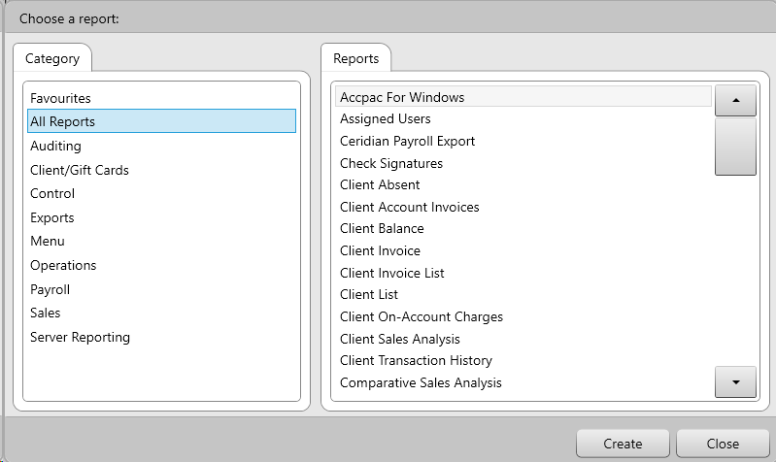

## Viewing/Printing a Report

1. Select a category, then the report you want to view.
2. Select the details you want to print/view.
3. Select an output for the report. Avrio’s report can be displayed on screen, sent to a wide (8.5” x 11”) printer, narrow (receipt) printer, exported to PDF, or exported to Excel.
4. Press **Generate**.
5. These buttons, found at the bottom of every on-screen report, help you navigate through the document:

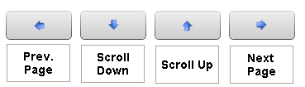

## Auditing

### Credit Card Audit

This report displays the messages transmitted between Avrio and the credit card module during a credit card transaction.

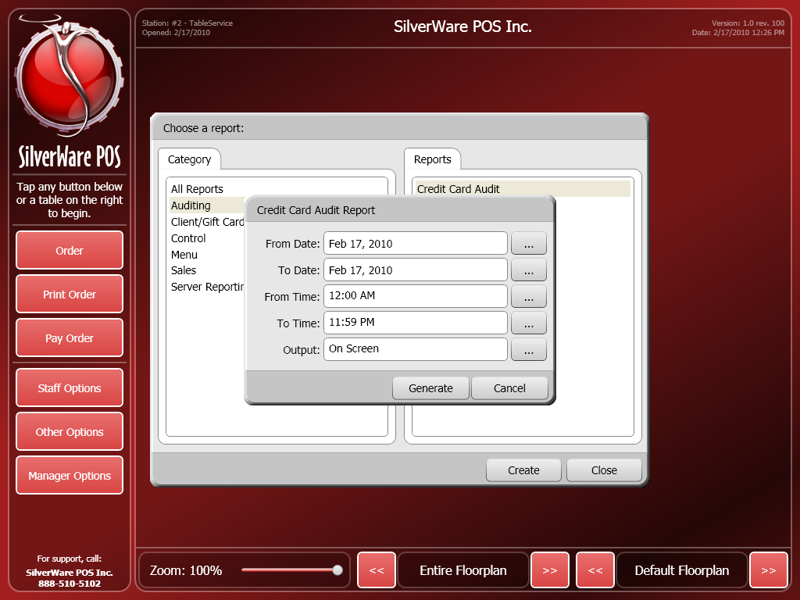

For this report you can choose the following criteria:

From Date/ To Date – Use these fields to select a date range the data will be based upon.

From Time/ To Time - Use these fields to select a time range the data will be based upon.

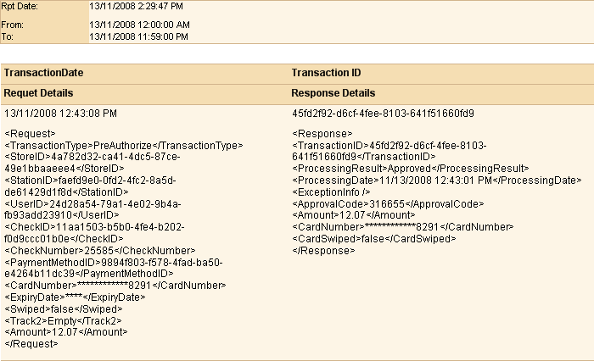

### Credit Card Summary

If your location is using Avrio’s integrated credit card processing, this report contains a summary of the transactions involved in a closed batch. It also displays a legend of the various states a credit-card transaction can be in.

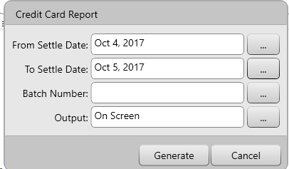

For this report you can choose the following criteria:

From Settle Date/ To Date – Use these fields to select a date range the data will be based upon.

Batch Number – This determines which batch of transactions the information is pulled from.

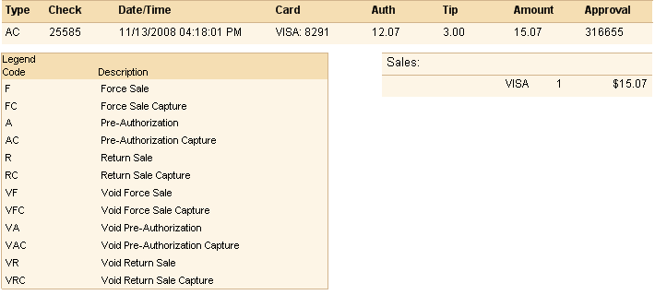

### Loyalty Audit

This report displays the messages transmitted between Avrio and the loyalty module during a loyalty card or client account transaction.

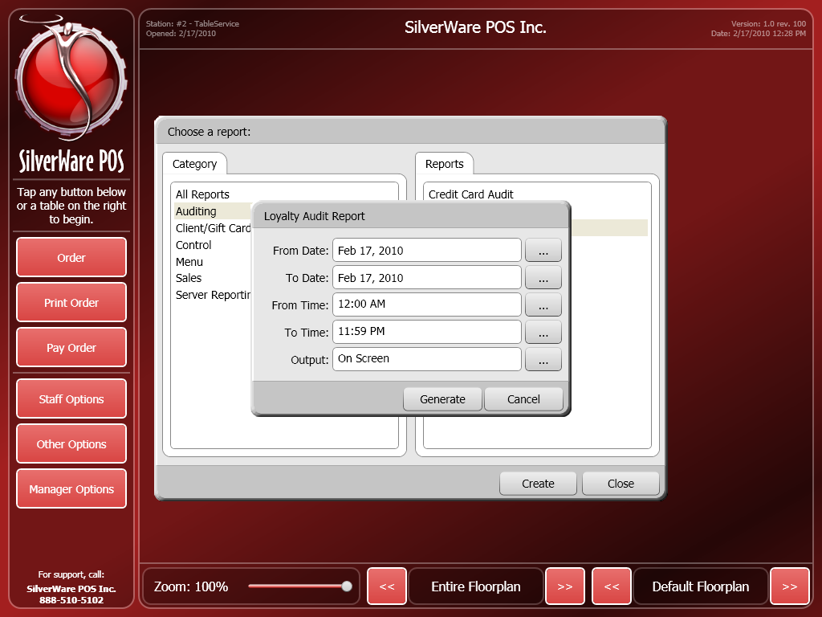

For this report you can choose the following criteria:

From Date/ To Date – Use these fields to select a date range the data will be based upon.

From Time/ To Time - Use these fields to select a time range the data will be based upon.

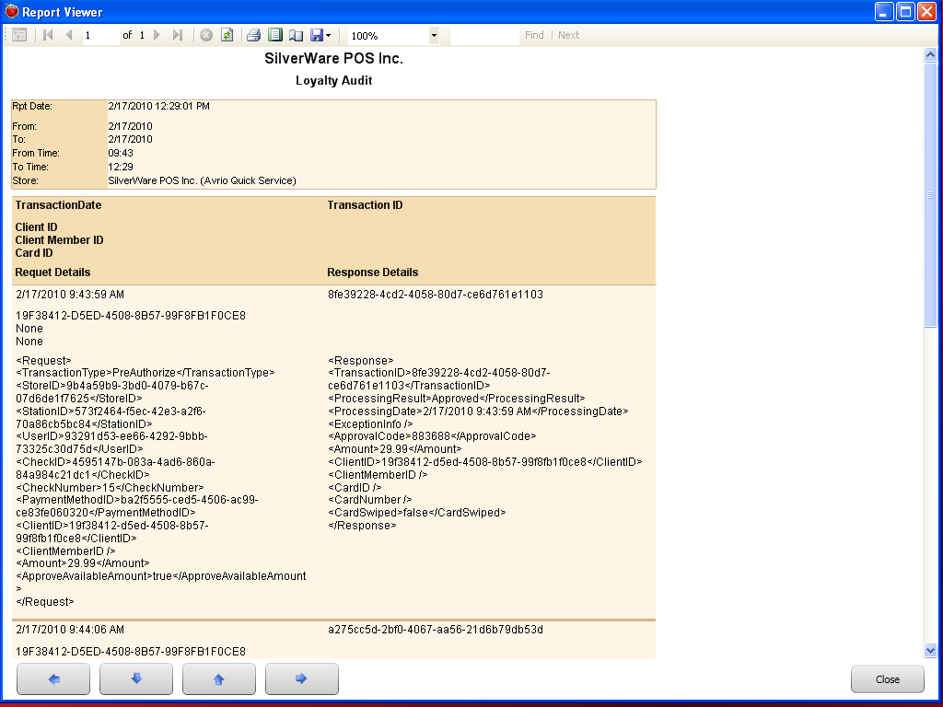

### System Audit

This report displays a log of the various actions users perform, such as: logging/out, accessing manager screens, etc. The report exists essentially to track which users have accessed higher-level and managerial functions in Avrio.

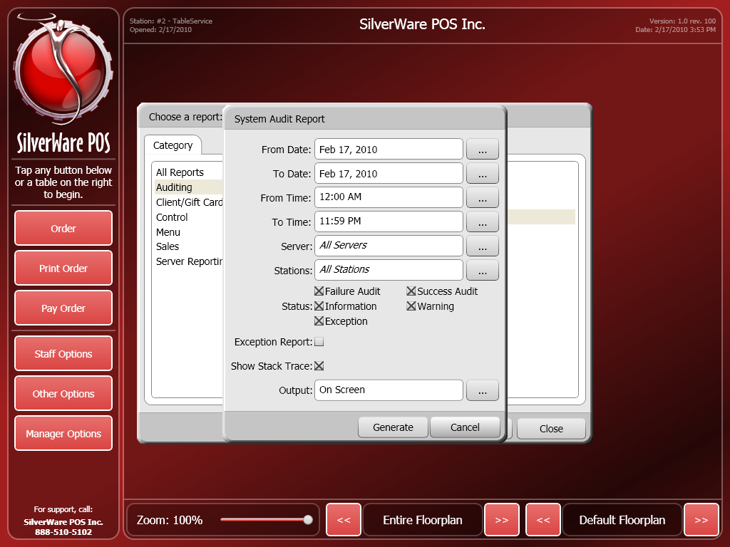

For this report you can choose the following criteria:

From Date/ To Date – Use these fields to select a date range the data will be based upon.

From Time/ To Time - Use these fields to select a time range the data will be based upon.

Server – Use this field to see information for all servers or a specific server.

Stations – Use this field to see what actions have been performed at all stations or a specific station.

Status – Use these options to determine which sort of events will be displayed.

* Failure Audit
* Success Audit
* Information
* Warning
* Exception

Exception Report – Check this option to show any deviation from the expected result

Show Stack Trace – Check this option to show the detailed trace of where a failure occurred in the code.

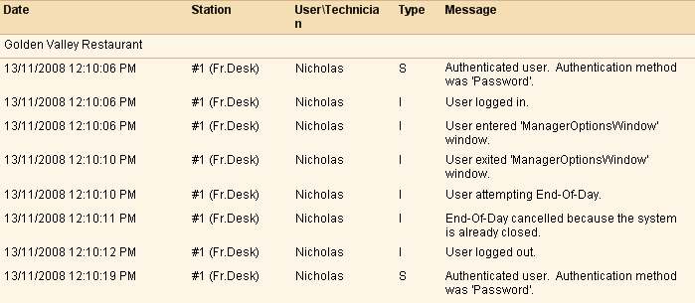

### User Audit

This report displays a log of any Re-Open or Change Tender Transactions performed by users.

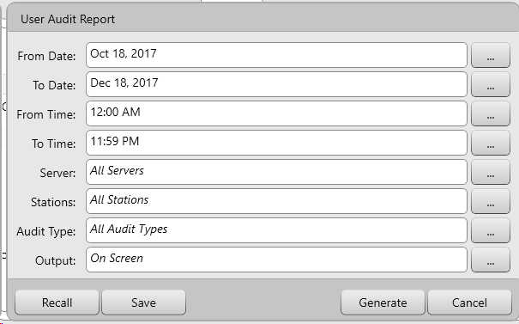

Here are the following criteria for this report:

From Date/ To Date – Use these fields to select a date range the data will be based upon.

From Time/ To Time - Use these fields to select a time range the data will be based upon.

Server – Use this field to see information for all servers or a specific server.

Stations – Use this field to see what actions have been performed at all stations or a specific station.

Audit Type – Use this field to filter between Re-Open or Change tender functions or both.

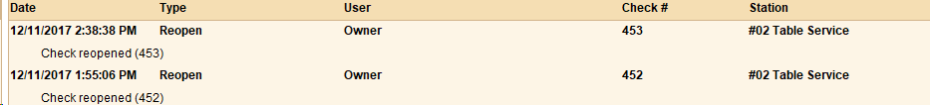

### PMS Transactions

This exports a CSV which shows the transactions that were posted to the Property Management System(PMS) from Avrio. Note that this is only for PMS 2.0 integration.

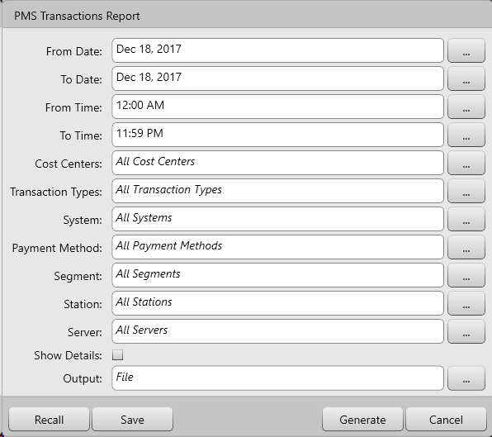

For this report you can choose the following criteria:

From Date/ To Date – Use these fields to select a date range the data will be based upon.

From Time/ To Time - Use these fields to select a time range the data will be based upon.

Cost Centers- use this field to filter which cost centers were posting to PMS

Transaction Type – this field is to filter what kind of post was transmitted to the PMS

System – If there are multiple PMS’s systems, you can use this filter to select a specific PMS.

Payment Method – use this field to filter what payment methods were posted to the PMS.

Segment – this field is to filter which segments (Breakfast, Lunch, Dinner) are shown on the report.

Station – this field is used to filter where each PMS post is coming from either between a specific station or all stations

Server – Use this filter to specify posts by a specific server or all servers.

Show Details – by enabling this option you can add filter to see all posts that were sent to the PMS instead of a summary.

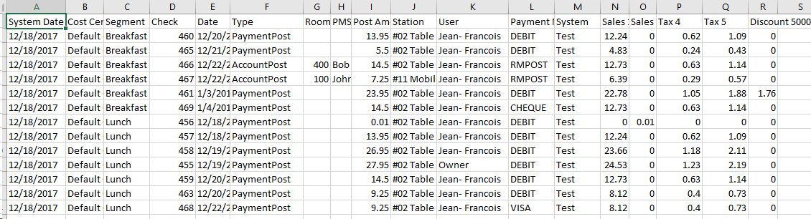

### Semi-Integrated Transactions Report

This report shows which transactions transmitted between Avrio and Semi-Integrated credit card devices.

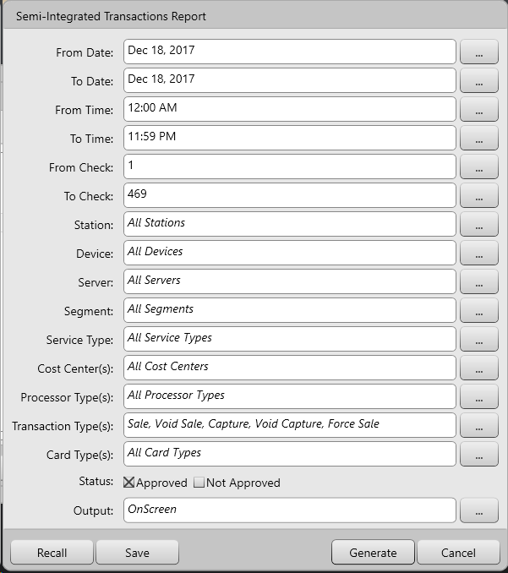

Here are the following search criteria for the Semi-Integrated Transactions report:

From Date/ To Date – Use these fields to select a date range the data will be based upon.

From Time/ To Time - Use these fields to select a time range the data will be based upon.

From Check/ To Check - Use these fields to select a range of checks that the data will be based upon.

Station – This field is used to filter where each credit card transactions is coming from either between a specific station or all stations

Device – Use this field to select a specific semi-integrated device.

Server – Use this field to see data based upon all servers or a specific server.

Segment – This field is to filter which segments (Breakfast, Lunch, Dinner) are shown on the report.

Service Type –Use this field to view Semi-Integrated transactions performed for all service types or specify a service type.

Cost Centers – Use this field to see data based upon sales at all cost centers or a specific one.

Processor Types – Use this field to filter between multiple credit card processors if there happens to be more than 1

Transaction Types - This filter is used to find specific transactions to the device, whether it’s a sale, void, capture, Pre-Auths or Forced Sale

Card Type – Use this filter to distinguish between different payment methods that were used through the device

Status – This filter is used to show transactions with or without approval codes.

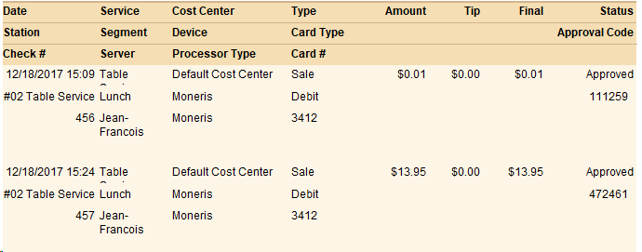

## Client/Gift Card Reports

These reports give you information about your clients and the items they’re charging to their accounts. You can also view information about gift card transactions.

### The Client Absent Report

The “Client Absent” report gives you the last day and time that a client was at your restaurant, based on the client’s last purchase. The client’s company is displayed as well.

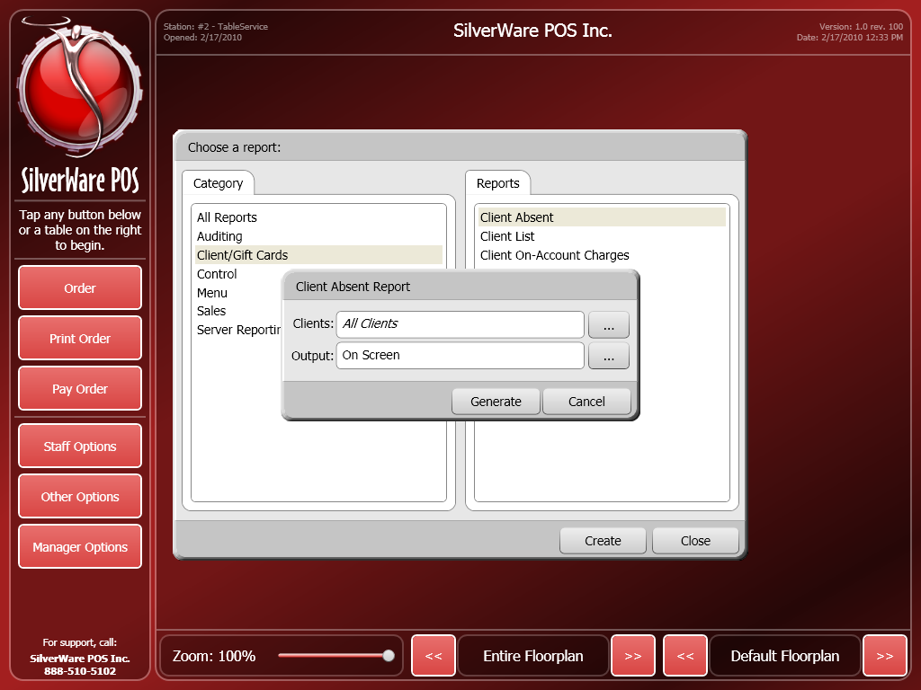

For this report you can choose the following criteria:

Clients – This field lets you display information for all clients or a specific client.

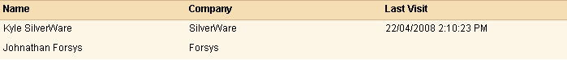

### Client Account Invoices

The “Client Account Invoices” report provides an accounts receivable statement for any on-account charges. The report only shows checks that have been closed and do not show totals if the check is still open.

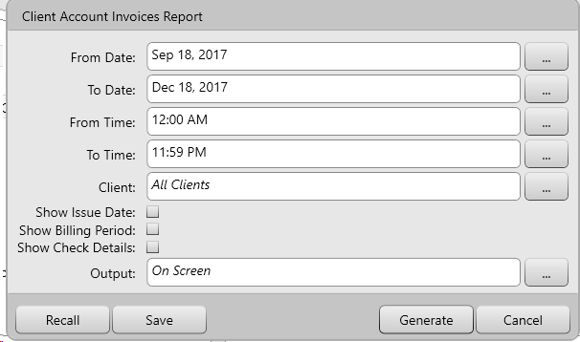

For this report you can choose the following criteria:

From Date/ To Date – Use these fields to select a date range the data will be based upon.

From Time/ To Time - Use these fields to select a time range the data will be based upon

Client- Use this filter to select specific clients that are displayed in the report.

Show Issue Date – This filter will show the date that they report was generated.

Show Billing Period – This filter will show the billing period on the report

Show Check Details – This filter will show all items that were ordered on the check

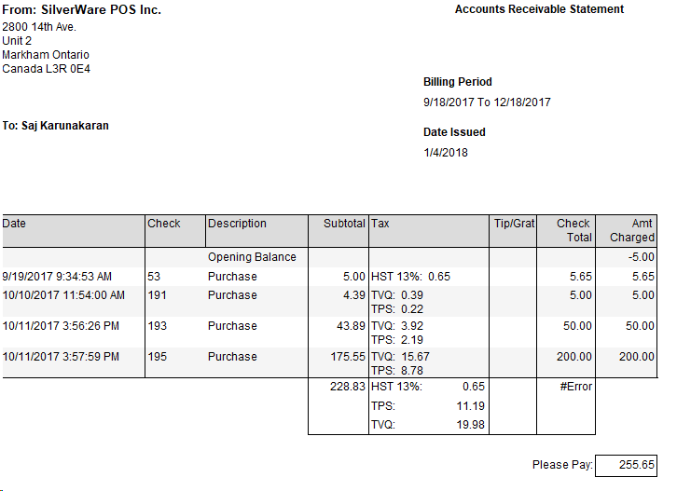

### Client Balance

The “Client Balance” report lists all clients as well as any Gift Cards with their outstanding money and point balances. This report will show the balance based on all transactions, even if a check is still open with a load/transaction.

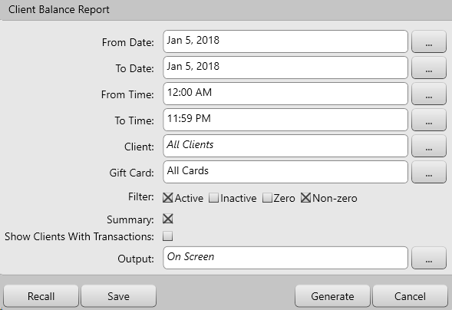

For this report you can choose the following criteria:

From Date/ To Date – Use these fields to select a date range the data will be based upon.

From Time/ To Time - Use these fields to select a time range the data will be based upon

Client- Use this filter to select specific clients that are displayed in the report.

Gift Card – Use this filter to select specific Gift Cards

Filter- this will allow a user to filter by Active, Inactive, Zero and Non- Zero Balances

Summary- this filter will summarize the money and point balances without showing how many points were earned during each transaction

Show Clients with Transactions – Use this filter to show only clients that have transactions on their accounts.

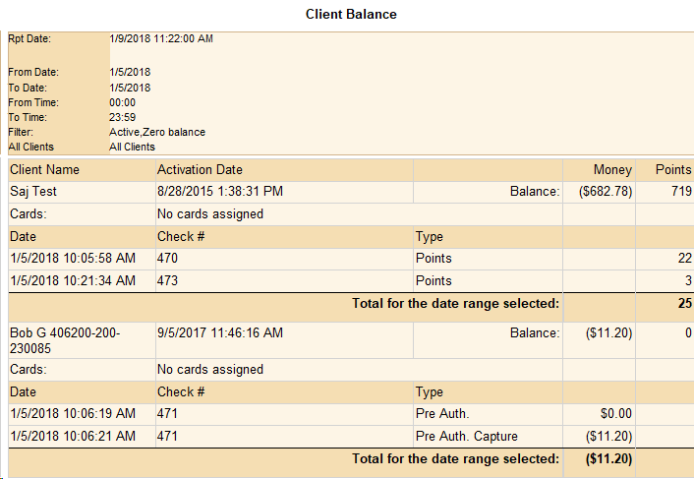

### Client Invoice

The “Client Invoice” report lists all individual checks that were charged to a client.

The report displays the client’s company and name, their address, phone number, their invoice totals, and any notes and delivery date and time.

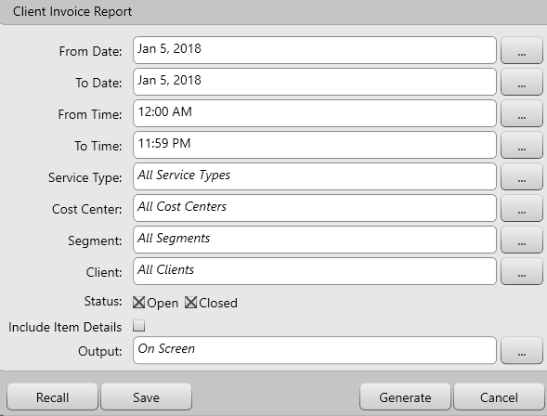

For this report you can use the following criteria:

From Date/ To Date – Use these fields to select a date range the data will be based upon.

From Time/ To Time - Use these fields to select a time range the data will be based upon.

From Check/ To Check - Use these fields to select a range of checks that the data will be based upon.

Service Type –Use this field to view transactions performed for all service types or specify a service type.

Cost Center – Use this field to see data based upon sales at all cost centers or a specific one.

Segment – This field is to filter which segments (Breakfast, Lunch, Dinner) are shown on the report.

Client- Use this filter to select specific clients that are displayed in the report

Status – Use this filter to show transactions whether they are closed or still open.

Include Item Details – Use this filter to show item details on each invoice.

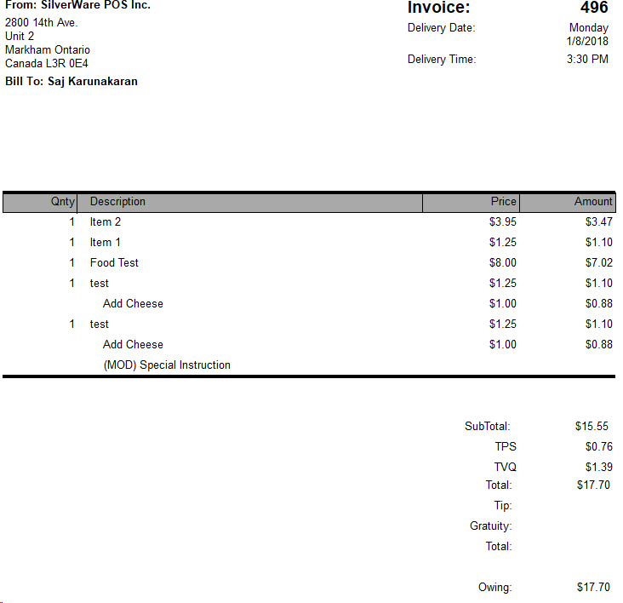

### Client Invoice List

The “Client Invoice List” report is a list of any on-account charges for all clients.

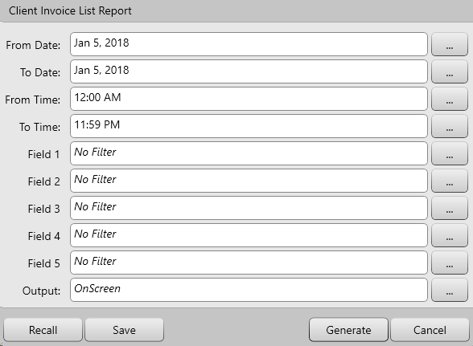

For this report you can use the following criteria:

From Date/ To Date – Use these fields to select a date range the data will be based upon.

From Time/ To Time - Use these fields to select a time range the data will be based upon.

Fields 1 through 5 – Use this filter for narrow search based on what is populated in this field for each client

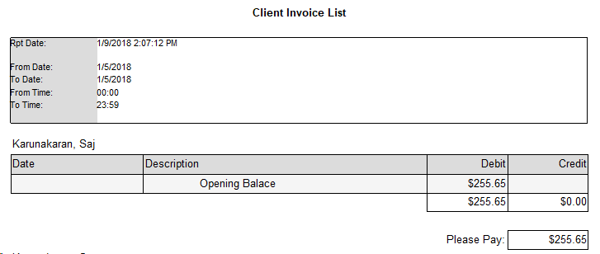

### The Client List Report

The “Client List” simply lists your clients and some of their information.

The report displays the client’s company and name, their address, phone number, their credit information, and any notes that have been entered about them.

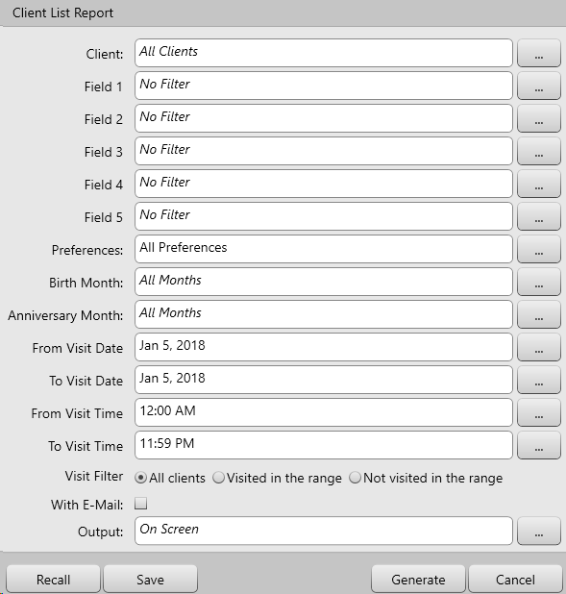

For this report you can choose the following criteria:

Clients – This field lets you display information for all clients or a specific client.

Fields 1 through 5 – Use this filter for narrow search based on what is populated in this field for each client

Preferences – Use this filter for narrow search based on what is populated in this field for each client

Birth Month – Use this filter to narrow search based on what is populated in this field for each client

Anniversary Month - Use this filter to narrow search based on what is populated in this field for each client

From Visit Date/ To Visit Date – Use these fields to select a date range the data will be based upon.

From Visit Time/ To Visit Time - Use these fields to select a time range the data will be based upon.

Visit Filter – Use this filter to show if the client was within or outside the visit range that was set.

With Email - will filter clients that only have email field populated on their profile

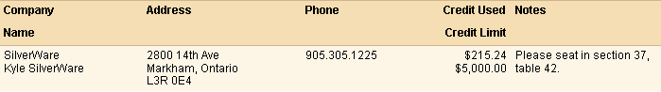

### The On-Account Charges Report

This report displays items that all clients have charged to their accounts. It also shows the client’s name, company, the date of purchase, and the items and their prices. The prices shown in the “Amount” column reflect any discounts and price levels that the client receives.

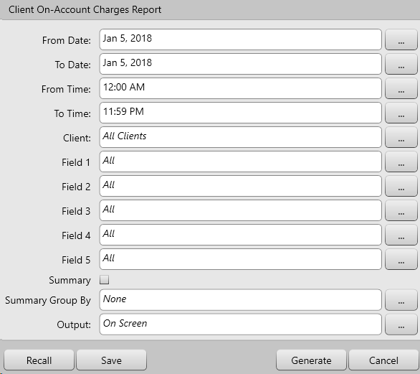

For this report you can choose the following criteria:

From Date/ To Date – Use these fields to select a date range the data will be based upon.

From Time/ To Time - Use these fields to select a time range the data will be based upon.

Clients – This field lets you display information for all clients or a specific client.

Fields 1 through 5 – Use this filter for narrow search based on what is populated in this field for each client

Summary – User this filter to summarize the clients by fields

Summary Group By - User this filter to summarize the client’s specific fields

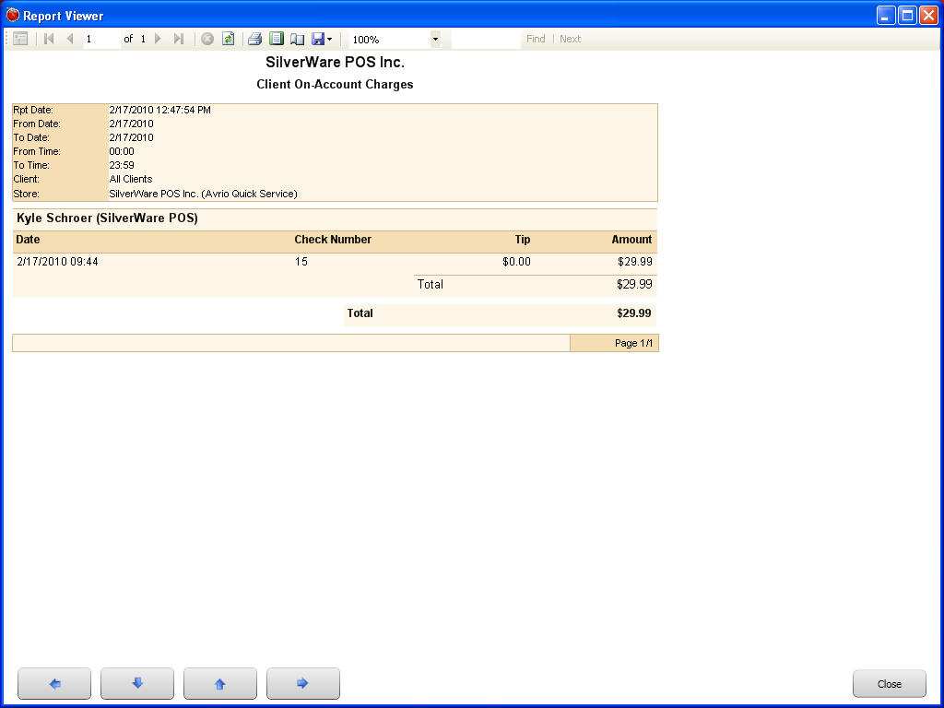

### Client Sales Analysis

This report shows the items ordered by clients, and the percentages of CLIENT sales the items account for.

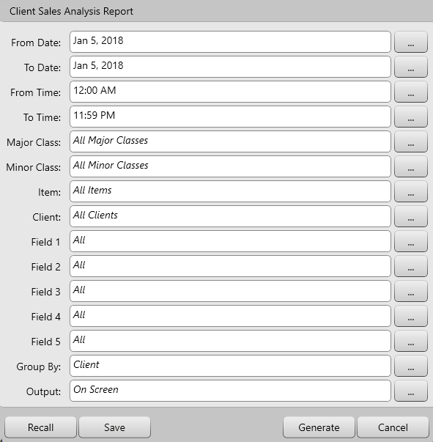

For this report you can choose the following criteria:

From Date/ To Date – Use these fields to select a date range the data will be based upon.

From Time/ To Time - Use these fields to select a time range the data will be based upon.

Major Class – Use this field to determine if the report displays information based on items reporting to all major classes, or one you’ve specified.

Minor Class – Use this field to determine if the report displays information based on items reporting to all minor classes, or one you’ve specified.

Item – Use this field to determine if the report displays information based on the specific menu item that was specified

Clients – This field lets you display information for all clients or a specific client.

Fields 1 through 5 – Use this filter for narrow search based on what is populated in this field for each client

Group By – organizes the report and groups them by client, major class, minor class and menu items

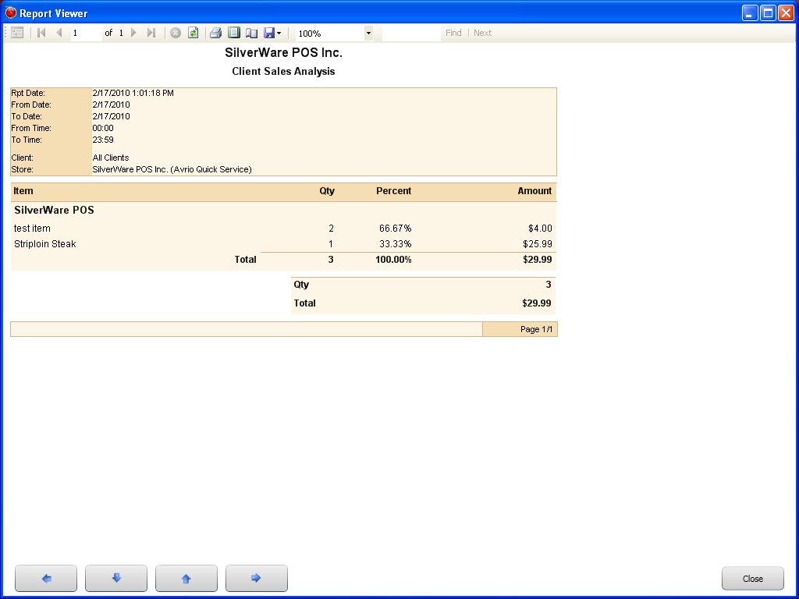

### Client Transaction History

This report displays each your clients’ orders, including items they ordered and the check the orders appeared on.

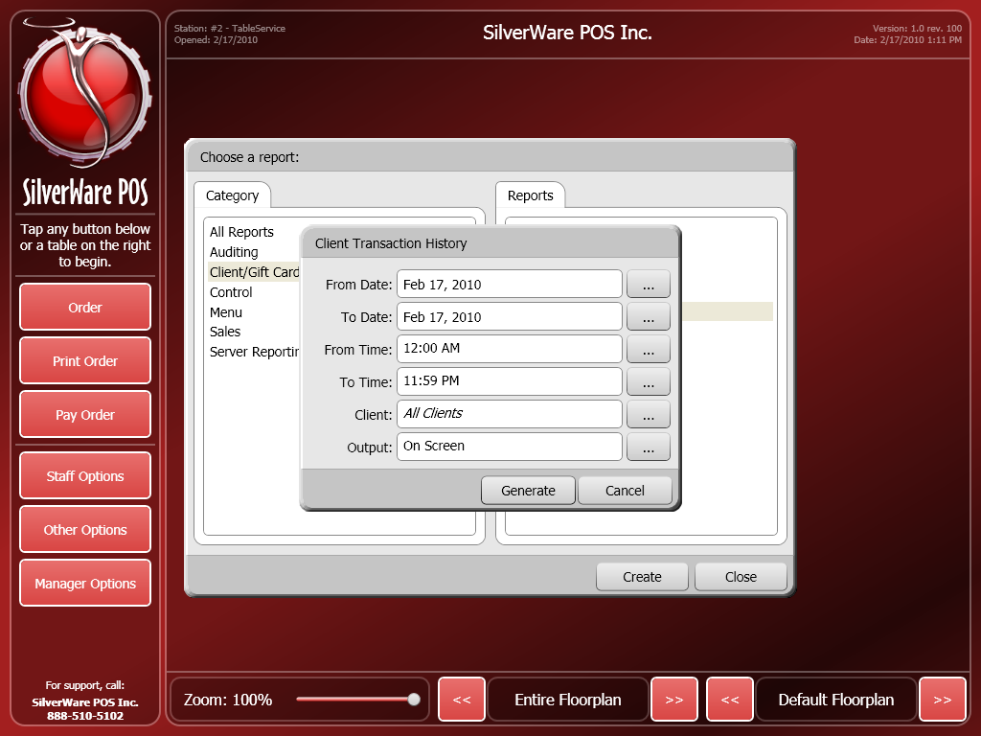

For this report you can choose the following criteria:

From Date/ To Date – Use these fields to select a date range the data will be based upon.

From Time/ To Time - Use these fields to select a time range the data will be based upon.

Clients – This field lets you display information for all clients or a specific client.

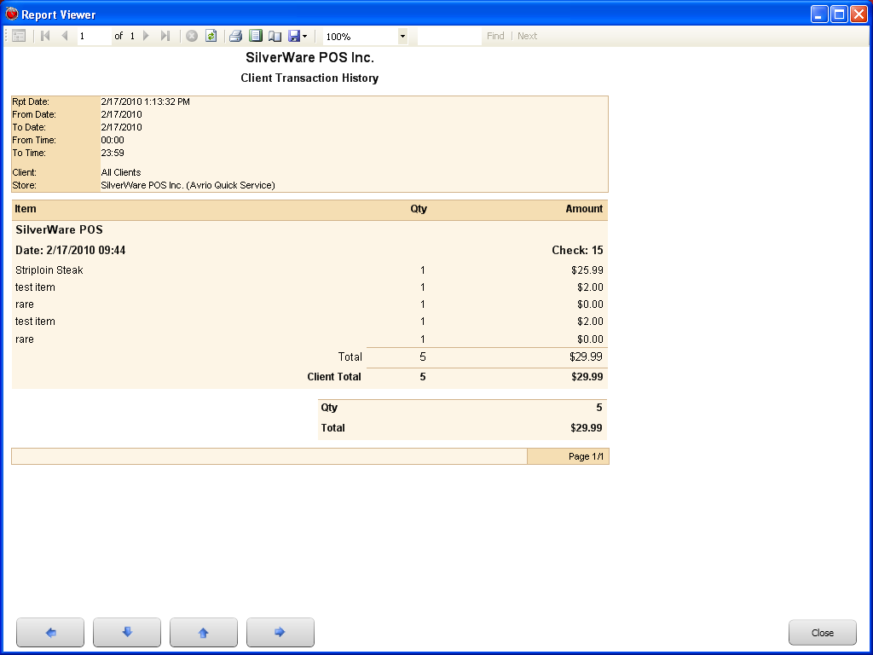

### The Gift Cards Report

This report displays information about transactions conducted with a gift card. Client and client card transactions are not included in this report.

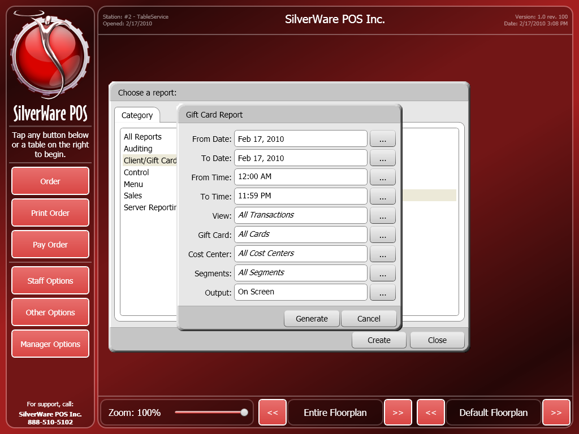

For this report you can choose the following criteria:

From Date/ To Date – Use these fields to select a date range the data will be based upon.

From Time/ To Time - Use these fields to select a time range the data will be based upon.

View – This field lets you choose which transactions the report will display.

* All – Displays all transactions
* Loads – Displays only transactions in which a gift card was loaded
* Discounted Loads – Displays only transaction in which a gift card was loaded, and the amount was discounted
* Redemptions – Displays only transactions in which a gift card was redeemed

Gift Card – Use this field to determine if the report displays information based on all cards, or a specific card.

Cost Center – Use this field to determine if the report displays information from all cost centers, or just a specific one.

Segments – Use this field to determine if the report displays information for all segments, or just a specific one.

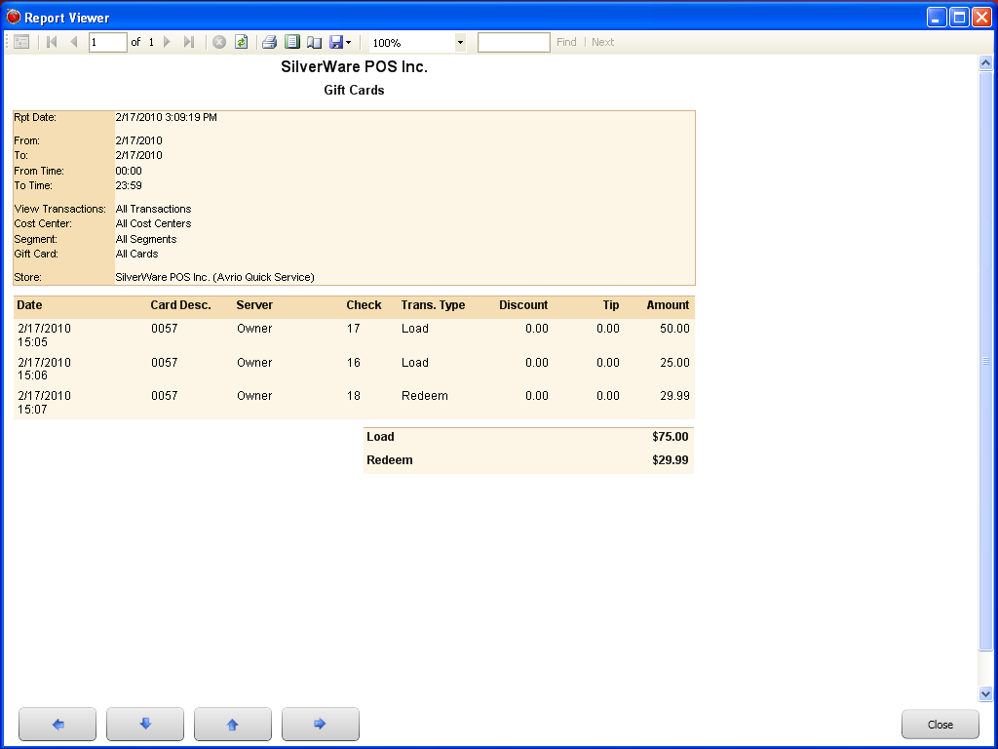

### Meal Plan Summary Report

This report will provide a sales analysis report for items that were ordered under a meal plan. It also shows the client’s name, company, the date of purchase, and the items and their prices

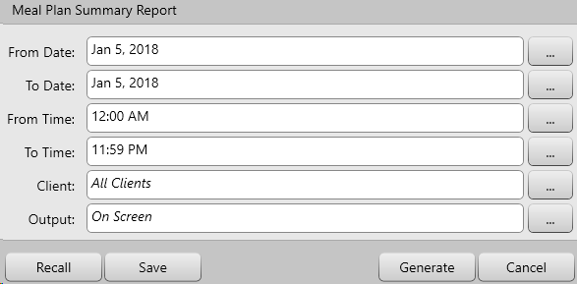

For this report you can choose the following criteria:

From Date/ To Date – Use these fields to select a date range the data will be based upon.

From Time/ To Time - Use these fields to select a time range the data will be based upon.

Clients – This field lets you display information for all clients or a specific client.

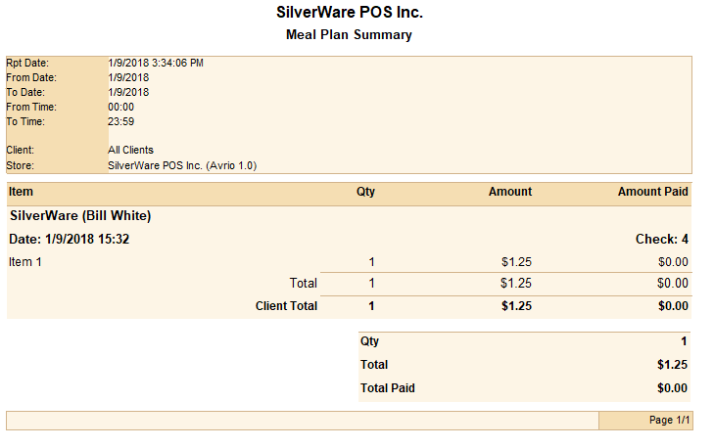

## Control Reports

Control reports monitor the discounts and voids your servers are performing.

### Assigned User Report

This report shows you users that were assigned to menu items on a check. This is mainly used to track commissions.

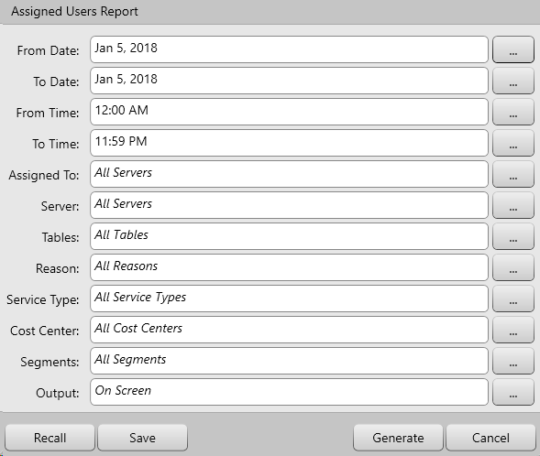

For this report you can choose the following criteria:

From Date/ To Date – Use these fields to select a date range the data will be based upon.

From Time/ To Time - Use these fields to select a time range the data will be based upon.

Assigned To: Use this field to see the information for all servers or specific servers that have been assigned to menu items.

Server – Use this field to see information for all servers or a specific server.

Tables – Use this field to filter by table

Reasons – User this field to filter by Assigned User Reason

Service Type –Use this field to view Assigned Users performed for all service types or specify a service type

Cost Center – Use this field to determine if the report displays information from all cost centers, or just a specific one.

Segments – Use this field to determine if the report displays information for all segments, or just a specific one.

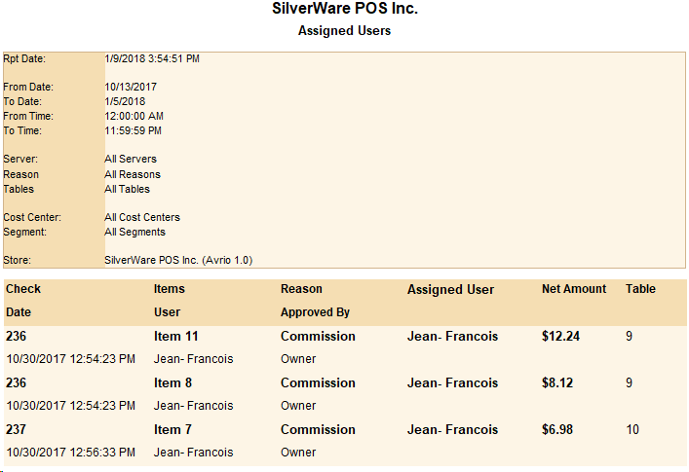

### Check Signature Report

This report shows the signature that was captured for a specific check. It also contains the server, cost center, segment, table, and total.

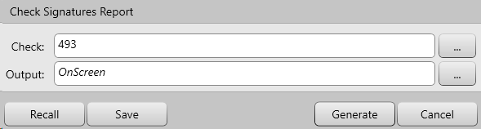

For this report you can use the following criteria:

Check – this filter is used to show an individual check

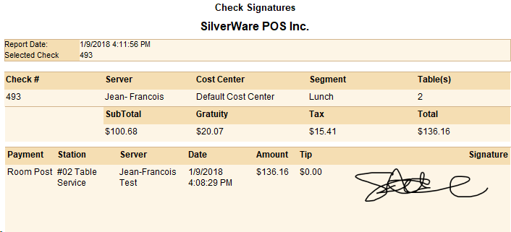

### The Discount Report

This report shows you information about discounts that fit the parameters (date/time range, employees, and discount reason) you set.

The report displays the check number, the user that selected the discount, the user that authorized it, the time and date of the discount, the item(s) discounted, the original and discounted price of the items, the discount reason that was used, and the percentage of the discount.

If an item is discounted, but then voided later on, it doesn’t appear on this report. When a cash discount is used, the report calculates the percentage of the discount.

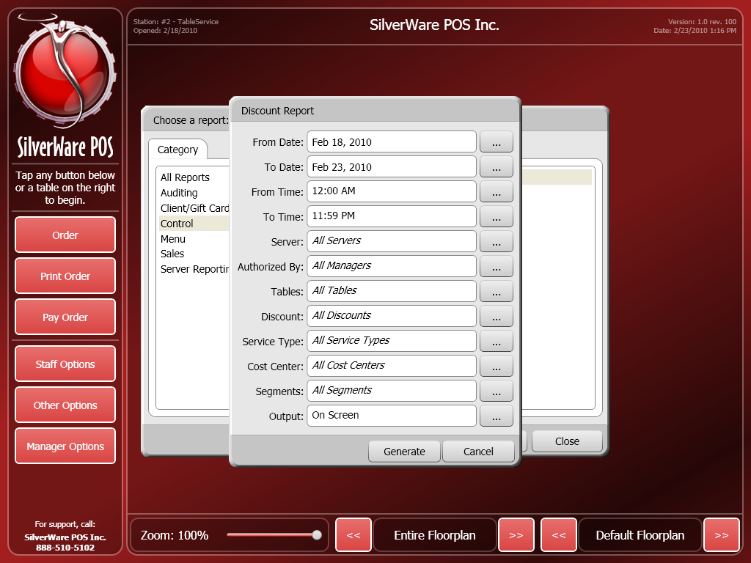

For this report you can choose the following criteria:

From Date/ To Date – Use these fields to select a date range the data will be based upon.

From Time/ To Time - Use these fields to select a time range the data will be based upon.

Server – Use this field to see discounts initiated by all servers or a specific server.

Authorized By – Use this field to see discounts authorized by all managers or a specific one.

Tables – Use this field to see discounts performed for all tables, or specify a table to view any discounts performed for it.

Discount – Use this field to see all discounts performed, or view information only about a specific discount.

Service Type –Use this field to view discounts performed for all service types, or specify a service type.

Cost Center – Use this field to view discounts performed for at all cost centers, or specify a cost center.

Segments – Use this field to determine if the report displays discounts performed during all segments, or just during a specific one.

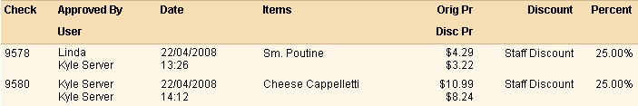

### Manager Auth Report

The “Manager Auth” report shows manager authorizations that were approved which encompasses a variety of Event Types.

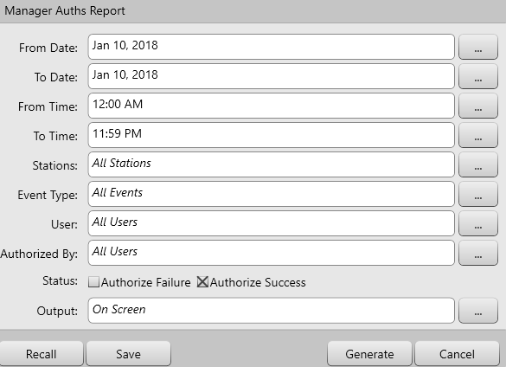

For this report you can choose the following criteria:

From Date/ To Date – Use these fields to select a date range the data will be based upon.

From Time/ To Time - Use these fields to select a time range the data will be based upon.

Station – This field is used to filter where each authorization took place between a specific station or all stations

Event Type – Use this filter to select specific or multiple authorization types

User- use this filter to select the requesting user of each authorization request

Authorized by – use this filter to select which user authorized the request

Status – use this filter to show results between successful and failed authorizations

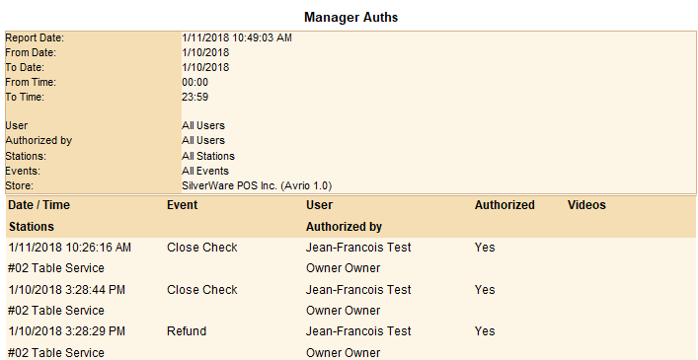

### The Pay-In/Pay-Out Report

This report displays any pay-ins and pay-outs performed by your server, ensuring accurate tracking of cash on hand.

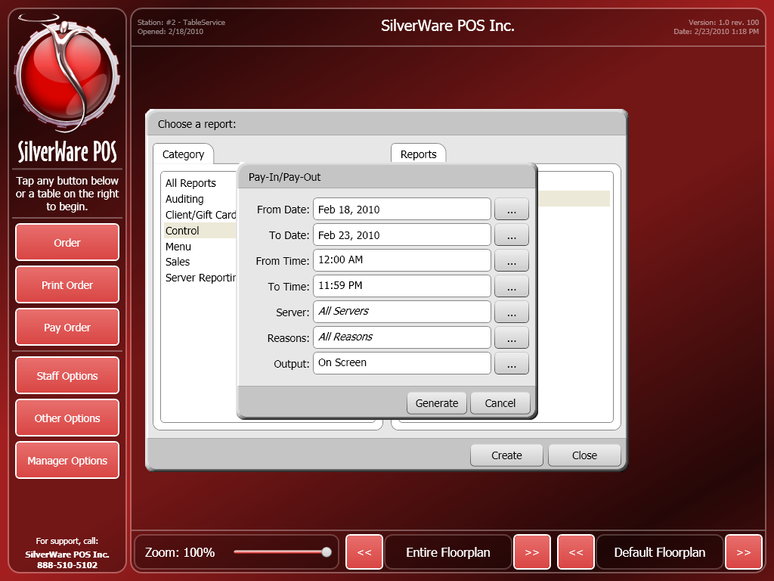

For this report you can choose the following criteria:

From Date/ To Date – Use these fields to select a date range the data will be based upon.

From Time/ To Time - Use these fields to select a time range the data will be based upon.

Server – Use this field to see pay-in/outs performed by all servers or a specific server.

Reasons –Use this field to see all pay-ins/out, or see only those performed for a specified reason.

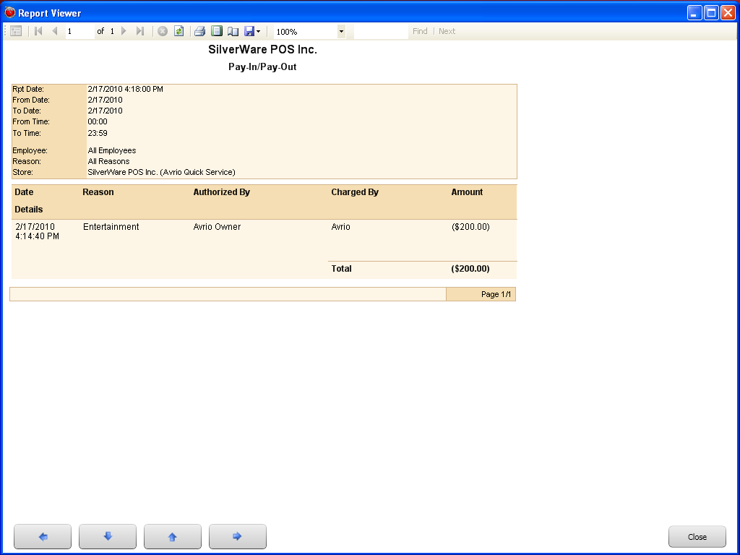

### Transfers Report

This report displays the transfers performed by your server and ensures accurate tracking of which orders were transferred and the which server/manager authorized each transfer.

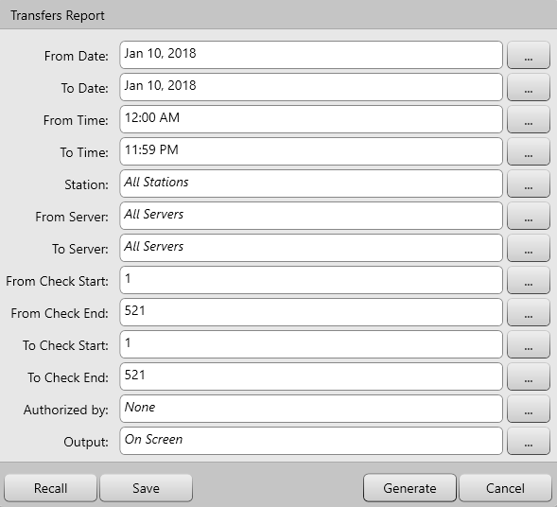

For this report you can choose the following criteria:

From Date/ To Date – Use these fields to select a date range the data will be based upon.

From Time/ To Time - Use these fields to select a time range the data will be based upon.

Station – This field is used to filter where each transfer took place between a specific station or all stations

From Server- Use this field to see all the transfers that came from a particular server or all servers

To Server- Use this field to see all the transfers that were given to a particular server or all servers

From Check Start/Check End – Use these fields to select a check range the data will be based upon

To Check Start/Check End – Use these fields to select a date range the data will be based upon

Authorized by – Use this filter to select which user authorized the request

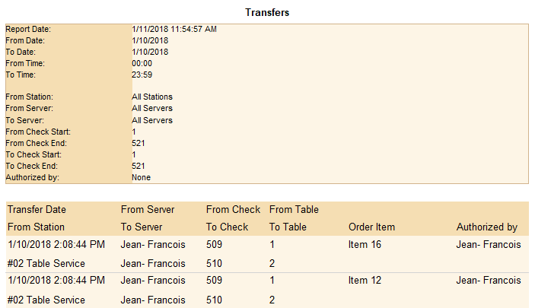

### The Void Report

This report shows you information about all the voids authorized within the parameters (date range, specific employees, and void reason) you set. You can choose how the report sorts the information as well.

The report displays the check, the user that selected the void and the user that authorized it, the time and date of the void, the item voided (and the quantity), the void reason that was used, and the voided item’s price.

If an item is discounted, but voided later on, it shows up at its original price.

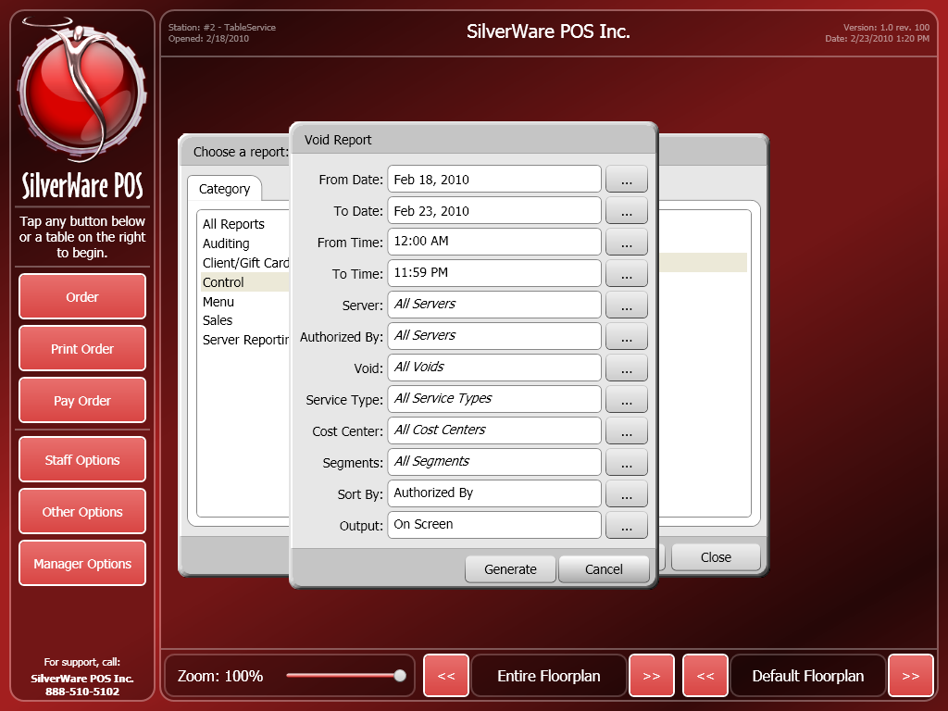

For this report you can choose the following criteria:

From Date/ To Date – Use these fields to select a date range the data will be based upon.

From Time/ To Time - Use these fields to select a time range the data will be based upon.

Server – Use this field to see voids initiated by all servers or a specific server.

Authorized By – Use this field to see voids authorized by all managers or a specific one.

Void– Use this field to see all voids performed, or view information only about a specific void reason.

Service Type –Use this field to view voids performed for all service types or specify a service type.

Tables – Use this field to see discounts performed for all tables, or specify a table to view any discounts performed for it.

Cost Center – Use this field to view voids performed for at all cost centers, or specify a cost center.

Segments – Use this field to determine if the report displays voids performed during all segments, or just during a specific one.

Sort By – Determines how the information will be sorted, either by who authorized the void, or who initiated it (the check owner)

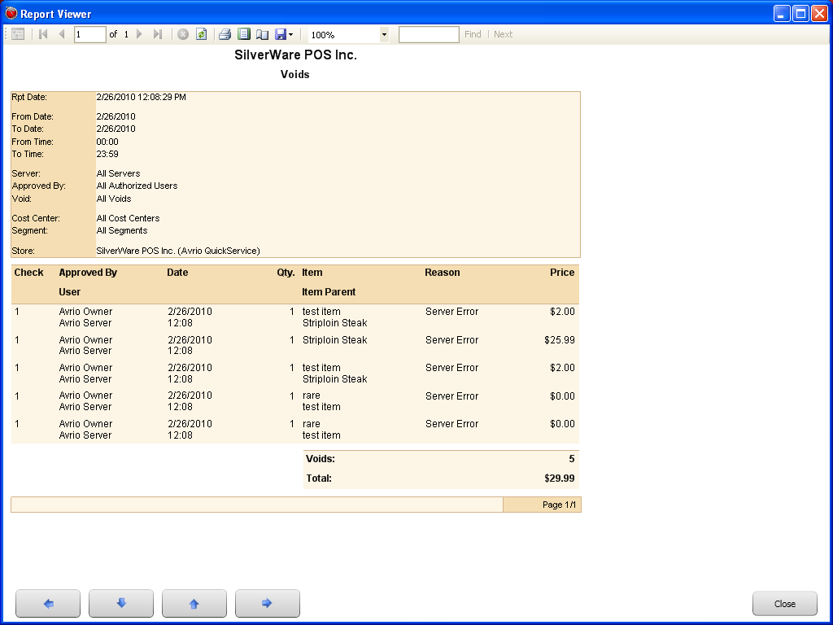

## Exports

Exports are used to generate CSV files that integrate with third party software.

### Accpac For Windows

This export is used to integrate with Accpac on Windows OS.

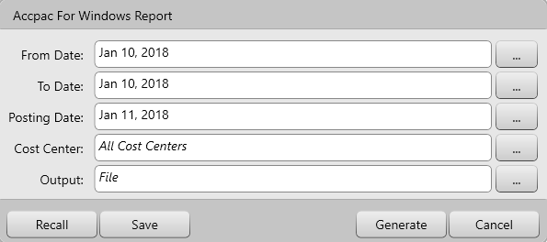

For this report you can choose the following Criteria:

From Date/ To Date – Use these fields to select a date range the data will be based upon.

From Time/ To Time - Use these fields to select a time range the data will be based upon.

Post Date – Use this field to select a date range for the posting period in the accounting software

Cost Center – Use this field to view transactions performed for at all cost centers, or specify a cost center

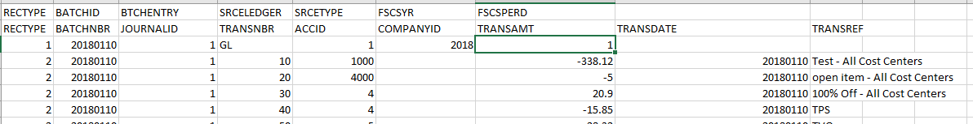

### Dataworks Export

This export is used to integrate with Dataworks analytics

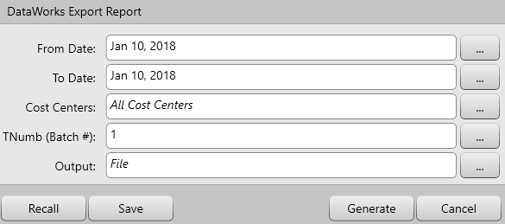

For this report you can choose the following Criteria:

From Date/ To Date – Use these fields to select a date range the data will be based upon.

From Time/ To Time - Use these fields to select a time range the data will be based upon.

Cost Center – Use this field to view transactions performed for at all cost centers, or specify a cost center Tnumb(batch#) – This field is used input the batch number of the export

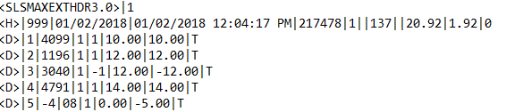

### Evention Export Report

This export is used to integrate with Evention.

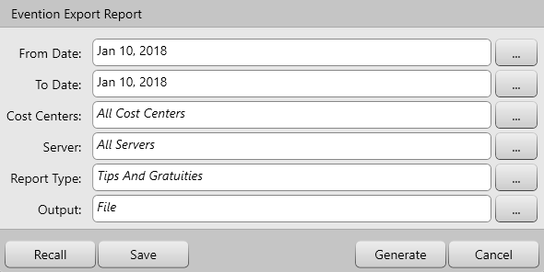

For this report you can choose the following Criteria:

From Date/ To Date – Use these fields to select a date range the data will be based upon.

From Time/ To Time - Use these fields to select a time range the data will be based upon.

Cost Center – Use this field to view transactions performed for at all cost centers, or specify a cost center

Server – Use this field to filter which server is shown for the data whether it’s a selected server or all servers.

Report Type – Use this field to filter between tips and gratuities, Secure drops, and Sales by User.

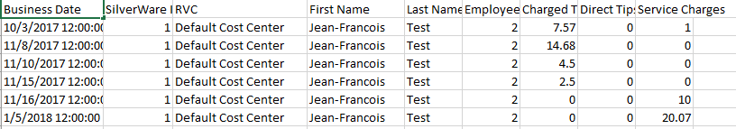

### FNB Shop Export Report

The FNB shop export is used to integrate with FNB at The Ritz.

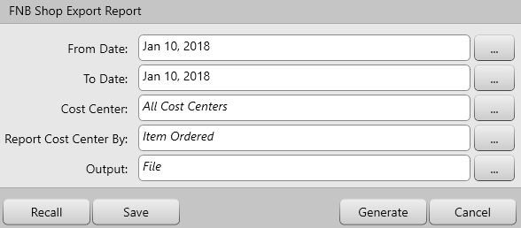

For this report you can choose the following Criteria:

From Date/ To Date – Use these fields to select a date range the data will be based upon.

From Time/ To Time - Use these fields to select a time range the data will be based upon.

Cost Center – Use this field to view transactions performed for at all cost centers, or specify a cost center

Report Cost Center By – Use this field to filter the export by Check Closed or Item Ordered

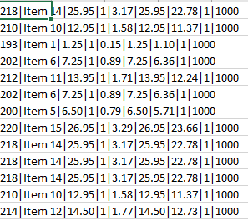

### QuickBooks G/L Report

This export is used to integrate with QuickBooks accounting software.

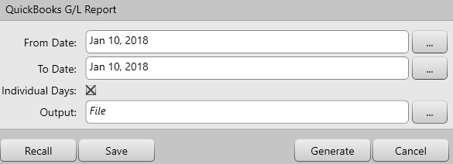

For this report you can choose the following Criteria:

From Date/ To Date – Use these fields to select a date range the data will be based upon.

From Time/ To Time - Use these fields to select a time range the data will be based upon.

Individual Days – Use this filter to show individual days in the export

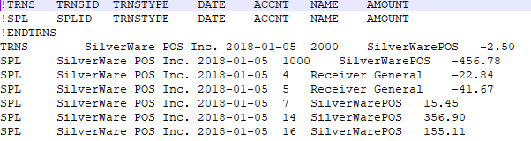

### Sage 300 Report

This export is used to Integrate with Sage 300 accounting software.

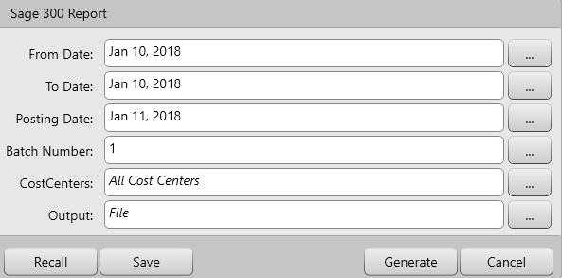

For this report you can choose the following Criteria:

From Date/ To Date – Use these fields to select a date range the data will be based upon.

From Time/ To Time - Use these fields to select a time range the data will be based upon.

Post Date – Use this field to select a date range for the posting period in the accounting software

Cost Center – Use this field to view transactions performed for at all cost centers, or specify a cost center

Batch Number - This field is used input the batch number of the export

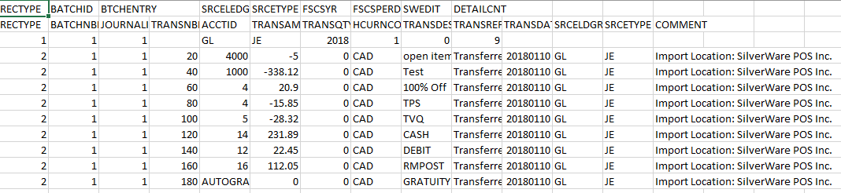

### Simply Accounting G/L Reporting

This export is used to integrate with Simply Accounting software.

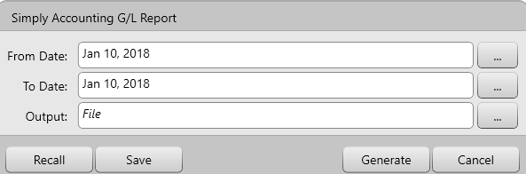

For this report you can choose the following Criteria:

From Date/ To Date – Use these fields to select a date range the data will be based upon.

From Time/ To Time - Use these fields to select a time range the data will be based upon.

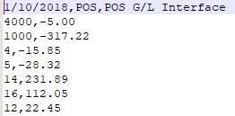

## Menu Reports

Menu reports let you view details about your menu items.

### The Menu Report

This report shows details for the menu classes/items you select.

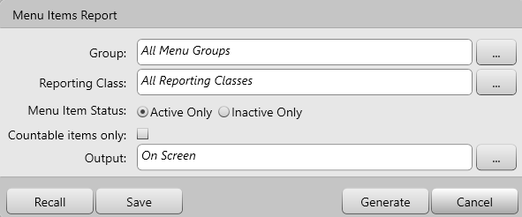

For this report you can choose the following criteria:

Groups – You can view items that appear in all menu groups, or you can choose to only view items that appear in a menu group you specify.

Reporting Class - You can view items that are linked to any reporting class, or you can choose to only view items that area linked to a reporting class you specify.

Menu Item Status –You can choose to view only active or inactive items.

Countable items only – Use this setting to filter items that are only part of menu item countdown

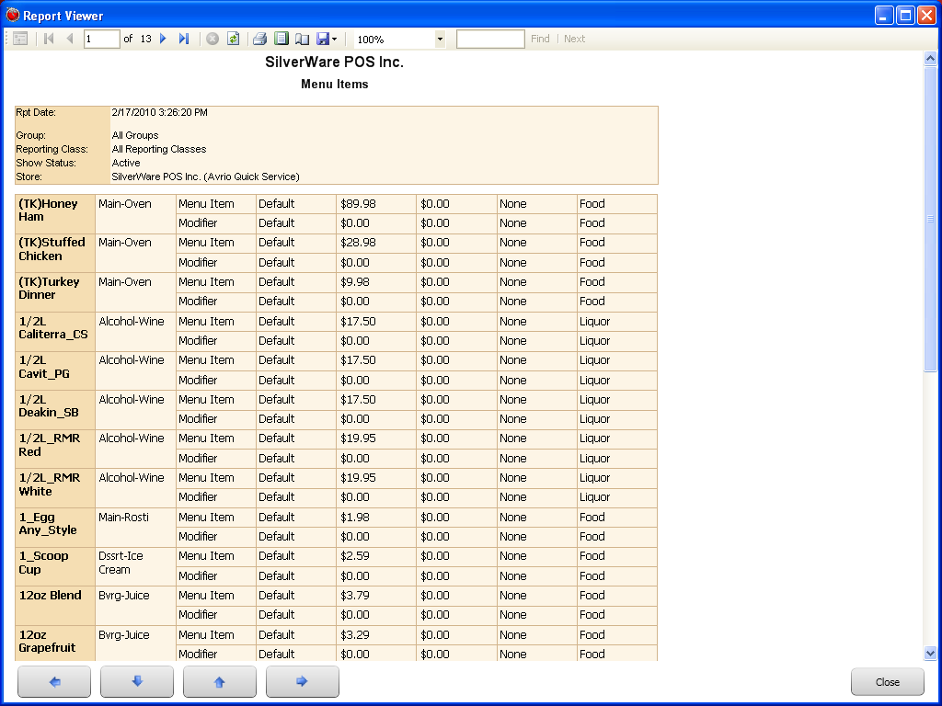

## Operations

Operations reports let you view details about Reservations, staff and open orders.

### Reservations

This report shows details about reservations in a specific date range.

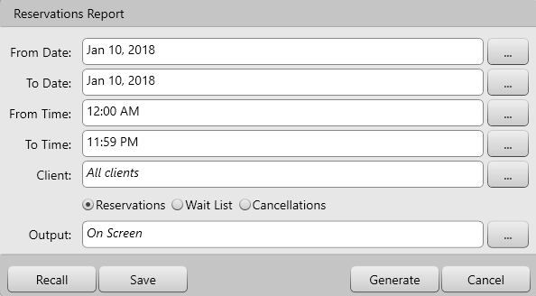

For this report you can choose the following criteria:

From Date/ To Date – Use these fields to select a date range the data will be based upon.

From Time/ To Time - Use these fields to select a time range the data will be based upon.

Clients – This field lets you display information for all clients or a specific client.

Selection Criteria- Use the buttons to filter by reservations, wait list or cancellations.

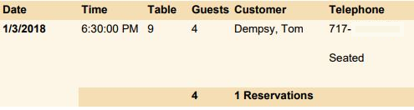

### Staff View Report

This report simply lists all staff members that are currently signed-in, and the time they signed-in.

You can view information for a specific staff member by choosing them from the “Server” drop-down box.

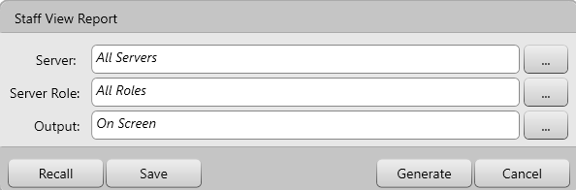

For this report you can choose the following critieria:

Server – Use this field to select a specific or all servers

Server Role –This field lets you specify which roles you will view information about. For example, you can see all managers that are signed-in, or all supervisors, kitchen staff, etc.



### Table View Report

The table view shows you all open tables, how many guests are at the table, when the table was opened, which employee is serving it, and the table’s current subtotal. The status column shows if the table’s check has been printed or not.

You can view information for a specific table by choosing it from the “Table” drop-down box.

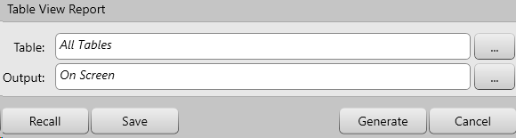

For this report you can choose the following criteria:

Table – Use this field to filter which tables can be viewed in the data.

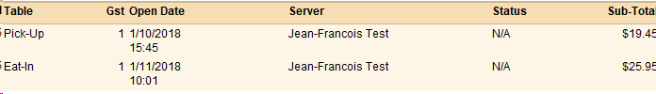

## Payroll

Payroll reports are exports that are used for third party payroll integration.

### Ceridian Payroll Export

This export is used to integrate with Ceridian. Each employee is identifiable in the export by their PayID.

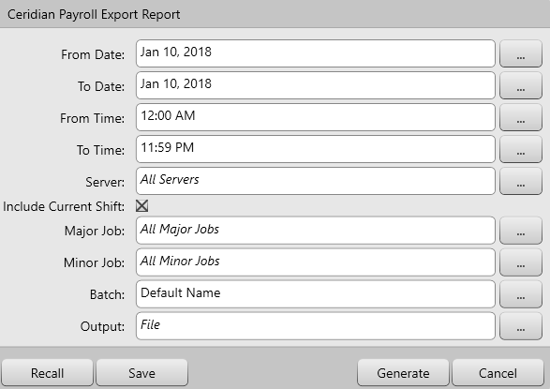

For this report you can use the following criteria:

From Date/ To Date – Use these fields to select a date range the data will be based upon.

From Time/ To Time - Use these fields to select a time range the data will be based upon.

Server – Use this field to see data based upon all servers or a specific server.

Include Current Shift – Use this check box to include the shift of employees that are still signed into the system

Major Jobs – Use this field to determine if the report displays information based on employees under all major jobs or one that’s specified.

Minor Jobs - Use this field to determine if the report displays information based on employees under all minor jobs or one that’s specified

Batch – Use this field to give the batch column a specific number

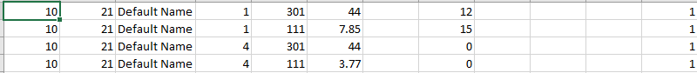

### Generic Payroll Export

This is a generic export that allows third party payroll integrations, integrate with our export.

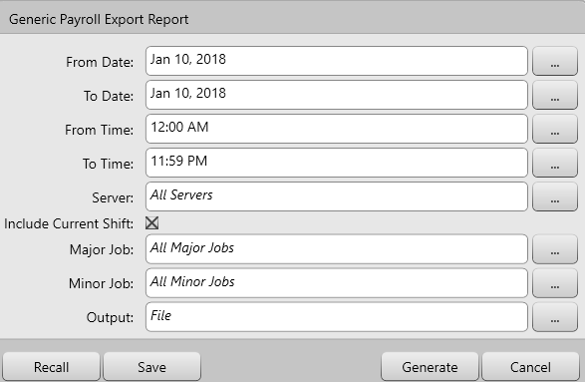

For this report you can use the following criteria:

From Date/ To Date – Use these fields to select a date range the data will be based upon.

From Time/ To Time - Use these fields to select a time range the data will be based upon.

Server – Use this field to see data based upon all servers or a specific server.

Include Current Shift – Use this check box to include the shift of employees that are still signed into the system

Major Jobs – Use this field to determine if the report displays information based on employees under all major jobs or one that’s specified.

Minor Jobs - Use this field to determine if the report displays information based on employees under all minor jobs or one that’s specified



### UltiPro Payroll Export

This export is used to integration with UltiPro payroll software.

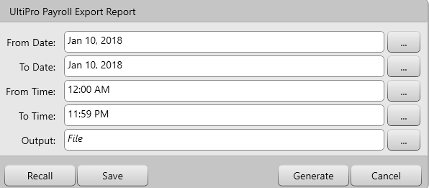

For this report you can use the following criteria

From Date/ To Date – Use these fields to select a date range the data will be based upon.

From Time/ To Time - Use these fields to select a time range the data will be based upon.

## Sales Reports

Sales reports show you detailed information about your sales, how they break down, if your servers owe the restaurant cash or vice versa, etc.

### Comparative Sales Analysis

This report breaks down your sales percentages by classes and items and compares them between multiple days.

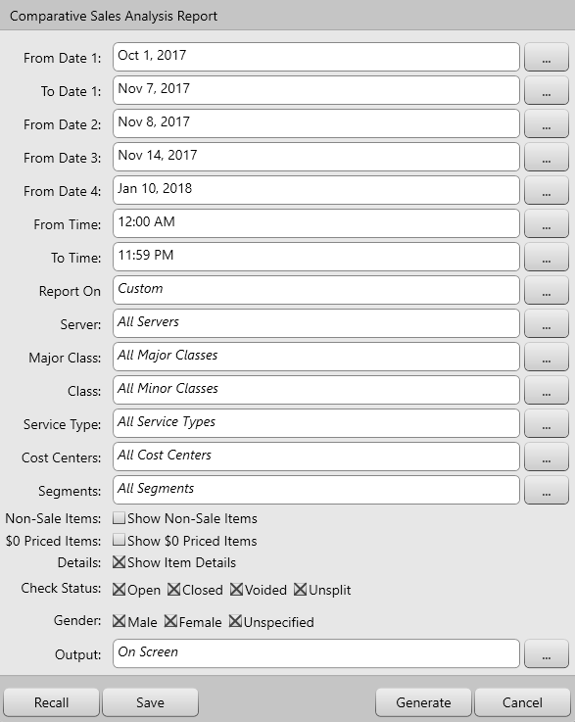

For this report you can choose the following criteria:

From Date/ To Date – Use these fields to select a date range the data will be based upon.

From Time/ To Time - Use these fields to select a time range the data will be based upon.

Report On – Use this field to filter how you want to compare the sales analysis by date, week, month, or days of the week.

Server – Use this field to see data based upon all servers or a specific server.

Major Class – Use this field to determine if the report displays information based on items reporting to all major classes, or one you’ve specified.

Minor Class – Use this field to determine if the report displays information based on items reporting to all minor classes, or one you’ve specified.

Service Type –Use this field to view data for all service types or a specific service types.

Cost Center – Use this field to view data from all cost centers or a specific cost center.

Segments – Use this field to determine if the report displays data from all segments or from a specific one.

Non-Sale Items – Use this check box to determine if the report includes non-sale items (gift cards, for example).

$0 Priced Items – Use this check box to determine if the report includes $0 priced menu items.

Details – Use this check box show the sales analysis down to menu item level instead of summarizing by reporting class

Check Status – Use the check boxes to determine which types of orders will be displayed in the report

* Open – Orders that are currently open
* Closed – Orders that have been closed and payment has been accepted
* Voided – Entire orders that were voided. Simply voiding an item does not mean it will be included on this report.
* Unsplit – An unsplit bill occurs when the following happens: A bill is split into multiple checks, then those checks are printed. If all of the items from one of those split checks are moved to one of the other checks, an “unsplit” has occurred?

Gender – Use these check boxes to filter by which gender the items were sold to

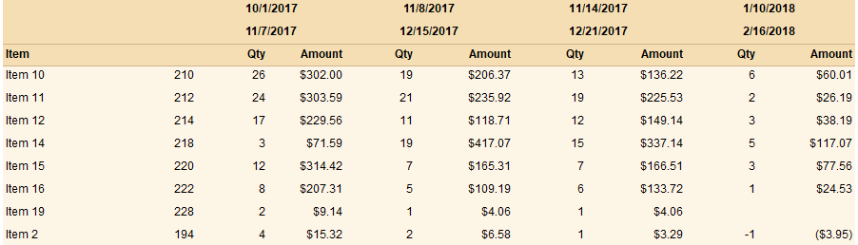

### Cost Analysis Report

This report breaks down your cost percentages by classes and items.

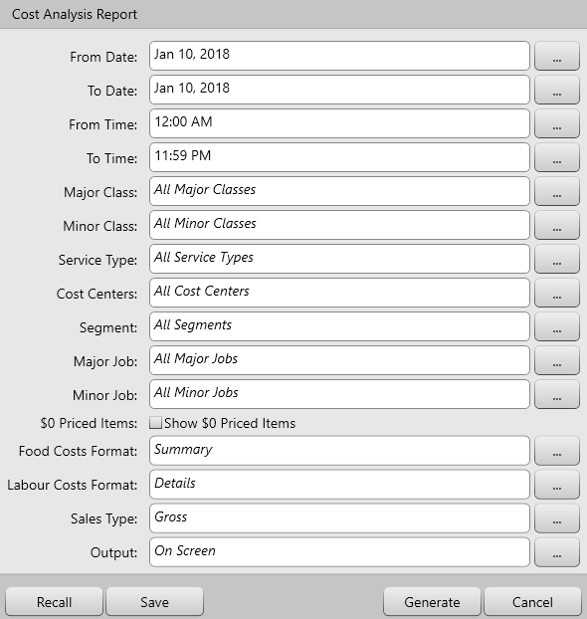

For this report you can choose the following criteria:

From Date/ To Date – Use these fields to select a date range the data will be based upon.

From Time/ To Time - Use these fields to select a time range the data will be based upon.

Report On – Use this field to filter how you want to compare the sales analysis by date, week, month, or days of the week.

Server – Use this field to see data based upon all servers or a specific server.

Major Class – Use this field to determine if the report displays information based on items reporting to all major classes, or one you’ve specified.

Minor Class – Use this field to determine if the report displays information based on items reporting to all minor classes, or one you’ve specified.

Service Type –Use this field to view data for all service types or a specific service types.

Cost Center – Use this field to view data from all cost centers or a specific cost center.

Segments – Use this field to determine if the report displays data from all segments or from a specific one.

Non-Sale Items – Use this check box to determine if the report includes non-sale items (gift cards, for example).

$0 Priced Items – Use this check box to determine if the report includes $0 priced menu items

Food Costs Format -Use this field to filter the Food cost analysis report in a detailed format or summary

Labour Costs Format – Use this field to filter the Labour Costs in a detailed format or summary

Sales Type – Use this field to filter the data by Gross or Net sales.

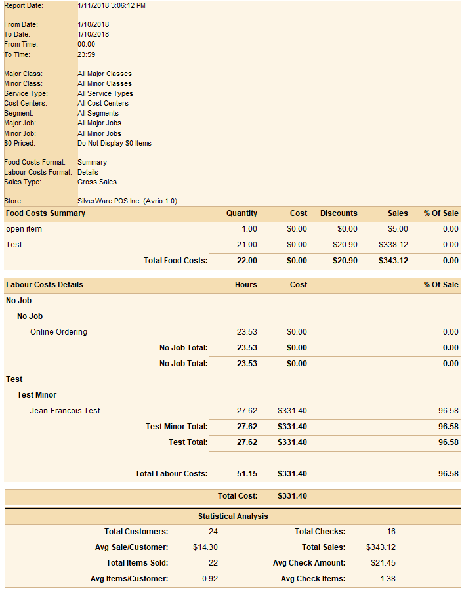

### The Daily Totals Report

The “Daily Totals” report tracks your servers’ sales, payments, voids, discounts, etc throughout the business day.

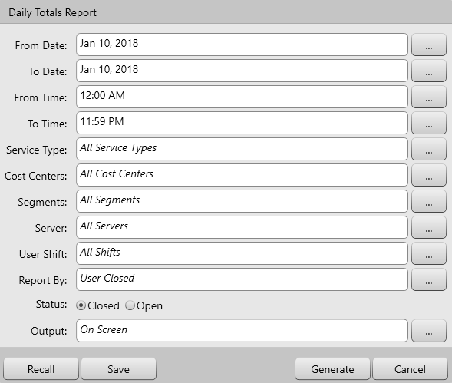

For this report you can choose the following criteria:

From Date/ To Date – Use these fields to select a date range the data will be based upon.

From Time/ To Time - Use these fields to select a time range the data will be based upon.

Service Type –Use this field to view a report based upon sales from all service types or a specific service type.

Cost Center – Use this field to view a report based upon sales from all cost centers or a specific cost center.

Segments – Use this field to view a report based upon sales from all segments or a specific segment.

Server – Use this field to view the report based on all servers’ sales, or only a specific server’s sales.

User Shift – Use this field to filter by specific shifts if there’s more than one shift per business day

Reported By – Use this field to filter sales by users opened or users closed.

Status – Use this field to view the report based on closed orders, or any currently open orders.

In this example, only information for one server is being displayed. Also, it is solely based on orders that have been closed.

This section displays the server’s sales, sorted by your major classes.

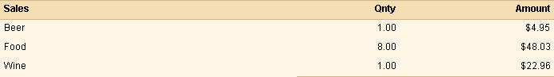

This section displays all taxes charged on this server’s sales.

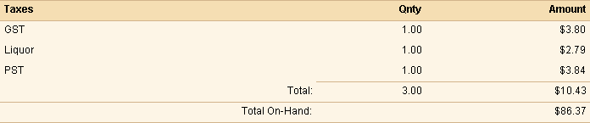

This section displays all payments accepted by the server.

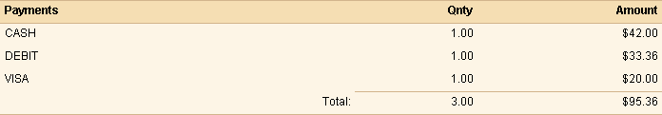

If the total “Net Cash Owing” has a minus in front, then the restaurant owes the server. In this example, the server owes the restaurant.

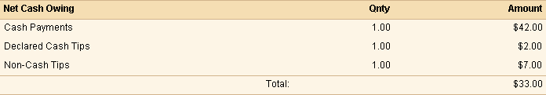

All discounts performed servers are shown here.

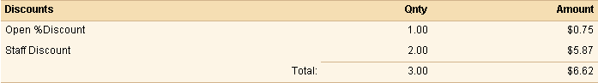

All voids performed by servers are shown here.

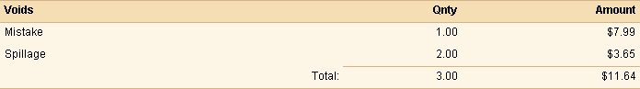

If a server unsplits a check, it will be listed in the “Cancellations” section. A cancellation will also appear when all items on a check are voided, and the server then presses **Send** or **Close**.

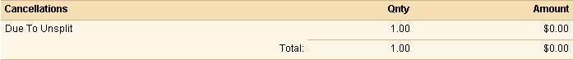

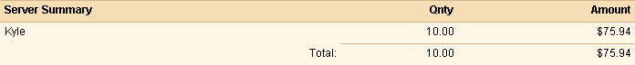

### Executive Summary Weekly Report

The Executive Summary Weekly report shows the Daily Totals report over the last 7 business days.

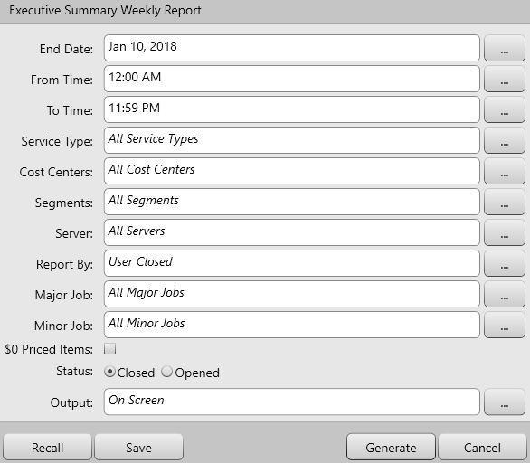

For this report you can choose the following criteria:

End Date – Use these fields to select a date range the data will be based upon.

From Time/ To Time - Use these fields to select a time range the data will be based upon.

Service Type –Use this field to view a report based upon sales from all service types or a specific service type.

Cost Center – Use this field to view a report based upon sales from all cost centers or a specific cost center.

Segments – Use this field to view a report based upon sales from all segments or a specific segment.

Server – Use this field to view the report based on all servers’ sales, or only a specific server’s sales.

Reported By – Use this field to filter sales by users opened or users closed.

Major Class – Use this field to determine if the report displays information based on items reporting to all major classes, or one you’ve specified.

Minor Class – Use this field to determine if the report displays information based on items reporting to all minor classes, or one you’ve specified.

$0 Priced Items – Use this check box to determine if the report includes $0 priced menu items

Status – Use this field to view the report based on closed orders, or any currently open orders.

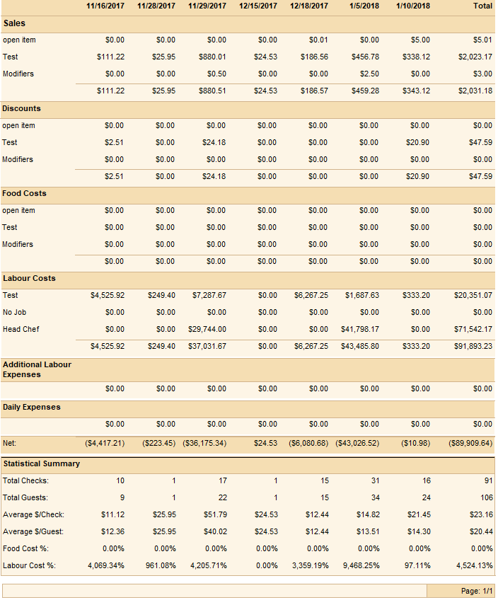

### Future Orders Client

The “Future Orders Client” report shows any future orders check information. The report displays the check number, time, client name, total and menu items that were ordered.

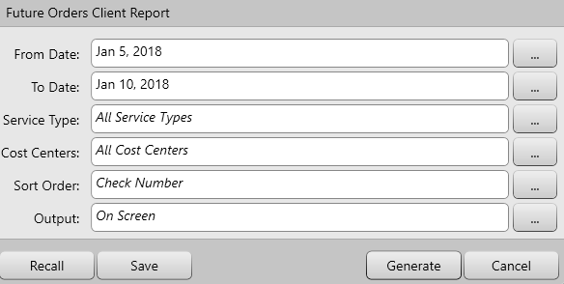

For this report you can choose the following criteria:

From/To Date – Use these fields to select a date range the data will be based upon.

From Time/ To Time - Use these fields to select a time range the data will be based upon.

Service Type –Use this field to view a report based upon sales from all service types or a specific service type.

Cost Center – Use this field to view a report based upon sales from all cost centers or a specific cost center.

Sort Order – Use this field to sort the report by check number, payment type, server name, sub-total, status or date and time.

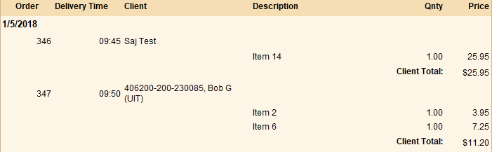

### Future Orders Summary

The “Future Orders Summary” report shows menu items that were placed in a future date.

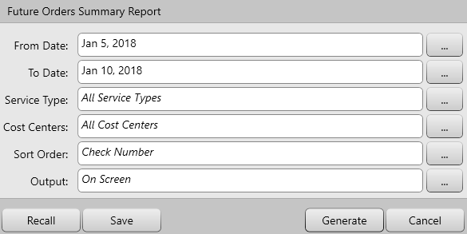

For this report you can choose the following criteria:

From/To Date – Use these fields to select a date range the data will be based upon.

From Time/ To Time - Use these fields to select a time range the data will be based upon.

Service Type –Use this field to view a report based upon sales from all service types or a specific service type.

Cost Center – Use this field to view a report based upon sales from all cost centers or a specific cost center.

Sort Order – Use this field to sort the report by check number, payment type, server name, sub-total, status or date and time.

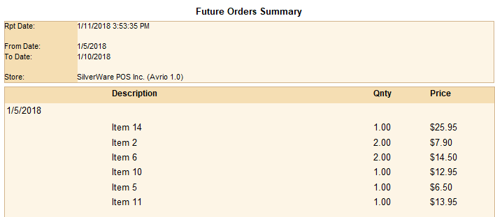

### Hotel Interface Report

The “Hotel Interface” report is a transaction report shows all checks that are processed to the Property Management Service (PMS). This report is only for integrations that are using PMS 1.0.

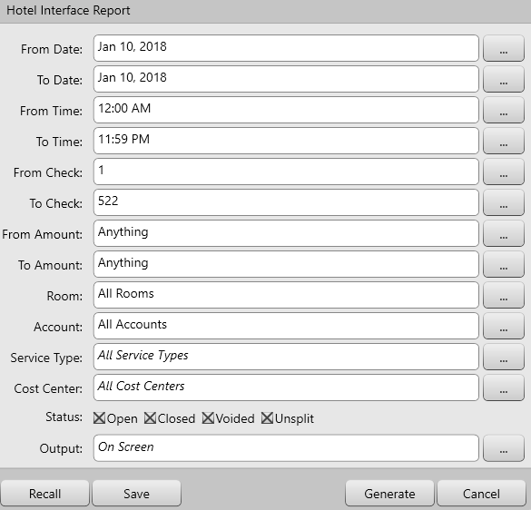

This report can use the following criteria:

From/To Date – Use these fields to select a date range the data will be based upon.

From Time/ To Time - Use these fields to select a time range the data will be based upon.

From/To Check – Use these fields to select a check range the data will be based upon.

From/Amount – Use these fields to select a dollar amount range the data will be based upon

Room- Use this field to select a specific room

Account – Use this field to select a specific account

Service Type –Use this field to view a report based upon sales from all service types or a specific service type.

Cost Center – Use this field to view a report based upon sales from all cost centers or a specific cost center.

Status – Use this field to filter between orders that were opened, closed, voided or unsplit.

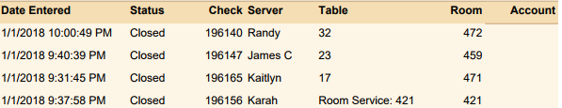

### The Hourly Sales Analysis Report

The “Hourly Sales” report shows your sales per hour. This report helps to identify your busiest periods.

The report displays the hourly periods of the day, the sub-total for the period, the taxes charged during the period, the total amount discounted during that period, and total for that period.

The information in this report is based on closed orders only.

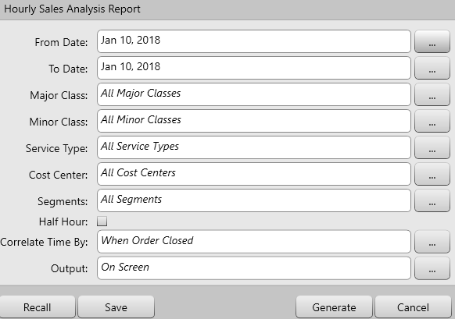

For this report you can choose the following criteria:

From/To Date – Use these fields to select a date range the data will be based upon.

Major Class- This field lets you choose if the report will display an analysis based upon one or more major classes you specify.

Minor Class – This field lets you choose if the report will display an analysis based upon all classes, or one that you specify.

Service Type –Use this field to view a report based upon sales from all service types or a specific service type.

Cost Center – Use this field to determine if the reports display info based on all cost centers, or based on one you specify.

Segments – Use this field to determine if the report displays information based on all segments, or just a specific one.

Half Hour – Check this box if you want the report to break sales down in to half-hour blocks instead of hour-long blocks.

Correlate Time by – Use this field to filter data by when order was closed, when items were ordered by new guests only or by item ordered by all guests.

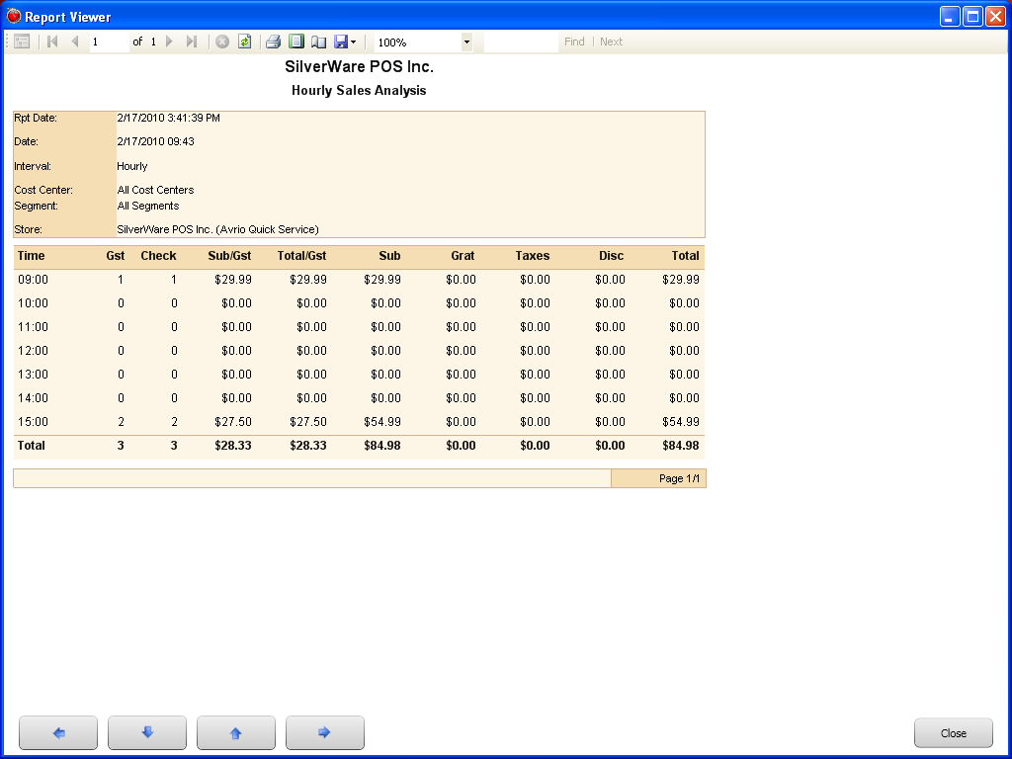

### The No Sale Report

The “No Sale” tracks any “no sales” (opening the cash drawer without conducting a transaction) performed by staff members.

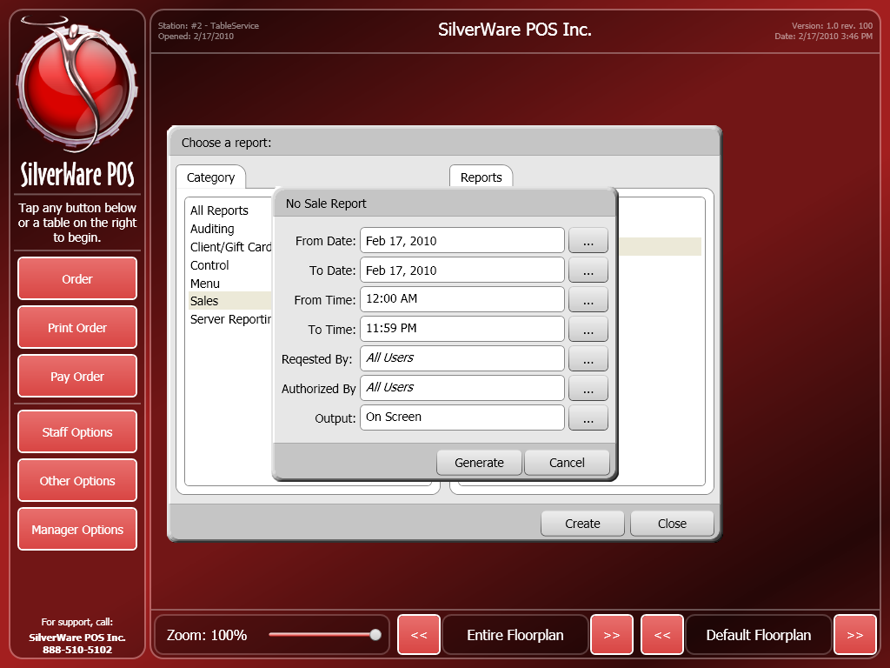

For this report you can choose the following criteria:

From Date/ To Date – Use these fields to select a date range the data will be based upon.

From Time/ To Time - Use these fields to select a time range the data will be based upon.

Requested By – This field determines if the report shows “no sales” initiated by all servers, or one you’ve specified.

Authorized By – This field determines if the report shows “no sales” authorized by all managers, or one you’ve specified.

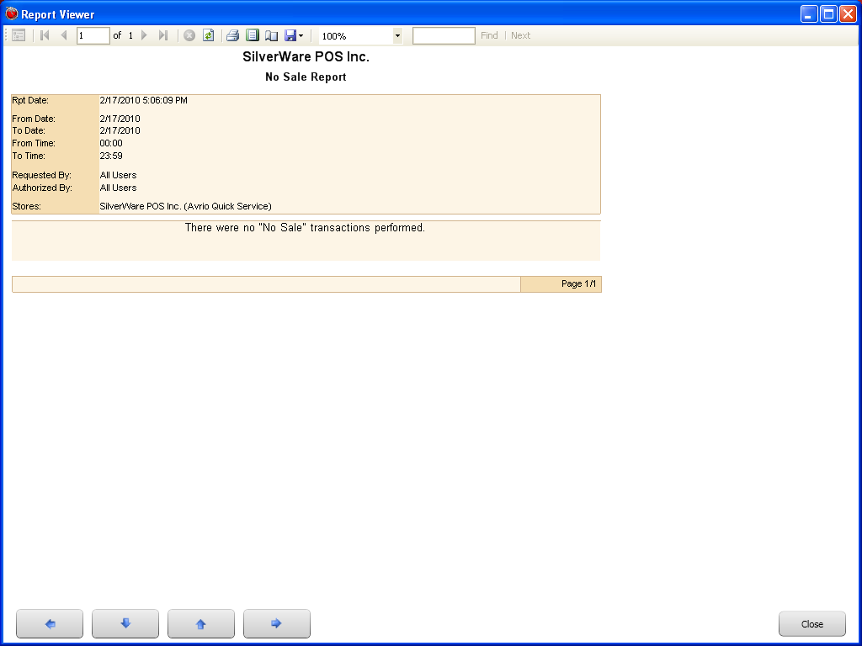

### The Register Summary Report

The “Register Summary” tracks transactions and payments.

You can see which employee was in charge of the order, and how they received payment, as well as all discounts and taxes that were applied to an order. It’s useful when searching for a missing or incorrectly added item, checking tip amounts, or seeing how a check was closed.

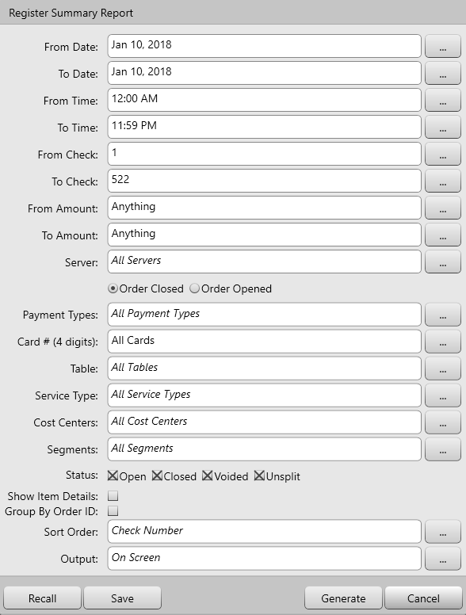

For this report you can choose the following criteria:

From Date/ To Date – Use these fields to select a date range the data will be based upon.

From Time/ To Time - Use these fields to select a time range the data will be based upon.

From Check/ To Check - Use these fields to select a range of checks that the data will be based upon.

Server – Use this field to see data based upon all servers or a specific server.

Order Opened/Closed- Use these fields to see the data based on the servers that initially opened the order or closed it.

Cost Centers – Use this field to see data based upon sales at all cost centers or a specific one.

Payment Types – Use this field to see data based upon checks closed with all payment types or one that you specify.

Table – Use this field to see data for all tables or specific table.

Service Type –Use this field to view data for all service types or a specific service types.

Cost Center – Use this field to view data from all cost centers or a specific cost center.

Segments – Use this field to determine if the report displays data from all segments or from a specific one.

Status – Use the check boxes to determine which types of orders will be displayed in the report

* Open – Orders that are currently open
* Closed – Orders that have been closed and payment has been accepted
* Voided – Entire orders that were voided. Simply voiding an item does not mean it will be included on this report.
* Unsplit – An unsplit bill occurs when the following happens: A bill is split into multiple checks, then those checks are printed. If all of the items from one of those split checks are moved to one of the other checks, an “unsplit” has occurred?

Show Item Details – Use this check box to determine if the report shows the items that were ordered on each check.

Group by Order ID – Use this check box to determine if the report will display data based on order number, not check number.

Sort Order – This field lets you choose how the data is sorted.

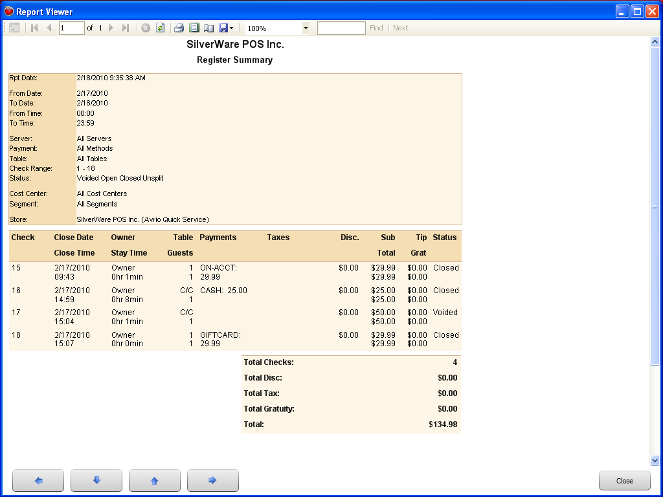

### The Sales Analysis Report

This report breaks down your sales percentages by classes and items.

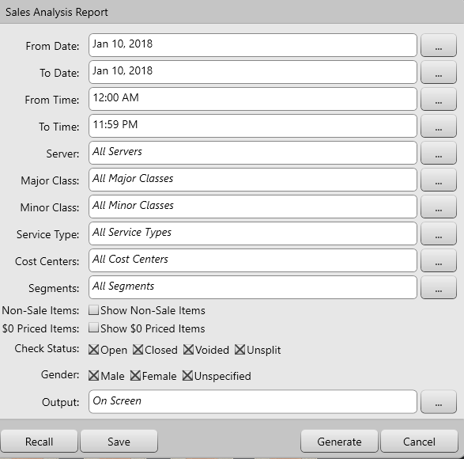

For this report you can choose the following criteria:

From Date/ To Date – Use these fields to select a date range the data will be based upon.

From Time/ To Time - Use these fields to select a time range the data will be based upon.

Server – Use this field to see data based upon all servers or a specific server.

Major Class – Use this field to determine if the report displays information based on items reporting to all major classes, or one you’ve specified.

Minor Class – Use this field to determine if the report displays information based on items reporting to all minor classes, or one you’ve specified.

Service Type –Use this field to view data for all service types or a specific service types.

Cost Center – Use this field to view data from all cost centers or a specific cost center.

Segments – Use this field to determine if the report displays data from all segments or from a specific one.

Non-Sale Items – Use this check box to determine if the report includes non-sale items (gift cards, for example).

$0 Priced Items – Use this check box to determine if the report includes $0 Priced menu items.

Status – Use the check boxes to determine which types of orders will be displayed in the report

* Open – Orders that are currently open
* Closed – Orders that have been closed and payment has been accepted
* Voided – Entire orders that were voided. Simply voiding an item does not mean it will be included on this report.
* Unsplit – An unsplit bill occurs when the following happens: A bill is split into multiple checks, then those checks are printed. If all of the items from one of those split checks are moved to one of the other checks, an “unsplit” has occurred?

Sort – Use this field to determine how the information is sorted.

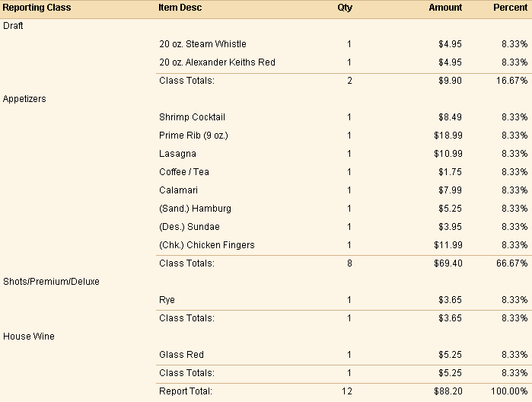

### Segment Analysis

This report breaks down your sales for any segments (time periods) that exist in your system.

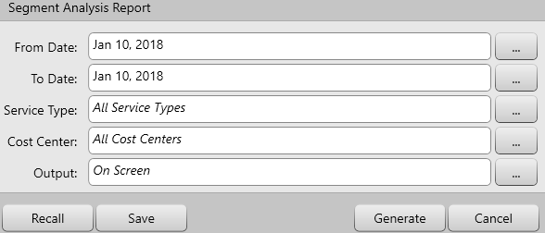

For this report you can choose the following criteria:

From/To Date - Use these fields to select a date range the data will be based upon.

Service Type –Use this field to view data for all service types or a specific service types.

Cost Center – Use this field to view data from all cost centers or a specific cost center.

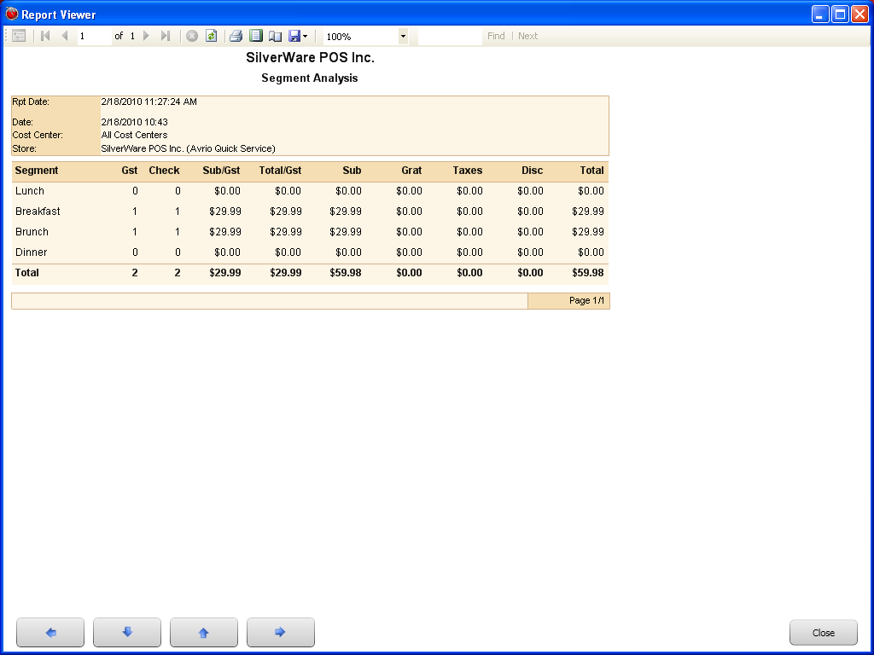

### Tax Totals

The tax totals report shows you all the taxes that have been charged during the period of time you specify, as well as the total sales before and after taxes.

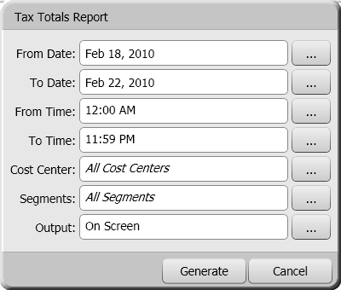

For this report you can choose the following criteria:

From Date/ To Date – Use these fields to select a date range the data will be based upon.

From Time/ To Time - Use these fields to select a time range the data will be based upon.

Cost Center – Use this field to determine if the reports display info based on all cost centers, or based on one you specify.

Segments – Use this field to determine if the report displays information based on all segments, or just a specific one.

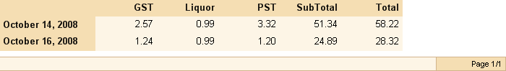

## Server Reporting

The Server reports let you see detailed information about your servers’ performance, and you can compare different employees’ sales stats.

### Employee List

The “Employee List” report lets you see detailed information on all servers that are currently in the system.

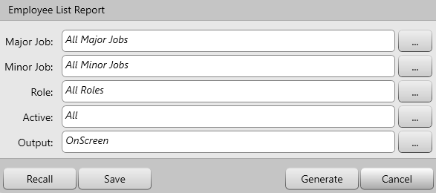

For this report you can choose the following criteria:

Major Jobs – Use this field to determine if the report displays information based on employees under all major jobs or one that’s specified.

Minor Jobs - Use this field to determine if the report displays information based on employees under all minor jobs or one that’s specified.

Role – Use this field to filter between the roles that are assigned to each employee. You can filter by server, bartender, kitchen, manager, supervisor, night- manager, owner, etc.

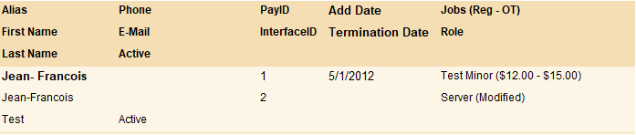

### Employee Shifts and Tips

The “Employee Shifts and Tips” report displays detailed shift information for each server. The report includes pay rate, tips and sales.

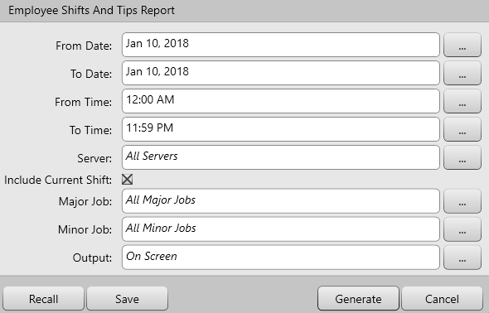

For this report you can choose the following criteria:

From Date/ To Date – Use these fields to select a date range the data will be based upon.

From Time/ To Time - Use these fields to select a time range the data will be based upon.

Server – Use this field to see data based upon all servers or a specific server.

Include Current Shift –This checkbox determines if any shifts that are in progress (a user is signed-in and working) are included in the report.

Major Jobs – Use this field to determine if the report displays information based on employees under all major jobs or one that’s specified.

Minor Jobs - Use this field to determine if the report displays information based on employees under all minor jobs or one that’s specified

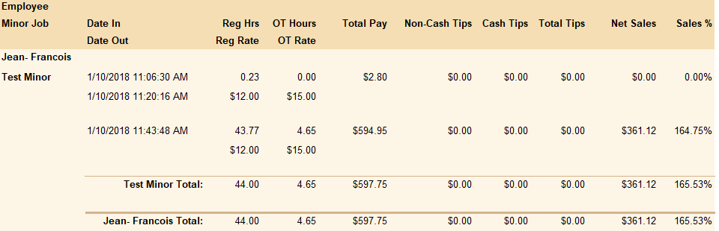

### Employee Timesheet

The “Employee Timesheet” report tracks employees’ sign-in and sign-out times.

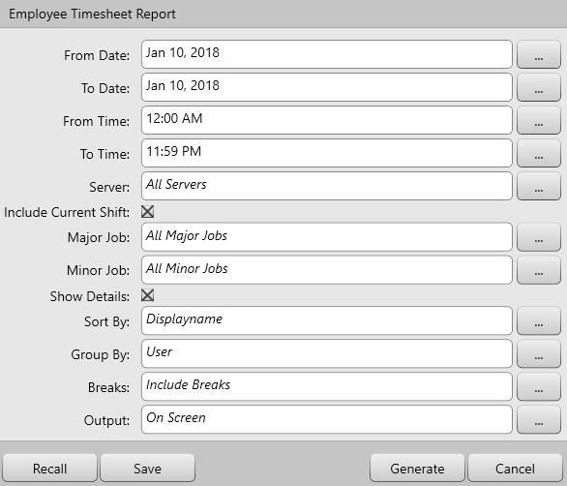

For this report you can choose the following criteria:

From Date/ To Date – Use these fields to select a date range the data will be based upon.

From Time/ To Time - Use these fields to select a time range the data will be based upon.

Server – Use this field to see data based upon all servers or a specific server.

Include Current Shift –This checkbox determines if any shifts that are in progress (a user is signed-in and working) are included in the report.

Major Jobs – Use this field to determine if the report displays information based on employees under all major jobs or one that’s specified.

Minor Jobs - Use this field to determine if the report displays information based on employees under all minor jobs or one that’s specified

Shows Details- Use this check box to show the detailed information on the employee’s shift

Sort By- Use this field to sort the information by the employee’s alias, first name, last name, major/minor job, interface ID or Pay ID

Group By- Use this field to group the information by user or by major/minor job

Breaks- Use this field to filter if breaks are shown in the report or to show user that did not take any breaks.

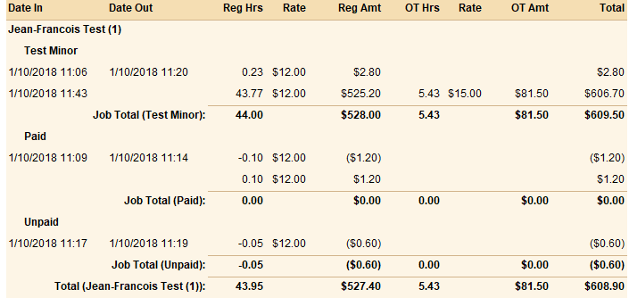

### The Server Contest Report

The “Server Contest” report shows you the quantities of an item/class that your servers have sold in a specific time-frame.

The information in this report is based on closed orders only.

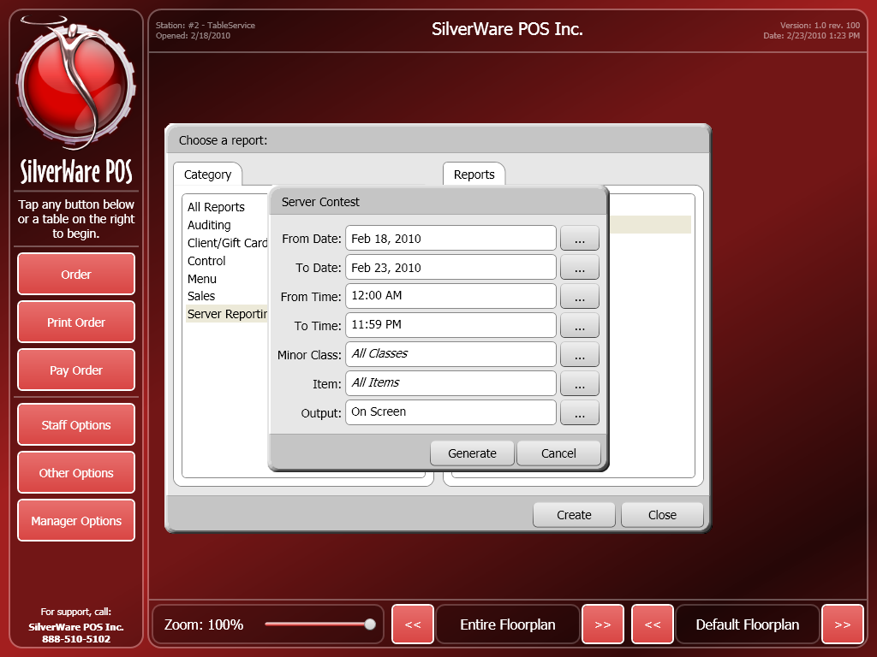

For this report you can choose the following criteria:

From Date/ To Date – Use these fields to select a date range the data will be based upon.

From Time/ To Time - Use these fields to select a time range the data will be based upon.

Minor Class – This field lets you choose if the report is based upon sales of items in all classes, or one that you specify.

Items – This field lets you choose if the report is based upon all item sales, or you can specify an item.

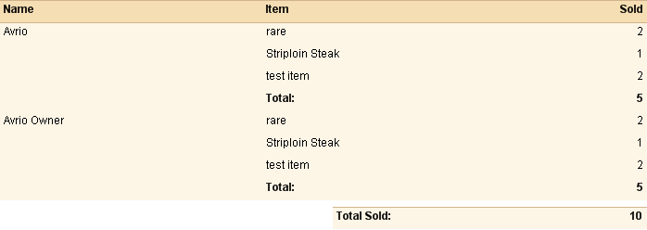

### The Server Performance Report

This report shows your servers’ sales statistics, as well useful averages in determining which servers are selling more per guest/table.

You can view information about a certain server, or leave the “Server” field blank to display data for all servers.

The information in this report is based on closed orders only.

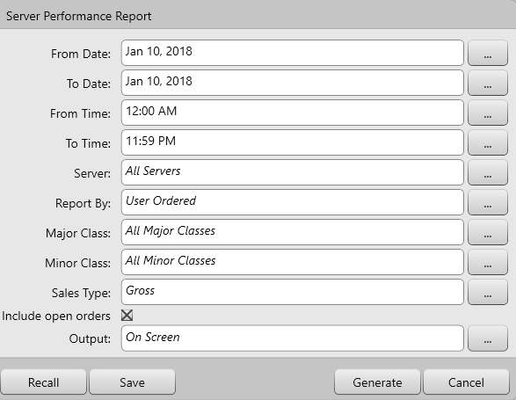

For this report you can choose the following criteria:

From Date/ To Date – Use these fields to select a date range the data will be based upon.

From Time/ To Time - Use these fields to select a time range the data will be based upon.

Server – Use this field to see data based upon all servers or a specific server.

Major Class – Use this field to determine if the report displays information based on items reporting to all major classes, or one you’ve specified.

Minor Class – Use this field to determine if the report displays information based on items reporting to all minor classes, or one you’ve specified.

Sales Type – Use this field to display the information either by Net or Gross Sales.

Include Open Orders – Use this checkbox to include orders that are still open as part of the data

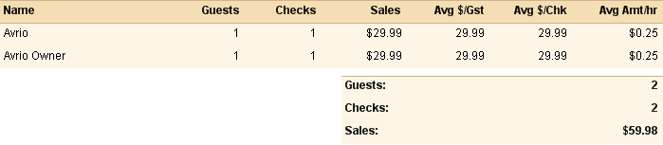

### Server Tip Declarations Report

This reports shows server tip and sales statistics. It displays information based on Non-Cash Tips, Cash Tips, Gross Tips, Auto Gratuities, Tip In/Out as well as Gross/Net Sales.

You can view the information about a specific server or all servers.

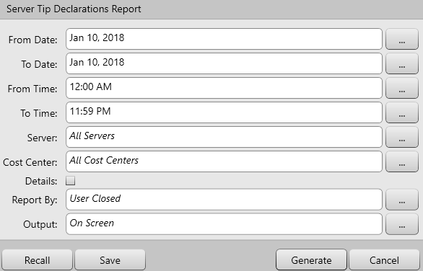

For this report you can choose the following criteria:

From Date/ To Date – Use these fields to select a date range the data will be based upon.

From Time/ To Time - Use these fields to select a time range the data will be based upon.

Server – Use this field to see data based upon all servers or a specific server.

Cost Center – Use this field to determine if the reports display info based on all cost centers, or based on one you specify

Details- Use this check box to show additional information in the report.

Reported by- Use this field to filter the data by server opened or server closed. 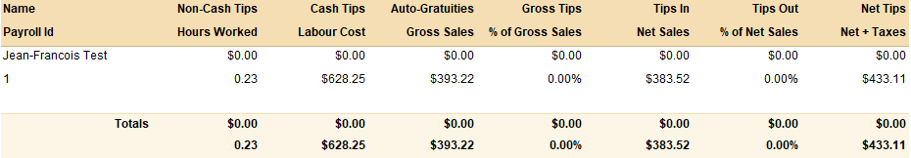

### Staff Average Sales Per Guest Report

This report displays the average sales of each server per every guest that they serve. This includes voids, discounts and dollars per guest.

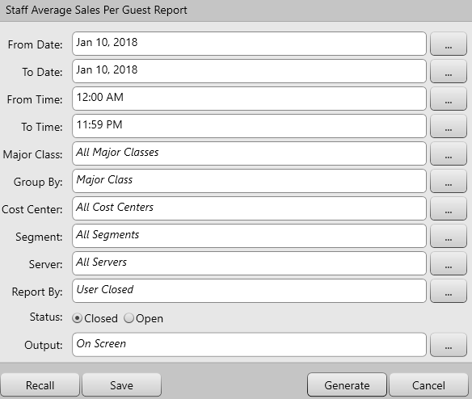

For this report you can choose the following criteria:

From Date/ To Date – Use these fields to select a date range the data will be based upon.

From Time/ To Time - Use these fields to select a time range the data will be based upon.

Major Class – Use this field to determine if the report displays information based on items reporting to all major classes, or one you’ve specified.

Group By- Use this field to group the information by user or by major/minor job

Cost Center – Use this field to determine if the reports display info based on all cost centers, or based on one you specify

Segment – Use this field to determine if the report displays information based on all segments, or just a specific one

Server – Use this field to see data based upon all servers or a specific server.

Reported by- Use this field to filter the data by server opened or server closed.

Status – Use this filter to show transactions whether they are closed or still open

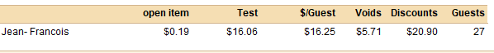

### Staff Tables Turns Report

This report displays the numbers of guests each server seated on their tables.

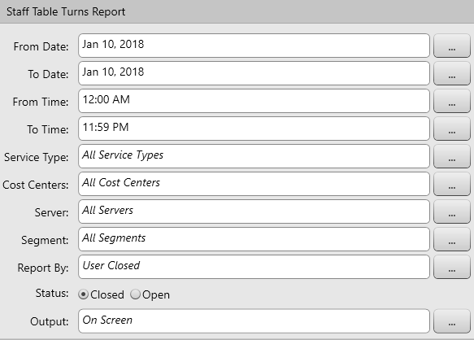

For this report you can choose the following criteria:

From Date/ To Date – Use these fields to select a date range the data will be based upon.

From Time/ To Time - Use these fields to select a time range the data will be based upon.

Service Type –Use this field to display information based on sales performed for all service types, or a specific service type.

Cost Center – Use this field to determine if the reports display info based on all cost centers, or based on one you specify

Server – Use this field to see data based upon all servers or a specific server.

Segment – Use this field to determine if the report displays information based on all segments, or a specific one

Reported by- Use this field to filter the data by server opened or server closed.

Status – Use this filter to show transactions whether they are closed or still open

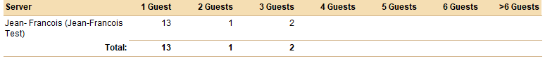

## Favourites

Avrio allows users to store their favourite reports whether it’s a Daily Total or Employee Timesheet report. This is available for all reports. When saving favourites the client can save it so that it’s only available to them or to everyone. The only settings that change are the date fields which switches to the current business date, but all other parameters that were altered will stay the same.

To save a favourite report, the user would have to first define their desired parameters and hit save as shown below:



When saving report, the user will have to create a report template as shown below:

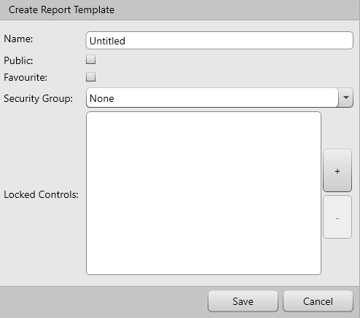

For this template you can use the following settings:

Name – Used to store the name of the favourite report

Public – This checkbox allows the favourite report available to all users

Favourite – This checkbox marks the report to be viewed under favourites

Security Group – Use this field to select make this favourite report only available to users in a specific security group.

Lock Controls – Use this field to lock the data for the fields in each report.

Once saved, Favourites reports can be viewed under the Favourites category in the reports window. Alternatively it can also be viewed if they select the specific report and select “Recall”. This will give a list of favourite reports for a specific report. Example, if a user created multiple Daily Totals reports but for specific cost centers they can save a favourite report for each cost center. When they go back to Daily Totals on another day and select “Recall” they will see all their favourites that were stored for each cost center.