Separate Service Charge and Gratuity in Daily Totals DataBit

Feature 38802

Contents

Change History 3

Feature Description 4

Benefits of Feature 4

Intended Userbase 4

Feature Setup 4

Screenshots 4

# Change History

|  |  |  |
| --- | --- | --- |
| **Version** | **Revision** | **Date** |
|  |  |  |
| 3.3001.25.11 | Avrio – Upgrade DataBits – Separate service charge from grats on daily totals | 07/22/2022 |
| 1.0 | Added Content – Thomson | 09/14/2022 |

# Scrum History

|  |  |  |  |
| --- | --- | --- | --- |
| **Number** | **Status** | **Type** | **Date** |
|  |  | |  |
| 38802 | Parent | Feature | 02/18/2022 |
| 41903 | Child of 38802 | Product Backlog Item | 07/07/2022 |
| 42199 | Child of 41903 | Test | 07/22/2022 |
| 41936 | Child of 41903 | Task | 07/11/2022 |
| 42003 | Child of 41903 | Task | 07/13/2022 |

# Product Description

This version of Avrio allows the separation of “Service Charges” from “Gratuities” on Daily Totals. It introduces a new section in daily totals for “Service Charges”.

Scenario:

There is a 2% administrative charge that needs to be implemented. This 2% cannot be a gratuity or a service charge. Since both Service Charge and Gratuity are classified and configured under the Gratuity Section, a gratuity or service charge will show under Servers Tip Declaration under the Gratuity Section and will report as one value).

# Functional Requirements

Separate “Service Charges” and “Gratuities” to different sections in the Daily Totals Report instead of both falling under the heading “Gratuities”.

“Service Charge” and “Gratuity” amount should be broken down separately and not combined to 1 value under “Net Cash Owing” as “Gratuities”,

# Appendix

Daily Totals Databit Previously: Gratuities and Service Charges both appear under Gratuities.

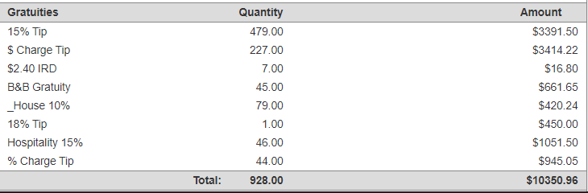

Net Cash Owing Previously: Gratuities and Service Charges amount are combined under Gratuities.

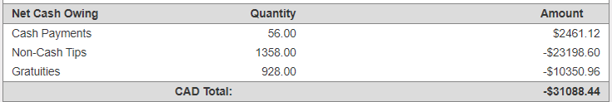

After enhancement, Gratuities and Service Charges are separated in Daily Totals Report Databit.

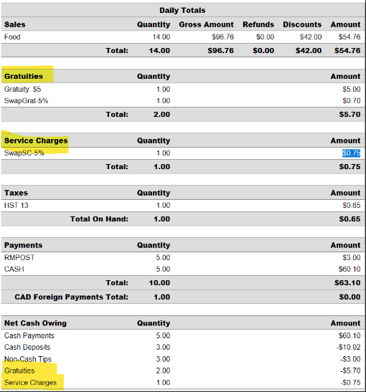

# Product Setup

How to Configure Setting:

1. Navigate to Manager Options > Configuration Tab > Gratuities
2. Setup a Gratuity with “Classification” as Gratuity
3. Setup a Gratuity with “Classification” as Service Charge

How to Test Setting:

1. Open a new check > order items
2. Apply the name of the Gratuity that has the classification as Gratuity
3. Apply payment and close check
4. Open another new check > order items
5. Apply the name of the Gratuity that has the classification as Service Charge
6. Apply payment and close check
7. Run a Daily Totals Databit Report > should show the separation of Service Charge and Gratuity

# Internal Analytics

KPIs to measure the success of the product