# Points, Coupons, and Frequent Diners

SilverWare Avrio lets you setup an intricate system of clients, points, and coupons. Details on random coupon generation can be found here.

The system described here lets you:

* Assign point values to menu items OR you can set up a system that gives points based on a check’s sub-total. You will need to contact your dealer
* Create clients that can earn points
* Automatically convert points for dollar spent into an on-account balance the client can spend.
* Create coupons that require points to earn, and then deduct points when redeemed.

So, as outlined above, the first step is to decide how you’re going to issue points. Points can be issued based on each dollar spent, or you can setup menu classes or menu items to give points.

Your Avrio dealer will have to set this up for you.

* If you opt to distribute points based on dollars spent, your Avrio dealer can take care of this. You will need to inform them how many points a client will earn per dollar. The calculation will be based upon the pre-tax sub-total.
* If you opt to distribute points based on menu items, you can set up which items/classes/etc offer points and the value they give.

## Setting up a Menu Item to Offer Points

If you decide to have your menu items give points, here are your options for determining an item’s point value.

You can assign a point value to your major/minor classes by filling out the **Points Earned** field. Much like taxes and printer settings, a minor class can inherit the **Points Earned** setting of its parent class, or can be set to a different value.

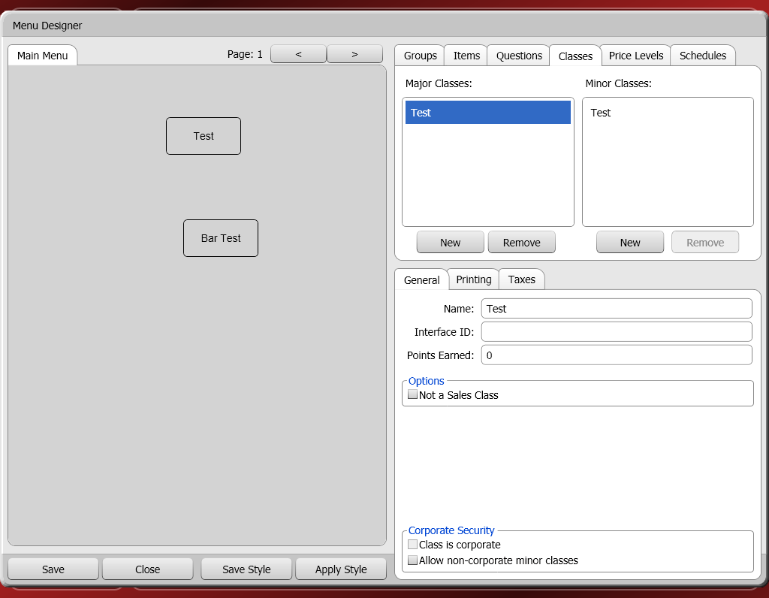

Items will then inherit the point value of their parent class. However, you can also turn off inheritance on an item and give it whatever point value you want.

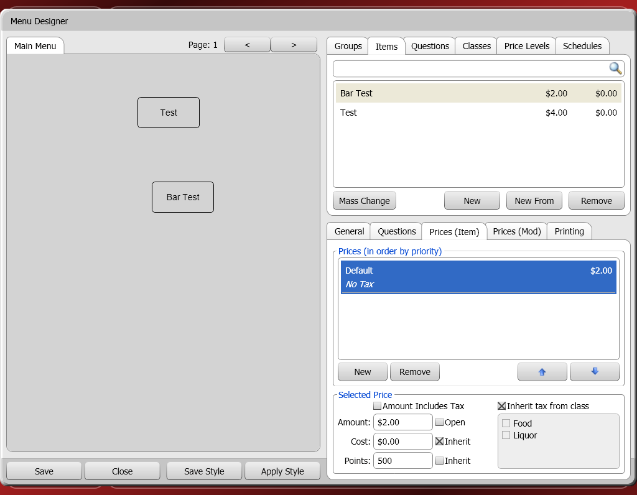

## Creating Clients that Can Earn Points

Now that menu items have been set up, you have to have clients that can earn points. See the previous section on clients to learn about creating clients.

The **Frequent Diner** check-box must be checked to allow a client to earn points. Now, when a client is assigned to an order, they will earn the appropriate amount of points.

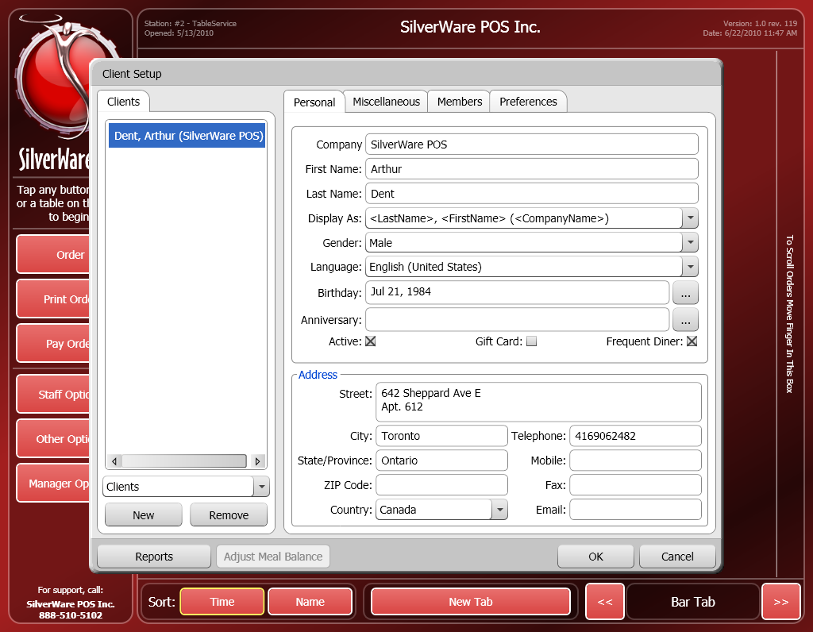

### Assigning a Client to an Order

These instructions show how to assign a client to an order. If you don’t do this when a client is dining, they will not earn points.

**From the Order Screen**

1. If the client has a loyalty card, swipe the card on the order screen. If no card is available, press **Other Options**, then **Assign Client** to see a list of possible clients.

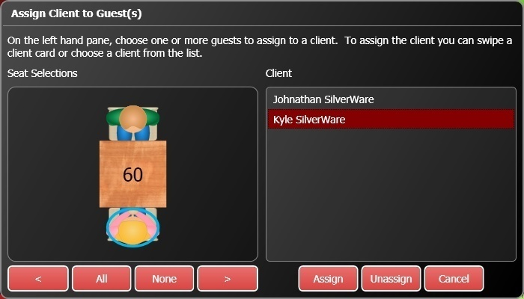

1. Touch a guest (or multiple guests), then a client name. Press **Assign** to assign their purchases to the client account.

* If you haven’t swiped the client’s card yet, you can swipe it now. The client will be selected from the list on the right. Now, touch the guests you want to assign to the client’s account and press **Assign**.
* If you have a long list of clients, swiping a client’s card will be much easier that finding them on the list.

## Creating Coupons

To create a coupon, open **Manager Options**, switch to the **Configuration** tab, and select **Coupons**.

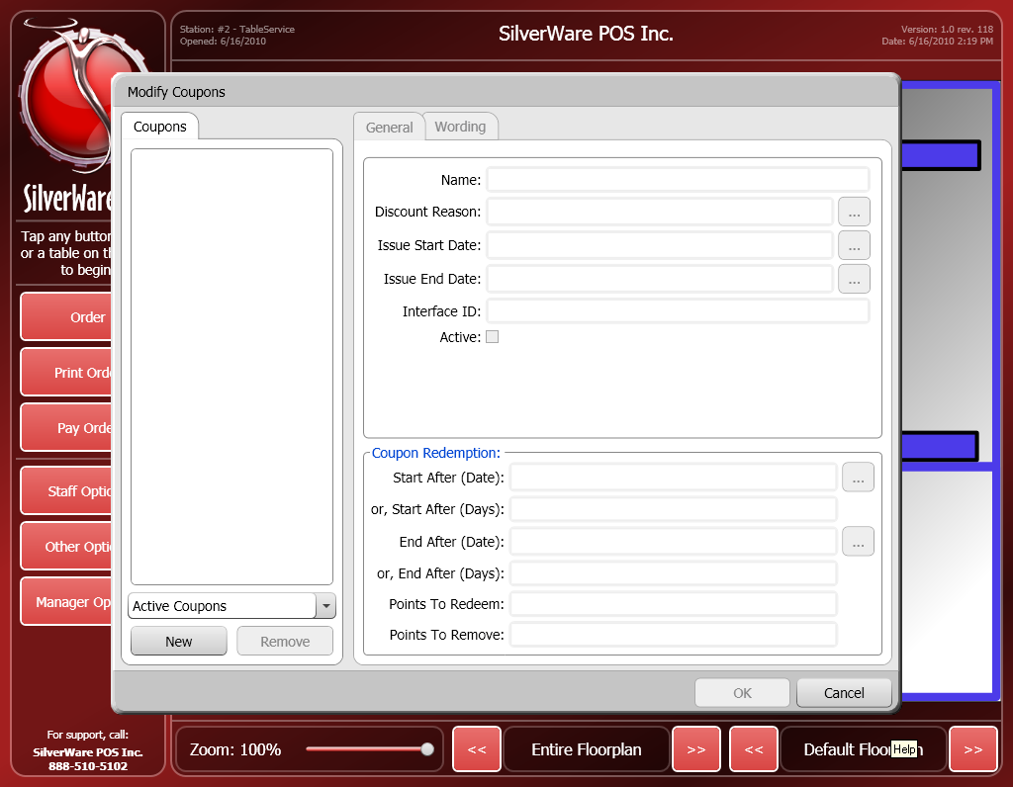

* Press **New** to create a new coupon.
* Enter the coupons name in the **Name** field.
* **Discount Reason** determines which discount will be issued on the coupon.
* Use the **Issue Start Date** and **Issue End Date** to enter a date range that the coupon can be issued within.
* **Interface ID** (undefined)
* **Active** determines if the coupon is active or not.
* **Start After (Date)** determines the beginning of the period during which the coupon can be redeemed. You can use this setting or the next one, Start After (Days)
* **Start After (Days)** determines how many days must pass from the time the coupon is issued before it can be redeemed.
* **End After (Date)** determines the end of the period during which the coupon can be redeemed. You can use this setting or the next one, End After (Days)
* **Points to Redeem** determines how or if any points a customer must have to redeem a coupon.
* **Points to Remove** determines how many points a customer loses when they redeem the coupon.
* **End After (Days)** determines how many days can pass from the time the coupon is issued before it can no longer be redeemed.

## Issuing Coupons

Once a client has earned points, they will become eligible for a coupon.

To issue a coupon:

1. While ordering, press **Other Options**.
2. Press **Redeem Points (Issue Coupon)**

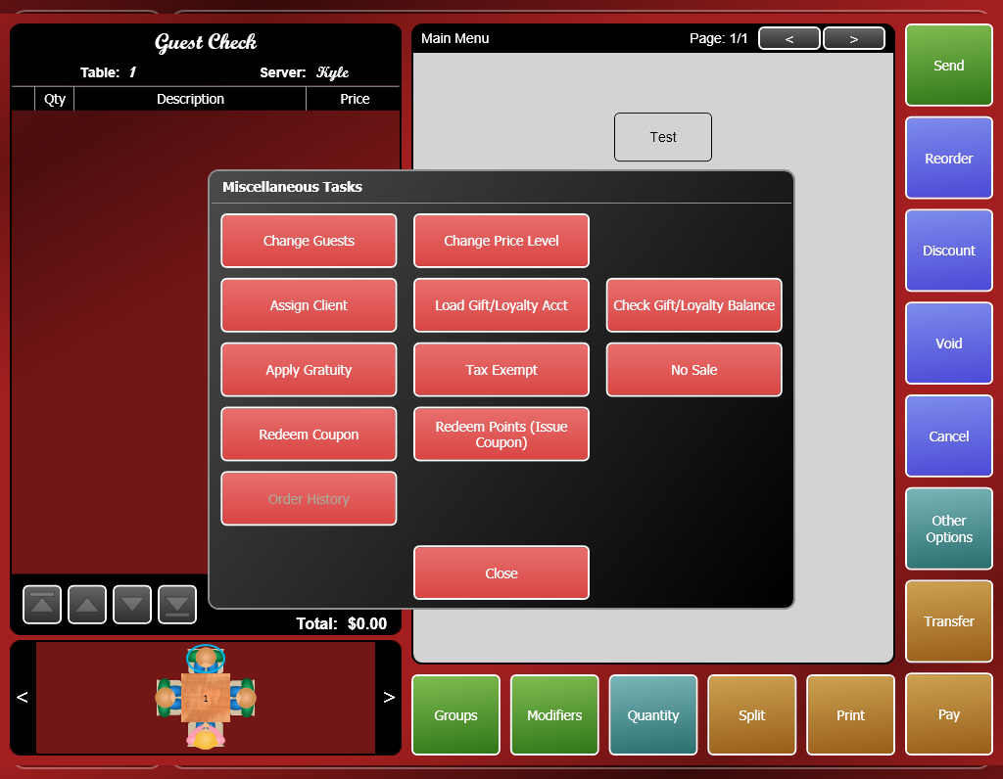

1. Highlight client you want to issue the coupon to and press **Select**

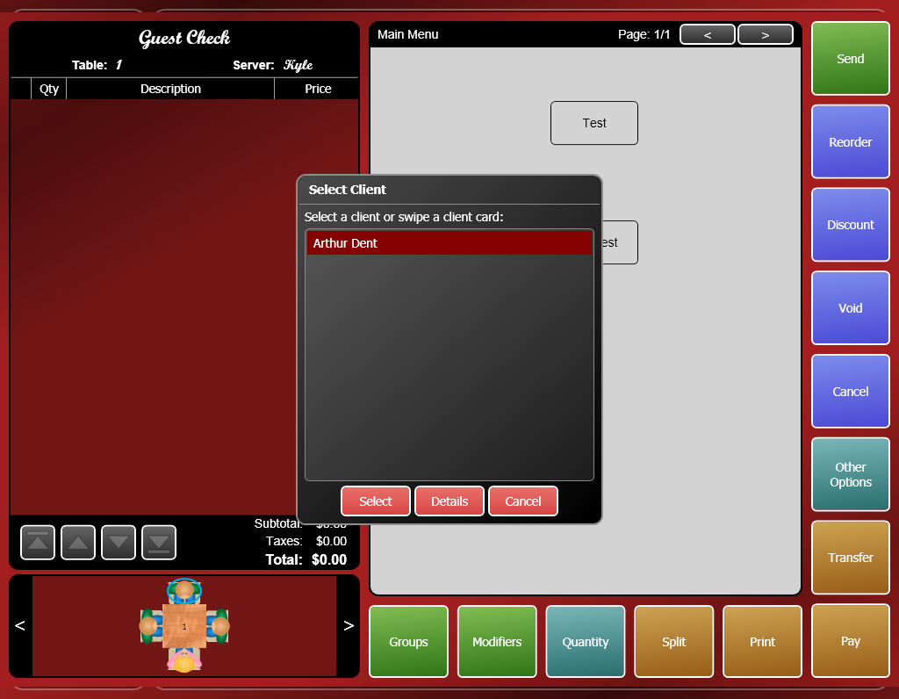

1. Select the coupon you want to issue and press **OK**.

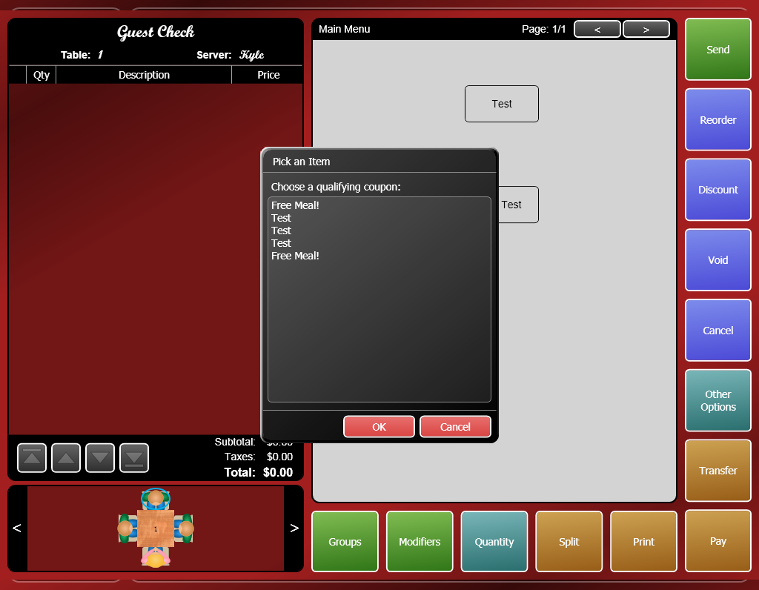

1. The coupon will print out of a check printer. There will be a number printed on the coupon that represents the coupon’s number. This number will be needed when redeeming the coupon.

## Redeeming Coupons

To redeem a coupon:

1. While ordering, select the item(s) you want to apply the coupon to.
2. Press **Other Options**.
3. Press **Redeem Coupon**



1. Enter a valid coupon #.
2. The coupon will be applied to the selected item(s).
3. A manager may need to approve the coupon when you send/print/pay the order.