|  |  |  |  |
| --- | --- | --- | --- |
|  | C:\Users\KSchroer.SILVERWARE\Documents\Projects\Logo Transp.tif | SilverWare POS Inc. |  |

**SilverWare POS Avrio**

Bartender Guide

Contents

Introduction 5

Warranty 5

Getting Help 5

Left-Handed? 5

Getting Started 6

The Stay Menu 7

The Bar Tab Screen 9

The Main Menu 11

Staff Options 12

Sign-in/out 12

Staff Sales Report 12

Sending Internal Email 13

Tip Declaration 16

Tip-Ins/Outs 18

Working with Multiple Cash Drawers 19

Pay-In\Out 20

Blind Drops 21

Other Options 22

Viewing a Loyalty Card’s Information 22

Redeeming Points for Coupons 23

No Sale 24

Menu Item Countdown 24

Clients 24

Ordering 25

Order Screen Options 28

Discounting Items 30

How to Apply/Remove Discounts from the Order Screen 30

How to Apply/Remove Discounts from the Close Order Screen 33

Voiding Items 34

Other Options 36

Adding/Removing Guests to an Order 36

Changing Price Levels 38

Item Lookup 39

Assigning Clients to an Order 40

From the Order Screen 40

From the Close Order Screen 40

Loading Gift Cards/Loyalty Accounts 41

Checking Gift Card/Loyalty Account Balances 42

Applying Gratuities 43

Tax Exemption 44

No Sales 46

Working with Coupons 47

Issuing Coupons 47

Redeeming Coupons 50

Order Details 51

Print Invoice 52

Assign User 52

Transferring Orders 53

To Transfer an Order to Another Server 53

To Transfer an Order to Another Table 54

To Transfer an Order to Another Server and Table 54

Viewing Open/Closed Orders 55

Printing Orders 57

From the Main Menu 57

From the Order Screen 59

Closing Orders 60

To Cash 60

To Credit Card 62

To Credit Card (With Integrated Processing) 63

Splitting a Bill that Involves Credit Cards 65

Forcing a Payment 66

Voiding a Credit Card Payment 67

To Debit Card 68

To Foreign Currency 69

To a Loyalty Card 70

Splitting a Bill that Involves Loyalty Cards 72

Forcing a Payment 73

Voiding a Loyalty Card Payment 73

To a Client’s Account 74

To Other 74

Index 75

# Introduction

SilverWare Avrio is a powerful restaurant-management tool operated through a touch-screen interface.

Avrio’s bartending mode allows you to easily track your bar customers and their orders.

## Warranty

SilverWare POS Inc. makes no warranty of any kind with regard to this material, including but not limited to, the implied warranties of merchantability or fitness for a particular purpose. SilverWare POS Inc. shall not be liable for errors contained herein or for incidental consequential damage in connection with the provision, performance or use of this material.

This document contains proprietary information protected by copyright. All rights are reserved. No part of this document may be reproduced, stored in a retrieval system, transmitted in any form or by any means, electronic, mechanical, photocopy, recording or otherwise, or translated into another language without the prior written consent of SilverWare POS Inc. The information contained herein is subject to change without notice.

## Getting Help

SilverWare’s office is located in Ontario, Canada and operates under Eastern Standard Time. If you wish to ask a general question, please call **905-305-1225** during normal business hours, **Monday – Friday 9:00 am to 5:00 pm**.

If you need technical assistance, please contact our technical-support center, which is open 24 hours a day, 7 days a week.

Telephone: **1-888-510-5102**

Fax: **1-905-305-1810**

## Left-Handed?

Management can turn on an option that flips Avrio’s layout for left-handed staff members.

# Getting Started

Before performing an action, users must identify themselves to the system using a numeric password, a swipe card, or a fingerprint scanner. When this window appears, enter your password, swipe your card, or press you finger against the biometric scanner.

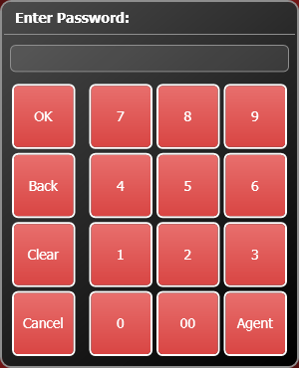

## The Stay Menu

After performing a function, SilverWare will prompt you for your next action. If no option is selected, the menu will disappear and you or the next server must enter your ID to perform another action.

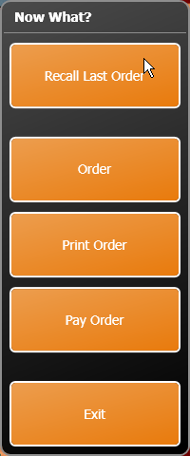

Management may disable this option, leaving you signed-in until you press **Cancel** on the main menu.

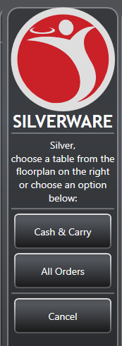

# The Bar Tab Screen

This is the starting point for all bartending operations.

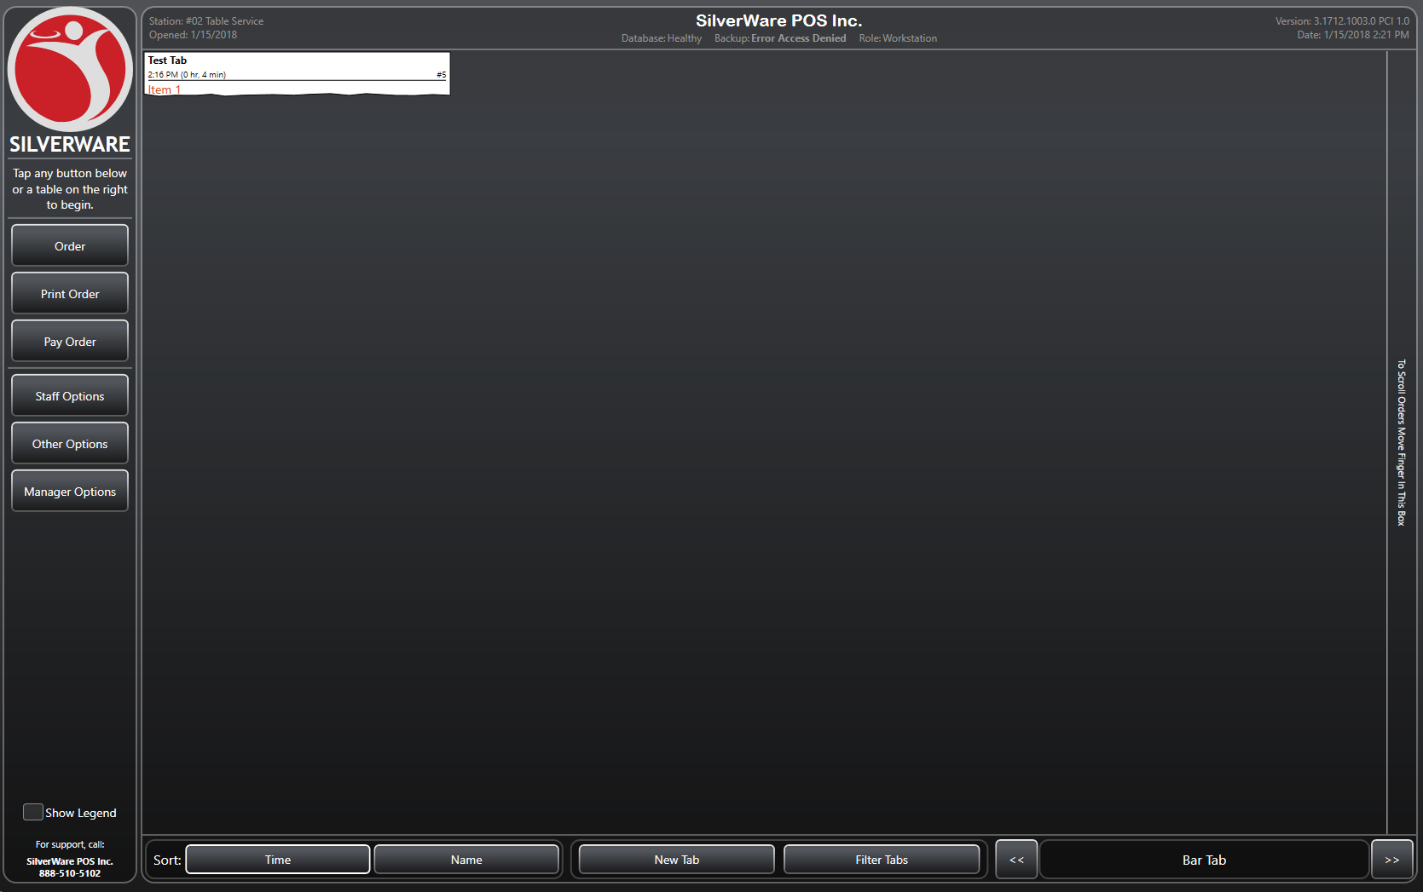

* Use the buttons on the left to start orders, print orders, or pay existing.
* Use S**taff Options** to sign-in/out
* Access miscellaneous options through **Other Options**.
* Access managerial functions through **Manager Options**
* You can sort by **Time** (the time the tab was started) or by **Name** (the description entered when starting a tab.
* You can start a new tab by pressing **New Tab**. When you run a tab, instead of occupying a table to store an order, you’ll have on-screen tabs (see image above) that represent your orders.
* Use the **Filter Tabs** button to:
  + See all orders**.**
  + See orders only related to a specific cost center.
  + See only the orders started by the users that using the station (meaning they have pressed order/print order/pay order and entered their code or swiped their user card).

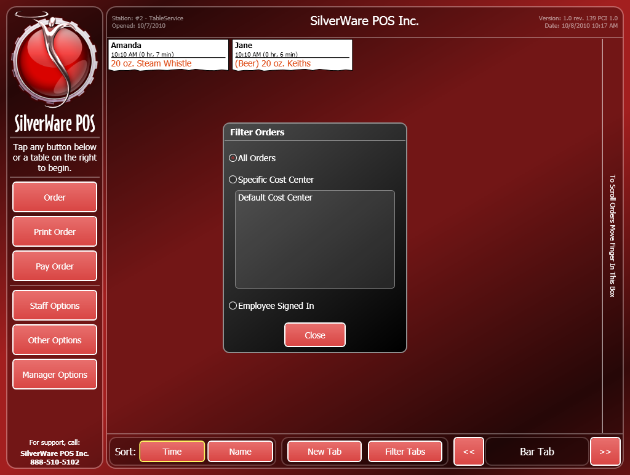

When you start a new tab, you’ll be prompted enter a description using the on-screen keyboard:

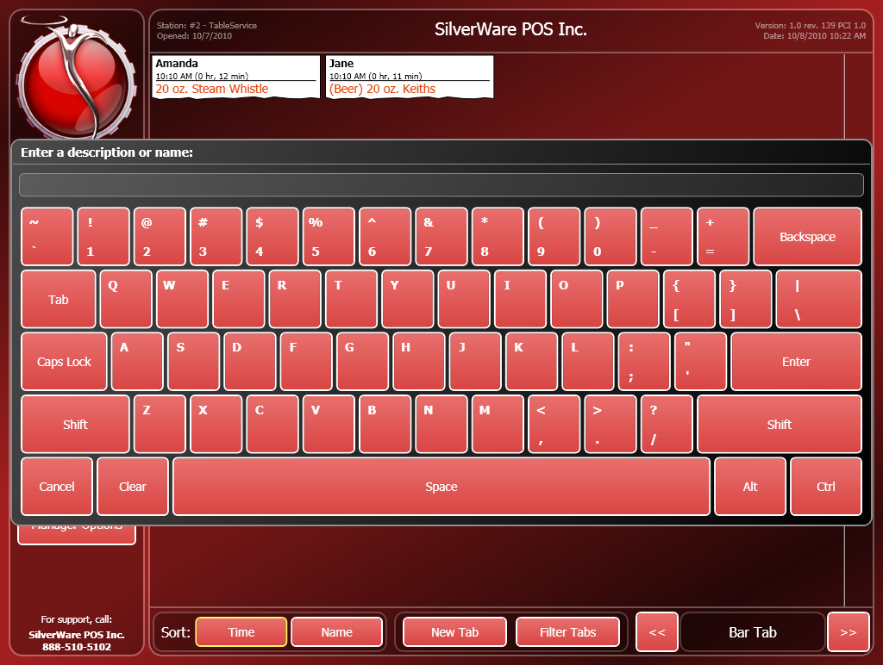

# The Main Menu

From here you can start, recall, print, and close orders. You can also process credit card transactions, and access staff, manager, and miscellaneous options.

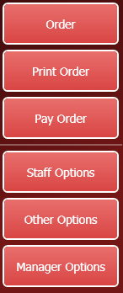

**Other Options** (not ready yet)

**Pay Order** takes you to the “Close Order” screen, where you can accept payment for a tab.

**Order** lets you start and recall cash and carry orders.

**Staff Options** contains the sign-in/out options, and other misc. functions.

**Manager Options** allows managers and owners to configure menus, employees, clients, etc.

**Print Order** lets you print a guest’s tab.

# Staff Options

The “Staff Options” menu lets you sign-in, sign-out, print reports, perform pay-ins/outs, and perform blind drops.

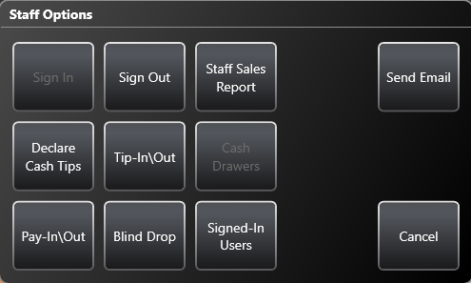

## Sign-in/out

At the beginning of your shift, you must sign-in to be able to place orders, close checks, etc. At the end of your shift, you must sign-out.

Your manager may also require you to sign-in/out for breaks.

**To Sign-in/out:**

1. On the main menu, press **Staff Options**.
2. Enter your ID. Your ID is either a numeric password, a swipe card assigned to you, or can be entered by scanning your fingerprint with a fingerprint reader attached to the workstation.
3. Press **Sign In** or **Sign Out**.

* If you have open orders when trying to sign-out, Avrio will offer to transfer them for you. See the instructions on transferring tables.

## Staff Sales Report

When you sign-out, a “Staff Sales Report” automatically prints. However, you can print it earlier in your shift if you need to. You can also use these feature to print your most recent shift report.

**To View/Print a Staff Sales Report:**

1. On the main menu, press **Staff Options**.
2. Enter your ID.
3. Press **Staff Sales Report**.

## Sending Internal Email

Avrio has a built-in email service that can be used to send messages amongst staff members.

**To send a message:**

1. On the main menu, press **Staff Options**.
2. Enter your ID.
3. Press **Send Email**.

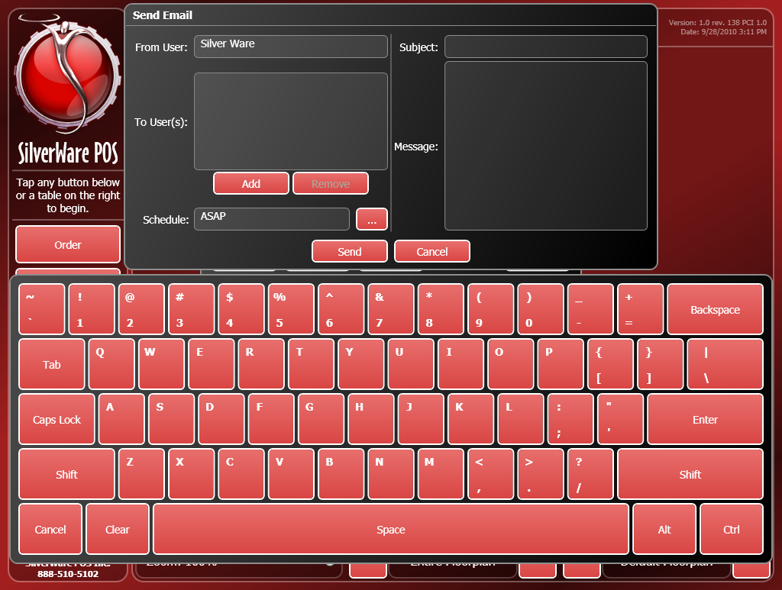

1. To add recipients, press the **Add** button. The “Add Recipient(s)” window will appear.

* You can filter possible recipients by selecting different roles or jobs using the **…** buttons
* Select recipients from the list on the right and press **Add Selected**.

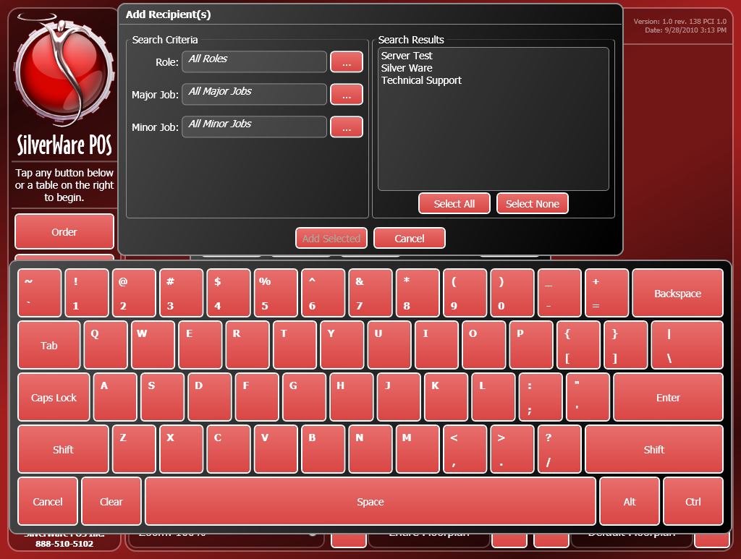

1. After you’ve added recipients, you can now enter your subject line and message. Touch the **Subject** area or message area and begin typing or use the on-screen keyboard to enter your message.
2. You can also choose when the recipient(s) will get the email by changing the **Schedule** option.
   * If “ASAP” is selected, they will receive the message the next time their server code/card/bio-metric is detected. If “Sign-in” or “Sign-out” is chosen, they will receive the email the next time they sign-in or out.

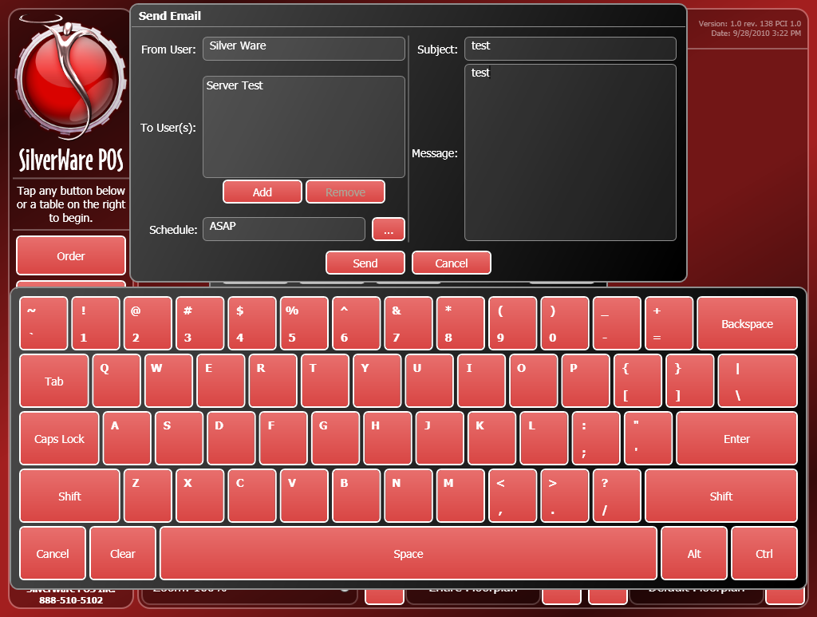

## Tip Declaration

In some states and provinces, cash tips have to be declared for tax purposes. Avrio handles this requirement easily. Non-cash tips (collected on debit/credit/gift cards) are always tracked.

To declare your cash tips manually:

1. On the main screen, press **Staff Options**.
2. Select **Declare Cash Tips**.

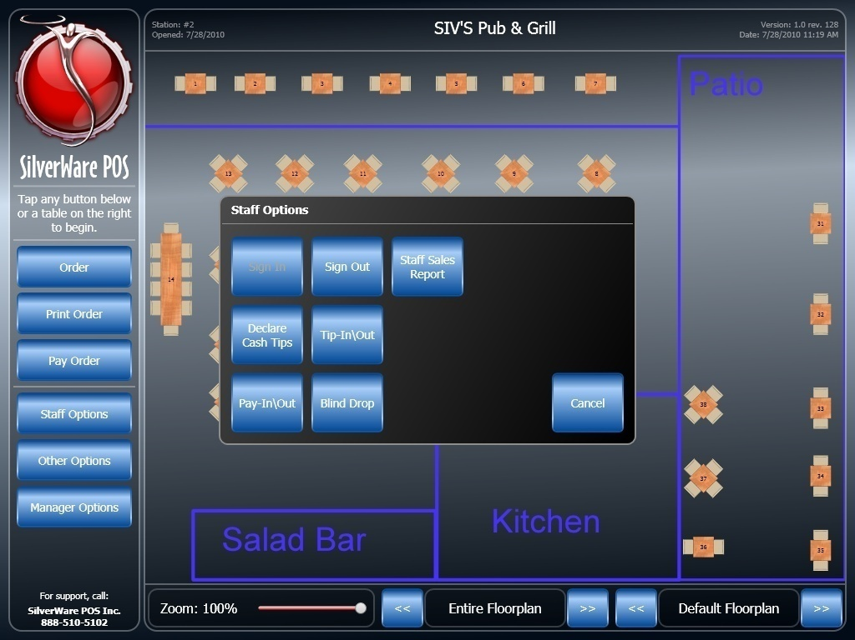

1. You’ll be presented with a summary of your sales for the current date of business (also called the “system date”).

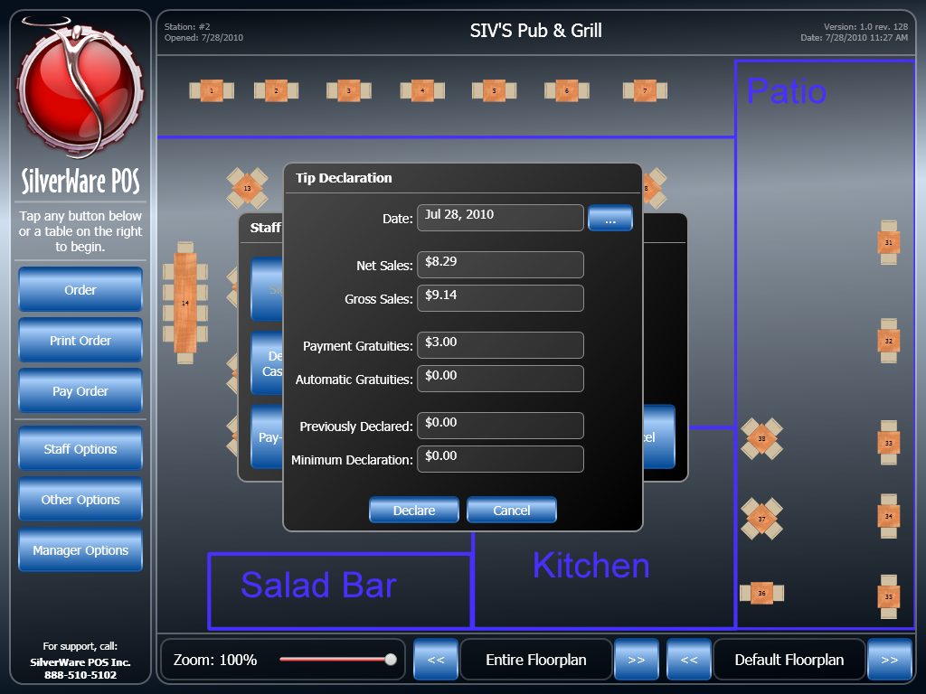

* + **Date** shows the system date the information is based on. Use the**…** button to change to a different date.
  + **Net Sales** shows your sales before taxes were applied.
  + **Gross Sales** shows your sales after taxes were applied
  + **Payment Gratuities** shows total non-cash gratuities.
  + **Automatic Gratuities** shows any gratuities from auto-grats (large-party gratuities, for example)
  + **Previously Declared** shows any amount you’ve declared for the date listed at the top
  + **Minimum Declaration** shows the minimum that you’re expected to declare (if this has been setup by management). Management can set up Avrio to track your cash sales and require you to declare a percentage of that figures as your cash tips.

1. Press **Declare** and you’ll be prompted to enter your cash tips. Enter the amount on the number that shows up and press **OK**.
2. One more prompt will follow. After you agree, a slip will be printed on a receipt printer.

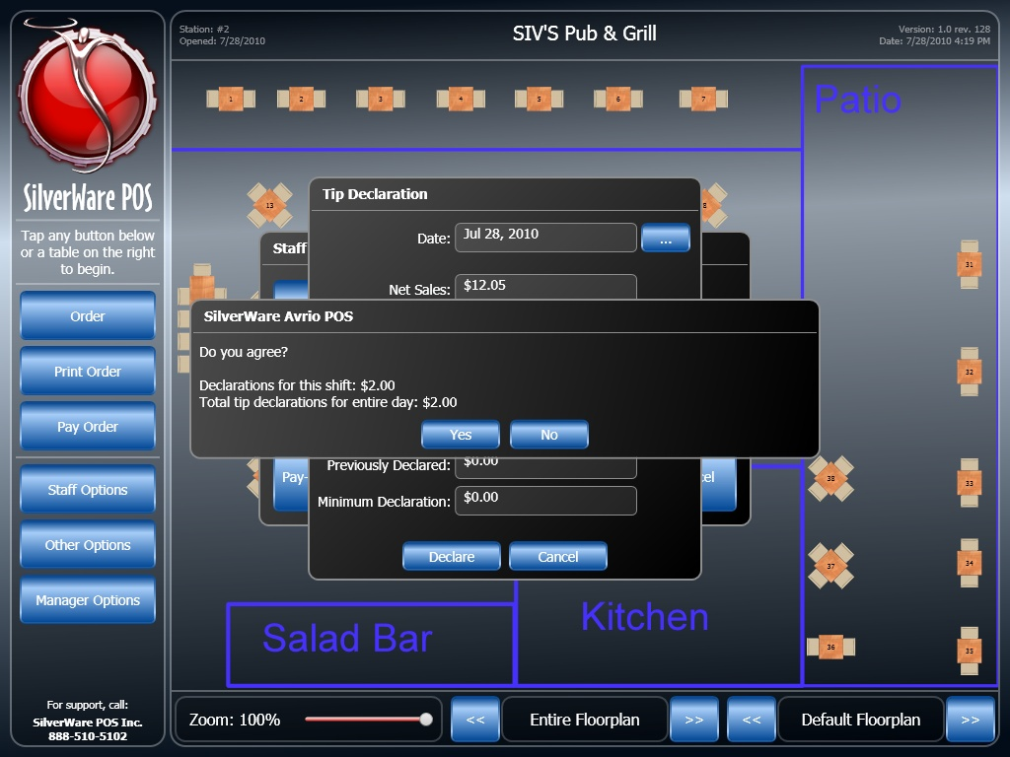

## Tip-Ins/Outs

Avrio also has the ability to track tip-sharing amongst servers. You can tip-out to other servers, or accept tips given to you by other servers.

To initiate a tip-in/out:

1. On the main screen, press **Staff Options**.
2. Select **Tip-In\Out**.



1. The tip-in/out window appears:

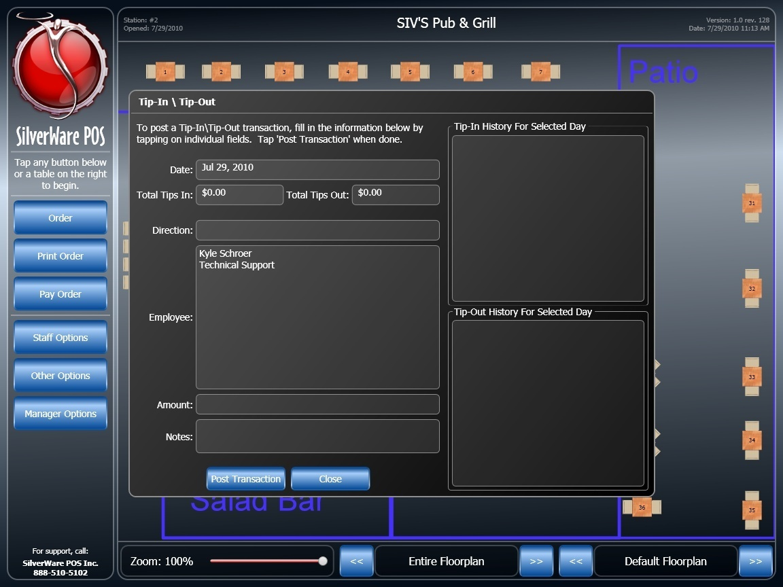

* Touch the **Date** field
* Touch the **Direction** field to choose if you’re going to tip-out to employee, or request a tip from another server. Choose **Tip-In** to request money from an employee, or select **Tip-Out** to give money to an employee.
* Select a user from the list of employees to determine who are you giving money to or requesting money from.
* Touch the **Amount** field to enter the amount to tip-in\out.
* Touch the **Notes** field to bring up an on-screen keyboard if you wish to enter notes about the transacation.
* Press **Post Transaction** to continue with the transaction. A manager may be required to authorize the transaction. Press **Close** to exit this window..

## Working with Multiple Cash Drawers

If you are a working at a POS station that has multiple cash drawers attached, you can assign one of the two drawers to yourself. This ensures that the correct drawer will open when you close checks containing a payment method that triggers the drawer.

1. On the main menu, press **Staff Options**.
2. Enter your ID.
3. Press **Cash Drawers**. The following screen appears:

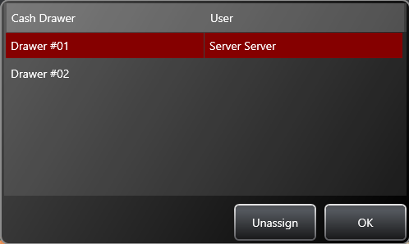

Select a drawer and press **Assign/Unassign** to give or remove your access to that drawer.

## Pay-In\Out

This option lets you pay money in or take money out of the cash register.

**To perform a pay-in\out:**

1. On the main menu, press **Staff Options**.
2. Enter your ID.
3. Press **Pay-In\Out**. The pay-in\out screen appears:

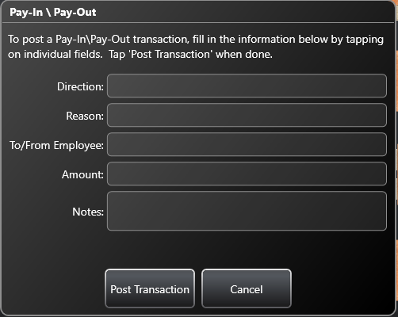

1. Touch the “Direction” field to choose if you’re taking money out of the cash, or putting money into it.
2. Press the “Reason” field to select from the pre-existing reasons.
3. Touch the “Amount” field to bring up a key-pad that lets you enter the amount you’re taking out/putting in.
4. If you are paying-out to a fellow employee, or taking money from a fellow employee, select the “To/From Employee” area and select their name.
5. Touch the “Notes” field to bring up an on-screen keyboard that allows you to enter notes about the transaction.
6. When complete, press **Post Transaction**. You may be asked for a manager’s authorization.

## Blind Drops

Blind drops are used when a restaurant wants you to give them your net cash owing without knowing how much it is supposed to be first.

**To perform a blind-drop:**

1. On the main menu, press **Staff Options**.
2. Enter your ID.
3. Press **Blind Drop**. A key pad appears.
4. Enter the amount for the blind drop, then press **OK**.

# Other Options

## Viewing a Loyalty Card’s Information

1. On the main menu, press **Other Options**. Enter your ID.
2. Press **Loyalty/Gift Card Balance**.
3. Swipe the card, or press **Manual** to enter the card number and PIN manually.
4. The card’s information will appear on screen. Press **Print** if you want to print it.

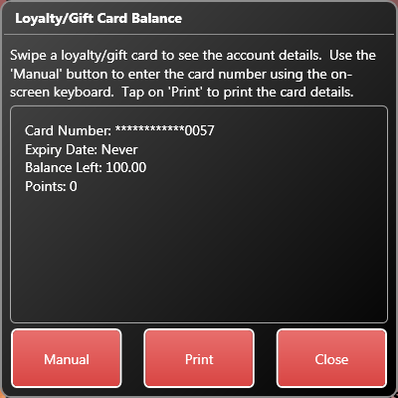

## Redeeming Points for Coupons

If your location offers a frequent diner program, clients will earn points for their purchases. These points can be redeemed for coupons which have discounts affiliated with them.

1. On the main menu, press **Other Options**. Enter your ID.
2. Press **Redeem Points (Issue Coupon)**
3. Highlight a client from the list that appears by touching their name.

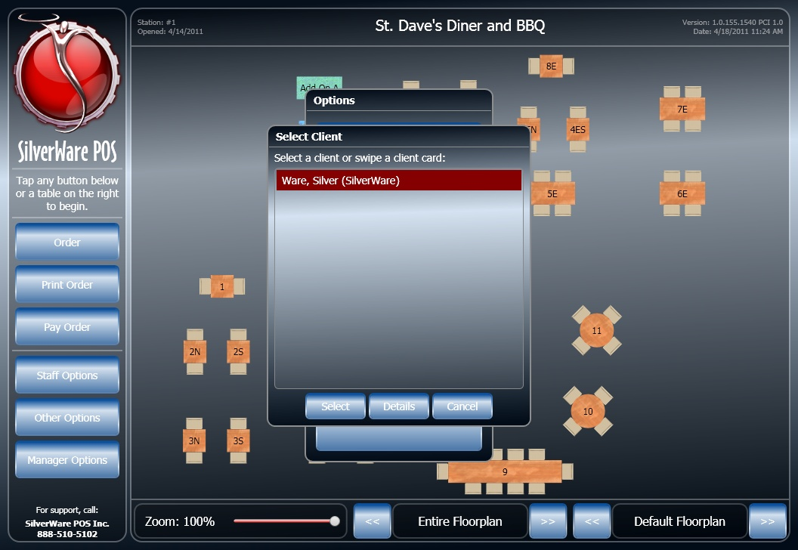

1. Press **Select** to look at the available coupons for the client you’ve highlighted.

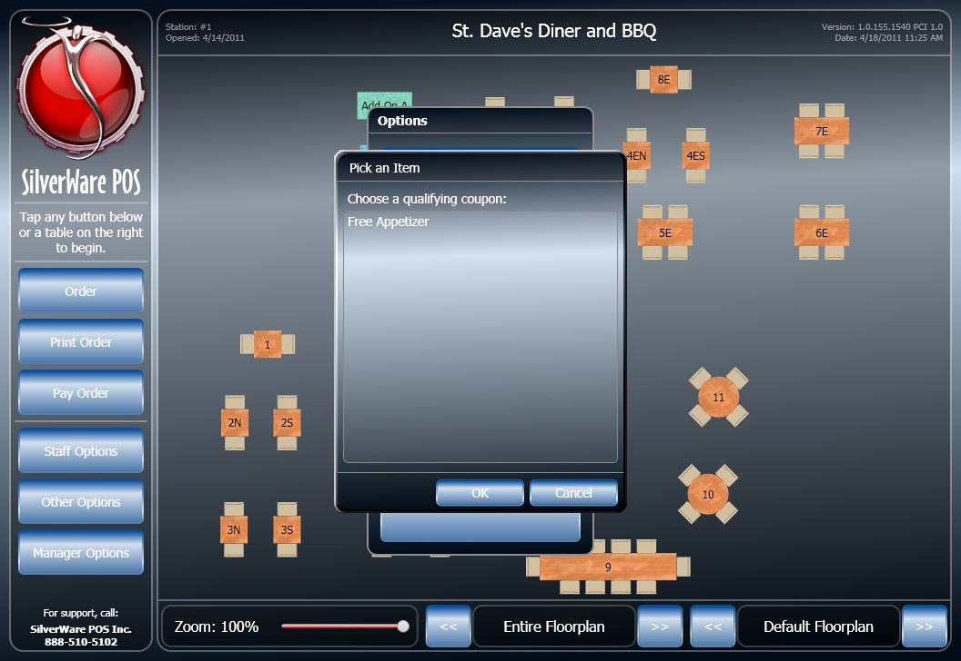

* Highlight a coupon and press **OK** to issue it. It will print at the receipt printer attached to the station you’re using.

## No Sale

Assuming you have access to the cash drawer and are allowed to perform no sales, you can open the cash drawer using this method:

1. On the main menu, press **Other Options**. Enter your ID.
2. Press **No Sale**

## Menu Item Countdown

See the Manager Guide for details on this feature.

## Clients

This area lets you search for existing clients to view their details. You may also be able to edit details or add new clients if your system has been setup to do so.

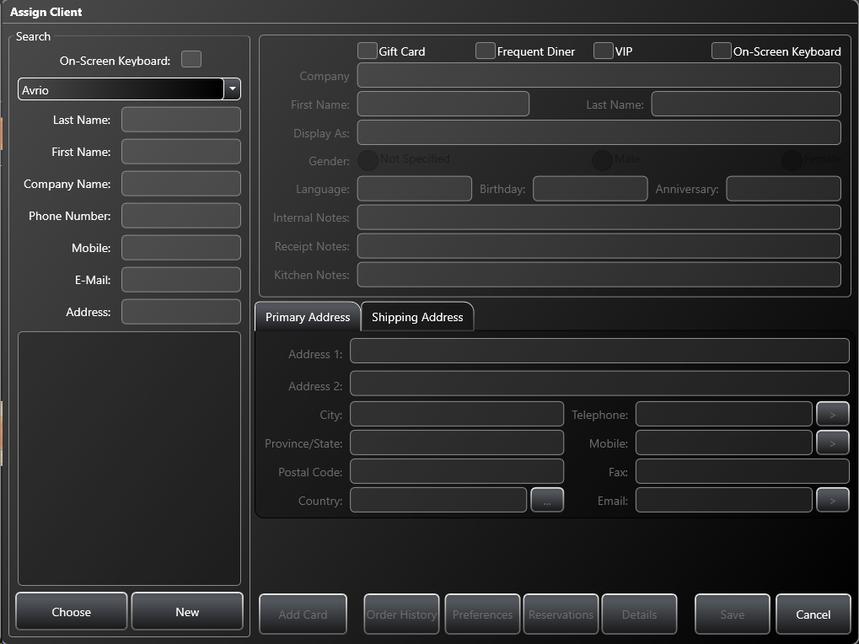

# Ordering

1. Touch **New Tab** start a new order.

* Touch an existing tab to recall that order. You can only recall tabs you started.
* You may be asked to enter the number of guests on the tab.

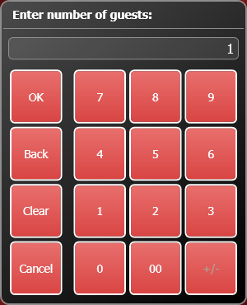

1. Enter a description of the customer. You can swipe a driver’s license to automatically apply the customer’s name to the tab. Otherwise, type a description. If there is no keyboard attached to the workstation, you can use the on-screen keyboard.

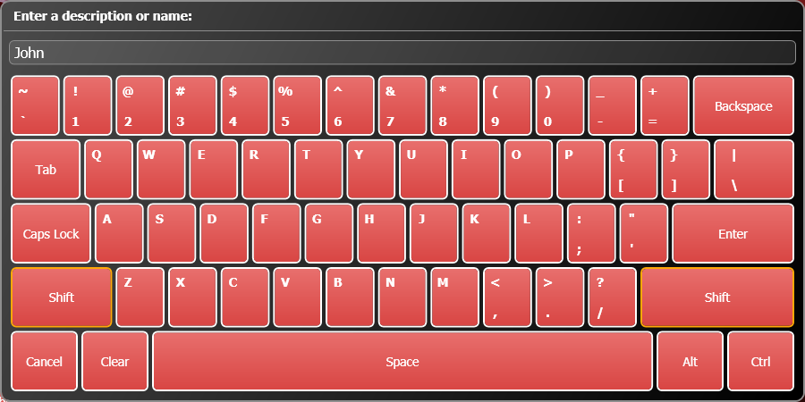

* Touch **Shift** to use an upper-case letter or an auxiliary symbol (!, @, etc). The shift key only affects the first button you touch after pressing it.
* Avrio may be configured to deny tabs to customers’ whose age (determined when the license is swiped) doesn’t match Avrio’s requirement.

1. The “Order Screen” appears.

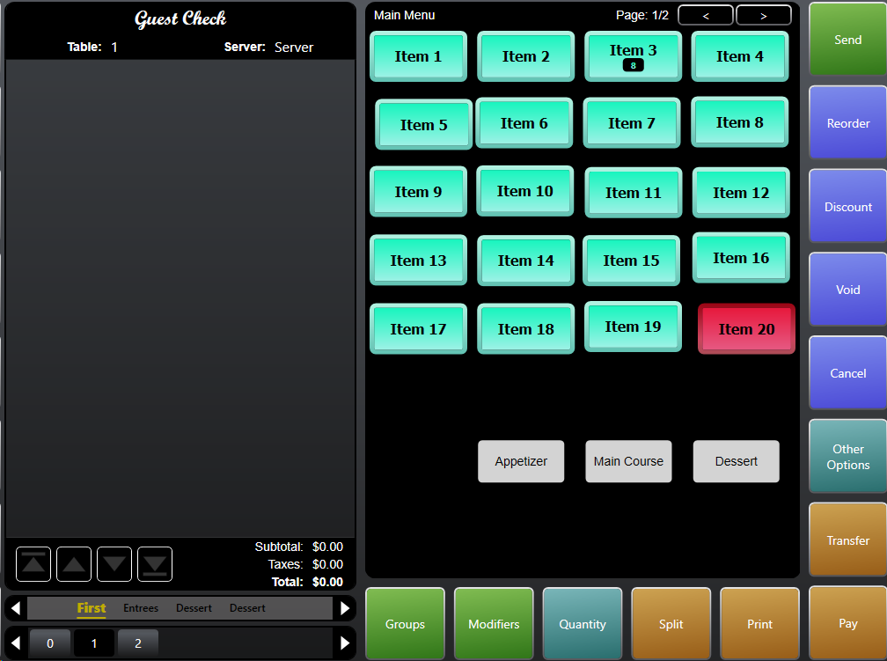

1. Touch a group to see the items within it. Select an item to order it. Transferred.
2. After adding items to the tab, they must be sent to the kitchen/bar. Press **Send**.

* Unsent items have a “+” sign next to them.

1. You can recall the tab simply by touching it on the main screen. Then you can order more items, print the tab, etc.
2. When the guest is ready to pay, press **Print** to print the tab.
3. Press **Close** to go to the “Close Order” screen and accept payment.

## Order Screen Options

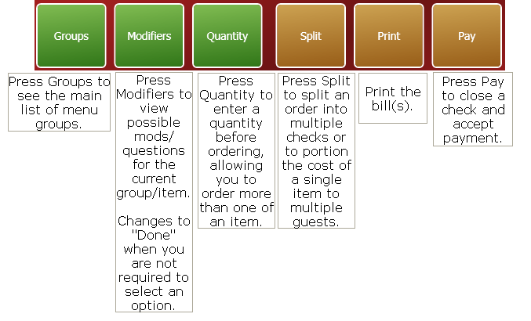

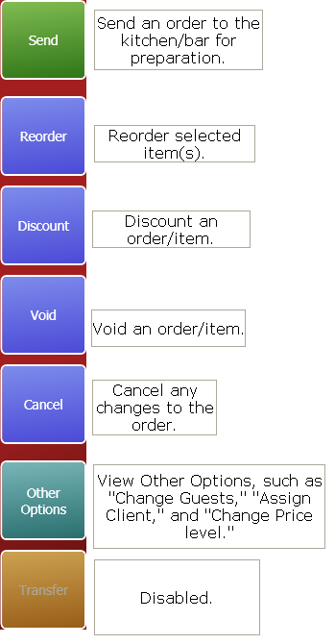

# Discounting Items

You can apply a discount to specific items or to everything that has been ordered so far. You may need a manager to approve the discount if you do not have authority to do so yourself.

## How to Apply/Remove Discounts from the Order Screen

1. If applying/removing a discount only to certain items, make sure you select them first.
2. Press the **Discount** button.

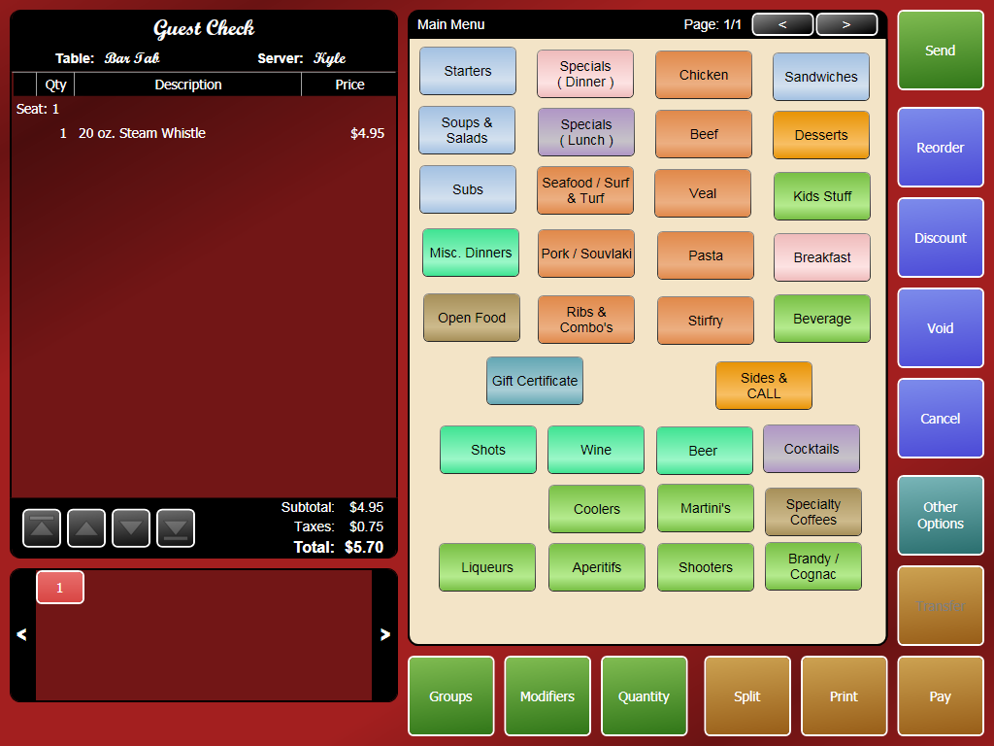

1. Select a discount to apply/remove.

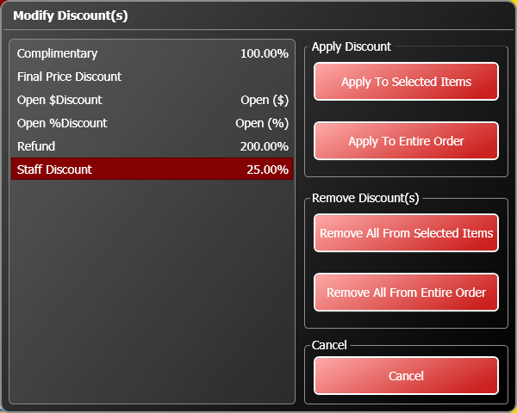

1. Select an option for applying/removing the discount. You can apply it to the item(s) you selected, or you can apply it to the entire order.
2. If you select an open dollar or percentage, enter the amount or percentage to discount on the keypad.
3. Send the order. A manager must now approve of the discount. Pressing **Approve/Deny Remaining** will approve/deny all the discounts, or the manager can pick which to approve/deny.

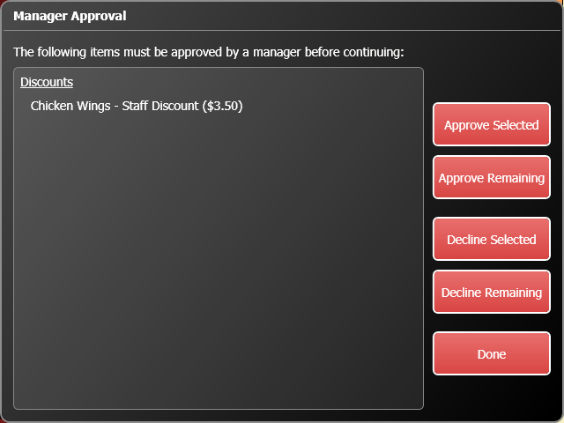

1. If you’re not authorized, a manager must enter their ID to complete the discount.

## How to Apply/Remove Discounts from the Close Order Screen

1. If you’re applying/removing a discount only to certain items, make sure you select them first.
2. Press the **Discount** button.

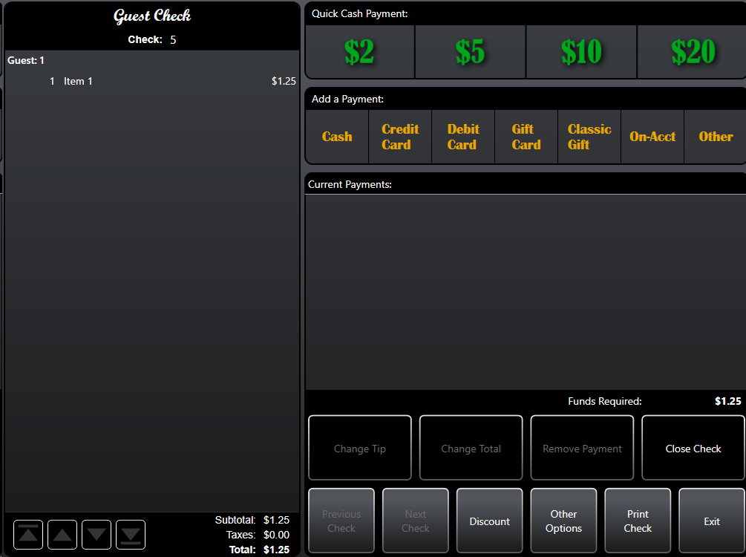

1. Select a discount to apply/remove.
2. Select an option for applying/removing the discount. You can apply it to the items you selected, or you can apply it to the entire order.
3. If you select an open dollar or percentage, enter the amount the amount or percentage to discount.
4. After entering payment(s), press **Close Check**.
5. A manager must now approve of the discount(s). Pressing **Approve/Deny Remaining** will approve all the discounts, or the manager can pick which to approve/deny.
6. If you’re not authorized, a manager must enter their ID to complete the discount.
7. Now the tab can be closed.

## Voiding Items

You can remove items from a tab by voiding them. If the item has already been sent for preparation, you will need to enter a reason, and you may need a manager’s approval as well.

1. On the “Order” screen, select the item(s) you want to void. If you’re voiding the entire order, you don’t have to select anything.
2. Press **Void**. Unsent items will simply disappear. Sent items require more information.
3. Select a reason.

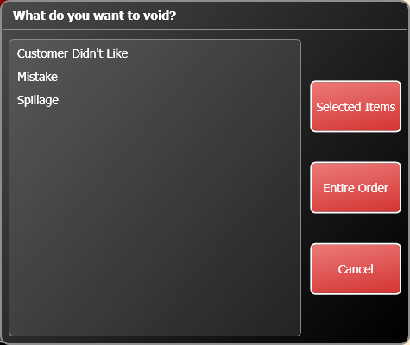

1. Press **Selected Items** to void the item(s) you selected, or **Entire Order** to void everything.
2. Press **Send**.
3. If you’re not authorized, a manager must approve of the voids. They can select which voids to approve/decline. Press **Done**, then enter a manager password.

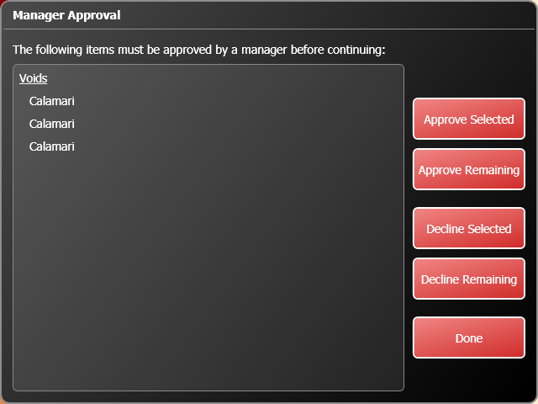

# Other Options

The “Other Options” button lets you perform a variety of functions.

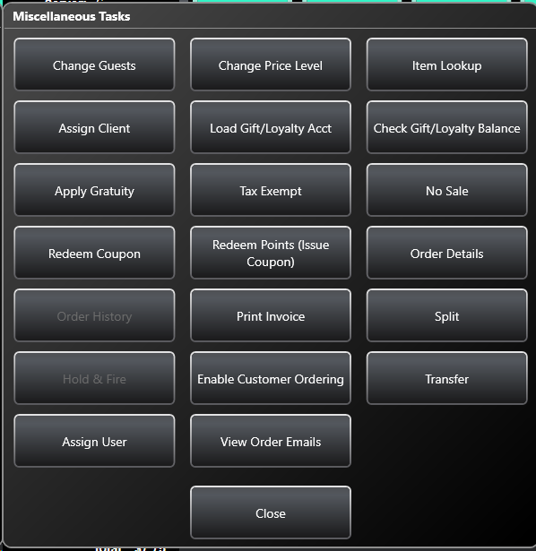

## Adding/Removing Guests to an Order

You can add/remove guests to an order in progress.

1. On the “Order” screen, press **Other Options**.
2. Press **Change Guests**.
3. The “Assign Guests” screen appears. Add/remove guests as you would when starting an order.

* Guests that have items assigned to them cannot be removed. Either void their items or assign them to another seat. To do this, select the items, then drag them to an occupied seat in the “Seat Selection” area on the “Order Screen.”
* Once you’ve sent items, you cannot change between graphical seating and quantity seating.
* When adding guests numerically, enter the total amount of people at the table, not the number of people being added.

## Changing Price Levels

Management can setup different price levels for items. These levels can be automatically controlled by schedules, but you may need to manually apply a different price level. When you change the price level, the new level is applied to all items you order until you send the order. You will have to change the level again if you need to recall the order. **You cannot select an item and then change the level using this option. You must change the level before ordering items.**

1. On the “Order” screen, select the item(s) to change.
2. Press **Other Options**.
3. Press **Change Price Level**.

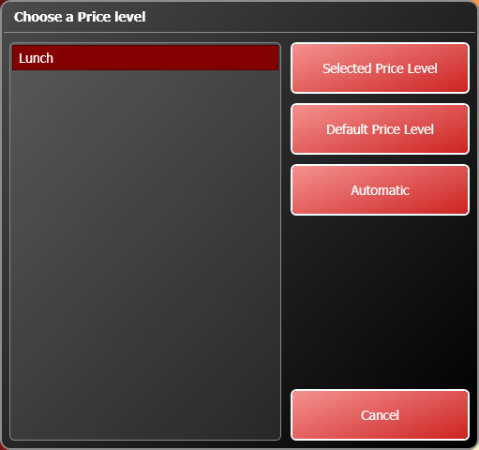

1. Select a price level from the list on the left, then choose one of the options on the right to apply a price level.

* **Selected Price Level** applies the price level you’ve selected.
* **Default Price Level** changes the items to its regular price.
* **Automatic** changes the item to the price it is scheduled for. Management can setup a schedule that determines what price level should be in use during certain hours.

1. You may need a manager to enter a password and complete the change.

## Item Lookup

This feature lets you search the menu for an item and then add it to the order.

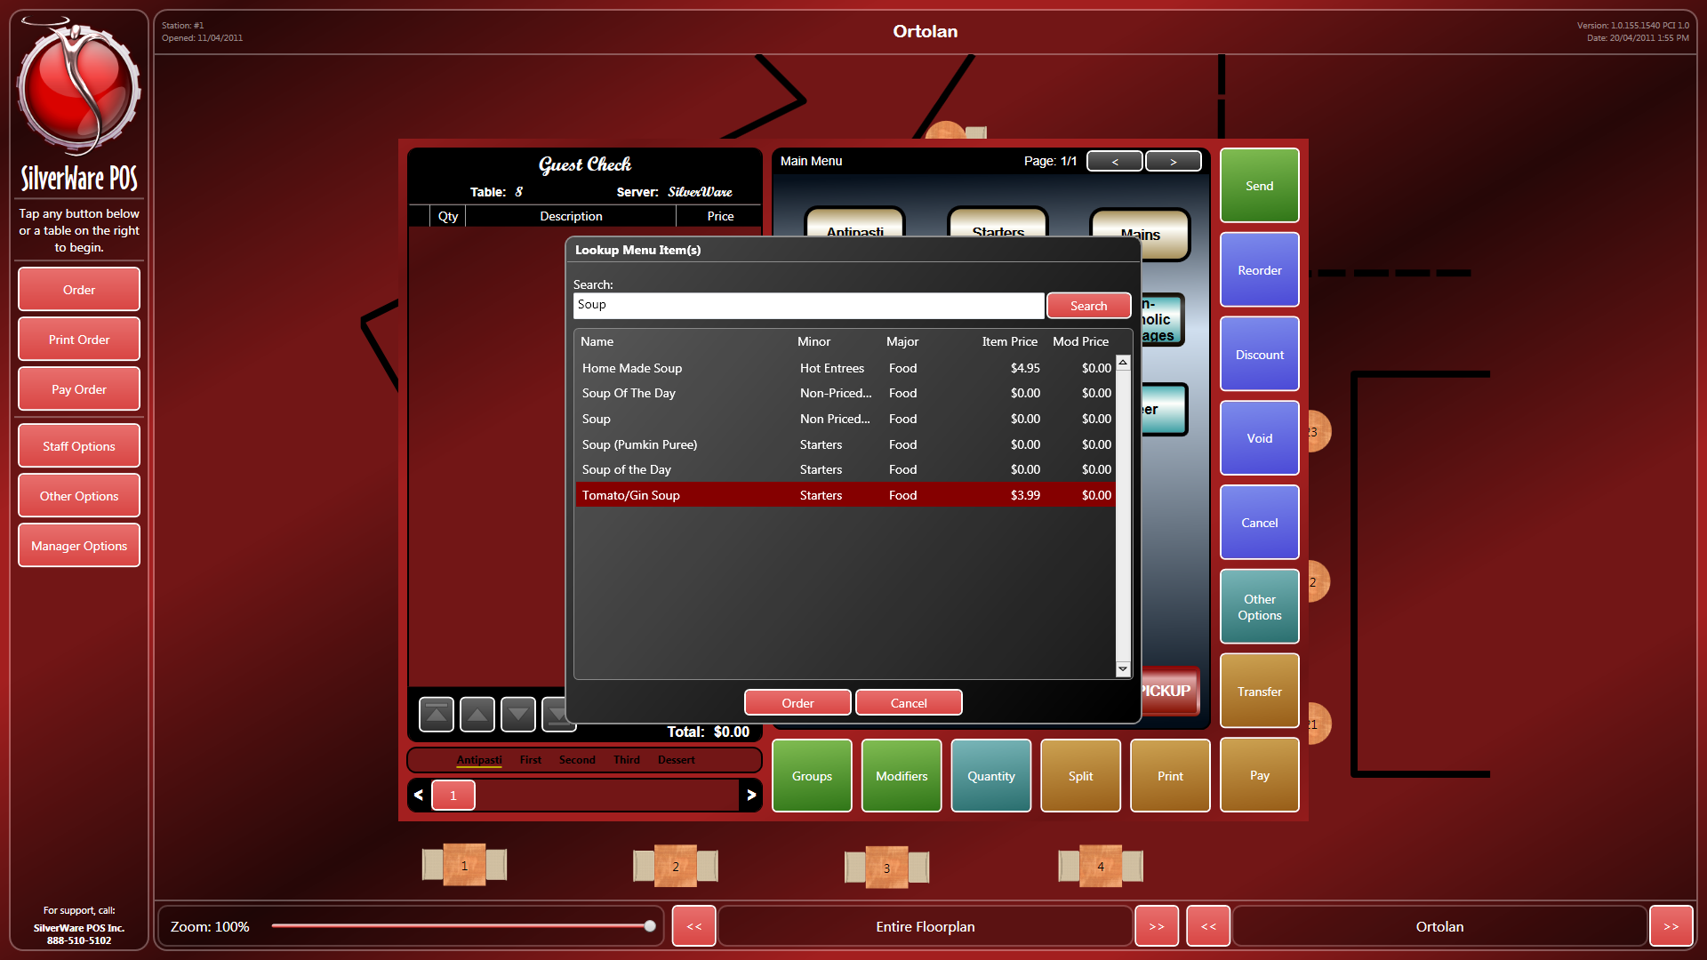

1. Type a description/item name and press **Search**.
2. If the item you’re looking for appears, select it and press **Order**. Otherwise, press Cancel or search again.

## Assigning Clients to an Order

If you’re serving a VIP/client, you will need to assign them to a seat. This ensures that any price levels or discounts they receive are applied to their orders, that they receive points (if you’re using a frequent diner program) and that you’ll be able to close the order on-account.

### From the Order Screen

1. If the client has a loyalty card, swipe the card on the order screen. If no card is available, press **Other Options**, then **Assign Client** to see a list of possible clients.

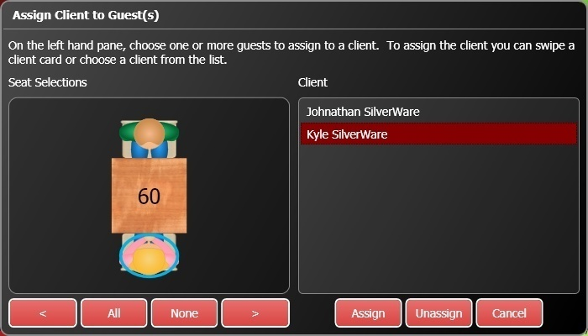

1. Touch a guest (or multiple guests), then a client name. Press **Assign** to assign their purchases to the client account.

* If you haven’t swiped the client’s card yet, you can swipe it now. The client will be selected from the list on the right. Now, touch the guests you want to assign to the client’s account and press **Assign**.
* If you have a long list of clients, swiping a client’s card will be much easier that finding them on the list.

### From the Close Order Screen

Note that if you assign the client from the “Close Order” screen, any discounts the client should receive will not be applied. It is recommended that all client assignment be performed on the “Order” screen.

1. Swipe the client’s card or press **Gift Card**.
2. The “Gift Card” window appears. You can swipe a card now if necessary.
3. Process the gift card transaction as you would normally. See these instructions.

## Loading Gift Cards/Loyalty Accounts

Within the “Other Options” menu on the “Order” screen, touch **Load Gift/Loyalty Acct** to load a gift card or make a payment to a loyalty account.

1. This window appears:

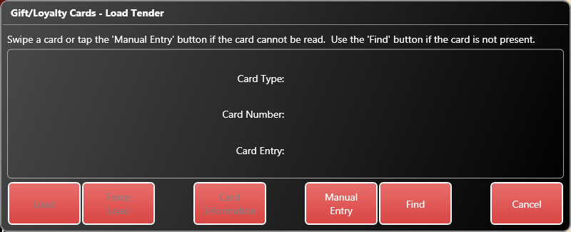

1. Swipe a card or enter press **Manually Entry** to enter the card information:

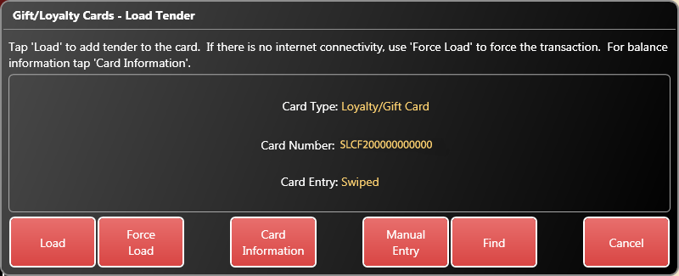

1. Now, choose **Load** to load the card normally, or **Force Load** to load the card if no connection to the loyalty service is possible. If you force the load, you will have to enter an approval code. Press **Card Information** to see information about the card’s current balance and any associations with a client.
2. Enter an amount to load.
3. The “Order” screen appears. You can now continue or close the order as per usual.

## Checking Gift Card/Loyalty Account Balances

Within the “Other Options” menu on the “Order” screen, touch **Check Gift/Loyalty Acct** to check a gift card’s or loyalty account’s balance.

1. Swipe the card, or press **Manual** to enter the card number and PIN manually.
2. The card’s information will appear on screen. Press **Print** if you want to print it.



## Applying Gratuities

The **Apply Gratuity** option allows you to add a gratuity to the order, such as a large party gratuity, bottle service, etc.

1. Within the “Other Options” menu on the “Order” or the “Close Order” screens, touch **Apply Gratuity**.
2. Select a gratuity to apply to the bill, then press **OK**, or press **None** or **Cancel** to exit this screen.

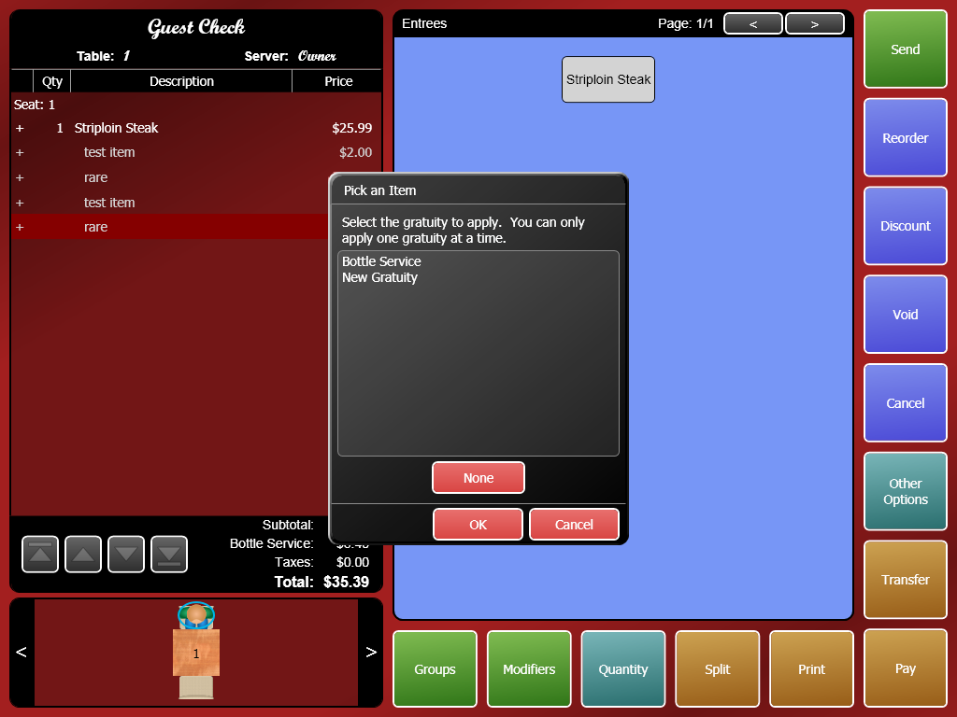

1. The gratuity will be charged upon all applicable items and added to the bill. Any items that are added after the grat has been applied will increase the amount of the grat.

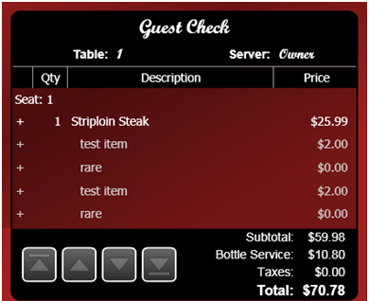

## Tax Exemption

Within the “Other Options” menu on the “Order” or the “Close Order” screens:

1. Touch **Tax Exempt** to remove taxes from an order.
2. On the right-hand side of the “Tax Exempt” screen, you can choose which taxes you’d like to exempt, and which checks will receive the exemptions.

* Check the boxes at the top to exempt the tax.
* Check the boxes at the bottom to select which checks will be exempted.
  + You can the **Show** button to show just the items on a specific check, or use the **Show All** buttons to see all items on all checks.
  + You can use the **Select All/Select None** buttons to select all or none of the checks so they will/won’t receive the tax exemptions.

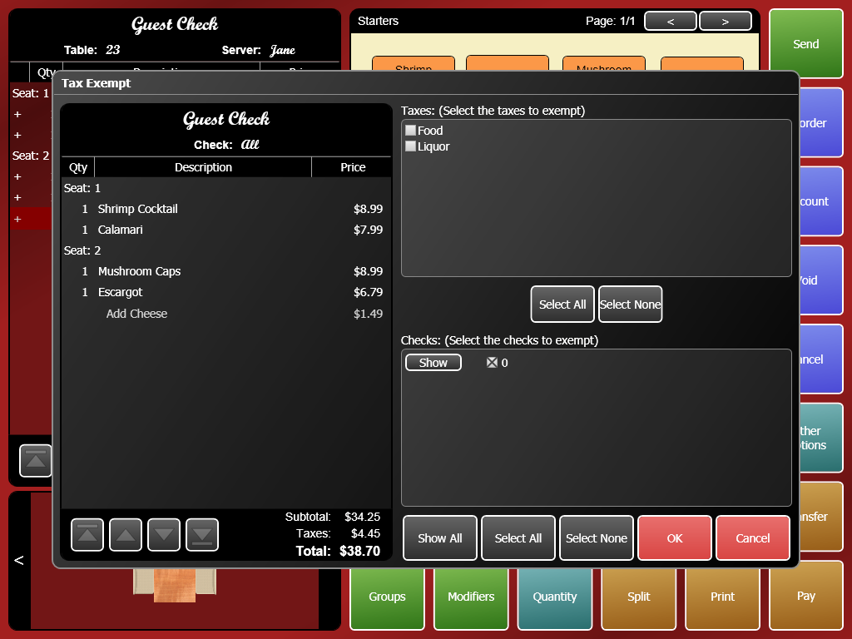

1. After applying all exemptions, press **OK** to continue.
2. You may need to enter a reason for the exemption (such as a Tax Exemption card number) and the exemption may need a manager’s authorization as well.

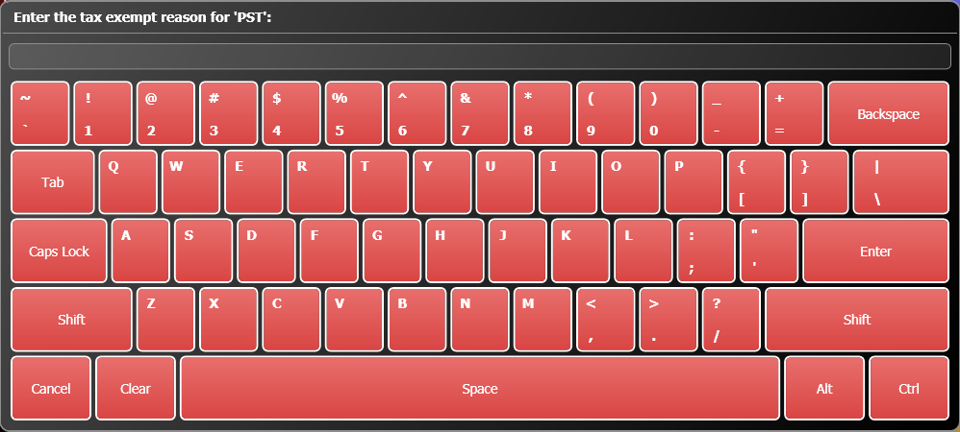

## No Sales

If you need to open the cash drawer without performing a sale:

1. Within the “Other Options” menu on the “Order” or the “Close Order” screens:
2. Touch **No Sale**. A manager may be required, and the drawer will open if you have access to it.

## Working with Coupons

From the “Other Options” menu, you can issue or redeem coupons.

### Issuing Coupons

To issue a coupon:

1. While ordering, press **Other Options**.
2. Press **Redeem Points (Issue Coupon)**

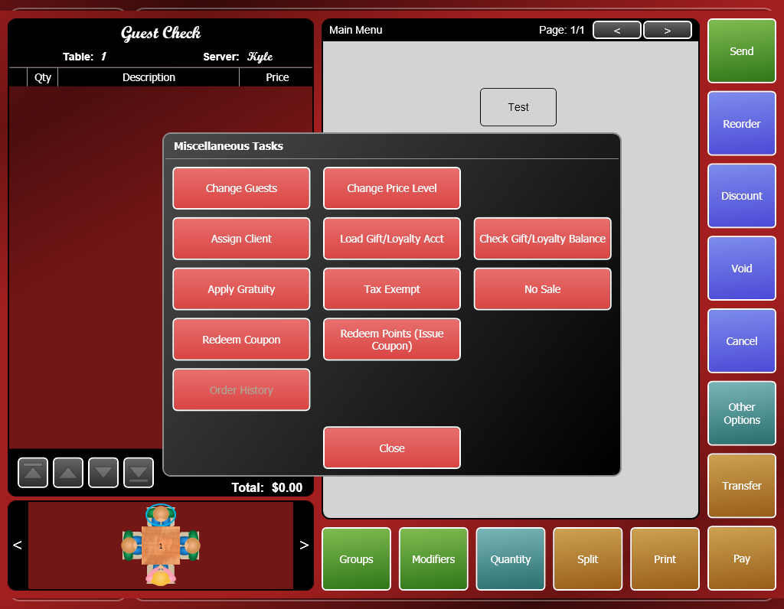

1. Search for and the client you want to issue the coupon to and press **Select**

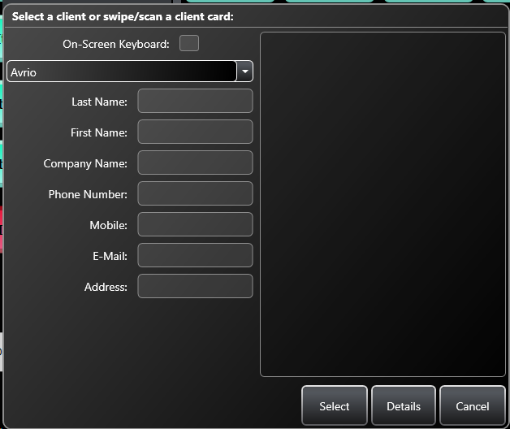

1. Select the coupon you want to issue and press **OK**.

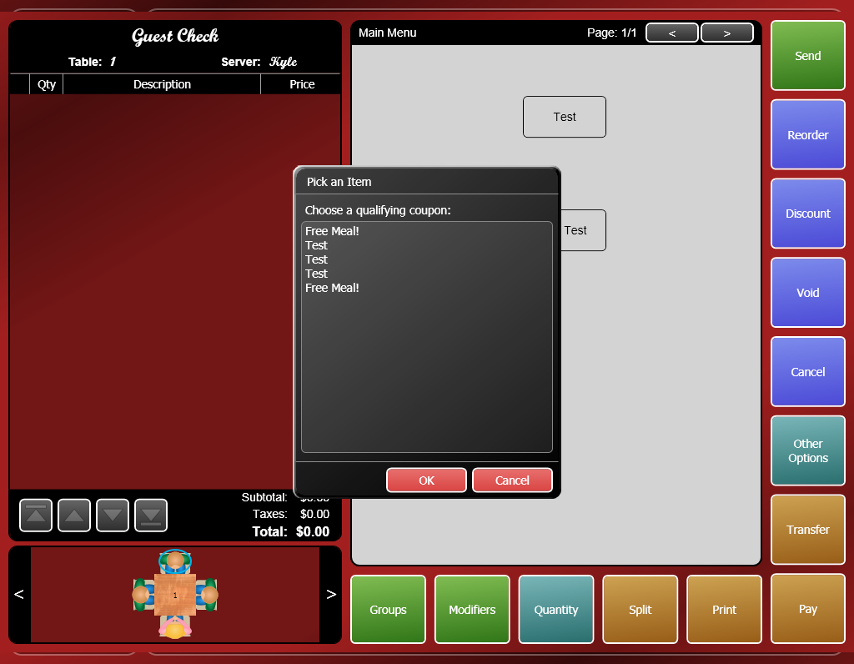

1. The coupon will print out of a check printer. There will be a number printed on the coupon that represents the coupon’s number. This number will be needed when redeeming the coupon.

## Redeeming Coupons

To redeem a coupon:

1. While ordering, select the item(s) you want to apply the coupon to.
2. Press **Other Options**.
3. Press **Redeem Coupon**



1. Enter valid coupon #.
2. The coupon will be applied to the selected item(s).
3. A manager may need to approve the coupon when you send/print/pay the order.

## Order Details

This option lets you view the details of your current order, including the time when you sent/fired items.

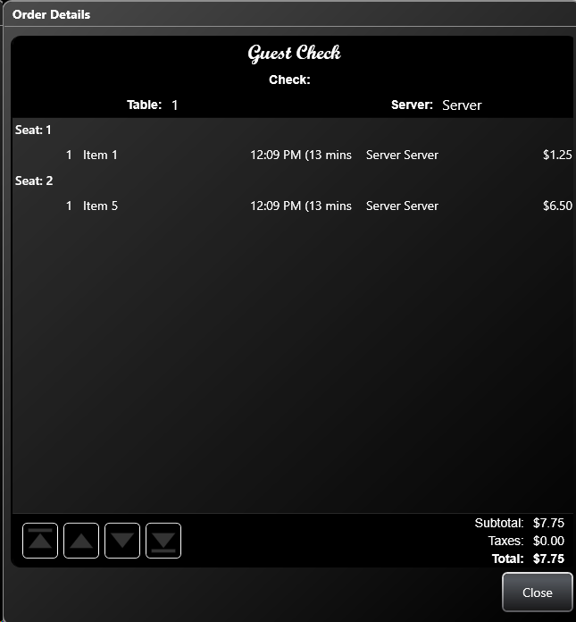

## Print Invoice

If the station you’re using has access to a desktop printer, you can issue an invoice as opposed to simple guest check for your current order.

You must first assign a client to the order.

## Assign User

This functionality can be used to track your sales of specific menu items, perhaps in an environment that gives a sales commissions.

1. Select the menu item(s) that are eligible for commissions
2. Press “Other Options”
3. Select “Assign User”
4. Select your name/the appropriate server name from the list.
5. Press Assign. Your screen should look like this at the end

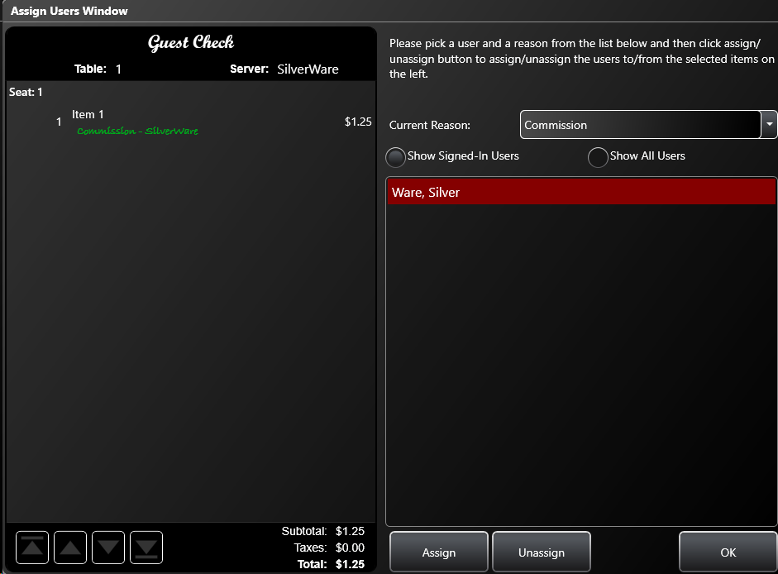

# Transferring Orders

Transferring orders lets you give your orders to another server and/or table. Entire orders must be transferred; you cannot transfer specific items.

## To Transfer an Order to Another Server

1. On the “Order” screen, press **Transfer**.

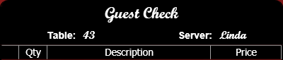

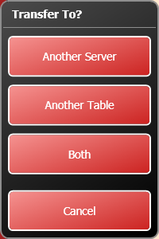

1. Press **Another Server**.
2. To transfer to a server that is signed-in, press **Yes**. That server has to enter their ID. To transfer to a server that is not signed-in, press **No**. A manager will need to enter their ID, then they will select a server to receive the order.
3. The server’s name displayed on the on-screen check will change.
4. The “Order” screen remains open.

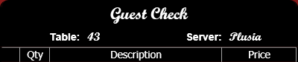

## To Transfer an Order to Another Table

1. Press **Transfer**.
   * If you only want to transfer certain items, select them before pressing **Transfer**.
2. Press **Another Table**.
3. Now you can transfer the whole order (or the selected) items to a new/empty table, or to an old/occupied table. Select an option, then touch a table on the floor plan.

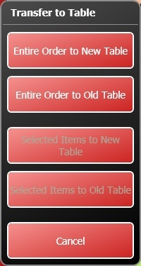

## To Transfer an Order to Another Server and Table

1. Press **Transfer**.
   * If you only want to transfer certain items, select them before pressing **Transfer**.
2. Press **Both**.
3. To transfer to a server that is signed-in, press **Yes**. That server has to enter their ID. To transfer to a server that is not signed-in, press **No**. A manager will need to enter their ID, then they will select the server.
4. Now you can transfer the whole order or just certain items to a new/empty table, or to an old/occupied table. Select an option, then touch a table on the floor plan.

# Viewing Open/Closed Orders

You can view a list of your open or closed orders for your current shift, or the entire day. You can also recall, print, or pay orders. This screen is a great way to find any open cash and carry (C/C) orders that you cannot see on the floorplan.

To view the orders:

1. On the main screen, press **Order**, and then enter your password.
2. Press **All Orders**.
3. A window appears, allowing you to choose which orders you’d like to view.

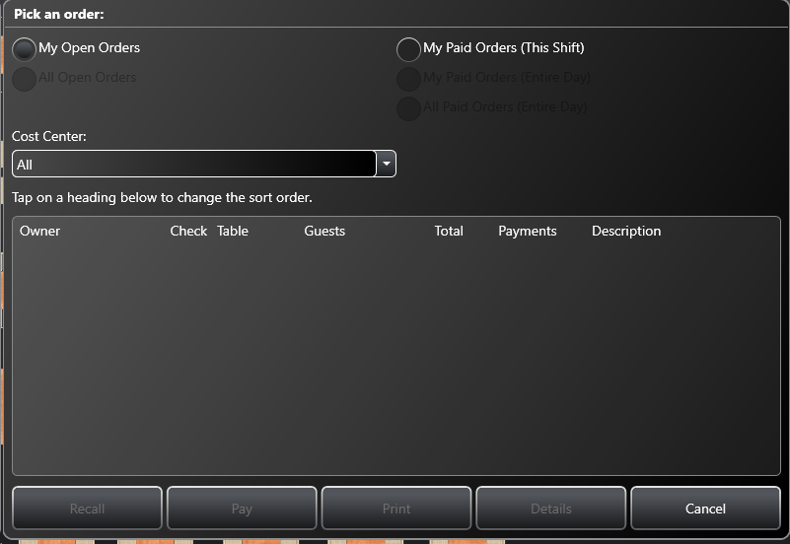

* **Owner** – The staff member in charge of the order
* **Check** – The check #.
* **Table** – The table #.
* **Guests** – The number of guests.
* **Subtotal** – The check’s subtotal.
* **Total** – The check’s total.
* **Payments** – Any payments already affiliated with the check
* **Description** – Any client/bar tab descriptions added to the order/check

# Printing Orders

When you’re ready to present the check to a table, you’ll need to print it first. There are a few ways to do this.

## From the Main Menu

1. Press **Print Order**.
2. Press **Cash & Carry** for cash and carry orders or **All Orders** to see all your open orders.
3. Select a table/order from the list and press OK.

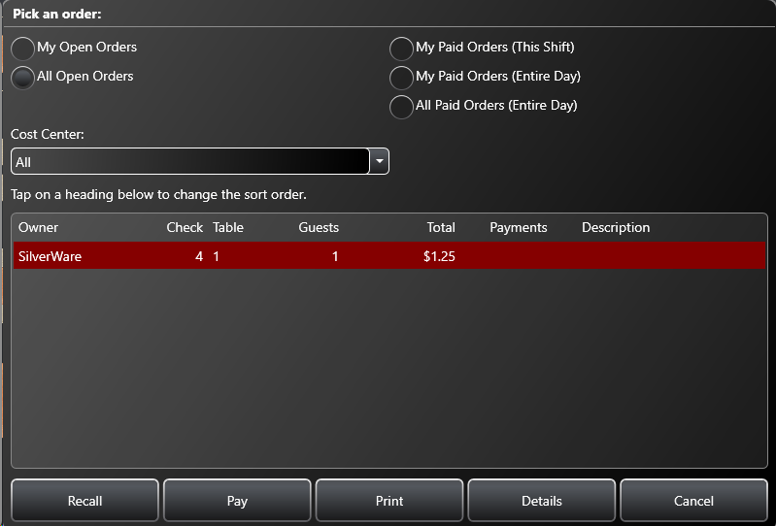

1. If you split the bill, select which check(s) to print by checking the bubble next to the bill number.

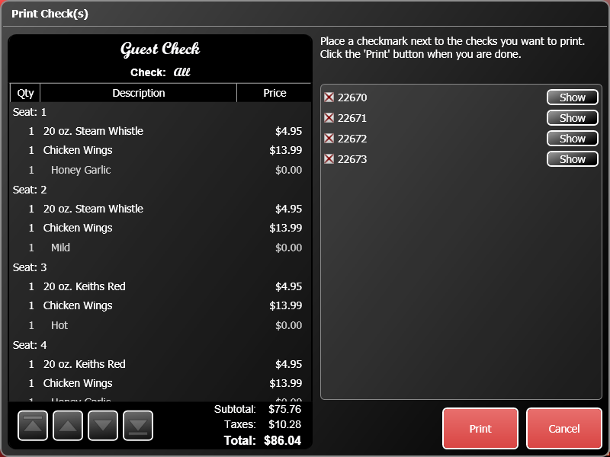

## From the Order Screen

1. Simply press **Print**.
2. If the bill was split, you’ll see this screen:



* Make sure the bubble is checked for the receipt(s) you want to print.
* You can press the **Show** button to see only the items on that check.

1. Press **Print**.

# Closing Orders

Press **Pay Order** (main screen) and select a table or cash and carry order, or **Pay** (order screen) to access the “Close Order” screen. When manually entering the amount a guest has paid, it’s best to enter the total (including) tip; this way the guest’s change or your tips are reported correctly.

## To Cash

If the customer pays with cash, use either the quick-cash buttons or press **Cash** to enter the amount the customer left, then press **Close Check**.

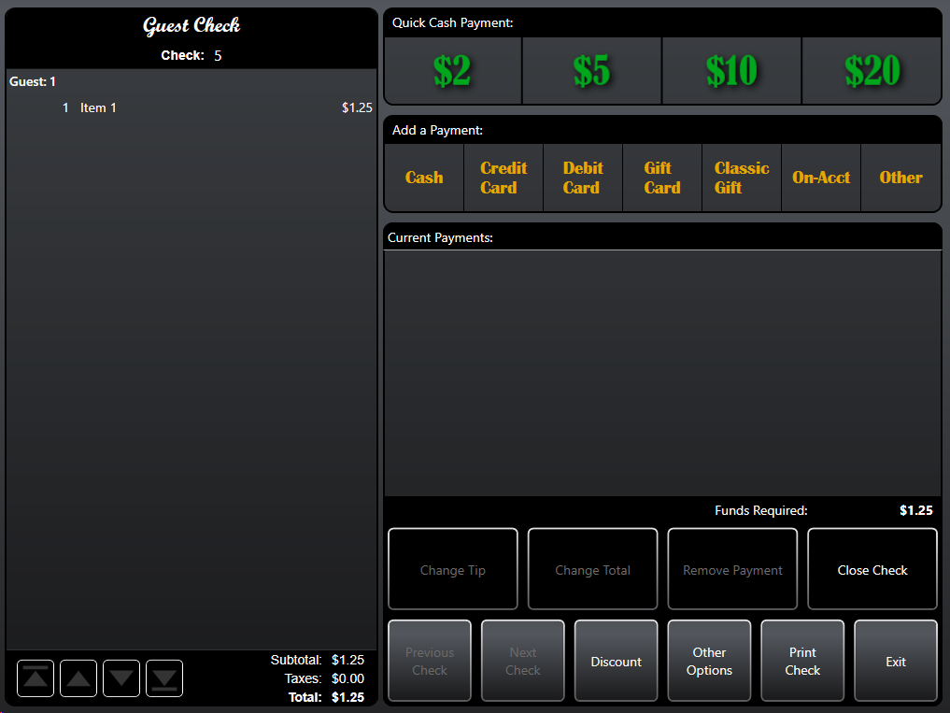

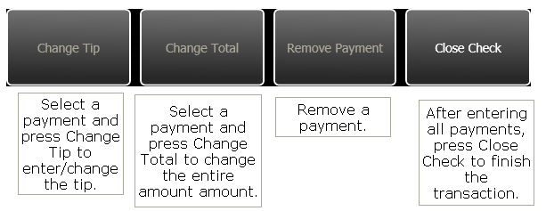

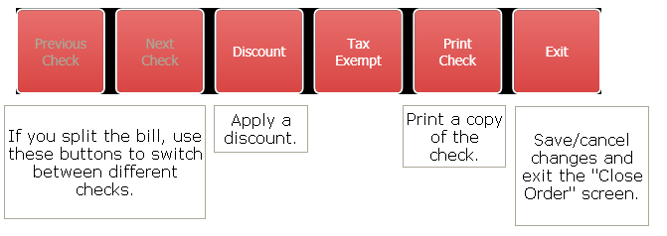

## To Credit Card

Your manager should provide instructions on using your processor. These instructions show how to ring in the payment as the proper type.

1. On the “Close Order” screen, press **Credit Card**.
2. Select the guest’s card type.

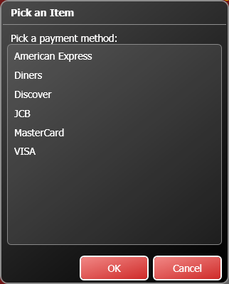

1. Enter the amount the guest is paying. Depending on how your manager has setup the different payment types, enter the total amount (including tip) that the guest is paying, and do not enter the tip separately.

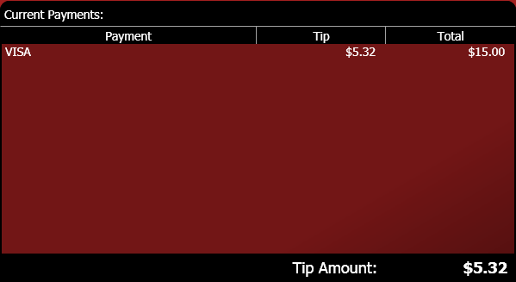

1. Enter any other payments
2. Press **Close Check**.

## To Credit Card (With Integrated Processing)

Follow these instructions to close a credit card order when your location is using Avrio’s integrated processing.

1. On the “Close Order” screen, press **Credit Card** or swipe a card and skip to instruction four.
2. The “Credit Card Authorization” window appears.

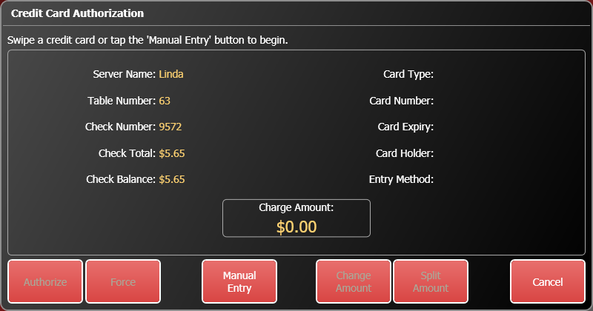

1. Swipe the customer’s card, or press **Manual Entry** to enter the card number and expiry date.
2. Verify that the card information and amount that appear match the card and bill you are working with. Press **Authorize** to start the authorization process. Wait while the authorization takes place.

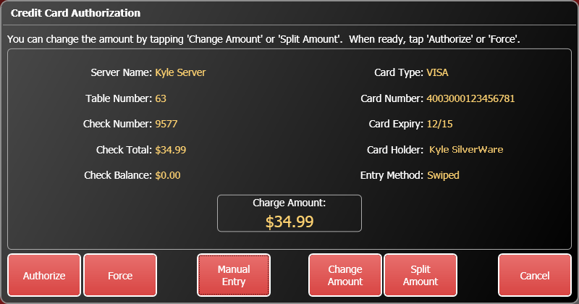

1. When the card is authorized, the “Close Order” screen displays the card type and the last four digits of the card.

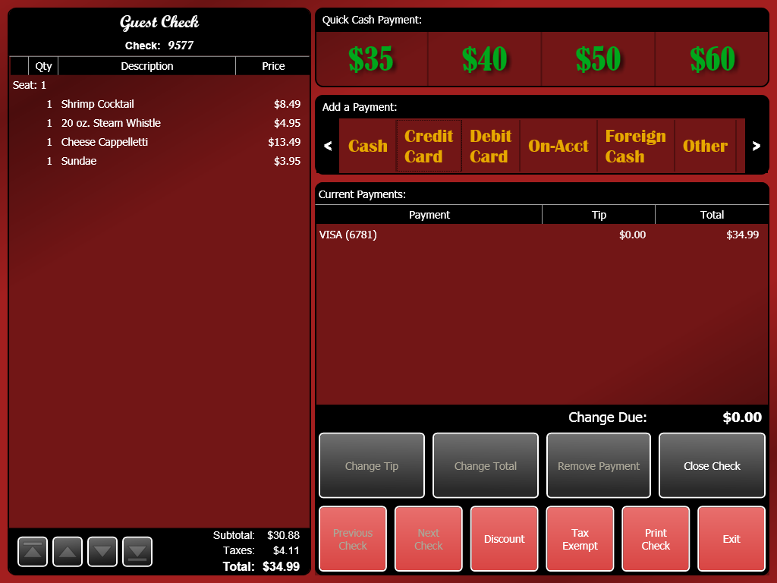

1. Select the credit card payment and press **Change Tip** to enter any tip the customer has added to the total.
2. Press **Close Check.**

## Splitting a Bill that Involves Credit Cards

If you want to accept two or more credit cards or one credit card and other payment methods for a bill:

1. On the “Close Order” screen, press **Credit Card**.
2. The “Credit Card Authorization” window appears.
3. Swipe a card, or use manual entry.
4. Press **Change Amount** to manually enter the amount this card will be paying. If you want to split the amount evenly, press **Split Amount** and enter the number of payments that will be used to pay the bill.

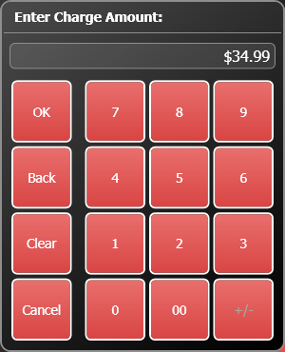

1. Press **Authorize** to begin processing the card. When the card is authorized, the “Close Order” screen displays the card type and the last four digits of the card.
2. Add any tip to the credit card payment.
3. There is still a balance remaining for the other customer(s) to pay. Enter payments using whichever method the customer wants to use until the balance due is $0.00.
4. When done, press **Close Check.**

## Forcing a Payment

If Avrio cannot connect to your processor, you have the option of forcing a transaction.

You will need an approval number, which you can obtain by calling your processor. **NOTE:** If you enter an incorrect approval number, the payment might not properly process a manager tries to close the batch, or your location may have to pay more to process the transaction.

1. On the “Close Order” screen, press **Credit Card** or swipe a card and skip to instruction four.
2. The “Credit Card Authorization” window appears.



1. Swipe the customer’s card, or press **Manual Entry** to enter the card information yourself. You will to enter the card number and expiry date if you enter it manually.
2. Press **Force**.
3. The on-screen keyboard appears. Enter the approval code provided by your processor.
4. When the card is forced, the “Close Order” screen displays the card type and the last four digits of the card as a payment.
5. Select the payment and press **Change Tip** to enter any tip the customer has added to the total.
6. Press **Close Check**.

## Voiding a Credit Card Payment

If you have already authorized a credit card payment, but need to remove it from a bill before it is finalized and closed:

1. Open the order.
2. Select the payment.
3. Press **Remove Payment**.
4. Avrio will communicate with your processor and void the payment.

## To Debit Card

Your manager should provide instructions on using your processor. These instructions show how to ring in the payment as the proper type.

1. Press **Debit** **Card** on the “Close Order” screen.
2. Enter the amount the guest is paying. Depending on how your manager has setup the different payment types, enter the total amount (including tip) that the guest is paying, and do not enter the tip separately.

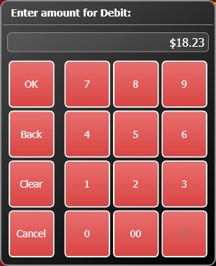

1. Enter any other payments
2. Press **Close Check**.

## To Foreign Currency

1. Press **Foreign Cash** on the “Close Order” screen.
2. Select the currency the guest is paying with.

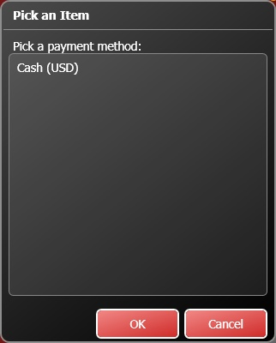

1. Avrio will prompt you, asking how much currency the guest is leaving. The amount is already calculated (including an exchange surcharge, if your location has one), but you can change the amount necessary.

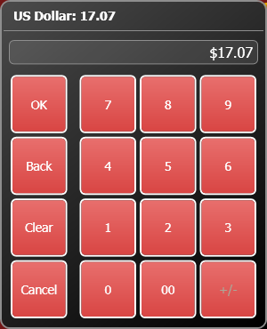

1. If necessary, enter any other payments or tips.
2. Press **Close Check**.

## To a Loyalty Card

Loyalty cards can be either gift cards or cards linked to a client account.

To close an order to a loyalty account:

1. Swipe the card on the “Close Order” screen or touch **Gift Card**.
2. The “Loyalty Authorization” window appears.

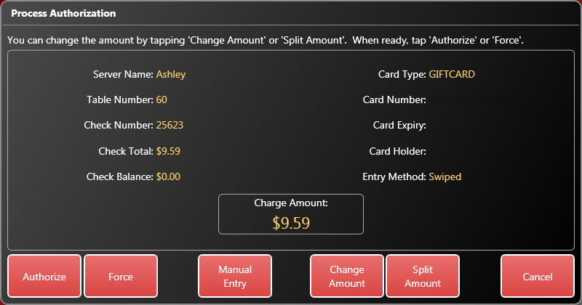

1. Verify that the card information and amount that appear match the card and bill you are working with. Press **Authorize** to start the authorization process. Wait while the authorization takes place.

* In the event the card doesn’t have enough funds to pay the entire bill, the balance available will be authorized and the remaining amount must be paid via another payment method (cash, credit, debit, etc).

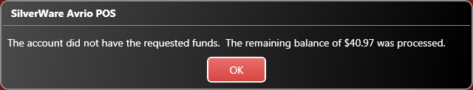

1. When the card is authorized, the “Close Order” screen displays the card type and the last four digits of the card.

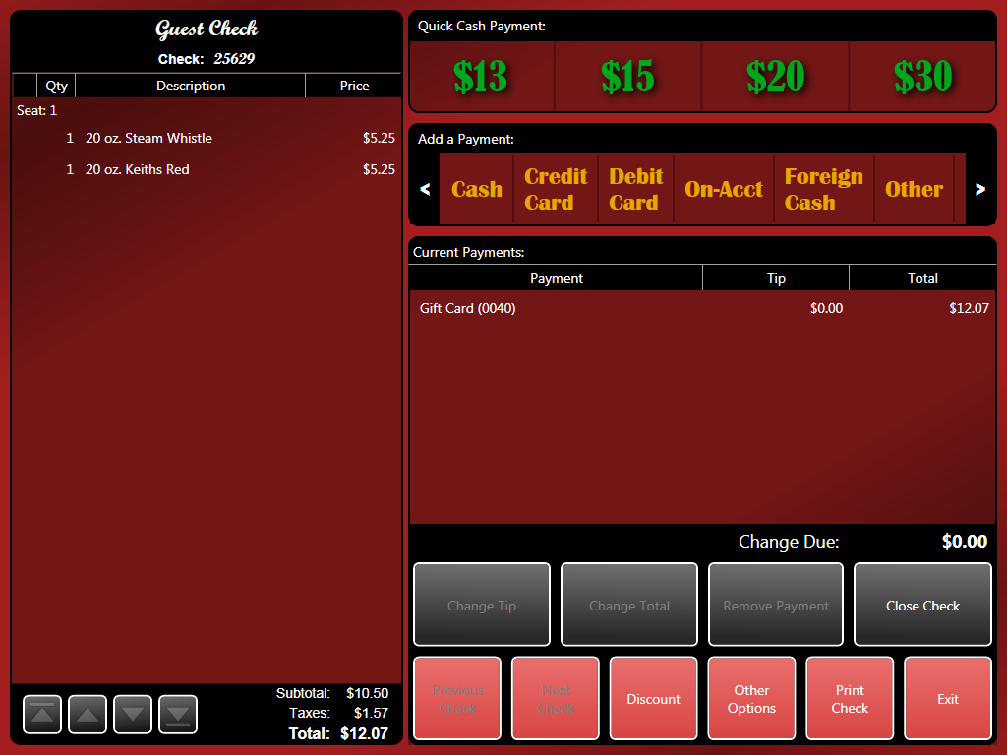

1. After the transaction has been authorized and any additional payments have been entered, press **Close Check**.

### Splitting a Bill that Involves Loyalty Cards

If you want to accept two or more loyalty cards or one card and other payment methods for a bill:

1. On the “Close Order” screen, swipe the loyalty card
2. The “Loyalty Card Authorization” window appears.
3. Press **Change Amount** to manually enter the amount this card will be paying. If you want to split the amount evenly, press **Split Amount** and enter the number of payments that will be used to pay the bill.



1. Press **Authorize** to begin processing the card. When the card is authorized, the “Close Order” screen displays the card type and the last four digits of the card.
2. There is still a balance remaining for the other customer(s) to pay. Enter payments using whichever methods the customers want to use until the balance due is $0.00.
3. When done, press **Close Check.**

### Forcing a Payment

If Avrio cannot connect to the loyalty service, you have the option of forcing a transaction.

You will need an approval code.

1. On the “Close Order” screen, swipe a loyalty card.
2. The “Loyalty Card Authorization” window appears.
3. Press **Force**.
4. The on-screen keyboard appears. Enter an approval code.
5. When the card is forced, the “Close Order” screen displays the card type and the last four digits of the card as a payment.
6. Select the payment and press **Change Tip** to enter any tip the customer has added to the total.
7. Press **Close Check**.

### Voiding a Loyalty Card Payment

If you have already authorized a loyalty card payment, but need to remove it from a bill before it is finalized and closed:

1. Open the order and go to the “Close Order” screen.
2. Select the payment.
3. Press **Remove Payment**.
4. Avrio will communicate with the loyalty service and void the payment.

## To a Client’s Account

1. Press **On-Acct**. If you haven’t already assigned a client to the order, you’ll receive an error. For more information about assigning clients, see this section.

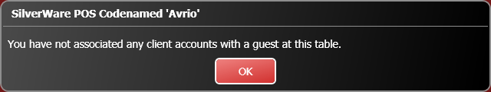

1. Enter the amount being paid on account.
2. If a tip is paid on account, make sure the on-account payment is selected and press **Change Tip**.
3. Press the payment type the tip is paid with. The tip amount appears automatically.
4. Press **Close Check**.

## To Other

1. Press **Other.**
2. Select a tender from the list, then press **OK**.
3. Enter the amount being paid.
4. Enter any required information (a gift certificate number or coupon code, for example).
5. Enter any other payments.
6. Press **Close Check**.

# Index

Adding/Removing Guests, 35

Assigning Clients, 39

From the Close Order Screen, 39

From the Order Screen, 39

Changing Price Levels, 37

Closing Orders, 59

To a Client’s Account, 73

To Cash, 59

To Credit Card, 61

To Debit Card, 67

To Foreign Currency, 68

To Loyalty/Gift Cards, 69

To Other, 73

Discounts, 29

Getting Help, 4

Gift and Client Cards, 40

Integrated Credit Card Processing

Forcing a Payment, 65

Purchases, 62

Splitting, 64

Voiding Payments, 66

Left-Handed?, 4

Loyalty Cards

Forcing a Transaction, 72

Splitting, 71

Voiding, 72

Ordering, 24

Options, 27

Printing Orders

From the Main Menu, 56

From the Order Screen, 58

Sign-in/out, 11

Staff Options, 11

Staff Sales Report, 11

Tax Exemption, 43

The Bar Tab Screen, 8

The Main Menu, 10

The Stay Menu, 6

Transferring Orders, 52

Voids, 33