SilverWare POS Inc.

Contents
Introduction 6
Warranty 6
Getting Help 6
Revision Information 6
Getting Started 7
Left-Handed Users 8
Starting/Recalling Server’s Tables 8
Viewing Open/Closed Orders 9
Rotating the Floor plan 10
Approving Transfers, Discounts, Voids, and Tax Exemptions 12
Menu Item Countdowns 13
Manager Options - General 17
Changing Tenders 19
Reopening Checks/Orders 21
Reprinting Close Stubs 22
System Dates 23
Splitting Dates 23
Changing Dates 26
Manager Options – Configuration 27
Menu Structure 29
Creating/Editing Menus 30
Creating a New Major or Minor Class 30
Major Class – General Options 31
Major/Minor Class – Printing Options 32
Major/Minor Class – Tax Options 33
Major Class – Misc Options 34
Minor Class – General Options 35
Creating a New Menu Group 37
Creating a Normal Menu Item 41
General Tab 43
Questions Area 45
Prices (Item) 46
Prices (Mod) 48
Printing 49
Misc Tab 51
Associations Button 53
Adding Items to Groups & Arranging and Stylizing Buttons 54
Using the Color Picker 59
Gradients 60
Button Styles 61
Saving Styles 61
Applying Styles 62
Questions 63
Creating a New Question 63
Price Levels 65
Creating a New Price Level 65
Applying a Price Level to an Item 66
Rule-based Menu Items 67
Making a Quantity-style Rule-based Item 67
Making a Specific-item Style Rule-based Item 72
Combos 73
Creating a Combo 73
Creating a 2-for-1, 3-for-1, etc, Combo 76
Price Level Combos 77
Menu Schedules 79
Price Levels 82
Menu Groups 83
Menu Items 83
Order Item Requirements 84
Default Menu Group 84
Mirada Menu Board Module 85
Employees 86
Personal Information 86
Security – Operational 87
Security – Managerial 89
Security – System 91
Security – Screens 92
Groups 94
Jobs 95
Misc. 97
Creating Jobs 99
Jobs Creation 99
Clients and Gift Cards 100
Creating a Client 101
Misc. 103
Members 105
Preferences & Fields 106
Adding a Gift Card 108
Loading a Gift Card 108
Themes 110
Theme Settings 111
Coupons 112
Modifying Floorplans 113
Editing/Creating/Moving Tables 114
Selected Table 115
Floorplan Settings 116
Payment Methods 118
Discount Reasons 121
Void Reasons 123
Pay-In\Out Reasons and Blind Drops 124
Gratuities 125
Order Item Requirements 127
System Settings 128
General 128
Courses 136
Printer Centers 137
Peripherals 138
Service Types 140
Stations 144
Taxes 147
Coupons 151
Roles 148
Subtotal Groups 149
Security Groups 151
Clock-In/Out Times 155
Manager Options – Maintenance 156
Performing Refunds 159
Working with Integrated Credit Cards 161
Closing Orders to Credit Cards 161
Splitting a Bill that Involves Credit Cards 163
Forcing a Payment 164
Voiding a Credit Card Payment 165
Settle Credit Cards 165
Working with Loyalty Cards 167
Viewing a Card’s Information 167
Splitting a Bill that Involves Loyalty Cards 168
Forcing a Payment 169
Voiding a Loyalty Card Payment 169
Points, Coupons, and Frequent Diners 170
Setting up a Menu Item to Offer Points 171
Creating Clients that Can Earn Points 173
Assigning a Client to an Order 174
Creating Coupons 175
Issuing Coupons 176
Redeeming Coupons 178
Meal Plans 179
Setting Up Meal Plans 179
Using Meal Plans 182
Assigning Clients to an Order 182
Languages 183
Index 184

Introduction
SilverWare Avrio is a powerful restaurant-management tool operated through a touch-screen interface. This guide is intended for users with access to managerial functions. Since it is possible (and likely) that users will have access to some managerial options, make sure they have access to the necessary portions of this guide.

Warranty
SilverWare POS Inc. makes no warranty of any kind with regard to this material, including but not limited to, the implied warranties of merchantability or fitness for a particular purpose. SilverWare POS Inc. shall not be liable for errors contained herein or for incidental consequential damage in connection with the provision, performance or use of this material.
This document contains proprietary information protected by copyright. All rights are reserved. No part of this document may be reproduced, stored in a retrieval system, transmitted in any form or by any means, electronic, mechanical, photocopy, recording or otherwise, or translated into another language without the prior written consent of SilverWare POS Inc. The information contained herein is subject to change without notice.

Getting Help
SilverWare’s office is located in Ontario, Canada and operates under Eastern Standard Time. If you wish to ask a general question, please call 905-305-1225 during normal business hours, Monday – Friday 9:00 am to 5:00 pm.
If you need technical assistance, please contact our Technical Support call center, which is open 24 hours a day, 7 days a week.
Telephone: 1-888-510-5102
Fax: 1-905-305-1810

Revision Information
Name | Title | Date of Update | Summary of Changes
Kyle Schroer | Technical Writer | 01/15/10 | Added section on meal plans
Kyle Schroer | Technical Writer | 02/17/10 | Added screenshot and details about client preferences
Kyle Schroer | Technical Writer | 06/22/10 | Updated with coupon and point information
Kyle Schroer | Technical Writer | 10/04/10 | Updated screenshots and functionality descriptions
Kyle Schroer | Technical Writer | 09/23/13 | Updated screenshots and functionality descriptions
Kyle Schroer | Technical Writer | 01/03/18 | Updated screenshots and functionality descriptions

Getting Started
Before performing any action, all users must identify themselves to the system using a numeric password, a swipe card or a fingerprint scanner (also known as a bio-metric device). If you want, a user can have a combination of these methods. For example, an employee can enter a numeric password if they’ve lost their card.
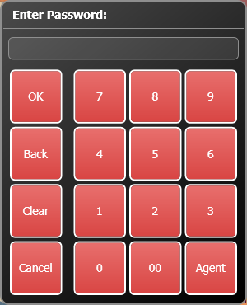
Managers need to have an administrative password to access some areas within “the Manager Options” section of the software. A SilverWare agent or dealer must setup a password for a manager/owner so they can access these areas. From that point, the manager/owner can create employees and give them access to Avrio components necessary to their role in the location.

The administrative password must follow these rules:
- Must be at least 8 characters.
- Have at least one each of these criteria:
  - Lowercase letters
  - Uppercase letters
  - Number or Symbol

Left-Handed Users
If you or another user requires Avrio to run in left-handed mode:
- On the main screen, touch Manager Options.
- Touch the “Configuration” tab.
- Touch Employees and enter your administrative password.
- Select the user from the list on the left.
- In the “Personal Information” section, set “Handedness” to “Left-Handed”

Starting/Recalling Server’s Tables
As a manager, you can start an order on behalf of a server, and you can recall an order even if you didn’t start it.
- Press Order, then touch an empty table, or simply touch an empty table.
  - Touch an occupied table to recall an order.
- Enter your ID.
- Unless you’ll be serving the guest, press Yes to order on behalf of a server. Select the server from the list. Press OK. Continue the ordering procedure as normal.
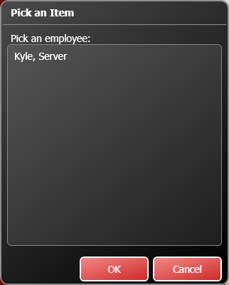

Viewing Open/Closed Orders
As a manager, you can view a list of your/all open or closed orders for the current shift, or the entire day. You can also recall, print, or pay orders. This screen is a great way to find any open orders that you cannot see on a floor plan.
To view the orders:
- On the main screen, press Order, and then enter your password.
- Press All Orders.
- A window appears, allowing you to choose which orders you’d like to view.
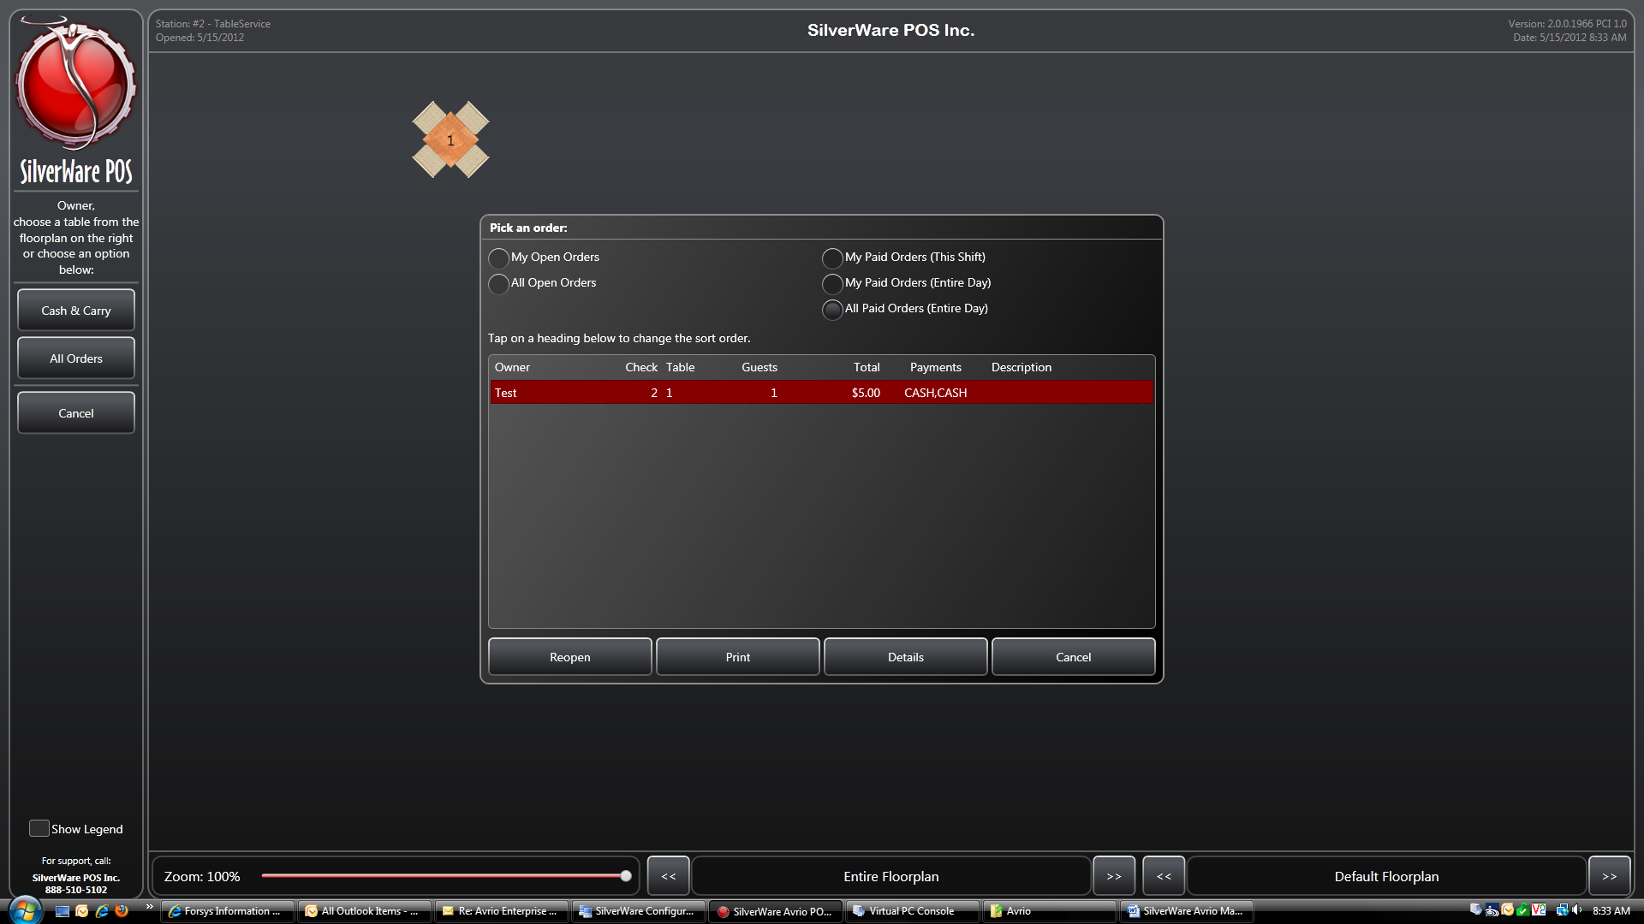
- Owner – The staff member in charge of the order
- Check – The check #.
- Table – The table #.
- Guests – The number of guests.
- Subtotal/Total – The order’s subtotal/total
- Payments – Any payments applied to order
- Description – Any description attached to the order (usually a bar tab name or quick-service order name)

Rotating the Floor plan
Avrio lets you rotate the floor plan, so your stations will always display the correct layout of your restaurant regardless of where they are placed.
- Touch the floor plan name at the bottom of the main screen.
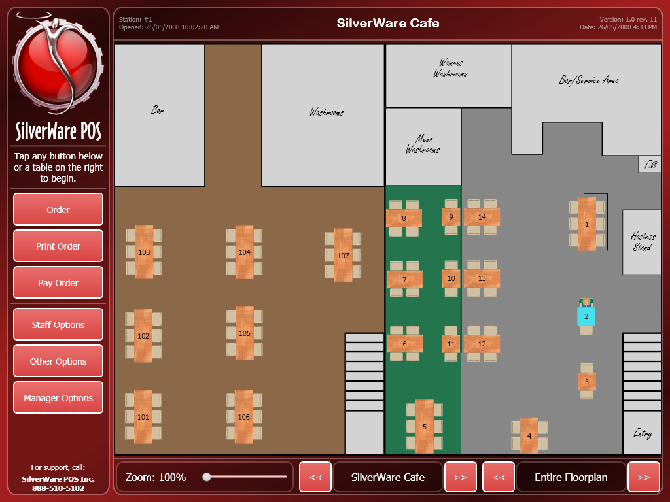

- It will change to Rotate.
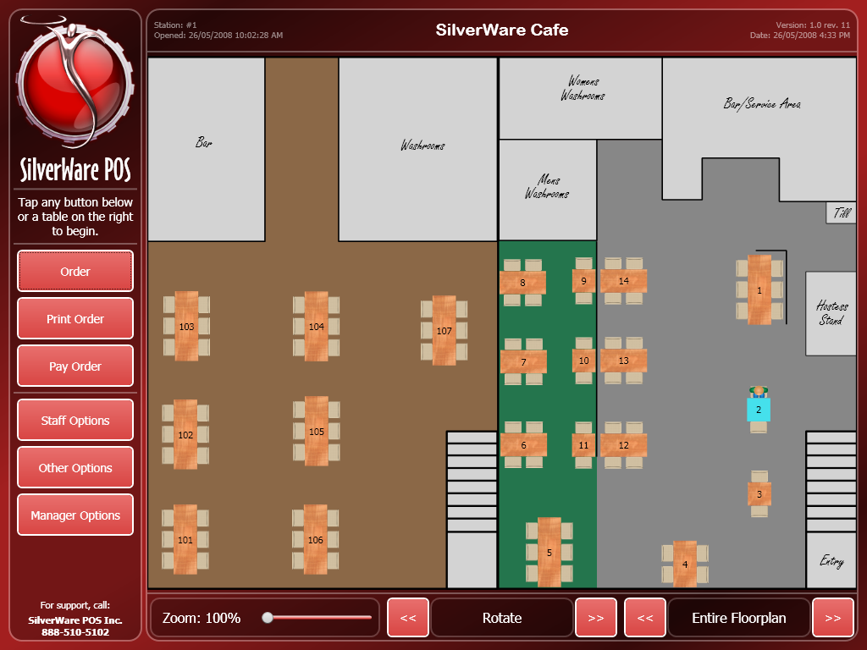
- Press the << and >> buttons. The floor plan rotates 90 degrees each time you press a button.
- Press Rotate to switch the button back to the name of the floor plan.

Approving Transfers, Discounts, Voids, and Tax Exemptions
As a manager, you may be required to approve a variety of actions. Some may just ask for your password (such as signing users in/out), but others, such as voids, discounts, and tax exemptions take a few more steps.
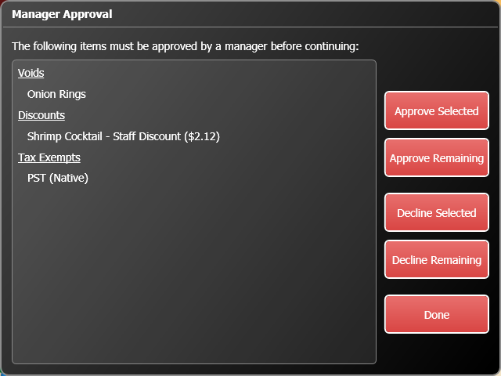
You can approve/decline all the items by pressing Approve Remaining or Decline Remaining. Or you can select specific items and approve/decline by pressing Approve Selected or Decline Selected. You will then have to enter your password.

Menu Item Countdowns
Once you’ve created menu items (described later in this manual), you can setup a countdown on each item. As the item is ordered, its quantity diminishes by one. This feature is often used for bottled beer or bottles of wine, or items where the quantity is easily defined.
To setup a countdown:
- From the main screen, press Other Options.
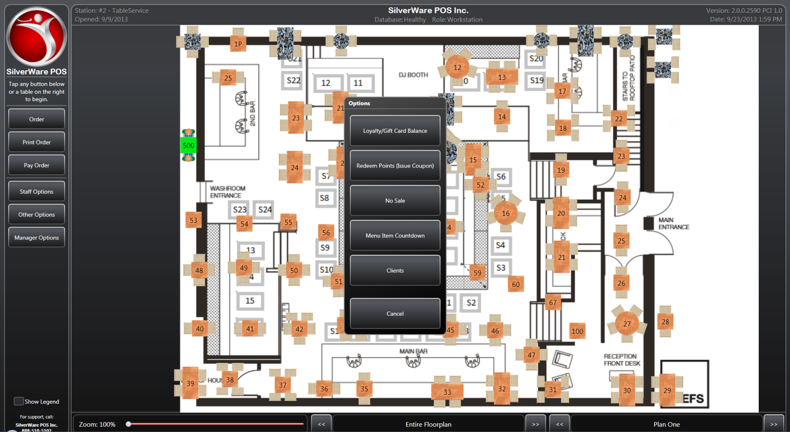
- Select Menu Item Countdown.
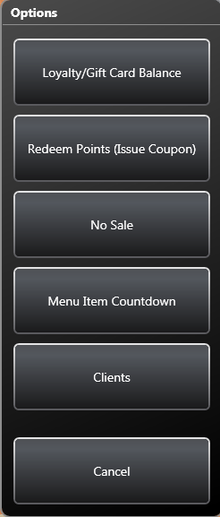

- You can place a countdown on an item by pressing Add Item.
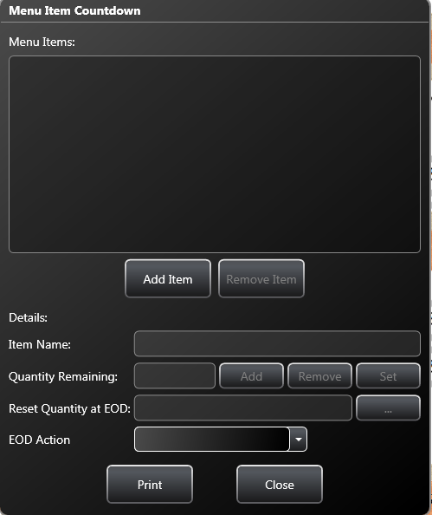
- Select an item from your list of menu items and press OK.
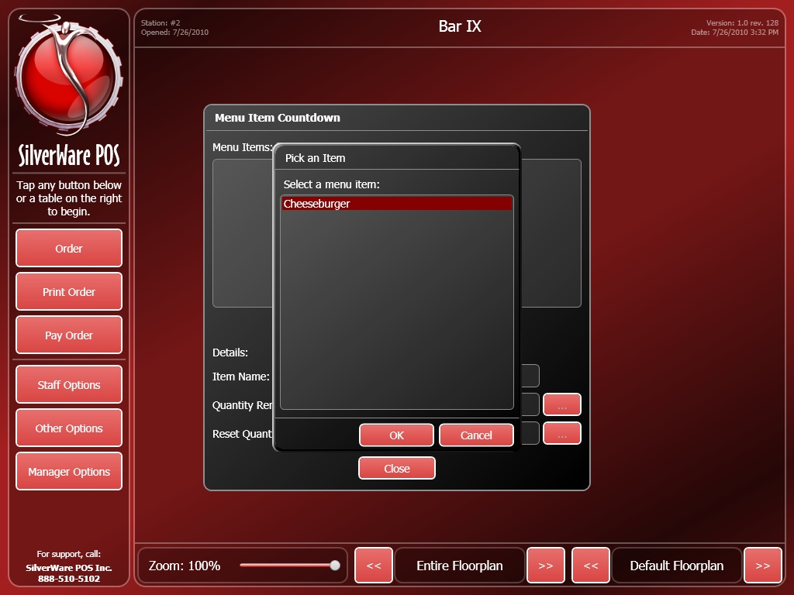

- Once an item has been placed on countdown, you can modify some of its countdown details.
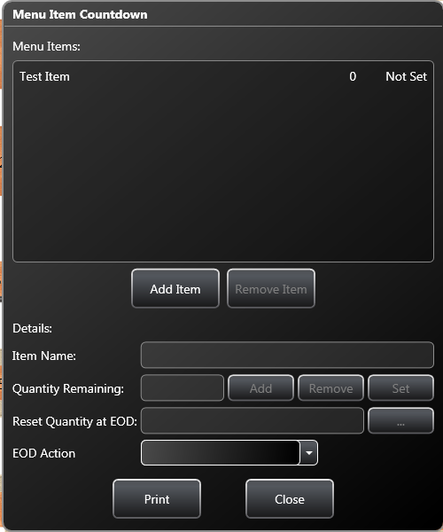
- Quantity Remaining shows you how many of the item you have left. You can use Add, Remove, or Set to modify this quantity.
- Reset Quantity at EOD determines if the quantity resets upon an end-of-day. You will be prompted to enter the quantity that the item will start at when starting a new day.
- EOD Action determines if any actions are taken to this item’s countdown status at end-of-day. You can remove it from countdown, leave it alone, or have it reset the quantity remaining to the # specified in the “Reset Quantity at EOD” area.

Manager Options - General
This area contains managerial functions, and gives you access to your reports, which provide you with important information about your sales, employees, clients, etc.
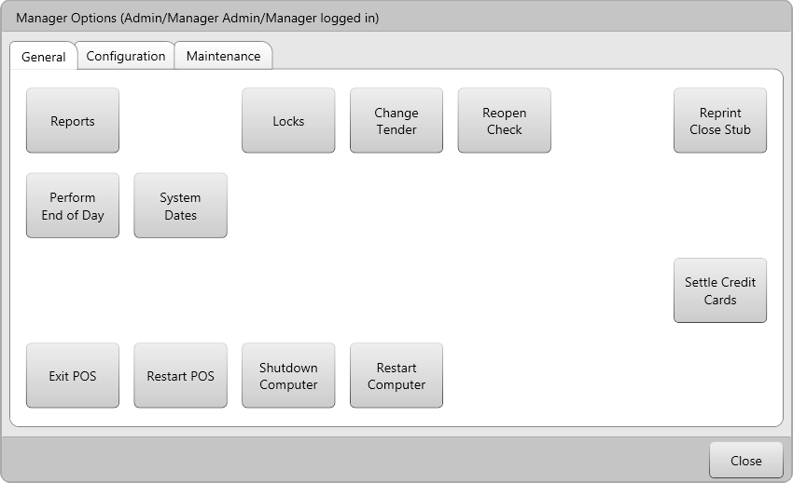
- Reports allows you to see and print a variety of reports and information.
- Locks lets you see the status of the various stations in your restaurant
- Change Tender lets you change the tender accepted for a check.
- Reopen Check lets you reopen a closed check.
- Reprint Close Stub lets you reprint the stub that prints when a check is closed.
- Perform End-of-Day shuts down the system, prints any necessary reports and server reads, performs system/database maintenance, and prepares the system for the next day.
- System Dates lets you check various open and close times, and lets you split a date if an EOD wasn’t performed when it was needed.
- Exit POS closes Avrio and allows you to perform typical Windows functions on the computer.
- Restart POS closes Avrio and then starts it back up. Useful for clearing odd glitches/error messages.
- Shutdown Computer exits Avrio and shuts down the system.
- Restart Computer exits Avrio and restarts the system.
- Settle Credit Cards allows you to finalize and settle batches when using Avrio’s integrated credit card processing (when you are swiping credit cards through a card-reader attached to the POS station).

Changing Tenders
If the wrong payment method was entered while closing a check, you can quickly change it without reopening the check.
- Touch Manager Options.
- Touch Change Tenders.
- Enter the check number. Press OK.
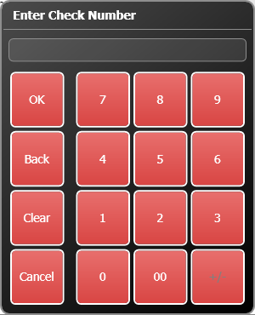

- The “Close Order” screen appears. Select a payment, then press one of the tender buttons to change it, or use Remove Tender to remove that payment.
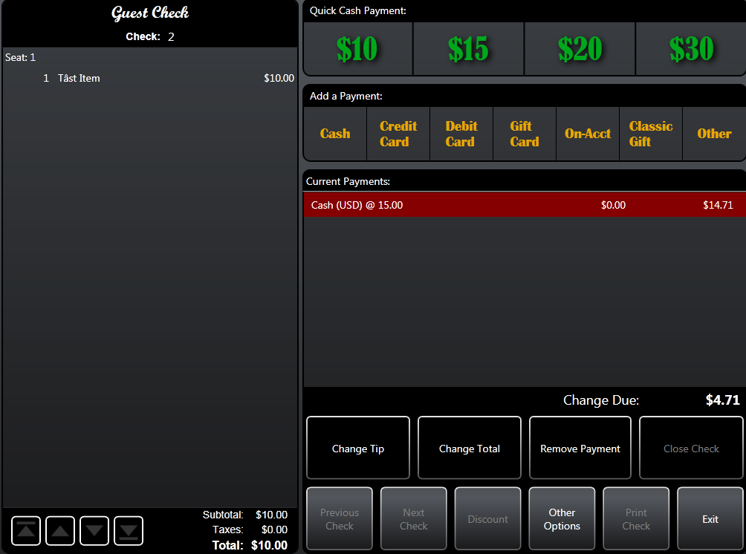
- Press Exit. Save the changes.

Reopening Checks/Orders
- Touch Manager Options.
- Touch Reopen Check.
- Enter the check number. Press OK.
- You will be asked to confirm your selection. Also, if the check was part of a split order, you will be asked to reopen only the one you want, or all the related checks.
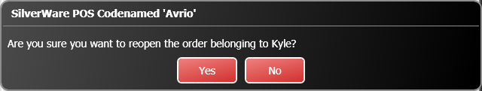
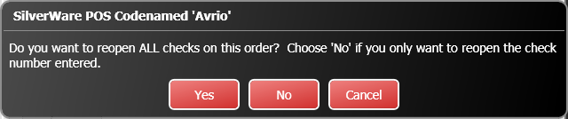
- The order is reopened at the same table. Only the original server or a manager/owner can access the order (unless the table is transferred to a new server). Note: any payments made on the order are still applicable when the order is reopened.
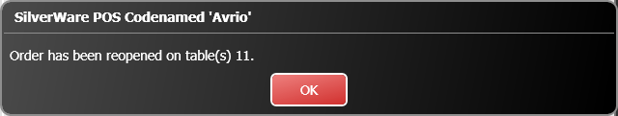

Reprinting Close Stubs
- Touch Manager Options.
- Touch Reprint Close Stub.
- Enter the check number. Press OK.

System Dates
The “System Dates” section lets you see and edit the various dates/times that your system was opened for business and when EODs were run, and you can insert new breakpoints if an end-of-day was missed.
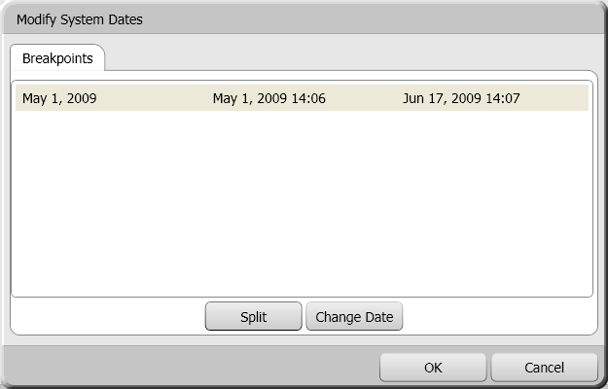The
The window is laid out like this:
Business Date | Date and time (24-hour clock) the system was opened. | Date and time (24-hour clock) the system was closed.

Splitting Dates
The “Split” function lets you insert an EOD so that sales data is moved to the following day. This function would normally be used when an EOD was not run after a location closed, and the next day’s sales have incorrectly become a continuation of the previous date.

To split a date:
- Select the entry you wish to modify.
- Press Split. This window appears:
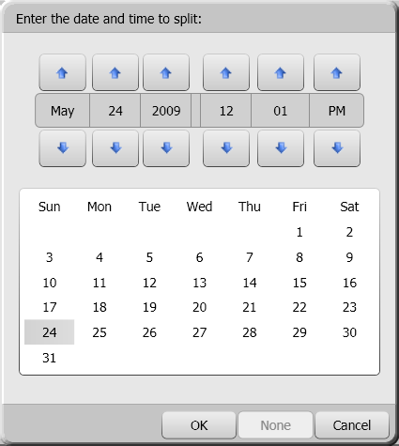
- Select the date and time you want the split to occur using the calendar and buttons.
- Press OK after you have selected the correct date/time.

- A new breakpoint is added and the appropriate sales data is moved to your new date/time.
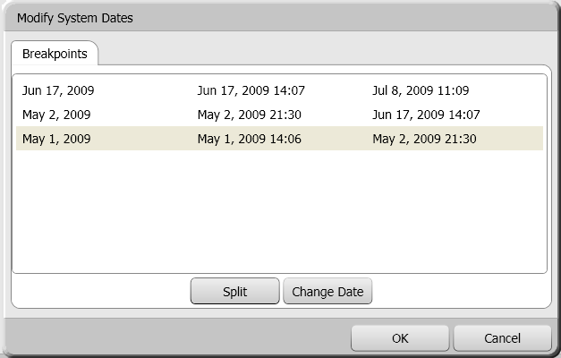
- Press OK in the “System Dates” screen to commit the changes. Make sure you understand the warning before pressing OK once more.
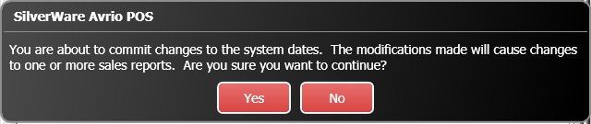

Changing Dates
You can use the “Change Date” to feature to change the business date connected to an opening and closing time.
To change a date:
- Select the entry you wish to modify.
- Press Change Date. This window appears:
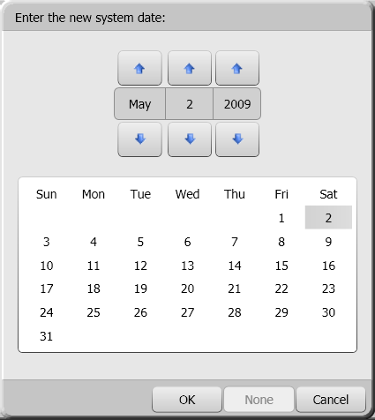
- Select a new date
- Press OK after you’ve selected a date.
- Press OK in the “System Dates” screen to commit the changes. Make sure you understand the warning before pressing OK once more.

Manager Options – Configuration
This menu lets you configure a variety of settings for your store.
To access the “Configuration” screen:
- Touch Manager Options on the main menu.
- Enter your ID.
- Touch the “Configuration” tab.
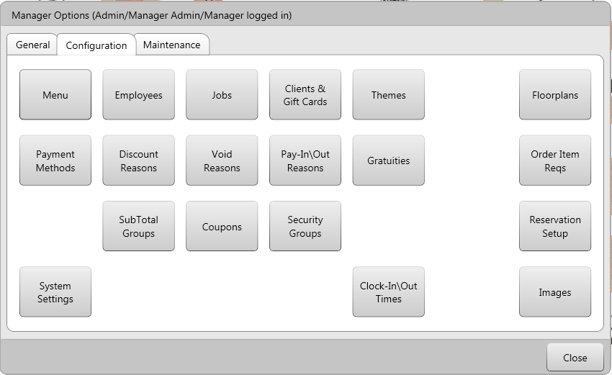

- Menu lets you create and edit menus, classes, groups, items, questions, and price levels.
- Employees lets you create/edit/deactivate employees. Requires administrative password.
- Jobs lets you create job roles and hourly wage rates that can be assigned to your employees. Requires administrative password.
- Clients & Gift Cards lets you add/edit/deactivate clients and their sub-members. Gift card management is also found here.
- Themes lets you customize Avrio’s colour scheme
- Floorplans lets you edit your floor plan by adding/removing tables, seats, etc.
- Payment Methods lets you add, edit, and deactivate the payment types you accept.
- Discount Reasons allows you to create/edit/deactivate discounts.
- Voids Reasons lets you create/edit the different reasons servers can choose from when voiding items/orders.
- User Reasons lets you setup employee commission reasons.
- Pay-In\Out Reasons lets you create/edit the reason your staff will use for pay-ins and pay-outs.
- Gratuities lets you setup gratuities that servers can apply to checks.
- Order Item Reqs lets you setup criteria that have to be fulfilled before an order can be sent/printed/closed.
- SubTotal Groups lets you create groupings that will appear on guest checks. You can use these groups to have food and liquor items show as separate totals on a single guest check.
- Coupons lets you create coupons that can be issued to customers or used in random coupon generation.
- Security Groups lets you create “groups” to assign to parts of your menu. You can then assign these groups to your staff to allow/deny access to editing these parts of your menu.
- Reservation Setup lets you configure your reservation system. See the Reservation Guide for more information.
- System Settings lets you change a variety of options. Requires administrative password.
- Clock-In/Out Times lets you modify employee’s shifts/jobs.
- Images lets you import picture and assign them to menu items. The assigned images can then be used with SilverWare’s online-ordering system.

Menu Structure
This is how Avrio’s menu structure is arranged:
A Menu contains all your classes, groups, and items. You can have multiple menus for one location, perhaps for different areas within the restaurant, different daily menus, or for special occasions.
Some examples of Major Classes are “Food” or “Liquor.” You can apply taxes and print settings to a major class, and the minor classes within it can inherit them.
Some examples of Minor Classes would be “Breakfast” or “Domestic Draught.”
Menu Groups appear on the “Order” screen. Examples might be “Pasta” or “Cocktails”. You can have groups within a group as well, allowing your servers to jump between groups without returning to the main menu. You only have to make a group once, but you can change the appearance of its button for the different places it appears in your menu (this is applicable to items as well).
Menu Items are the actual items customers can order. They must be assigned to a minor class, and they must be placed within a menu group or a question to be visible/available (unless they are price-rule items or combos). Examples might be “Carbonara” or “Classic Martini.”
Questions allow menu items to be modified, but also contain menu items. For example, you might offer a baked potato, mashed potatoes, or rice as a side dish with a meal. Those three items have to be created, and then you can create a question that offers them when a customer orders an item. You may also use a question to determine how an item should be prepared, i.e. you may have a question that asks how a meat item should be prepared, with “Rare,” “Medium,” and “Well-done” being the possible answers.
Price Levels allow you to quickly charge a different price for an item without having to change the price in the menu designer. You might have different levels for VIPs, for delivery service, or for lunch.

Creating/Editing Menus
To create a new menu:
- Go to Manager Options Configuration Menu.

Creating a New Major or Minor Class
- Go to Manager Options Configuration Menu.
- The “Menu Designer” screen appears.
- Press Classes.
- Use the New and Remove buttons to create/erase classes.
  - You must select a major class before you can create a minor class within it.
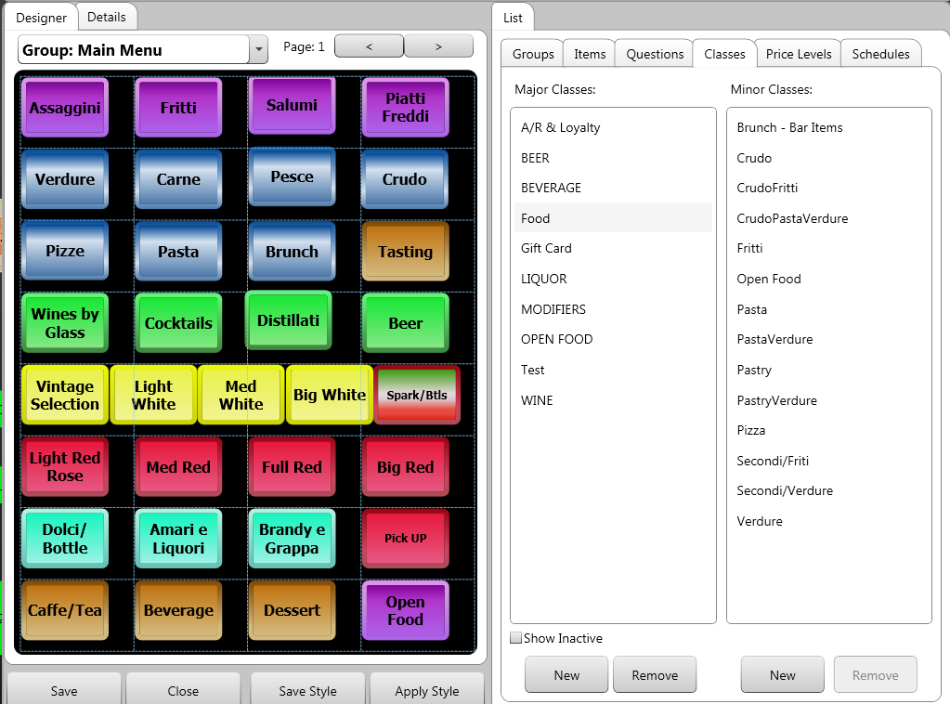

Major Class – General Options
In the “General” section you can:
- Name the class.
- Interface ID lets you specify an ID that can be used in programs that are integrated with Avrio (Optimum Control, for example).
- Inherit Point Per Dollar – This is related to the frequent diner point system and is covered in another document.
- SubTotal Group - If you are printing separate food/beverage/liquor/etc subtotals on your guest checks, select one of those groups from this drop-down box so that items reporting here will show their $ values in the appropriate group on a guest check.
- Course is used to determine which course this item is affiliated with, when using Avrio’s hold & fire system.
- Active lets you activate/deactivate the class
- Set it as Not a Sales Class if this class contains gift cards or other merchandise that isn’t food or drink.
- Choose a Security Group to allow/deny people rights to edit items belonging to this class.
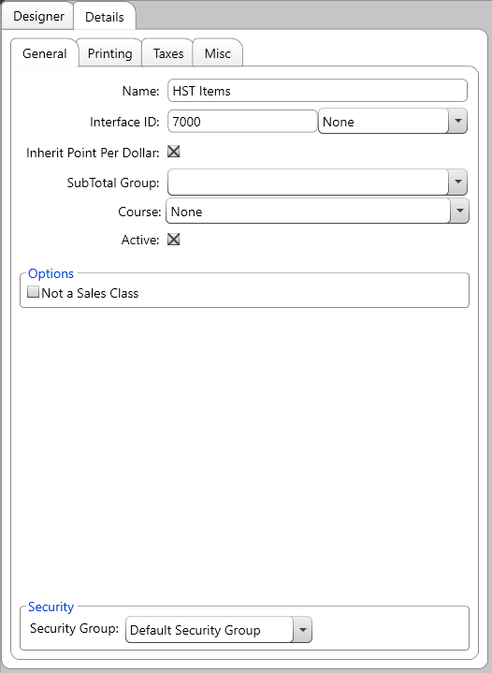

Major/Minor Class – Printing Options
You can set a default printing location for menu items that report to a particular class. By default, minor classes inherit these printing locations from their major class, and menu items inherit their printing location from their minor class.

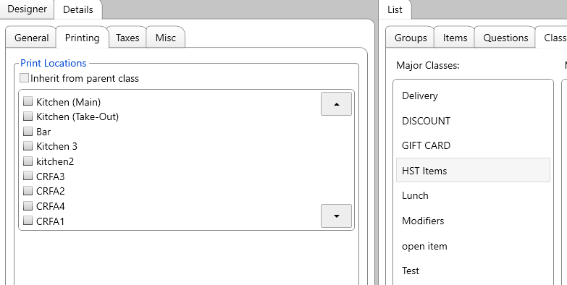

Major/Minor Class – Tax Options
You can set default taxes for menu items that report to a particular class. By default, minor classes inherit tax settings their major class, and menu items inherit their tax settings from their minor class.

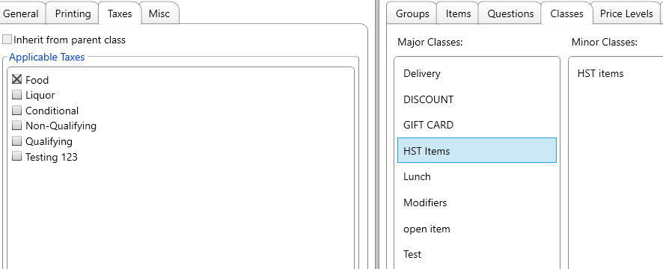

Major Class – Misc Options
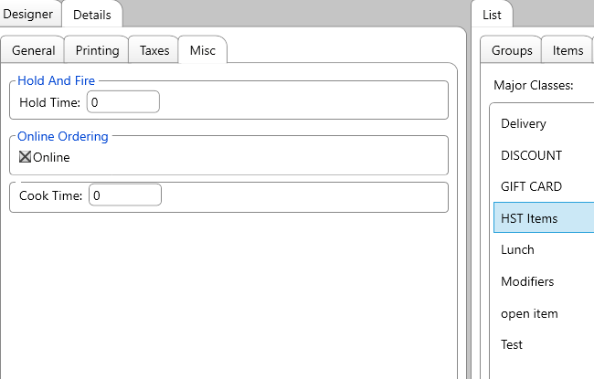

Hold Time – If you are using the Avrio hold & fire system and want items to automatically fire to the kitchen based on their class, set that time value here (in seconds)
Online Ordering – If you are using Avrio’s online-ordering system, this checkbox is used to determine if menu items reporting to this class will be available for online orders.
Cook Time is used when integrating with KDS software, such as QSR CSK. Enter the time it takes to prepare menu items in this class (in seconds). These times are sent to the KDS and are used in determining when a menu item should become visible on a screen for cooks to make them.

Minor Class – General Options
A minor class has some different options within the “General” tab.
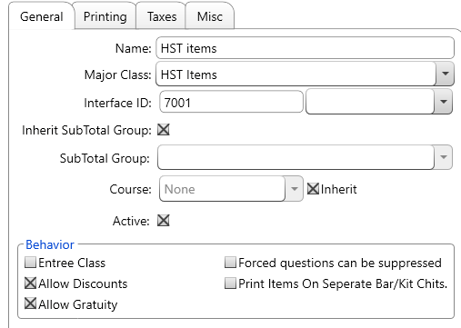
- Name displays the name of the minor class. You can change the name.
- Major Class lets you change a minor class’ reporting assignment.
- Interface ID is used with a variety of software exports and integrations.
- Inherit Subtotal Group determines if sales of items in this minor class should display on a guest check with the same subtotal group as the major class it is a part of. When turned off, you can manually set a Subtotal Group in the drop-down box below.
- Course determines which course the items reporting to the class are a part of, when using Avrio’s hold & fire module.
- Active determines if the class is active or not. You cannot add more menu items to an inactive course.
- Entrée Class determines if items in this class are considered “entrée items.” If so, they are used in the timing calculations for table indicators (late ordering entrée, for example). See the Table Indicators section for more details. There is also reporting available on the # of entrée items sold.
- Allow Discounts determines if items in this reporting class can be discounted or not (must be turned on for meal plans items)
- Allow Gratuity determines if items in this reporting class are used when calculating auto-gratuities (gratuities that are placed on the bill like a tax and charge a percentage of the total)
- Forced Questions can be suppressed determines if any forced questions (meat temperature, liquor prep, etc) applied to items in this class will be suppressed on any station that is set to suppress forced questions.
Often used at bar stations where the bartender shouldn’t be prompted by Avrio as to how to prepare a drink.
- Print Items on Separate Bar/Kit Chits determines if items reporting to this class will be printed on their own chits, even if ordered together and sent to the kitchen at the same time.

Creating a New Menu Group
- Go to Manager Options Configuration Menu.
- The “Menu Designer” screen appears.
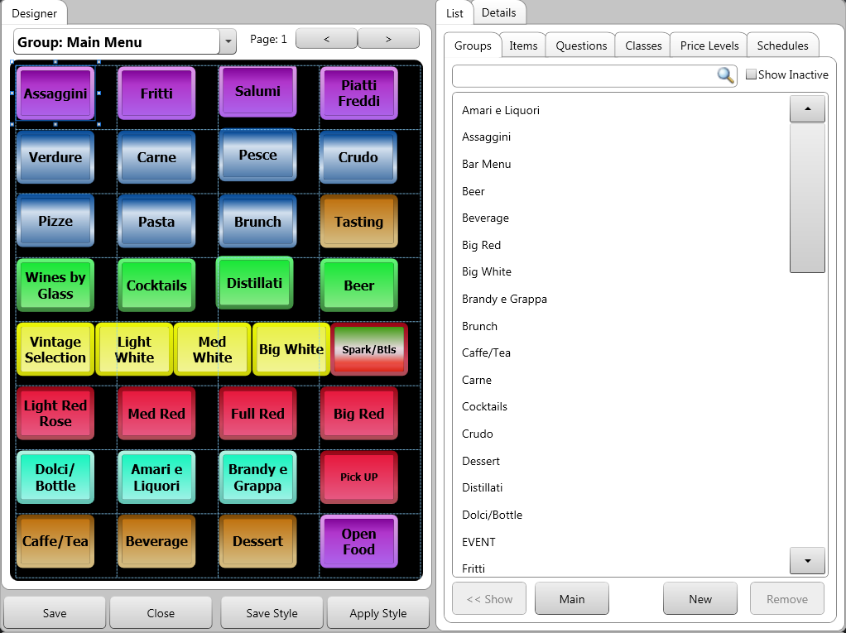

- Press Groups.
- Press New.
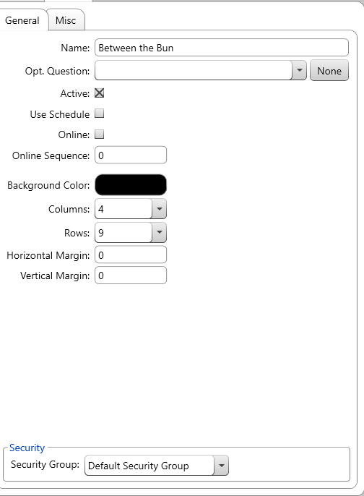
- Type in a name for the group.
- You can enter an optional question (see the section on creating questions) for all items in the group. Servers can access the question on the “Order” screen by selecting the group, then pressing the Modifiers button at the bottom of the screen.
For example, this is where you might place your “No” (No Onions, No Spice, etc) or “Extra” (Extra Cheese, Extra Sauce, etc.) options. For greater customization, you can even place questions within this optional question.
- Use the active checkbox to make this group active/inactive
- If you do/don’t want this group to only be available according to a schedule (see Schedules later in this document), turn this check-box on or off.
- If you do/don’t want this group and the items within into only be available for online orders, turn the Online checkbox on/off
- Select the background color that appears when this group is showing on the “Order” screen. See the section on Using the Color Picker.
- The “Columns” and “Rows” options let you customize how many buttons can fit inside the group. By setting these how you’d like, Avrio will show a grid in this group, and will let you resize and snap buttons to the grid.
- The “Horizontal/Vertical Margins” options let you set margins for this group. They are measured in pixels.
- The “Security Group” drop-down lets you make this group accessible only to staff that have access to the same security group (this is configured through the “Groups” and “Employees” areas of Manager Options).
- Under the “Misc” tab, the “Associations” button lets you see which other groups/questions you have placed this group inside.
- Now, press and drag the new group to the menu. To place it within another group, you first have to select an existing group from the list, then press Show, or you can select an existing group from the drop-down box at the top of the page

- The “Appearance” tab appears when you’ve selected the button, and lets you edit the text that appears on the button, as well as modify the button’s colors and border. See the section on Using the Color Picker.
If you placed the button incorrectly, press Remove Button.
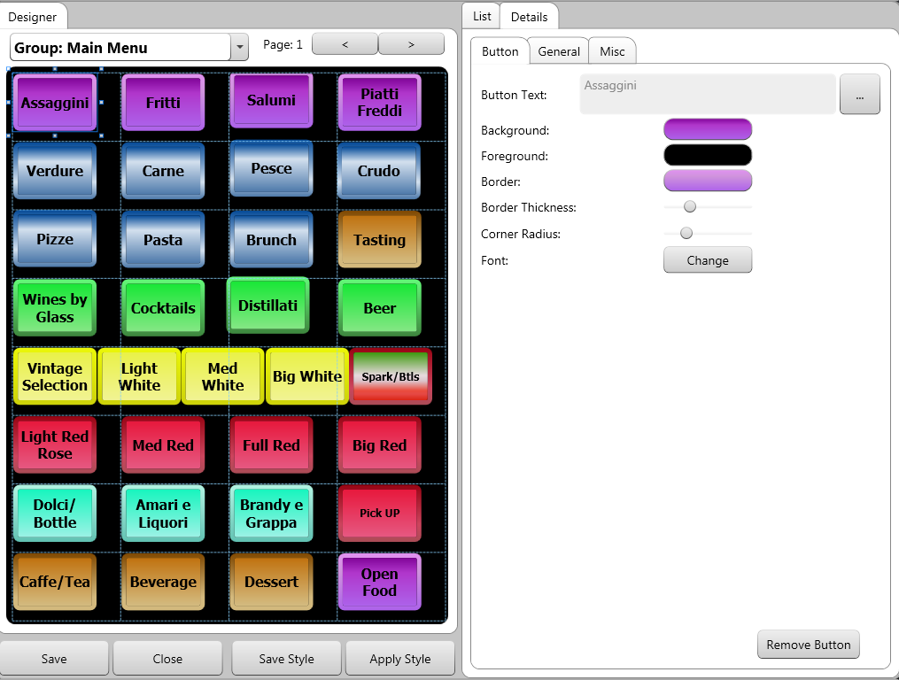

Creating a Normal Menu Item
- Go to Manager Options Configuration Menu.
- Touch the Items tab.
- Press New.
  - If you want to copy the price and question properties of an existing item to a new item, select the existing item and press “Duplicate.”
- Choose a minor class for the item. This also determines which major class the item is a part of. For example, “open item” would be the minor class, and “Food” would be the major class.
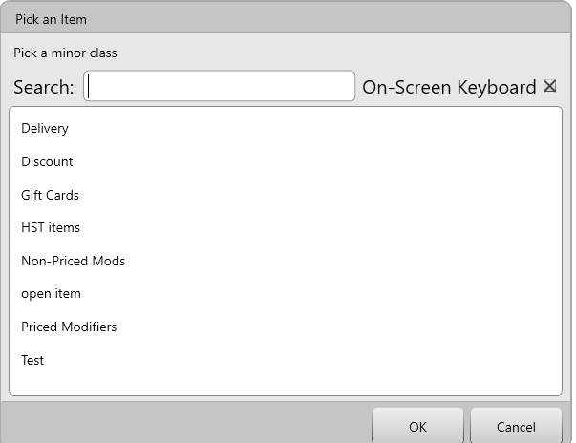
- Fill in the information in the “General,” “Prices (Item),” “Prices (Mod),” and “Printing” sections. “Questions” only has to be filled out for items with side dishes, sizes, temperature/flavor, or other forced modifiers. See the section on Questions for more information.

General Tab
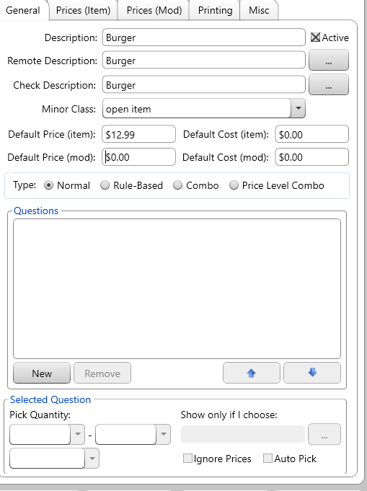
- Description is the name that appears throughout Avrio.
- Remote Description is what appears on the kitchen/bar/remote printers (Use the … button to copy the name from the “Description” field).
- Check Description is what appears on the guest check (Use the … button to copy the name from the “Description” field).
- Minor Class is the category that the item reports to in sales data.
- Default Cost (Item) is the cost (to the restaurant, not the customer) of the item when/if it’s ordered as an entrée.
- Default Cost (Mod) is the cost (to the restaurant, not the customer) of the item when/if it’s ordered as a modifier.
- Active determines if the item is active/inactive. An inactive item still appears in the menu, but is translucent and cannot be ordered.
- Type is the type of item:
  - “Normal” items can have questions/modifiers (which may have price themselves), but don’t require additional information to determine a price.
  - “Rule-Based” items are placeholders. They appear on the menu, but are actually links to the priced items.
For example, if you offer a variety of steak sizes, the server will press the “Steak” menu item, which has no price. The server will then be asked which size to order. Once a size has been selected, one of the different steaks you’ve created (but doesn’t appear on the menu) will be selected. See the section on Rule-Based Items for more information.
  - “Combos” detect when a certain combination of items are ordered, then they apply a price for that group of items, instead of the individual price for each item.
For example, your location may have a combo that allows a guest to choose one sandwich, one side, and one beverage at better price than if they were priced individually. See the section on Combos for more information.
  - “Price Level Combos” detect when a certain combination of items is ordered, and the modifies the prices of those items. This is typically used for a “Prix Fixe” menu. I.E. You may have an app that is normally $13, a main that is usually $25, and a dessert that is $15 dollars. If you set up a “price level combo” you can have those three items come to a total of $48 instead of $53 (13+25+15)

Questions Area

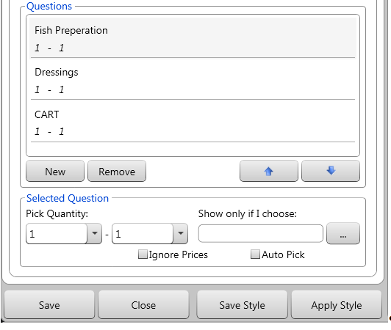

- Press New or Remove to add/remove a question/forced modifier to the item.
- Use the arrows to set the order that the questions will be asked.
- Use the “Pick Quantity” options to allow a server to pick more than one answer. For example, if a customer can choose one side-dish, use 1-1. 1-2 means the customer can have one or two sides, 2-2 means the customer must pick two, etc. Leave the first number as 0 if the customer isn’t required to pick anything at all.
- Use “Show only if I choose” to show a question only when a certain option is chosen in a previous question. For example, if you have a question offering a variety of salads (Caesar, Greek, and House), add a question that shows the dressing options. Select the dressing question, and then press the … button. From the menu that appears, select the “House Salad” item (as Caesar and Greek salads already have a certain type of dressing).
NOTE: In most cases, it will probably just be easier to attach the “Dressing” question to the house salad, so it will appear every time the house salad is ordered, regardless if it is ordered on its own, or as an answer to a question.
- Ignore Prices ignores the price the modifiers normally have, changing them to $0.00 when being used to modify this item.
- If Auto Pick is on, the server won’t have to make any selections; all modifiers in the question will be ordered automatically.

Prices (Item)
Generally you’ll be able to set prices for the majority of your items back on the “General” tab. However, if you want to see more details about your items’ pricing, or add different price levels to an item, you may look in this area.
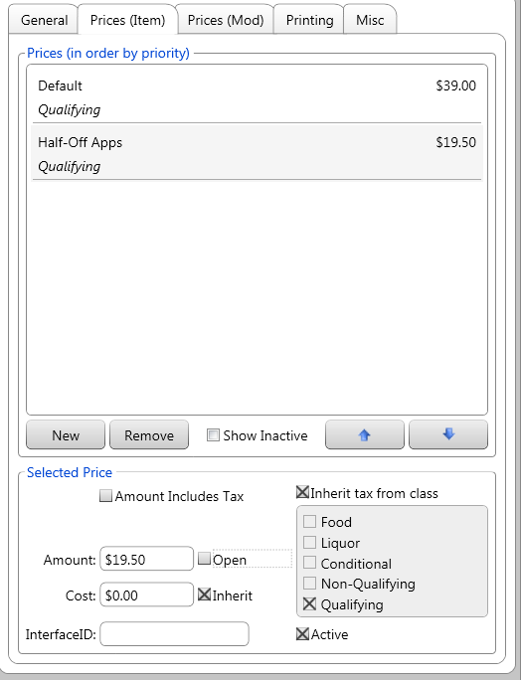

- The “Amount” field is where you enter the price. NOTE: If this is a scalable item, the price is PER UNIT OF MEASUREMENT.
- Turn on the “open” checkbox if you want this item to have an “open” price, meaning that the server will enter the price after touching the item.
- Use the New/Remove buttons to create/remove different price levels for the item.
- Use the Priority Arrows to give a certain price level priority over others. This is useful when you have scheduled price levels, but you may also have a VIP with their own price level order some items. If the VIP level is lower than the scheduled level, make sure you put the VIP level at second spot in the list, with the other level(s) beneath it.
Avrio checks for price levels start after the default level. It always looks for other active levels (by priority), before charing the default price.
- Check Amount Includes Tax if the appropriate taxes have already been included in the item’s price.
- If Inherit tax from class is checked, the item will take its tax settings from the minor class it’s a part of.
- Check Inherit to use the default cost you set in the “General” section. Otherwise, enter a cost in the “Cost” field.
- Use the Active checkbox to make a price active/inactive. You should never make the “default” price inactive.
- An item’s InterfaceID is the code that is sent to other software, often inventory-tracking programs such as Optimum Control or Freepour.

Prices (Mod)
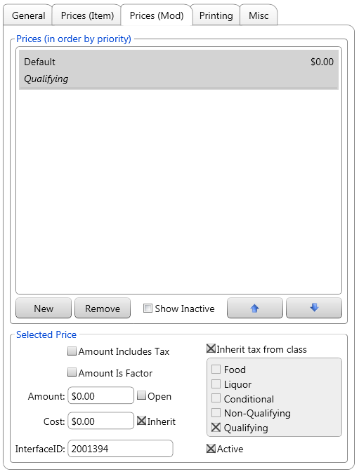
This section is essentially the same as the “Prices (Item)” tab, but these settings are used if/when the item is ordered as a modifier. The mod price is used when the item is ordered from a question (side choice, add-ons, etc) or from an optional question (accessed when a server presses the Modifiers button while ordering).
One option that is different here is the ability to set the mod price as a “factor.” When using a factor instead of a price, the price will be a percentage (that you set in the amount field) of the price of the item it is modifying. Based on the example image above, the “Test Fries” will be priced at 10% of the item it is modifying. So, if they were a modifier of a sandwich priced at $5, the fries would be priced at $0.50.
You can also set the amount to Open so the server can enter the factor amount.
NOTE: If this is a scalable mod, the price is PER UNIT OF MEASUREMENT.

Printing
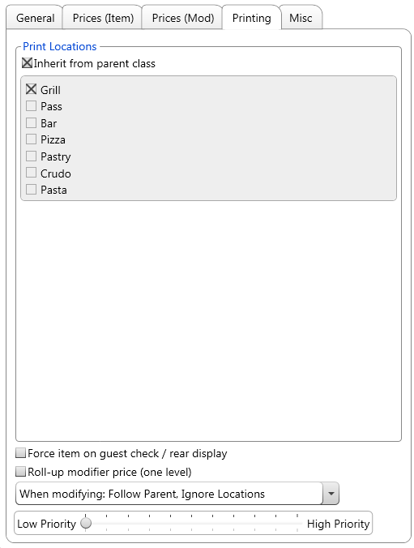

- Check Inherit from parent class to use the same print settings as the minor class the item is included in.
- Check Force item on guest check / rear display if you want this item to always print on a guest check or display on a customer-facing display. Items with a price are forced on to the guest check, but items priced at $0 will only show if this is checked.
- Check Roll-up modifier price (one level) if you want the price of this item to roll up into the price of any item it is modifying.
- When an item is modifying another, you have a few different printing options:
  - Follow Parent, Ignore Locations – The modifier will only print at the same locations as the item it is modifying. It will appear indented and underneath the main item, and will print in red if printing on an impact printer. This is the most common choice.
  - Use Locations – The item will print by itself and the destinations checked above (“Grill” in the image on the previous page).
  - Follow Parent, Use Locations – The item will follow its parent and appear indented and underneath the parent. It will also appear by itself at whatever destinations are checked.
- Priority determines the placement of the item on the kitchen/bar slip. Items print in order of seat, course, highest priority, then the sequence they were ordered in.

Misc Tab

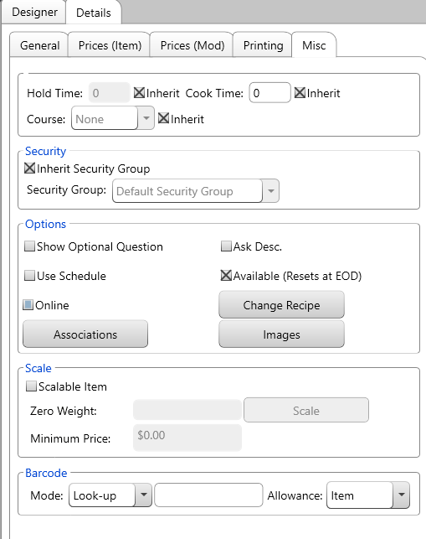

Hold and Fire
- An item will inherit its fire time (the amount of time it waits after being held before it is automatically fired to the kitchen) from its minor class. If you want, you can disable this and set the item’s time manually.
- Cook Time is the time value that will be sent when integration with a KDS system. This settings can be inherited from the item’s minor class or set manually per item.
- Course determines which item the course is a part of when using Avrio’s hold and fire functionality.
Security
- An item will inherit its security group from its minor class. However, you can disable the inheritance and choose a different security group. Users will only be to modify the item if they have access to that security group.
Options
- Show Optional Question forces the optional question for the group the item is a part of to display when the item is ordered.
- Use Schedule determines if the item is affected by the menu scheduling options. An item will be available at all times, unless this option is turned on. If it is, the item will only be available according to a schedule.
- Online determines if the menu item is available/unavailable for online ordering.
- Ask Description prompts the user to enter an additional description/ more instructions for the kitchen when this item is ordered.
- Available makes the item available/unavailable for ordering. Unavailable items can still be modified.
- Change Recipe lets you enter a recipe for the item. Servers can search for this recipe while ordering.
- Images is used to affiliated images with this menu item on the online ordering system.
Scale
- Check Scalable Item if this item will be sold by weight.
- If the item has a container with weight that you do not want include in the price, weigh the container and enter the measure in the Zero Weight
- If you will charge a minimum price if the customer doesn’t buy enough of the item, enter that price in the Minimum Price field.
Barcode
- The Barcode Data field contains the barcode assigned to the selected item.
- Switch Barcode Mode between “Look-up” or “Assign.”
  - When set to “Look-up,” Avrio will search for an item when you can a barcode
  - When set to “Assign,” Avrio will assign a barcode to the selected item.
- Barcode Allowance lets you choose if the item can be scanned as an item, a mod, or both.
  - NOTE: An item can only be scanned as answer to a question if it has been dragged into the question.

Associations Button
This screen lets you see where you have placed this item. It shows all the groups/questions that contain the item.

Adding Items to Groups & Arranging and Stylizing Buttons
In order to add an item to a group, you will first need to have that group visible. There are two ways to navigate to the desired group:
- Touch the “Groups” tab, then select the group you want the new item to be a part of. Press Show.

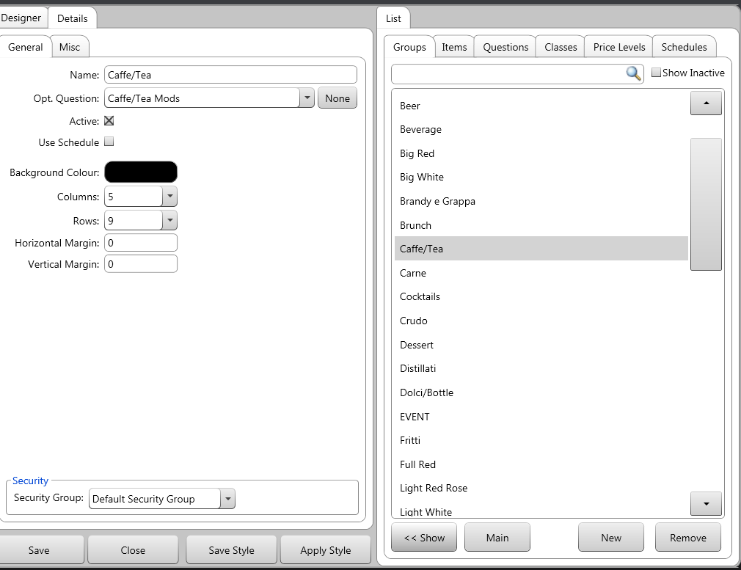
OR
- Go to the “Designer” tab at the top left of the menu designer and select your group from the drop-down box
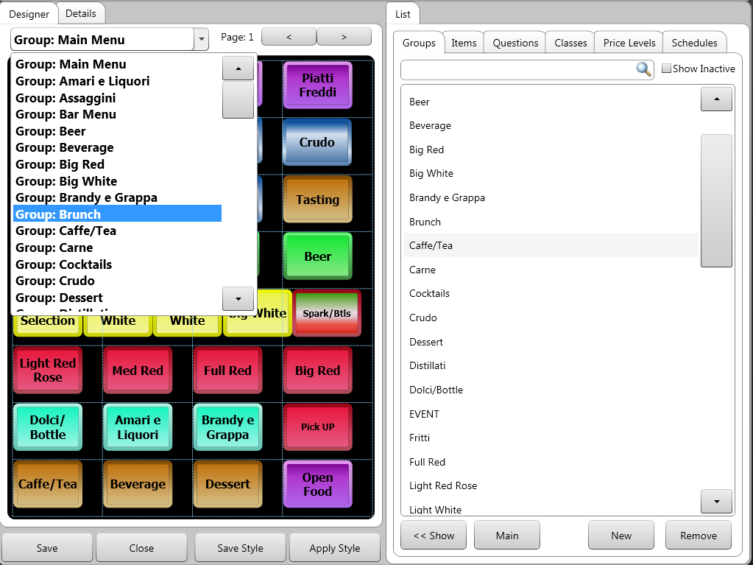

- Now, select the “Items” tab. You have two ways to add the item to group:
  - You can click and drag the item from the list over to the designer side of the page OR
  - You can click the “Add” button that appears to right of the item (visible in the screenshot below)
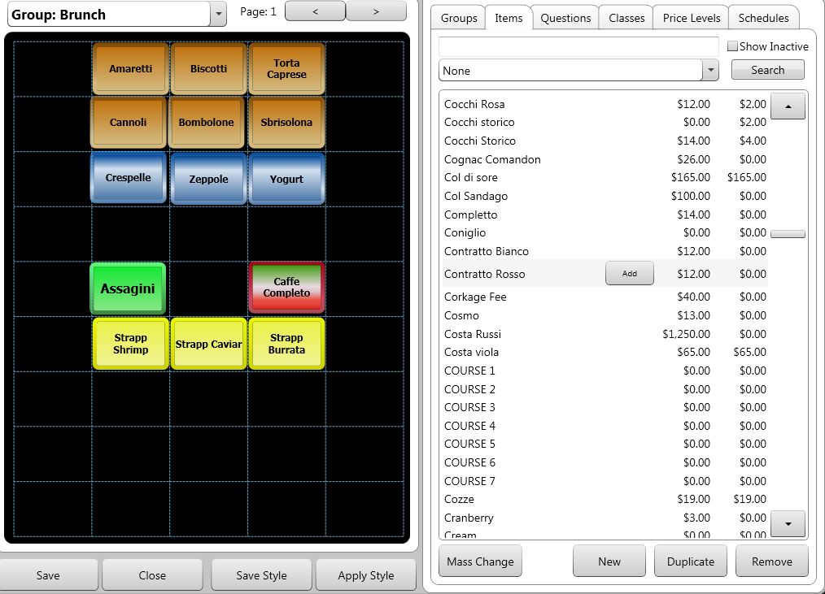
- After you have added items, you have a few options to arrange the buttons.
  - You can simply click and drag the items to move them. Assuming you have a grid of cells in the group, they will snap to cells.

  - You can click on any empty area of the group and drag over multiple items to select them at once. After you can do, you can use the menu designer’s auto-arrange features.
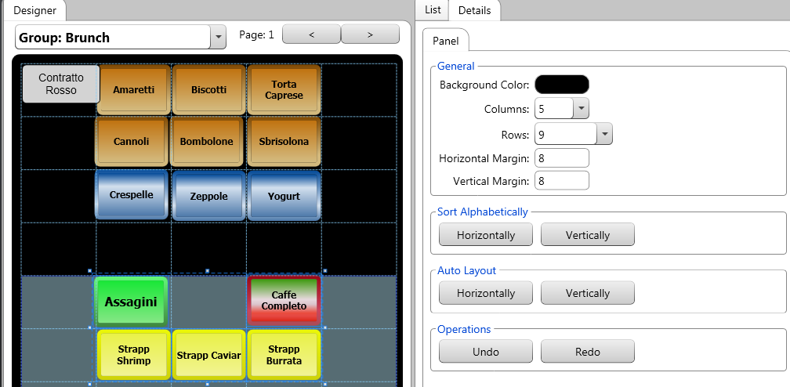
Here is what the selected items look like after use the horizontal auto-layout, and alphabetical auto-layout
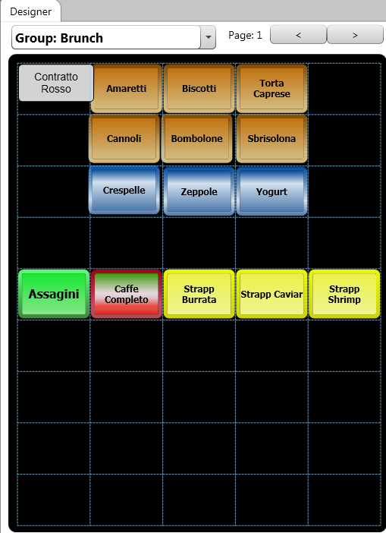
If you click on a single button in the designer panel, The “Button” tab that appears on the top-right of the screen lets you edit the text that appears on the item’s button, as well as modify the button’s colors and border.
If you placed the button incorrectly, press Remove Button.
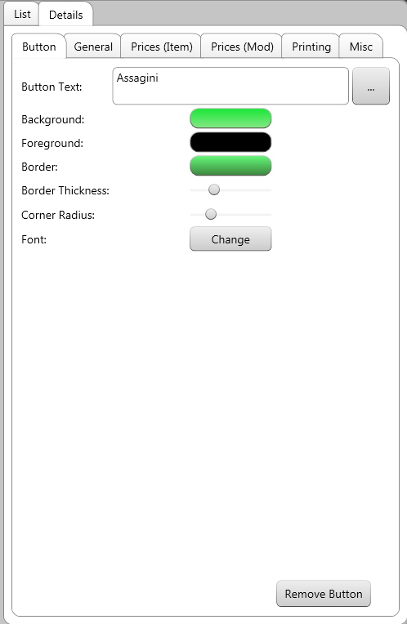
- Button Text is the text that appears on the button.
- Background determines the button’s color.
- Foreground determines the color of the text on the button.
- Border determines the color of the button’s border
- Border Thickness determines how thick the button’s border is.
- Corner Radius determines how rounded the button’s corners are.
- Font lets you choose a different font for the button’s text.
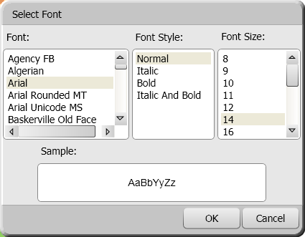

Using the Color Picker
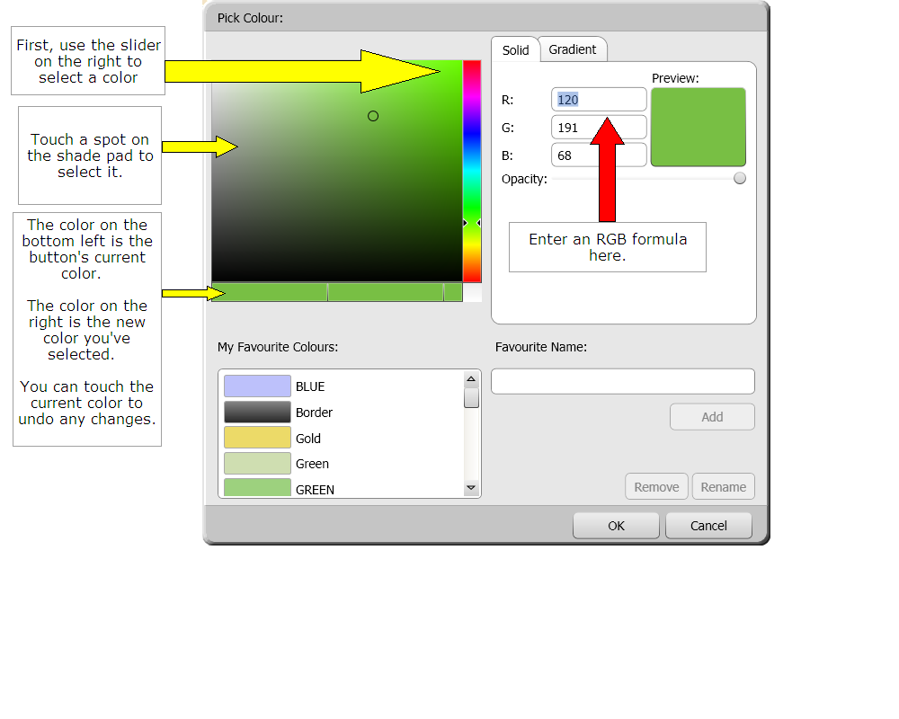

The color picker gives you two ways of selecting a color for the button. You can use the sliding bar and the shade pad on the left side of the screen, or you can enter the color in RGB format. Wikipedia has an excellent list of RGB formulas.
Avrio allows you to store an unlimited number of colors, so can quickly create a standardized look for your menu. Once you’ve created a color you like, touch the “Favorite Name” field and enter a name. Press Add to add the color to your favorites.
Select an existing favorite color and press Remove or Rename if you wish to get rid of a color or if you want to change its name.
You can use the “Opacity” slider to make the object transparent.

Gradients
Gradients allow you to make buttons that have two or more colors blended together.
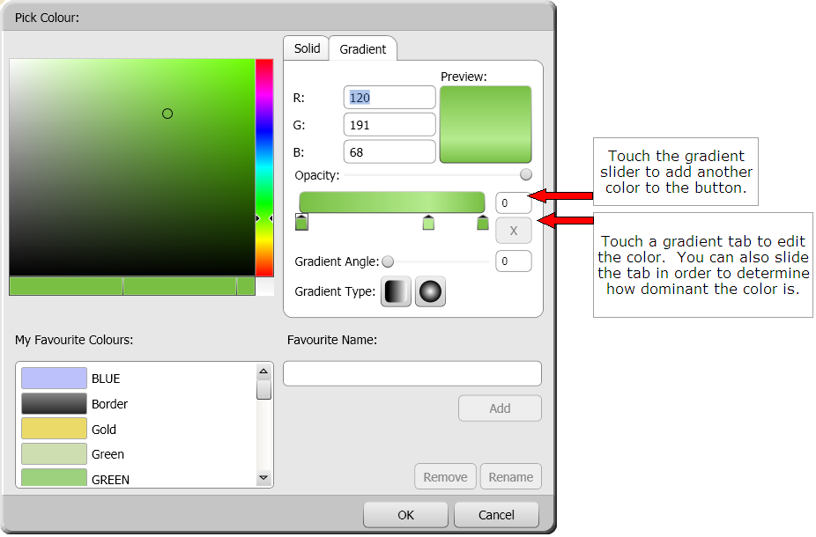
The shade selection area and color slider work the same as they do when making non-gradient colors. However, you first have to choose one of the tabs underneath the gradient slider on the right side of the screen.
- The Gradient Angle slider lets you change the colors’ direction. The default is top-to-bottom, but you can change to left-to-right, diagonally, or anywhere in between.
- Gradient Type lets you choose either the standard rectangular gradient or a circular/bull’s-eye style. When using the circular style, you cannot change the angle.

Button Styles

Saving Styles
After you edit a button you can save its size and appearance for use on other buttons throughout your menu.
- Select the button you wish to save.
- Press the “Save Style” button.
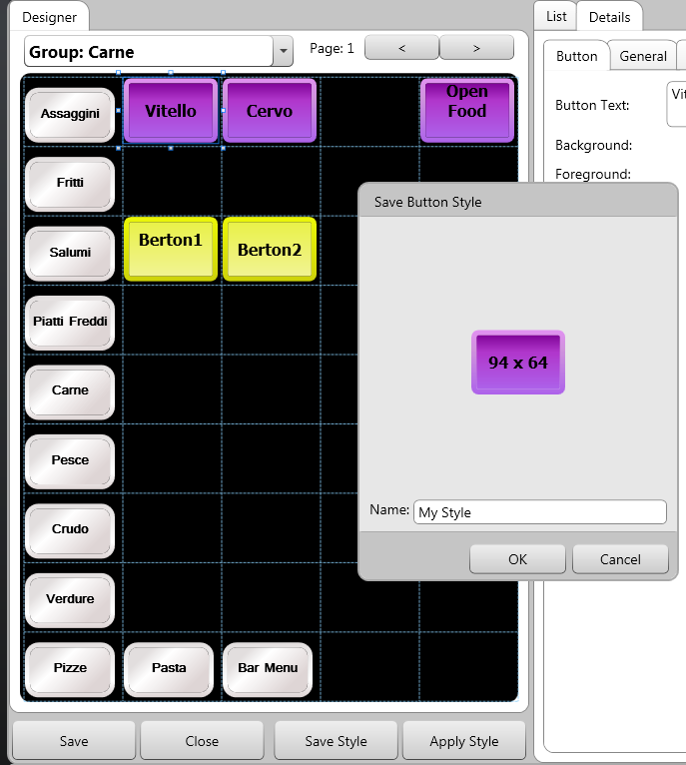
- Give the style a name.
- Press OK.

Applying Styles
After you add a button to a group, you can apply one of your saved styles. You can also select multiple buttons and apply one style to all of them at once.
- Select the button you wish to modify.
- Press the “Apply Style” button.
- Select a style from the list that appears.

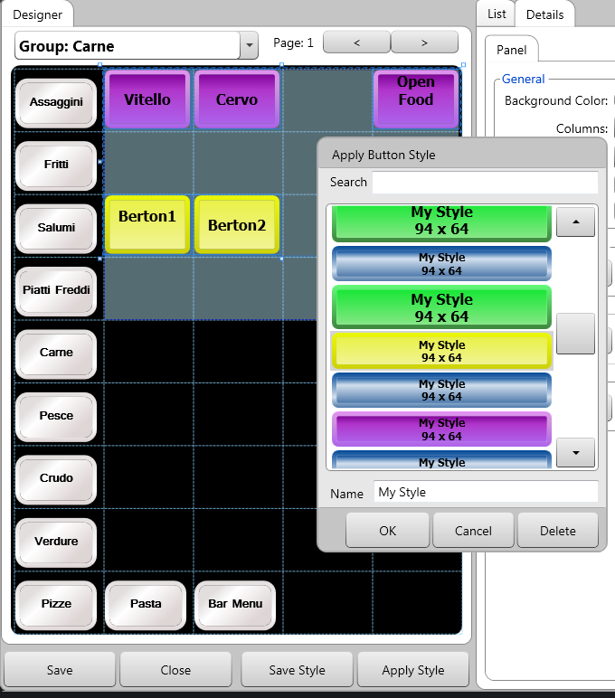
- Press OK.

Questions
Questions are used to modify items, add side dishes, etc.

Creating a New Question
- First, create the items that the question will contain. For example, a question about salad dressings might contain “Ranch” “Balsamic” “Raspberry Vinaigrette” etc. These items must be created first, using the previous instructions.
- Once the items are created, touch the Questions tab.
- Press New and begin filling out the details

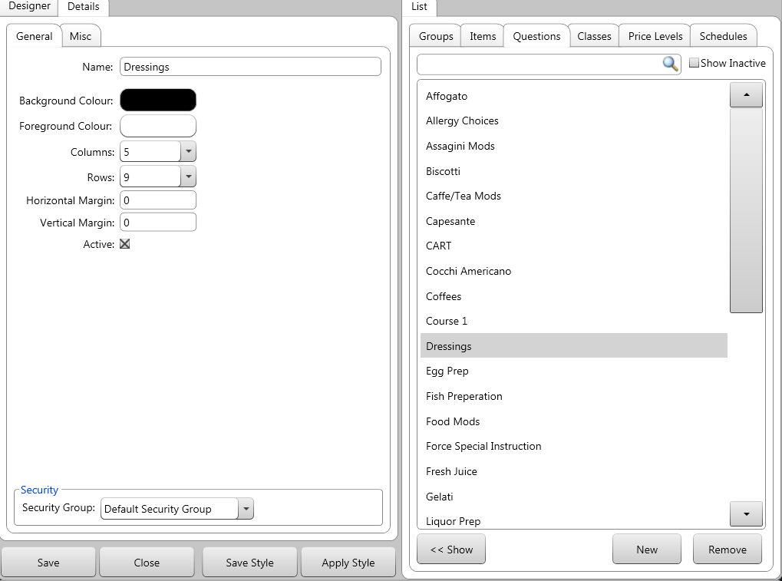

- Name the question.
- Select the color that will appear on the menu when the question is asked. Only the background color can be modified.
- Similar to groups, you can set up a grid and margins to fit the buttons in an orderly fashion.
- Also similar to groups, you can set a security group on the question so only users assigned that group can modify the question or its contents.
- The Availability drop-down box lets you determine if this questions is available only in POS, online orders, or both.
- The Security drop-down box is used to assign the question to a security group. Only users of the appropriate level and with access to that security will be to edit the question’s contents and properties.
- Make sure your new question is highlighted in the light on the right side of the screen. Press Show.
- Press the “Items” tab.
- Find the items you want (the different dressing), and then drag them to the left side of the screen, or press the add button that appears when you select the item from the list.
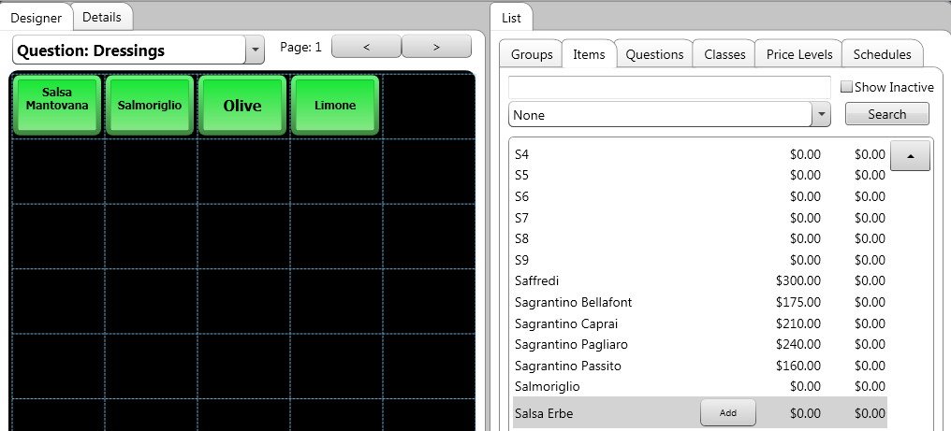

- If you drag the wrong item into the question, touch the item’s button, then the “Button” tab. Press Remove Button.
The question is ready for use. It will now appear in the list of questions that can be applied to a menu item.

Price Levels
Price levels allow you to offer multiple prices for one item, instead of creating the item many times over and giving it a different price each time. These price levels, alongside the price level scheduler, allow you to easily automate discounts/special events, such as a lunch menu or TGIF pricing.

Creating a New Price Level
- Go to Manager Options Configuration Menu.
- The “Menu Designer” screen appears.
- Touch the Price Levels tab.
- Press New.
- Name the new price level.
- You can also set a security group on the price, so it will only be accessible to users assigned that security group.
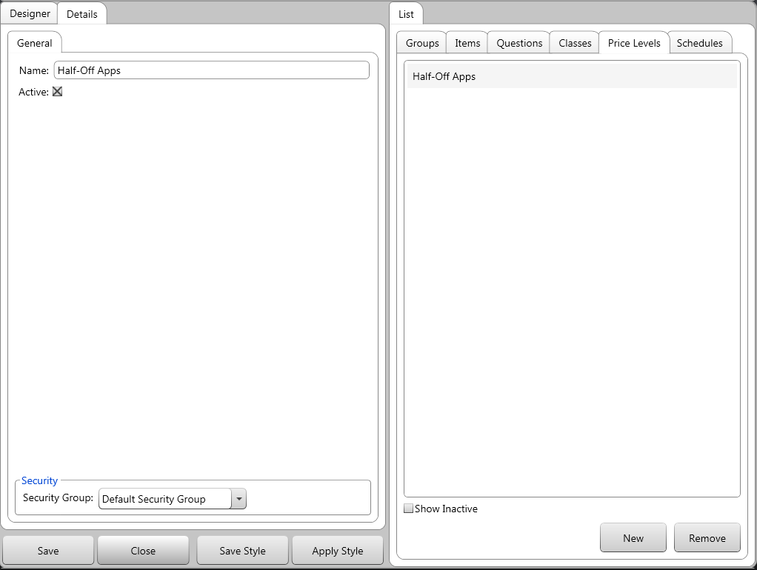

Applying a Price Level to an Item
- In the “Menu Designer,” touch the Items tab. Select an item.
- In the item’s Prices (Item) or Prices (Mod), press New.
- Select your new price level and press OK.
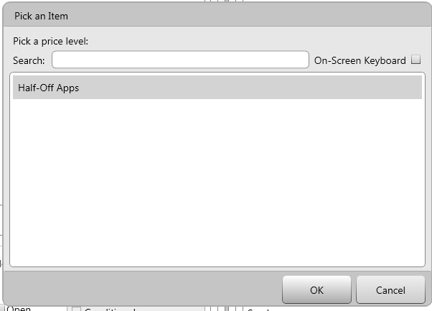
- Fill out the price information for the item at the new price level.
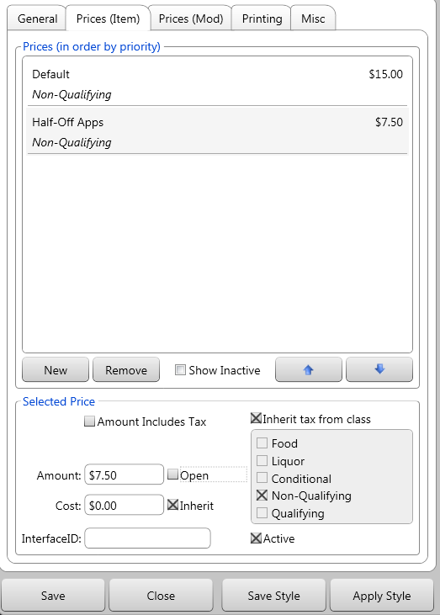

Rule-based Menu Items
Rule-based items allow you to offer a variety of sizes or options for an item without cluttering your menu. There are two types of rule-based items: quantity and specific item.
Instead of creating buttons for a variety of pizzas at different costs, you can create an item that chooses the cost based on the number of toppings on the pizza. Or you can offer different steak sizes without having to make and place buttons for all of them.

Making a Quantity-style Rule-based Item
In this example, we’ll make a pizza that chooses a price based on how many toppings are added.
- Go to Manager Options Configuration Menu.
- The “Menu Designer” screen appears.
- Touch the “Items” tab.
- Press New.
- Choose a minor class for the item.
- Enter the regular, remote, and check descriptions. For example, name it “One-Topping Pizza.”
- Price/cost the pizza as you’d like.
- Leave the type as “normal.”
- Fill out the remaining options as you’d like.
- Create three more items, a “Two-Topping Pizza,” a “Three-Topping Pizza,” and a “Four-Topping Pizza.”
- Press the “Questions” tab at the top of the screen.
- Use the instructions in the Questions section to create a question called “Pizza Toppings.” The possible answers should be some different toppings you offer. Create these toppings, pricing them as you wish.

- Create a new item called “Pizza.” Don’t give it any price/or cost information. Change the type to “Rule-Based.”
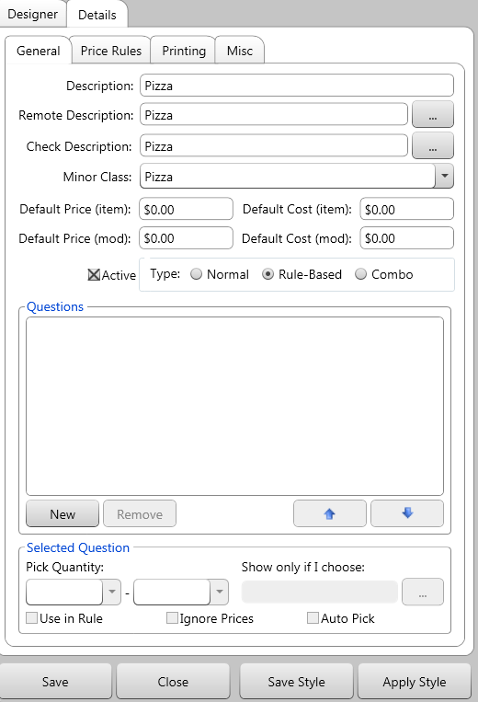
- In the Questions area, add the “Pizza Toppings” question you created earlier and check off the Include in “Rule-Based” Price.
- In the “Pick Quantity”area, select the smallest possible answer and the largest possible answer for the question. In this example, you should enter “1” in the first drop-down box, and “4” in the second. This means that the guest has to choose at least one topping, but can’t choose more than four.
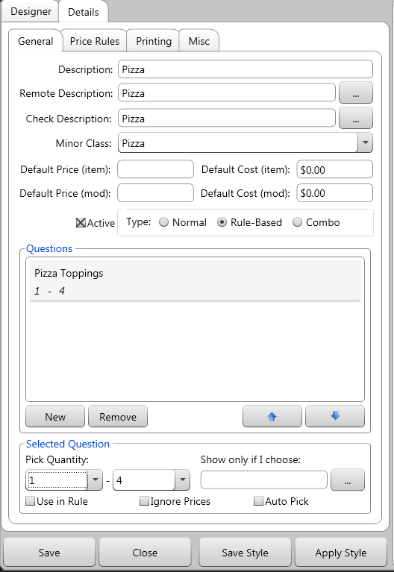
- Press the Price Rules tab.
- Press New. By default, the Quantity button is checked. Leave it checked.
- Set the quantity options to “1” and “1.” Press Assign and choose the “One-Topping Pizza” as the “Target Menu Item.” This way, if the server enters one of the topping options and presses Done, the one-topping pizza will be placed on the bill. Press OK.
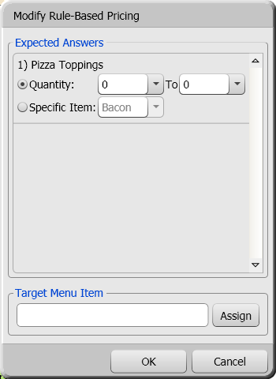
- Repeat steps 17-20, but set the quantity options to “1” and “2” and the “Target Menu Item” to “Two-Topping Pizza.” This way, if the server enters two of the appetizer options, a “Two-Topping Pizza” will be placed on the bill.
Repeat this twice more, setting the quantities as 1-3, and 1-4, and set the target items as the three-topping pizza and four-topping pizza, respectively.
- Press OK.

- In the “Default Assignment” section of the “Price Rules” tab, you can select an item that will be ordered if none of the conditions are met. Press Assign and then select an item from the list.
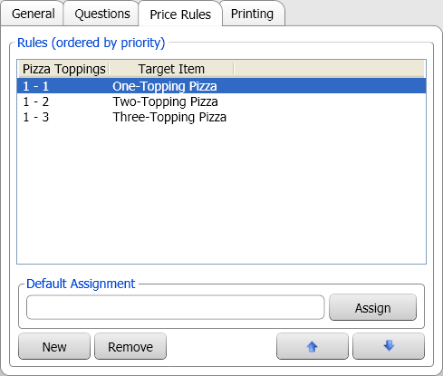
- Press the Groups tab at the top of the screen. Select the group you want to add the “Pizza” to and press Show.
- Press the Items tab. Touch and drag the “Pizza” to the other side of the screen.
- The item should now be accessible in the menu.

Making a Specific-item Style Rule-based Item
In this example, we’ll make a steak that chooses a price based on size.
- Go to Manager Options Configuration Menu.
- The “Menu Designer” screen appears.
- Touch the “Items” tab.
- Press New.
- Choose a minor class for the item.
- Enter the regular, remote, and check descriptions. For example, name it “9 oz Steak.”
- Leave the type as “normal.”
- Fill out the remaining options as you’d like.
- Create another item, a “12 oz Steak.” Fill out the remaining options and price as you’d like.
- Create two more items, “9 oz” and “12 oz” and give them a price of $0.00. Make they don’t have an open price.
- Press the “Questions” tab at the top of the screen.
- Use the instructions in the Questions section to create a question called “Steak Size.” The possible answers should the “9 oz” and “12 oz” items you just made.
- Create a new item called “Steak.” Don’t give it any price/or cost information. Change the type to “Rule-Based.”
- Press Questions at the top of the “Item Properties” section. Add the “Steak Size” question you created earlier. Check Include in “Rule-Based” Price.
- In the “Pick Quantity” tab, select “1” and “1.”
In this example, your guest must pick one and only one size.
- Press the Price Rules tab.
- Press New. By default, the “Quantity” button is checked. Change the selection to “Specific Item.”
- Select “9 oz.” Press Assign and set the “9 oz Steak” as the “Target Menu Item.” This way, if the server enters select the “9 oz” size, the “9 oz Steak” will be placed on the bill.
- Press OK.
- Repeat steps 19-21, but select “12 oz.” and set the “Target Menu Item” to “12 oz Steak.” This way, if the server selects the “12 oz” size, the “12 oz Steak” will be placed on the bill
- Press the Groups tab at the top of the screen. Select the group you want to add the “Steak” to and press Show.
- Press the Items tab. Touch and drag the “Steak” to the other side of the screen.
- The item should now be accessible in the menu.

Combos
Combos allow you to assign a price to a set of items when they are ordered separately. For instance, you can create a combo that will activate whenever a sandwich, soft drink, and side item are ordered.

Creating a Combo
In this example, we’ll create a combo that activates when a sandwich, soft drink, and side item are ordered.
- Create any items that will be part of the combo.
- Create an item named “Sandwich Combo” Set it to “combo.”
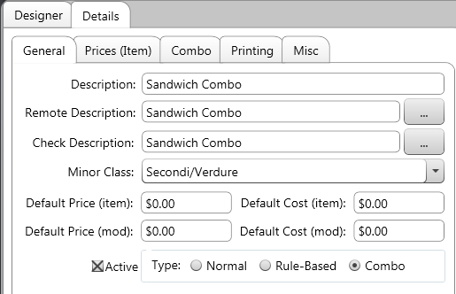
- Price the combo.

- Touch the “Combo” tab. Press New.
- The “Group Name” is the name of this component of the combo. In this example, this component will be named “Sandwich,” as the guest can choose from a variety of sandwiches.
- The “Quantity” field determines how many items from this component must be selected to activate the combo.
- Press Add Group to add entire menu groups to this component. For instance, you can add all your sandwiches to the combo.
- Press Add Item to add a specific item to this component.
- Press Remove to remove a group/item from this component.
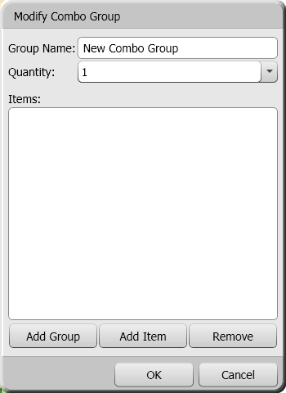

- Press Add Item. Select an item to add to this component. Press OK once you’re done adding items.
- Press New again. Name this component “Side.” Add the items/groups you’d like. Press OK when you’re done adding items.

- Press New. This component will be named “Beverage.” Add the drinks/groups you’d like. Press OK when you’re done.
The “Combo” tab should look something like this when you’re finished. You may have more items in each component, depending on how many you added.
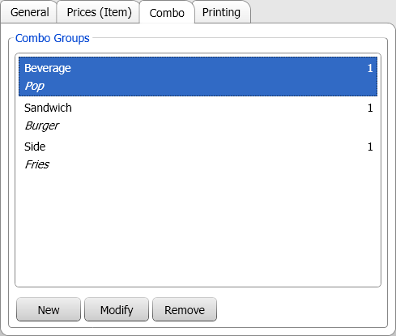
Now, when a server orders an item from each component, the combo item and price will activate.
In this example, if the server orders two burgers, two fries, and three pops, the combo will show twice, and the last pop will be left on its own, and its normal price will apply.

Creating a 2-for-1, 3-for-1, etc, Combo
The combos feature allows you to create “2-for-1” style deals with ease.
- Create any items that are necessary for the deal.
- Create the combo item. Name it “2-For-1 Burger” and price it as you’d like.
- Press the “combo” tab. Press New.
- Name the component “Burger.”
- Set the quantity field to “2.”
- Press Add Item. Add an item to the component.
The combo tab should look something like this:
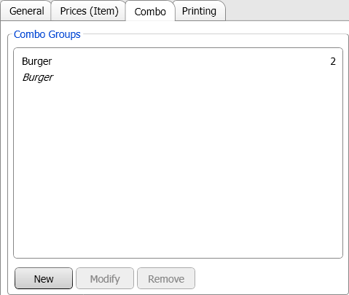
Now, when a server orders two burgers, the combo price will activate.

Price Level Combos
As mentioned earlier, “price level combos” can be used to setup “Prix Fixe” or set course menus.
In this example, we’ll create a combo that activates when an appetizer, main item, and dessert are ordered over the course of a meal (as opposed to all being ordered at once)
- Create the menu items that will be part of the prix fixe menu.
- Create a price level called “Prix Fixe”
- Create an item named “Prix Fixe” and set its “type” to “Price Level Combo.”
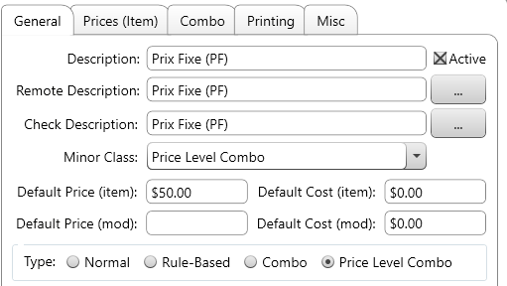
- The price doesn’t need to be set on this item.

- Touch the “Combo” tab. Press New.
- The “Group Name” is the name of this component of the combo.
- The “Quantity” field determines how many items from this group must be selected to activate the combo.
- If “Keep Price” is turned on, the menu items will retain their original price. For this example, this should be turned off.
- For our “Prix Fixe” example, an “Override Pride Level” must be set. We will set to the price level created in step 2.
- Press Add Group to add entire menu groups to this component. For instance, you can add all your appetizers to the combo.
- Press Add Item to add a specific item to this component.
- Press Remove to remove a group/item from this component.
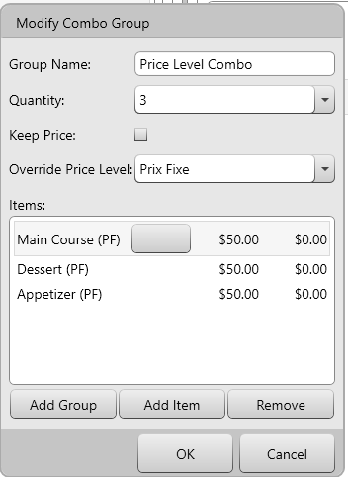

- Press Add Item. Select an item to add to this component. Press OK once you’re done adding items.

Now, when a server orders 3 items from the options you added, those items will be sold at their “Prix Fixe” price instead of their default price.

Menu Schedules
The “Schedule” tab lets you setup schedules in your menu. These schedules let you customize:
- When menu groups are available
- When items are available
- Which price level will be applied to an item/items either during a particular time or perhaps for a particular order type (i.e. delivery orders having different pricing than dine-in)
To create a schedule:
- Select the “Schedule” tab from the top-right of the menu designer, then press New.
- Enter a name for the schedule
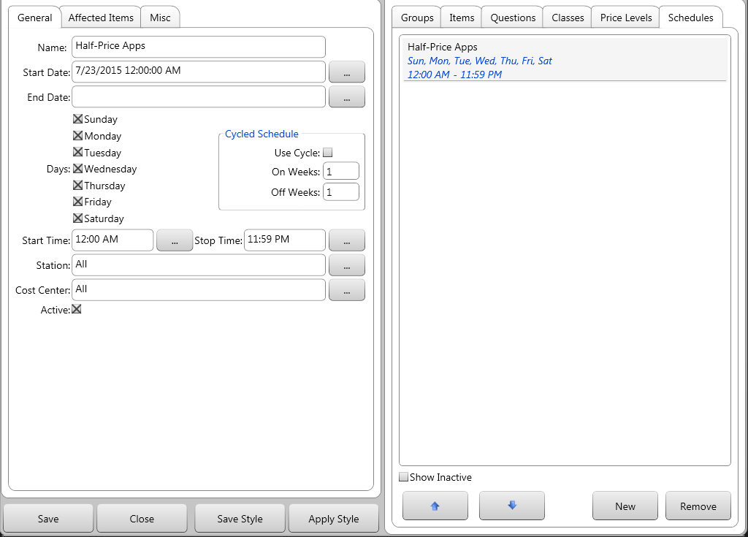

- Now you can edit when/where the schedule will be in effect.
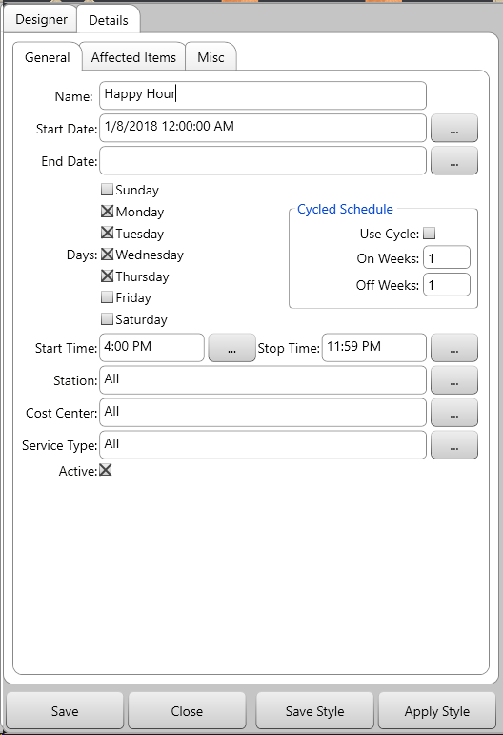

- Name is the name of the schedule.
- Start Date is when the schedule will begin. When you create the schedule, this field will be auto-filled with the current date. You can change as you wish.
- End Date is when the schedule stops.
- Days determine which days the schedule affects prices and changes item/group availability.
- Start/Stop Time determines the hours the schedule affects prices and changes item/group availability.
- Stations determines which stations are affected by the schedule. You can select an individual station, or all stations.
- Cost Center determines if the schedules only affects certain cost centers.
- Service Type lets you apply the schedule to a particular order type (bar tabs, C/C, take-out, etc)
- Security Group (found under the “Misc” tab) determines which users can modify the schedule and the prices/items/groups/etc it will affect. Only users assigned the same security group will have access to modify the schedule.
- Cycled Schedule lets you have the schedule turn on/off for a particular # of weeks in a row. I.e. On for one week, off for three, then back on.
Switch over to the “Affected Items” tab to determine what the schedule will actually do.
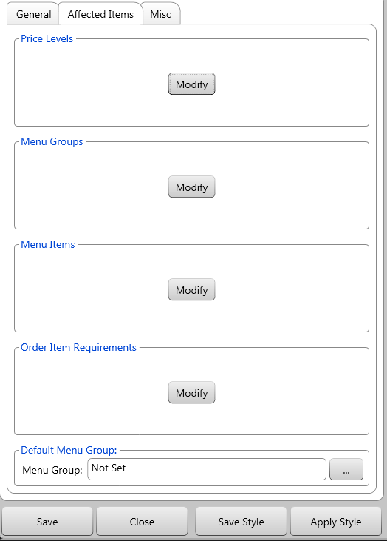

Price Levels
Press Modify to change how this schedule affects price levels. You must have multiple price levels in your system for this to be of any use.
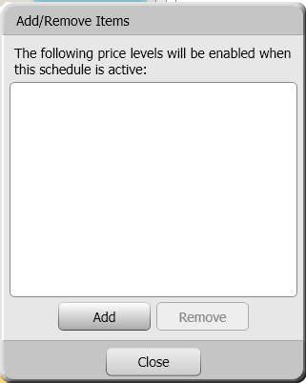
Use the Add/Remove buttons to add or remove price levels to this schedule. When you press add, your price levels are displayed and you can choose one to add to your schedule.

Menu Groups
Press Modify to change which menu groups are available during your schedule.
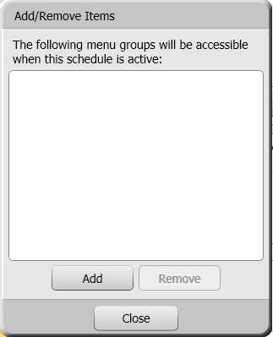
Use the Add/Remove buttons to add or remove menu groups to this schedule. When you press add, your menu groups are displayed and you can choose one to add to your schedule.

Menu Items
Press Modify to change which menu items are available during your schedule. If you check the “Use Schedule” option in a menu item’s properties, it will not be available any time unless you include it in a schedule.
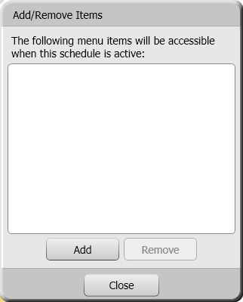
Use the Add/Remove buttons to add or remove menu items to this schedule. When you press add, your menu items are displayed and you can choose one to add to your schedule.

Order Item Requirements
Press modify to change when any Order Item Requirements will be in effect.

Default Menu Group
This lets you pick a menu group that will display automatically when servers are ordering.

Mirada Menu Board Module
If you are using digital menu board software/hardware supplied by Mirada Media, you should know the following about manipulating your items and menu boards:
- The groups of items displayed on a menu board can usually be found in a menu groups named, “DMB – GroupName” or something with “DMB” in the title.
- The way the buttons are laid out inside the “DMB” group determine how the items are listed on the menu board. The menu boards read the items by their descending order. Whatever button is highest will be the first on the menu board.
- If your menu board has multiple price columns:
Item Name | Small Price | Medium Price | Large Price
Caesar Salad | $3 | $4 | $5
- To set up items to be in these columns, you will have the three caesar salad items in your DMB group. They will each need to have a “Menu Board Description” of “Caesar Salad.” In the recipe for each caesar salad item, you will have either $p1 (for column 1, the “Small Price”) $p2 (for column 2, the “Medium Price”) or $p3 (for column 3, the “Large Price”)
- As well as the $p1, $p2, $p3, etc tags, you can add descriptions that will appear underneath the item on the menu board in the items’ recipe option.

Employees
The “Employees” menu lets you add, manage, and remove employees.
To access this screen, go to Manager Options Configuration Employees.
Touch an employee’s name to select them, or press New to add a new profile. Remove takes the selected employee off the list.

Personal Information
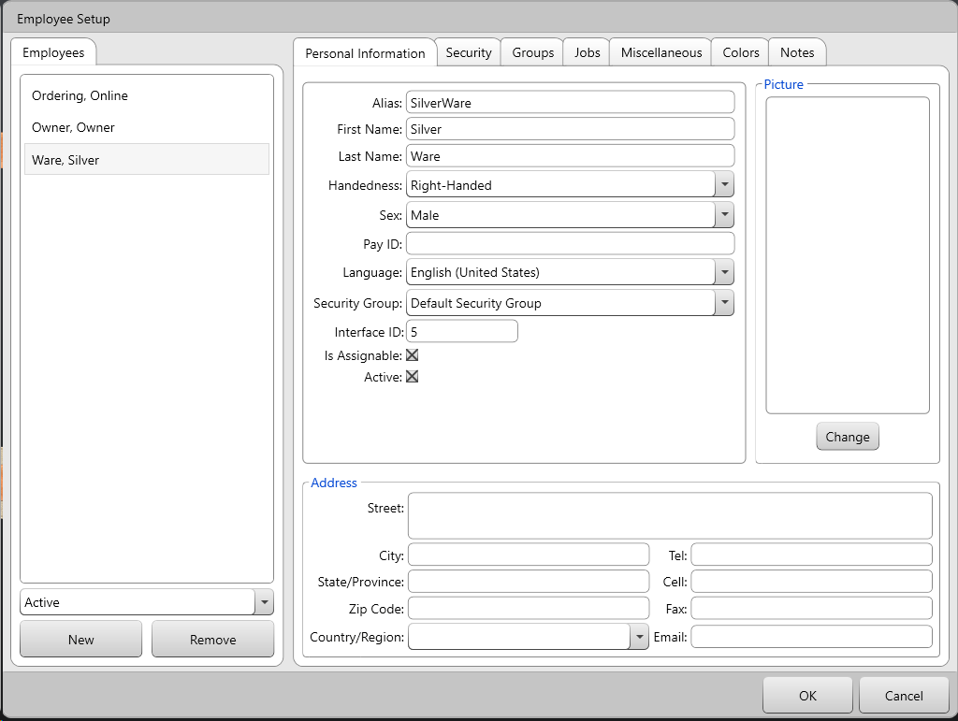
- Alias is the name that appears on Avrio screens and guest checks.
- Handedness lets you select a layout for Avrio. Change this to “Left-Handed” to flip the standard layout for a left-handed employee when they’re using a workstation.
- Pay ID should be filled in if you’re using any of Avrio’s payroll exports (Ceridian, generic, etc)
- Language lets you choose what language the program displays in when this employee is the active user (if translations have been installed).
- Security Group lets you set which security group this user is classified as, which determines who can edit this particular user.
- Is Assignable determines if the user can be “assigned” to particular menu items on their checks, allowing them to get a report on the sale of those items, perhaps for the sake of earning commission.
- Active can be

Security – Operational
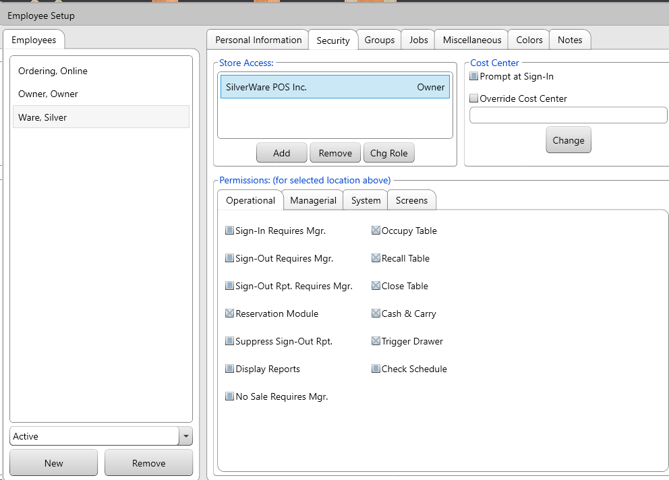
Store Access
Before setting an employee’s security options, you must give them access to a store:
- Press Add (in the “Store Access” section) then select a store from the list that appears. You can add as many stores as necessary, but an employee can only have one role per store.
- You must also assign a role to the employee, such as “Server,” “Supervisor,” “Manager,” or “Kitchen.” Roles determine the default Avrio functions an employee can access (though this can be easily modified).
Depending on the role you assign, as well the settings in the different “Security” tabs, you can give a server access to some of the managerial options, or block a supervisor from some managerial functions, etc.
If you ever need to change someone’s role, select them, then press Chg Role.

Cost Centers
Cost centers are used for reporting and printing purposes. As items are ordered and checks are closed, these items and checks report to a cost center. Cost centers are assigned to an item or check based on the user, station, or table conducting the transaction. Cost centers can also be linked to a printer center, so as an item/check is sent to be printed, it may be printed to the printer center associated with a cost center, depending on how the printer center priorities are setup.
- Prompt at Sign-In lets you determine if the system asks an employee, when he/she signs-in, to select a cost center to assign their orders to.
- Override Cost Center lets you enter the cost center that all this user’s sales will report to.
Permissions
The following properties can be set differently for different sites if the employee works in a different role at another location (perhaps server at one, supervisor at another).
Each of these settings has four possible states. These states apply to all employee security options.
- An unchecked grey box means the setting has been set to off
- A checked grey box means the setting has been set to on.
- An unchecked blue box means the setting is off by default.
- A checked blue box means the setting is on by default.
- Sign-In Requires Mgr. determines if a manager is required to enter a password to sign the employee in.
- Sign-Out Requires Mgr. determines if a manager is required to enter a password to sign the employee out.
- Sign-Out Rpt. Requires Mgr. determines if a manager is required to print an employee’s sign-out report.
- Reservation Module determines if this user can use any features of an Avrio reservation station.
- Display Reports determines if a lower-level user (server or bartender, for example) can generate any of Avrio’s reports, or only templates marked as public by a manager/owner.
- Suppress Sign-Out Rpt. stops a sign-out report from automatically printing.
- Occupy Table allows/denies the employee from starting dine-in orders.
- Recall Table allows/denies the employee from recalling dine-in orders they started.
- Close Table allows/denies the employee from closing orders.
- Cash & Carry allows/denies the employee from processing cash & carry orders.
- Trigger Drawer determines if the cash drawer will open for the employee when necessary. If the employee won’t need access to the cash drawer, don’t check this option.
- Check Schedule is only needed when Avrio is integrated with a scheduling service such as HotSchedules. When this is integration is active AND this check box is turned on, the user will only be able to sign-in and work in accordance with their HotSchedules profile

Security – Managerial
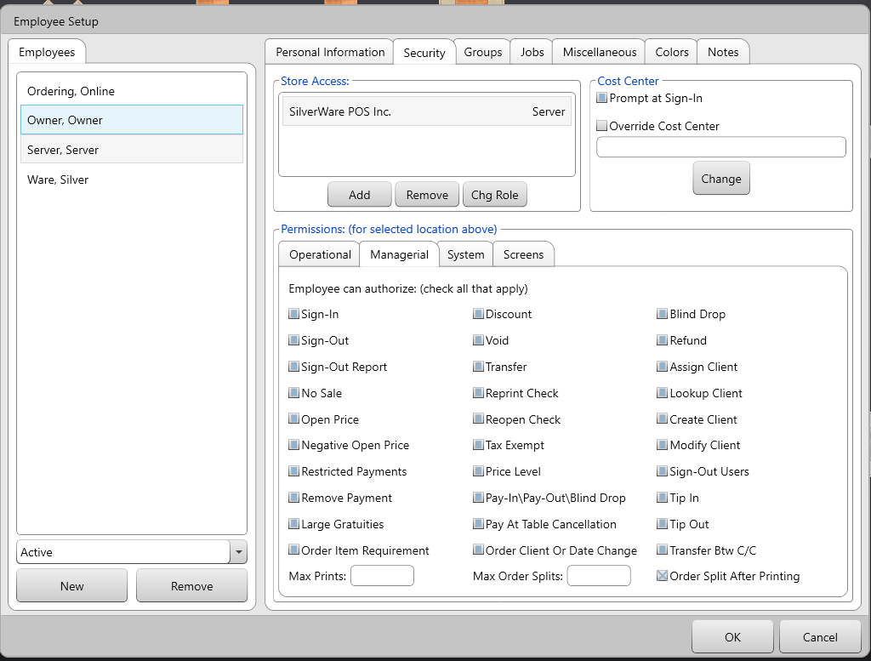
The “Managerial” tab lets you give an employee certain privileges without giving them full manager status, or you can give a supervisor/manager less access than Avrio does by default.
- Sign-In allows the employee to sign-in employees that need a manager to sign them in.
- Sign-Out allows the employee to sign-out other employees that need a manager to sign them out.
- Sign-Out Report allows the employee to print a sign-out report for employees that normally need a manager to authorize it.
- No Sale allows the employee to perform a “no sale” and open the cash drawer.
- Open Price allows the employee to charge an open price for items.
- Negative Open Price allows the user to authorize a check that contains an open-priced item that was set to a negative value, usually for a the purpose of a refund
- Restricted Payments allows the user to authorize payment method that are set to require a manager when attempting to use them to close a check.
- Remove Payment allows the user to remove a payment applied to a check, if that payment method requires authorization for removal
- Large Gratuities allows the user to approve tips that exceed the threshold set in the “System Settings” area
- Order Item Requirement allows the user to authorize an being sent/printed/closed even when it doesn’t match all the requirements set in the “Order Item Requirement” area
- Max Prints determines how many copies of check this user can print
- Discount allows the employee to authorize discounts.
- Void allows the employee to authorize voids.
- Transfer allows the employee to transfer orders to different tables/servers.
- Reprint Check allows the employee to reprint a check.
- Reopen Check allows the employee to reopen a closed check.
- Tax Exempt allows the employee to tax exempt their orders
- Price Level allows the employee to change the price level being used in an order.
- Pay-In\Pay-Out\Blind Drop allows the employee to perform pay-ins\outs and blind drops.
- Pay At Table Cancellation allows the user to authorize cancelling the “Wait” screen that appears when attempting to pay a check via a wireless credit/debit terminal.
- Order Client or Date Change allows the user to authorizing changing the date and/or client on a order that already has these details assigned
- Max Order Splits determines how any checks this user can split in order into.
- Blind Drop lets this user authorize blind drops (money being removed from the cash drawer/float with reconciliation).
- Refund allows the user to authorize a refund being perform on a check
- Assign Client lets the user authorize a client being assign to a check, if the server/user placing the order is not allowed to do so themselves.
- Lookup Client lets the user authorize a client look-up, if the server/user placing the order is not allowed to do so themselves.
- Create Client lets the user authorize the creation of a new client.
- Modify Client lets the user authorize the modification of an existing client.
- Sign-Out Users lets the user authorize another employee attempting to sign-out users.
- Tip In and Tip Out lets the users authorize tips being transferred between employees.
- Transfer Btw C/C lets the user authorize a transfer that would cause a check to move from one cost center to another.
- Order Split After Printing determines if this user can authorize an order being split into multiple checks if one check has already been printed.

Security – System
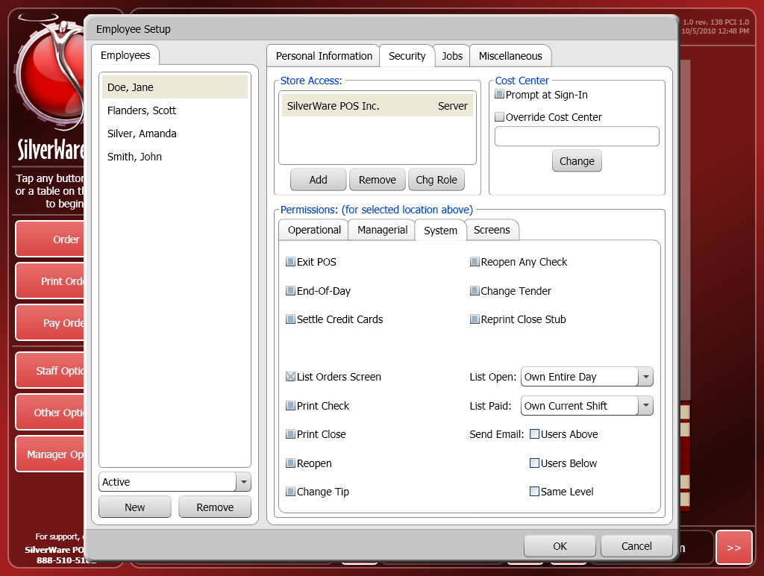
The “System” tab contains more managerial functions that an employee can/cannot perform, depending on how you set them up. An employee must have access to the “Manager Options” screen to access these functions.
- Exit POS lets the employee shut down Avrio and return to the station’s operating system.
- End-Of-Day lets the employee initiate an “End-Of-Day.”
- Settle Credit Cards lets the employee run a batch close.
- Reopen Any Check lets the employee open any closed orders.
- Change Tender lets the employee change the payment(s) accepted on a check.
- Reprint Close Stub lets the employee reprint close stubs.
- List Orders Screen lets the employee see the list order screen, which displays their open/closed orders for the current day/shift.
- Print Check lets the user print checks from the “List Order” screen.
- Print Close lets the user print close order stubs from the “List Order” screen.
- Reopen lets the user reopen their closed orders from the “List Order” screen.
- Change Tip/Tender lets the user change the tip amount on an order from the “List Order” screen.
- List Open Determines which open orders the employee can see (none, their own, or all).
- List Paid determines which closed orders the employee can see (none, their own, or all).
- The Send Email area determines which other employees this user can send an internal memo to.

Security – Screens
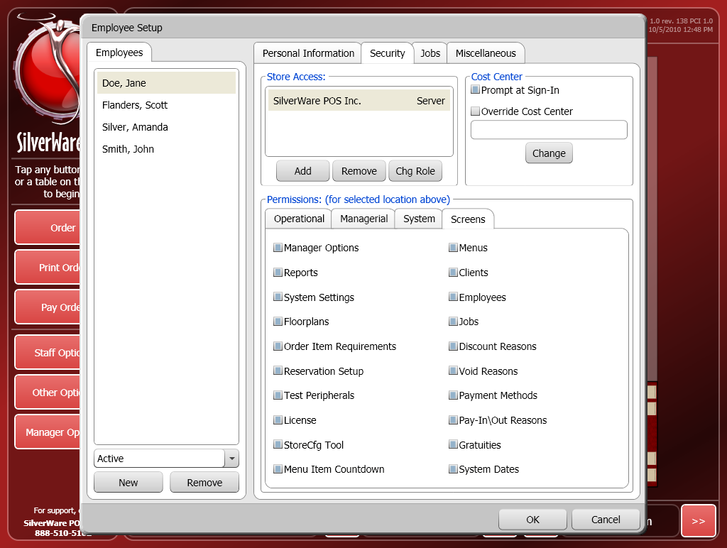
This tab lets you determine which of the managerial screens a user can access. Even if a user has access to a component on that screen, they must be able to view the screen to perform any functions it contains.
In the “Void Reasons” and “Discount Reasons” areas, you can set the “Role to modify” to the same level as employees, but only an employee with the permissions to those screens can modify a void or discount reason. For example, you can create a “Staff Discount” that can be modified by servers, but only servers with the “Discount Reasons” box checked in this area can actually access the “Discount Reasons” screen and modify a discount you give them access to.
- Manager Options lets the employee access the main “Manager Options” window, this has to be checked for any of the other options to be accessible.
- Reports lets the employee access and generate reports.
- System Settings lets the employee access the “System Settings” window. The employee must have an administrative password to access this section.
- Schedules lets the employee access the “Schedules” window.
- Floorplans lets the employee access the “Floor plans” window.
- Order Item Requirements lets the employee access the “Order Item Requirements” window.
- Reservation Setup lets the employee access the “Reservation Setup” window.
- License lets the employee access the “License” window.
- StoreCfg Tool lets the employee launch the Avrio Store Configuration utility.
- Menu Item Countdown lets the employee access menu Item countdown functionality
- Menus lets the employee access the “Menu” window.
- Clients lets the employee access the “Clients & Gift Cards” window.
- Employees lets the employee access the “Employees” window. An administrative password is required.
- Discounts Reasons lets the employee access the “Discount Reasons” section and modify discounts that have the “Role to Modify” level set to equal to or lower than the employee’s role.
- Void Reasons lets the employee access the “Void Reasons” section and modify void reasons that have the “Role to Modify” level set to equal or lower than the employee’s role.
- Payment Methods lets the employee access the “Payment Methods” window.
- Pay-In\Out Reasons lets the employee access the “Pay-In\Out Reasons” window.
- Gratuities lets the employee access the “Gratuities” window.
- System Dates lets the employee access the “System Dates” window.
- Gratuities lets the employee access the “Clock In & Out Times” window.
- Services lets the employee access the “Services” window.
- Security Groups lets the employee access the “Security Groups” window.
- Labour Scheduler lets the employee access the “Labour Scheduling” window.
- Signed-In Users lets the employee view a list of signed-in users via “Staff Options”
- Credit Card List lets the employee view and re-auth the credit cards affiliated with a check.
- Themes lets the users access the “Themes” window.

Groups
This area lets you determine which security groups the employee has access to. For example, if the employee has access to the menu designer, they will only have access to groups/items/classes/etc with the same security group assignment.
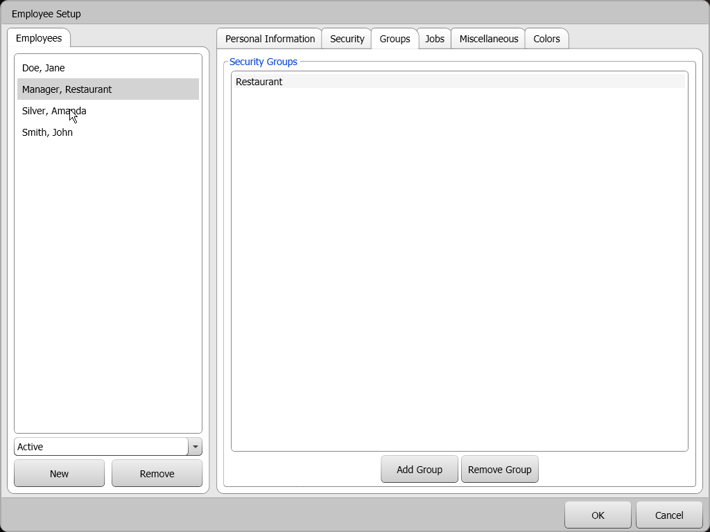

Jobs
This area lets you assign jobs and pay rates to your employee. See the Jobs section of this document for information on creating jobs.
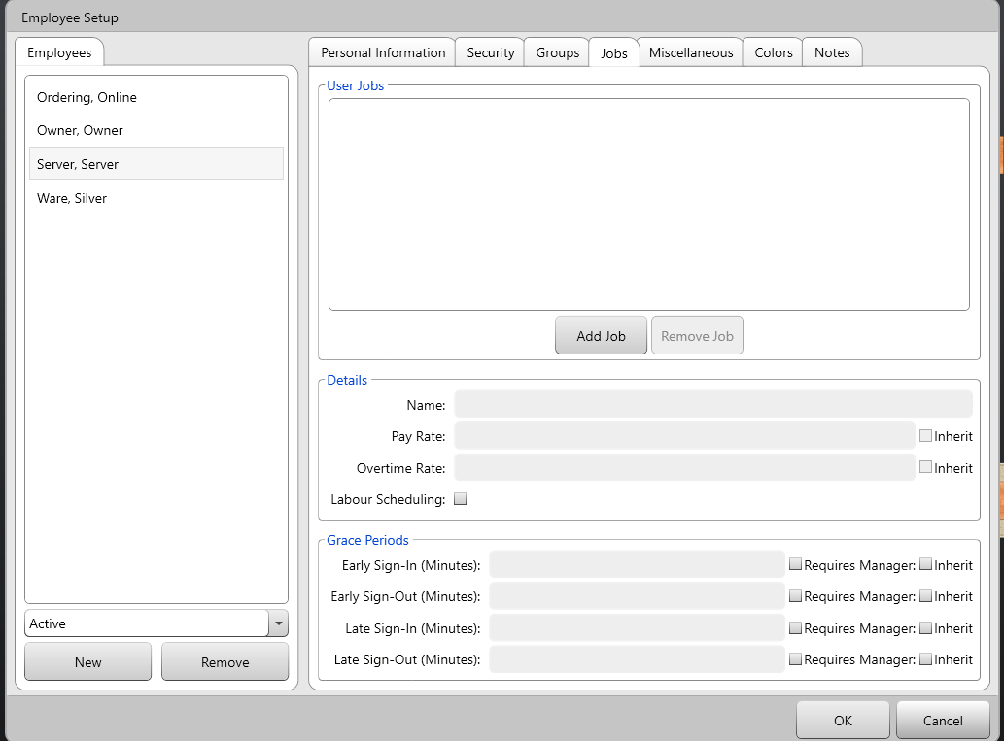
- Select an employee from the list on the left-hand side of the screen.
- Press Add Job and choose a job from the list that appears.
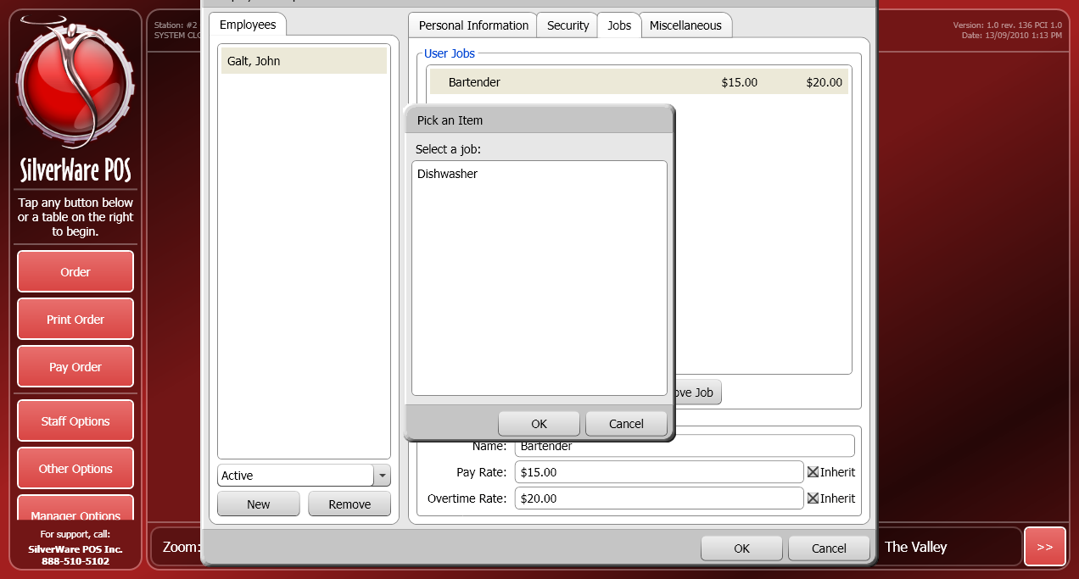
- Once you’ve added a job, you can turn off the “Inherit” check boxes if you want to assign a different pay rate or overtime rate to the selected employee.
NOTE: Employees can have multiple jobs, each with a different pay rate and overtime rate. They will be prompted to choose a job when signing-in. The appropriate pay rate will be used when calculating their wages.
The Labour Scheduling checkbox should be turned when integrated with a labour service such as HotSchedules. This ensures that the employees hours are synced between Avrio and HotSchedules. The Grace Periods can then utilized as well. These settings let you setup how early/late before/after their scheduled shift the user can sign-in/out, and with or without manager approval being required for those situations.

Misc.
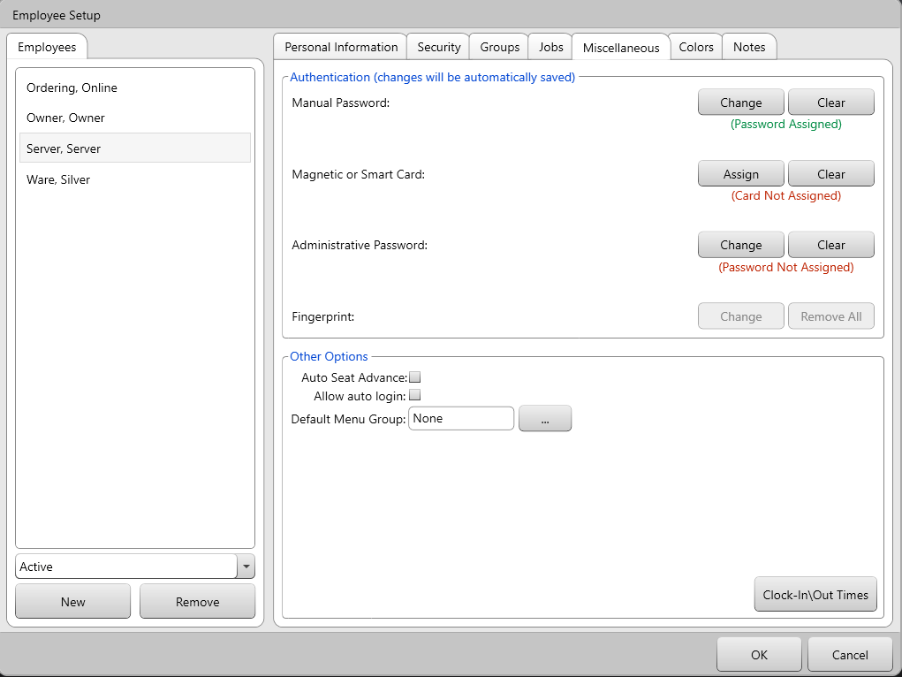
An employee’s password/swipe-card/fingerprint is how SW identifies them, assigns orders to their records, tracks their hours, etc.
- Manual Password lets you assign a numeric password to the employee. Press Clear to remove the numeric password associated with this employee.
- Magnetic of Smart Card lets you assign a magnetic swipe card to this employee. Press Clear to remove the swipe card associated with this employee
- Administrative Password lets you create a password for an employee that needs to access the “System Settings” or “Employees” screens. The password must meet these criteria:
  - Must be at least 8 characters.
  - Have at least one each of these criteria:
    - Lowercase letters
    - Uppercase letters
    - Number or Symbol
- Fingerprint lets you assign a fingerprint that this employee can use instead of a manual password or swipe card. This requires the Avrio biometrics module and a fingerprint scanner.
- Auto Seat Advance determines if the next guest is automatically selected after an employee orders an item for a guest. This may make it much easier for employees to split the bill later.
- Allow Auto Login determines if this user can be automatically logged in and considered the “active” user for a particular station without anyone actually having to sign-in.
- Default Menu Group lets you set a particular menu group to be the first page visible when this user starts an order.
- Clock-In\Out Times lets you modify an employee’s clock-in/out times.
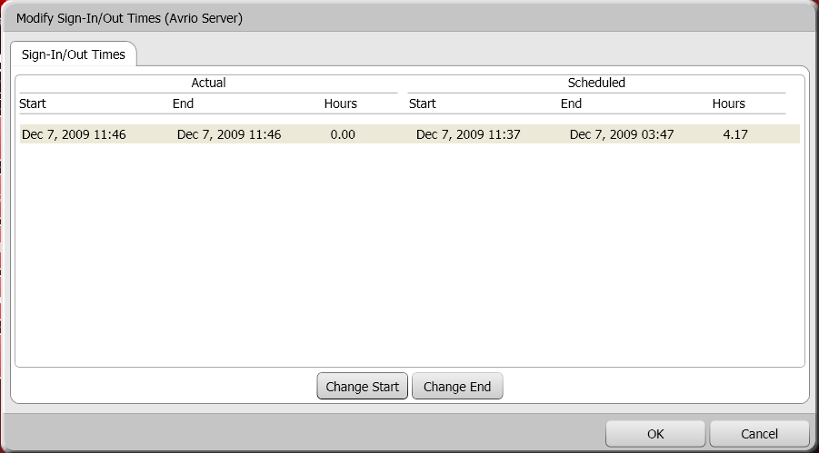
- Select a shift, the use the Change Start/Change End buttons to modify the date and time the shift started/ended.
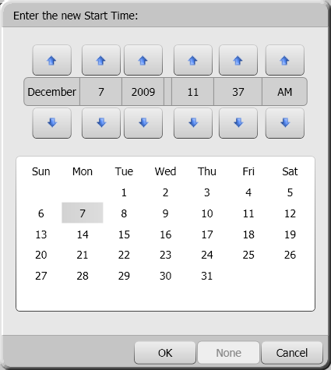

Creating Jobs
The Jobs area within Manager Options lets you create jobs and assign pay-rates to them. These jobs can then be assigned to an employee. When you view an Employee Timesheet report, employees with jobs will show the employee’s name, their shift and the job they worked during each shift, their pay-rate, and the report will also calculate the employees’ wages before any taxes, deductions, bonuses, etc.

Jobs Creation
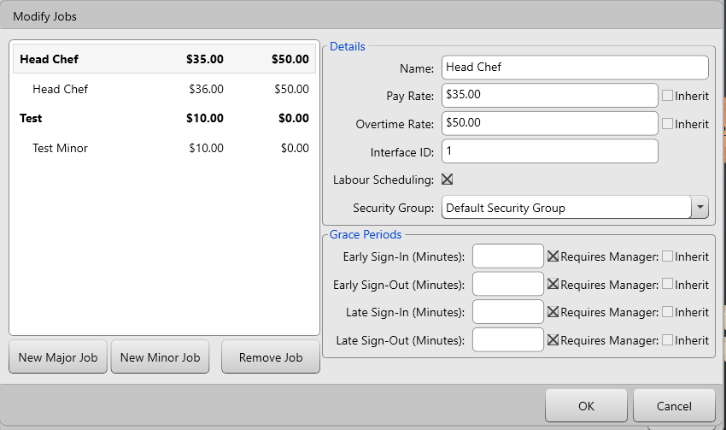
- Press New Major Job to create a new major job type, such as “Kitchen” or “Serving Staff”
- Assign a pay rate and overtime rate to the major job. Minor jobs can inherit these rates, or you can overwrite them.
- Select a major job, and then touch New Minor Job to create a minor job that falls underneath the major job, such as “Dishwasher” under “Kitchen” or “Bartender” under “Serving Staff.” As , mentioned above, you can turn off the “Inherit” check boxes when you have a minor job selected, allowing you to assign a different pay rate or overtime rate to the minor job.
- See the “Employees” section of this document for information on assigning jobs and pay rates to employees.
NOTE: When assigning jobs to employees, you can assign a pay-rate and overtime rate specific to that individual as well.
In an environment where Avrio is integrated with HotSchedules, Labour Scheduling and Grace Periods can then utilized as well. Labour Scheduling should be turned on if you want any shifts worked by users with these jobs assigned to be synced with HotSchedules. Grace Periods let you setup how early/late before/after their scheduled shift a user with the assigned job can sign-in/out, and with or without manager approval being required for those situations. These settings can be changed/overwritten on individual users, or the employee can inherit the settings based on the job(s) assigned to them.
See this section for information on assigning jobs to employees.

Clients and Gift Cards
Clients and gift cards are part of Avrio’s integrated loyalty system. Avrio swipe cards can be used for either a client account or as a gift card; it is simply a matter of how the card is configured within the program.
Avrio lets you create a database of clients. You can assign discounts or different price levels to a client, and you can setup a credit account. You can also extend these benefits to the client’s family or associates.
Press New to create a client, or touch a client’s name to edit the client’s properties. Press a client and touch Remove to erase the client’s information. If a client has a purchase history, you will not be able to remove him/her.

Creating a Client
Press New to create a new client.
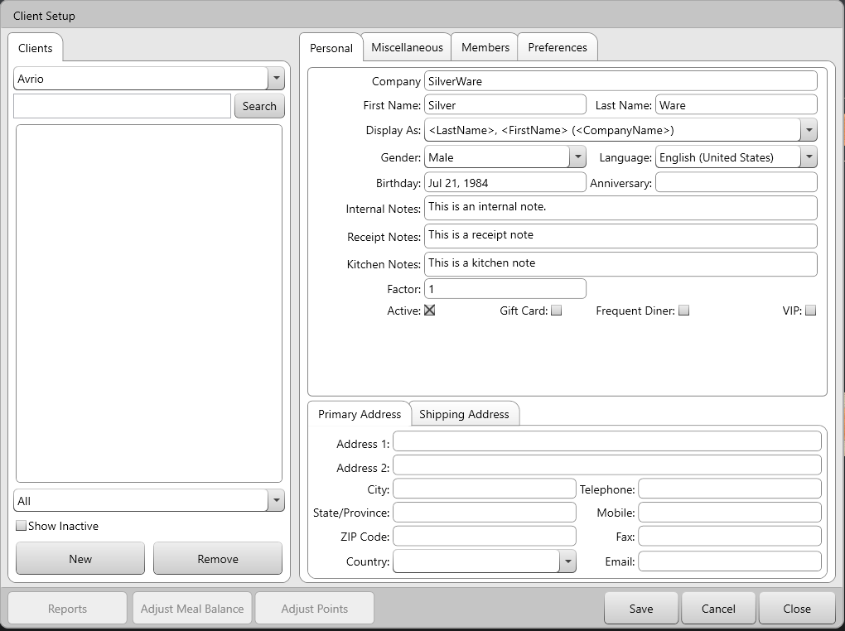
- Company is where you enter the client’s company, if applicable.
- First Name is where you enter the client’s first name.
- Last Name is where you enter the client’s last name.
- Display As determines how the client’s name/company information is displayed. There is an option to as “Card Number” which you should select if this account is going to be a gift card.
- Language is where you enter the client’s preferred language.
- Birthday is where you enter the client’s birthday. Avrio can be setup to remind users that a client’s birthday is approaching. Press the … to open a date-selection box.
- Anniversary is where you can enter the client’s wedding anniversary/special date. Avrio can be setup to remind users that the day is approaching, perhaps to invite the guest and spouse for a discounted meal. Press the … to open a date-selection box.
- Internal Notes lets enter notes about his client that will only be visible within the Avrio software itself
- Receipts Notes lets you enter a note that will print on any receipts this client is affiliated with.
- Kitchen Notes lets you enter a note that will print on any kitchen chits this client is affiliated with.
- Factor is used with Avrio’s “Frequent Diner” system. If this client will be earning points on their purchases, the factor settings lets you increase (i.e. double/triple/etc) the rate at which they earn points.
- Active determines if a client/card is active or not. If you cease business with a client (but cannot delete him/her because they made a purchase), check this box to effectively remove the client.
- Gift Card should be checked if this loyalty account is a gift card instead of a long-term client.
- Frequent Diner determines if this client earns points for their purchases. See this section for more information on the point system.
- VIP lets you differentiate this client from other, non-VIP clients. Some settings can be applied to VIPs only, and some reports let you filter on VIP info only.
You can then fill in the client’s primary/shipping Address and contact info.

Misc.
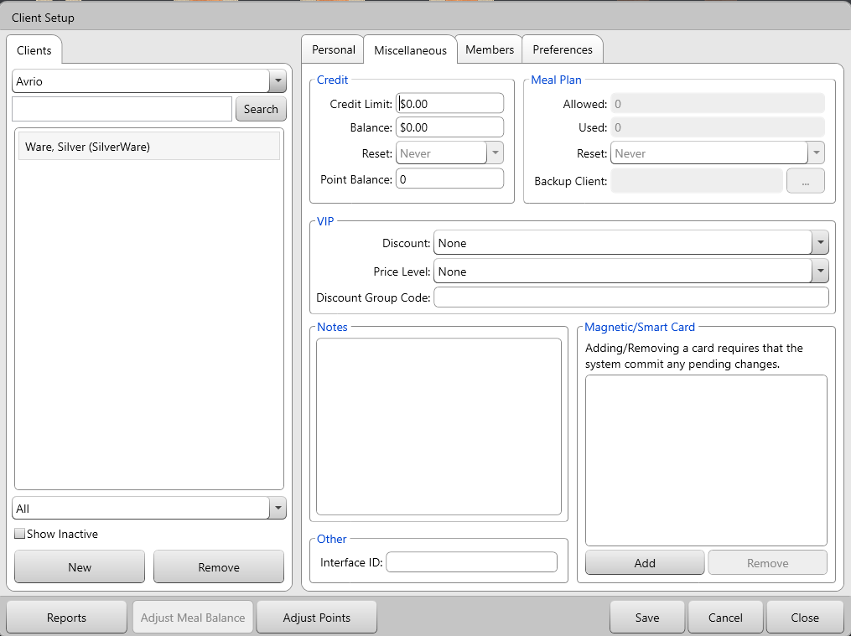
Credit
- Credit Limit allows you to give the client credit. If you give a client credit, and also assign a swipe card to the client, the swipe card can be used to charge this credit.
- Balance shows the client’s balance owing. If in the negative, this means a balance is owed to the customer.
- Reset determines if/when the client’s credit resets.
  - Never – The client’s credit never resets.
  - Daily – The client’s credit resets daily. Tell your SilverWare dealer what time of day you want the balance to reset.
  - Weekly – The client’s credit resets weekly. Tell your SilverWare dealer which day of the week you want the balance to reset.
  - Monthly – The client’s credit resets monthly. Tell your SilverWare dealer which day of the month you want the balance to reset.
Meal Plan
- Allowed determines how many meal-plan items this client can order.
- Used shows how many meal-plan items this client has ordered.
- Reset determines if/when the client’s meal-plan balance resets
  - Never – The client’s meal plan never resets.
  - Daily – The client’s meal plan resets daily. Tell your SilverWare dealer what time of day you want the balance to reset.
  - Weekly – The client’s meal plan resets weekly. Tell your SilverWare dealer what time of day you want the balance to reset.
  - Monthly – The client’s meal plan resets monthly. Tell your SilverWare dealer what time of day you want the balance to reset.
  - Factor Monthly – The client is given the number of allowed meals you set in the allowed field, multiplied by the number of days in each month.
- Backup Client allows this client to use meals from another client if their own balance hits zero.
Point Balance shows the client’s current point balance. Points can be redeemed for coupons, which are one-time-use coupons.
VIP
Theses options apply regardless if the client has been marked as a VIP or not.
- Discount lets you assign a discount to the client that will be applied to all orders. Clients cannot have open discounts, only discounts with designated percentages or dollar amounts can be selected. Disable for gift cards.
- Price Level lets you assign a price level to the client, so that all items are ordered at that price level. For example, all items might have a “VIP” price level in which they are $1 less. Disable for gift cards.
Notes
- Notes allows you to enter notes about the client.
Magnetic/Smart Card
- Magnetic/Smart Card lets you can assign a swipe card to a client. Press Assign to assign a card. Obviously this must be done for a gift card, but is optional for a client account.
Other
- Interface ID lets you attach an ID # to this client that would be used for exports/reporting.

Members
You can associate people to a client’s account. These “members” can have their own swipe cards, but they’ll receive the same discounts/price level as the client. The bill is still applicable to the client.
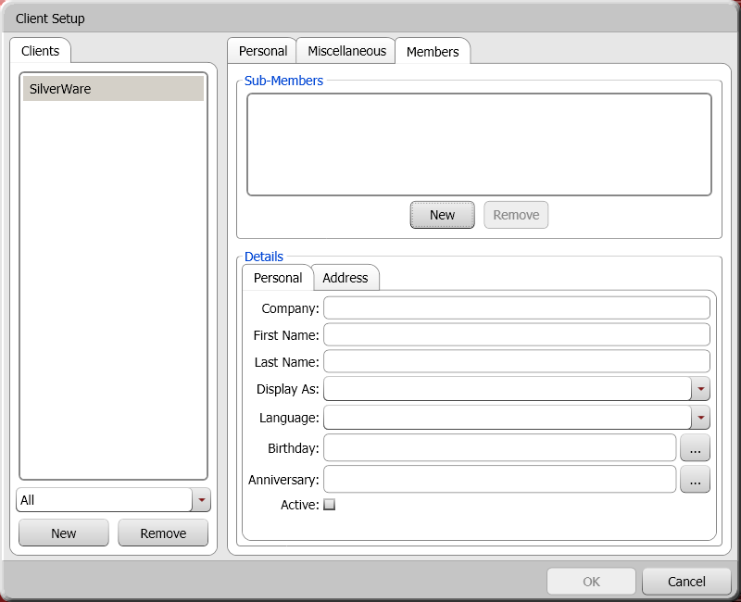
Select a client on the left, then use New and Remove to add/erase members. You can’t remove a member with a purchase history.
- Company is where you can enter the member’s company, if applicable.
- First Name is where you enter the member’s first name.
- Last Name is where you enter member’s last name.
- Display As determines how the member’s name/company is displayed.
- Language lets you enter the member’s language.
- Birthday is where you enter the member’s birthday. Press the … to open a date-selection box.
- Anniversary – The member’s anniversary/special date. Press the … to open a date-selection box.
- Active determine if the member is active/inactive. Members with a purchase history cannot be removed, so make them inactive if you want to disable their account.
- Magnetic/Smart Card lets you assign/remove a card to the member.

Preferences & Fields
The “Fields” area can be used for sorting clients. Some reports let you filter clients based on their matches with these fields.
Press the “…” button to create fields and the possible selections for each field.
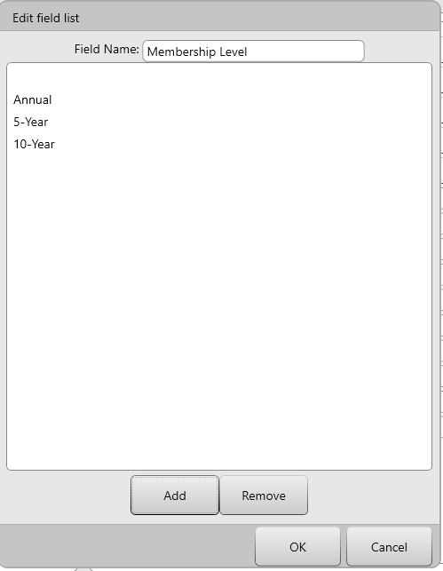

The “Preferences” area exists so you can create a list of a client’s preferences. Filling out this area by simply typing the client’s preferences in the fields provided.
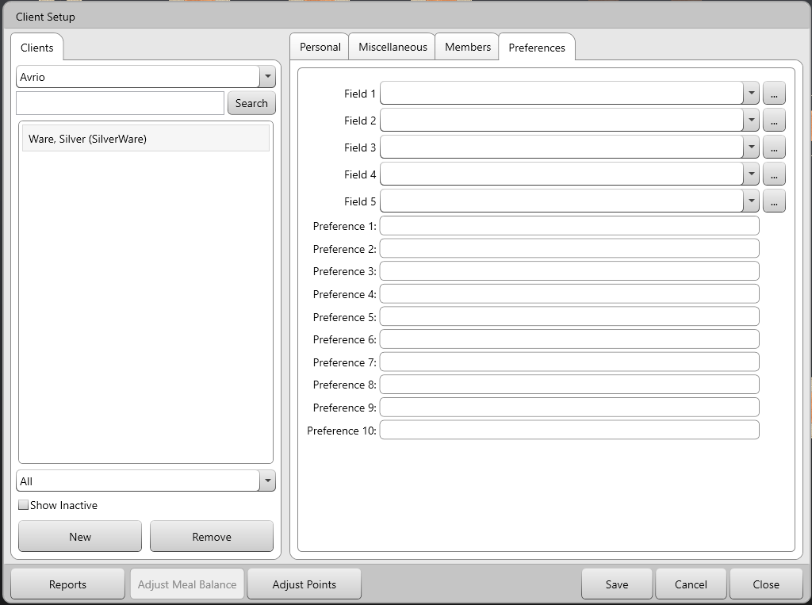

Adding a Gift Card
To add a gift card to your system:
- In the “Client Setup” window, add a new client.
- Check the “Gift Card” box.
- Change the “Display As” property to “Card Number.”
- Go to the “Miscellaneous” tab and Add a magnetic/swipe card.

Loading a Gift Card
Within the “Other Options” menu on the “Order” screen, touch Load Gift/Loyalty Acct to access loyalty functions.
- This window appears:
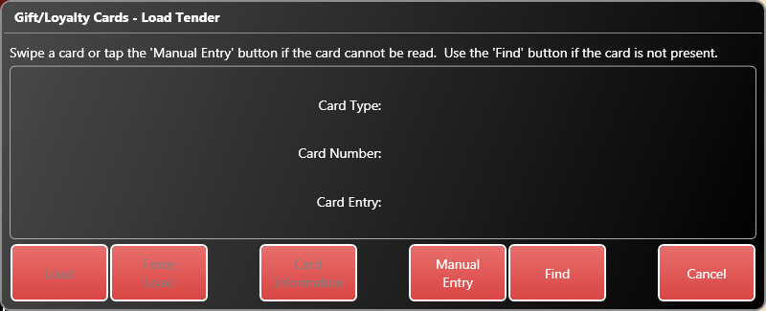

- Swipe a card or enter press Manual Entry to enter the card information:
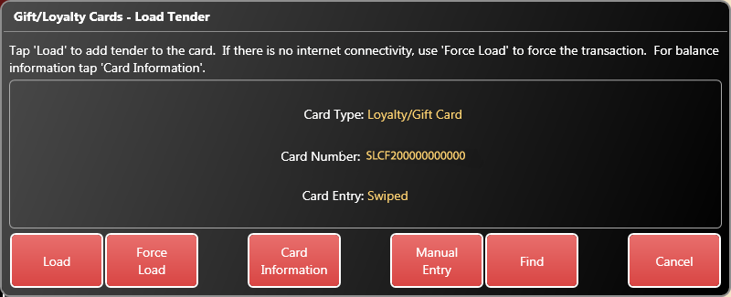
- Now choose Load to load the card normally, or Force Load to load the card if no connection to the loyalty service is possible. If you force the load, you will have to enter an approval code. Press Card Information to see information about the card’s current balance and any associations with a client.
- Enter an amount to load.
- The “Order” screen appears. You can now continue or close the order.

Themes
This area lets you customize the look of Avrio. There are built-in “system” themes, and you can also create your own.
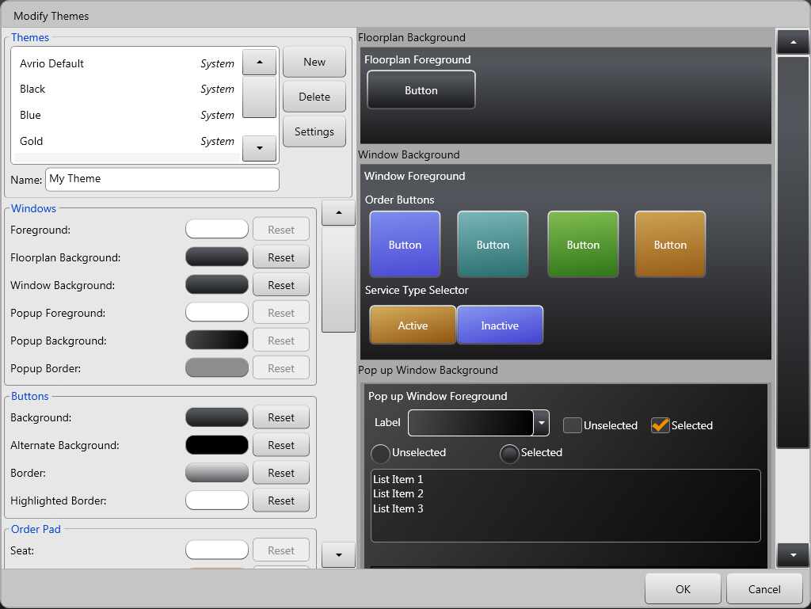
You can select any of these on the left-hand side of the screen to preview a theme. The various Avrio components on the right-hand side will change as you select different themes.
To create a new theme, press the New button and select a theme to use as a basis for your new theme
You can delete any of your custom themes by selecting and pressing Delete. You cannot delete “system” themes
You can modify a component’s colour by using the various colour-picker boxes next to the component name on the left.

Theme Settings
The settings area is how you actually assign themes to your store/stations. Press the Settings button on the main “Themes” window to access this area.
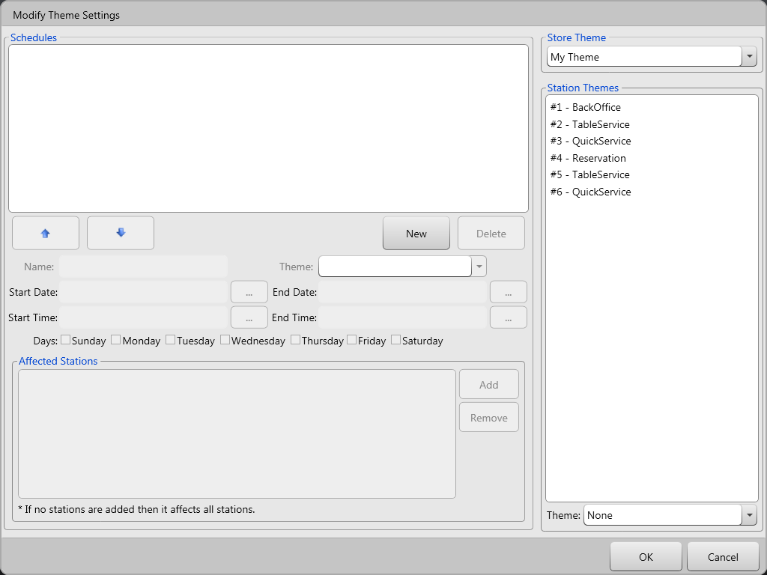
To set a theme for the entire store, select a theme from the “Store Theme” drop-down window in top-right corner of the screen.
You can also select an individual station and set a theme for it. To do so, select a station from the list on the right and then select a theme from the “Theme” drop-down box in bottom-right corner of the screen.
You can also schedule themes using the scheduler on the left side of the screen. You can schedule themes to change in the entire store, or you can schedule theme changes for specific stations.

Coupons
Coupons are essentially a way of issue a one-time use of a discount that already exists in your system. Before creating a coupon, make sure you have a discount in your system that represents what you want to do with the coupon.
The “Coupons” section is where you can create coupons to be issued to clients or that can be used when randomly generating coupons (see the “Miscellaneous” section of System Settings for instructions on generating random coupons). Any coupon can be used for both purposes.
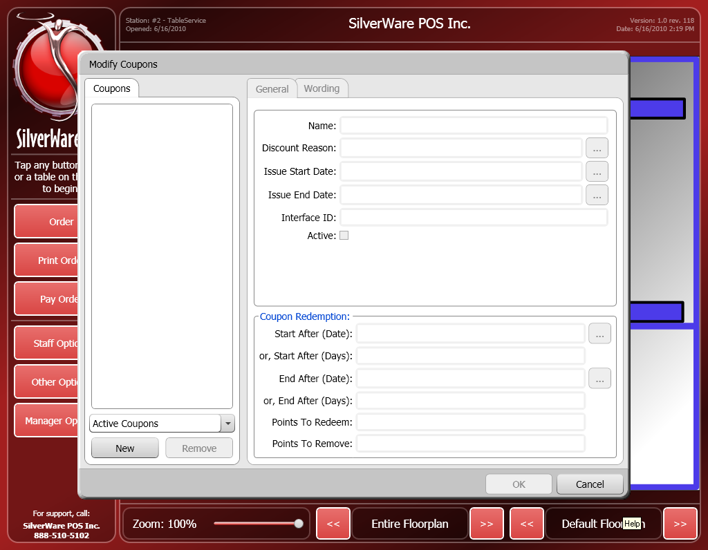
- Press New to create a new coupon.
- Enter the coupons name in the Name field.
- Discount Reason determines which discount will be issued on the coupon.
- Use the Issue Start Date and Issue End Date to enter a date range that the coupon can be issued within.
- Interface ID (undefined)
- Active determines if the coupon is active or not.
- Start After (Date) determines the beginning of the period during which the coupon can be redeemed. You can use this setting or the next one, Start After (Days)
- Start After (Days) determines how many days must pass from the time the coupon is issued before it can be redeemed.
- End After (Date) determines the end of the period during which the coupon can be redeemed. You can use this setting or the next one, End After (Days)
- Points to Redeem determines how or if any points a customer must have to redeem a coupon.
- Points to Remove determines how many points a customer loses when they redeem the coupon.
- End After (Days) determines how many days can pass from the time the coupon is issued before it can no longer be redeemed.

Modifying Floorplans
The Floor Plan Designer lets you add, edit, and remove tables. You can also setup table indication and assign tables a cost/printer center. To access this feature, go to Manager Options Configuration Floorplans.
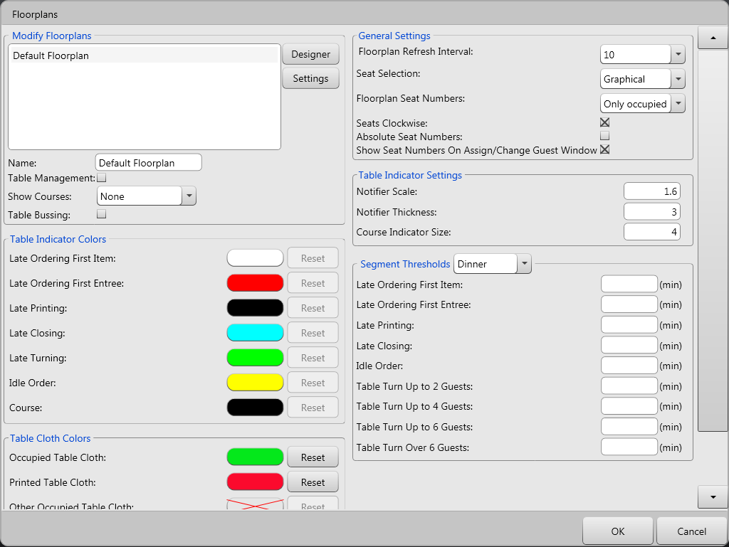
To add/remove/modify the tables on a floor, select a plan from the list in top-left corner of the screen and press Designer.

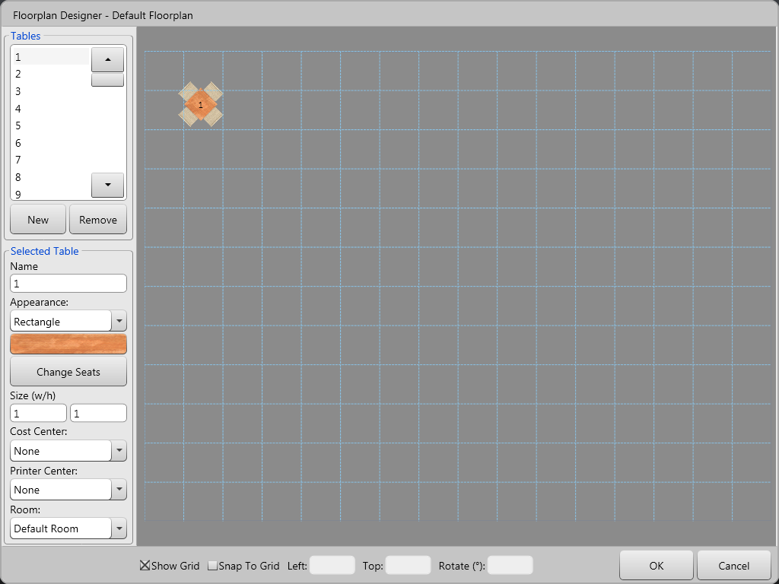
Touch and drag a table to move it around the floor plan. The options at the bottom of the screen let you:
- Show Grid displays a grid for easy table alignment
- Snap To Grid causes tables to stay attached to a grid, making it very easy to keep tables in line with each other.
- Left determines the selected table’s position, in pixels, from the left edge of the floor plan.
- Top determines the selected table’s position, in pixels, from the top edge of the floor plan.
- Rotate lets you rotate the selected table.

Editing/Creating/Moving Tables
- Select a table on the floor plan or from the list to modify its properties.
- Press New to create a new table, then select it from the list on the left and drag it to the floor plan to add it.
- Select a table from the list or the floor plan and press Remove to remove it.

Selected Table
Name lets you enter/change the name of a table.
Shape lets you select a shape for the table; circular or square/rectangle.
Size lets you change the width/height of a table.
Surface lets you select a surface for the table.
Seats lets you add/remove normal and spare seats to a table:
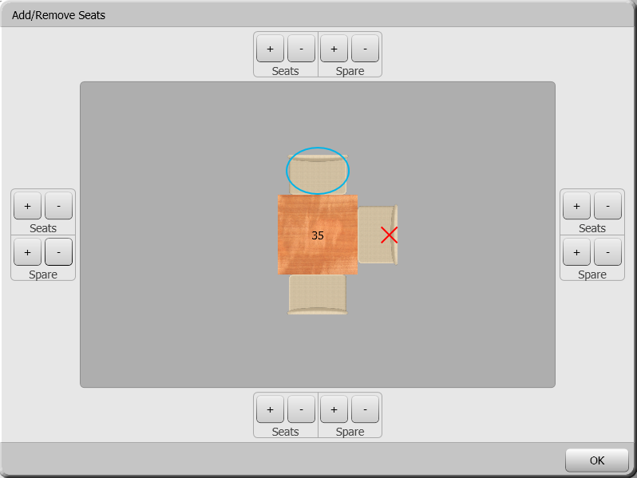
The seat with the blue ring around will be used as seat one when a server is ordering for this table. Touch a seat to move the blue ring to it and mark it as seat one.
Use the + and - buttons on each side of the table to add/remove a seat/spare seat to a table. Adding spare seats allows employees to add larger parties to table when ordering. Seats marked with a red “X” are spares.
Cost Center lets associate this table with a cost center.
Printer Center lets you associate this table with a printer center.

Floorplan Settings
There are a variety of settings available in the floorplan screen:
- Name – Name your floorplan
- Table Management – Turns the table management system on/off. The table management system lets you setup time-based indicators, which are explained below.
- Show Courses – Lets you show indicators on the tables to show how many courses have been ordered or fired for the table
- Table Bussing - Causes tables to change colour after an order has been closed to indicate that they need to be bussed.
The “Indicator Colours” settings let you choose the colours the tables will become to indicate various states
- Late Ordering First Item – The table has seated guests, but no order has been placed yet
- Late Ordering Entrees – No items that are considered entrees have been ordered yet. An item is considered an entrée if it has order on the course that is set an the entrée course (this is set in the “Courses” section of “System Settings”)
- Late Printing – The check(s) has not been printed after X minutes.
- Late Closing – The order has not been closed after X minutes.
- Late Turning – After the previous was closed, a new order has not been started after X minutes.
- Idle Order – No items have been ordered for an existing order after X minutes.
- Course – The colour that the course indicators will be.
Table Cloth Colours
This area lets you customize the colours that tables will be depending on the current logged in user:
- Occupied Table Cloth – Colour when table is occupied.
- Printed Table Cloth – Colour when check(s) has been printed
- Other Occupied – When a user is logged in (they’ve pressed order, print order, or close order) they will see their own tables as the occupied table color, and other users’ tables as the “Other Occupied” colour.
- Other Printed – When a user is logged in (they’ve pressed order, print order, or close order) they will see their own printed tables as the printed table color, and other users’ printed tables as the “Other Printed” colour.
- Dirty Table Cloth – Colour when the table needs to be bussed
General Settings
- Floor plan Interval determines how often the floor plan updates to reflect changes (customers seated/leaving, bills printed, etc).
- Seat Selection determines the default seating style used on the “Assign Guests” screen when an employee starts a dine-in order.
- Floorplan Seat Numbers determines if seat numbers on shown on tables:
  - Only on occupied seats
  - All seats
  - Never
- Seats Clockwise is used to determine how seats are numbered.
- Absolute Seat Numbers determines how seats are numbered. When off, seats are number only when occupied. When on, seat always have a number even if no guest is on the seat.
- Show Seat Numbers on Assign/Changes Guests Window determines if seat numbers are visible assigning guests to a table, or changing the number of guests on an existing order
Table Indicator Settings
- Notifier Scale and Notifier Thickness determine the size of the indicator rings.
- Course Indicator Size determines the size of the dots that show on tables to indicate which course the table is on.
Segment Thresholds
This area lets you define the times (in minutes) for the various table indicators to show on the floorplan.

Payment Methods
This screen lets you add, edit, or deactivate the payment types you accept.
To access this screen, go to Manager Options Configuration Payment Methods.
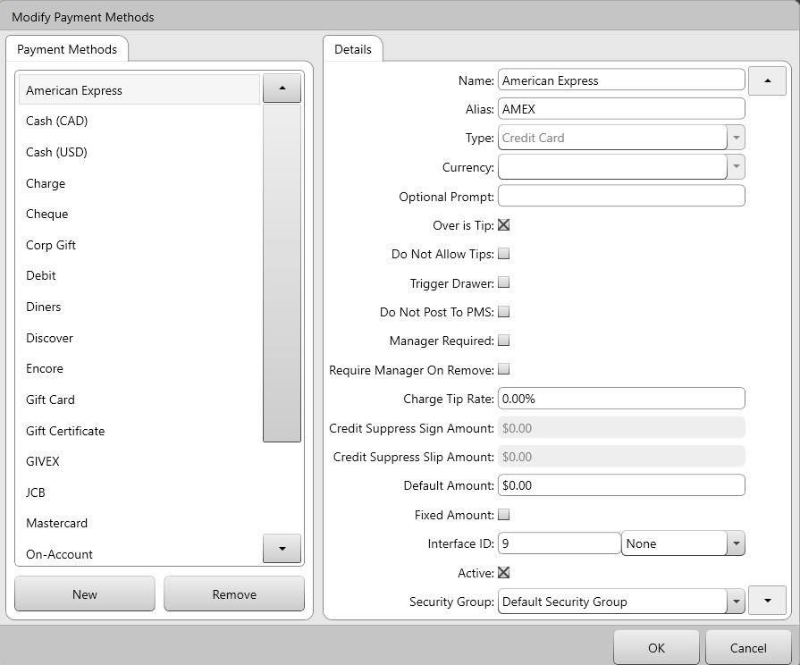
Use New and Remove to add/remove methods. You cannot remove a payment type that has been used, but you can deactivate it.

When you press New, you’ll be prompted to choose a “type”.
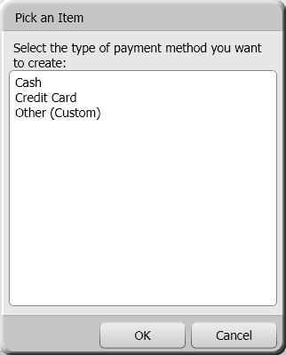
- Name is where you enter the name of the method.
- Alias is the name of the method as it will be displayed on receipts.
- Type is where you choose the style of funds the method is (cash, credit card, on account, gift card, etc). Once a type is chosen for a new method, it cannot be changed, so you’ll have to remove a method if you choose the wrong type.
  - The type also determines if you can choose a currency or not (i.e. credit card types cannot be linked to currency).
- Currency lets you choose a currency to base the method on, when the method is cash.
- Optional Prompt allows you to attach a prompt to a payment method. The user has to enter more information about the payment, such as a gift certificate number or a coupon code.
- Over is Tip determines if any amount that goes over the balance due is automatically considered a tip, and no further payment is required. The server should enter the total amount that the customer is paying, and should not enter the tip separately.
When turned off, any amount over the balance due is assumed to be change that will be given back to the customer.
- Do Not Allow Tips lets you disable the ability for the payment type to apply tips to a check.
- Trigger Drawer determines if the cash drawer opens when this payment type is used.
- Do Not Post to PMS is only used in environments where Avrio is integrated with a hotel property management system. If this setting is turned on, checks containing this payment method will not be posted to the to the hotel PMS.
- Charge Tip Rate lets you charge your servers when a they accepts a tip on this payment method. The dollar value generated by this function will be added to their “net cash owing”
- Credit Suppress Sign Amount is used to determine if a signature line will appear on integrated credit card slips printed by Avrio, based on the dollar value of the check.
- Credit Suppress Slip Amount is used to determine if credit card slips will print, based on the dollar value of the check.
- Default Amount forces the payment method to apply the specified dollar value to the check when the payment method is used.
- Fixed Amount set the “Default Amount” (as described above) as fixed, so it cannot be changed after being applied to a check
- Interface ID is used to attach an ID # to this payment method, for use in various integration or exports
- Active lets you activate or deactivate the method. Once a payment method has been used, you cannot remove it, you can only deactivate it to stop it from being used again.
- Security Group lets you assign this payment method to a security group, limiting which users can edit it.

Discount Reasons
The “Discount Reasons” screen is where you create/edit/remove discounts.
To access this screen, go to Manager Options Configuration Discount Reasons.
Press New to create a new discount. You can select “Percent Off” to create discounts that takes a percentage off an item or bill, or “Value Off” discounts that take a dollar value off an item or bill.
If a discount will be assigned to a client, it cannot be an open amount and you cannot set it to inactive.
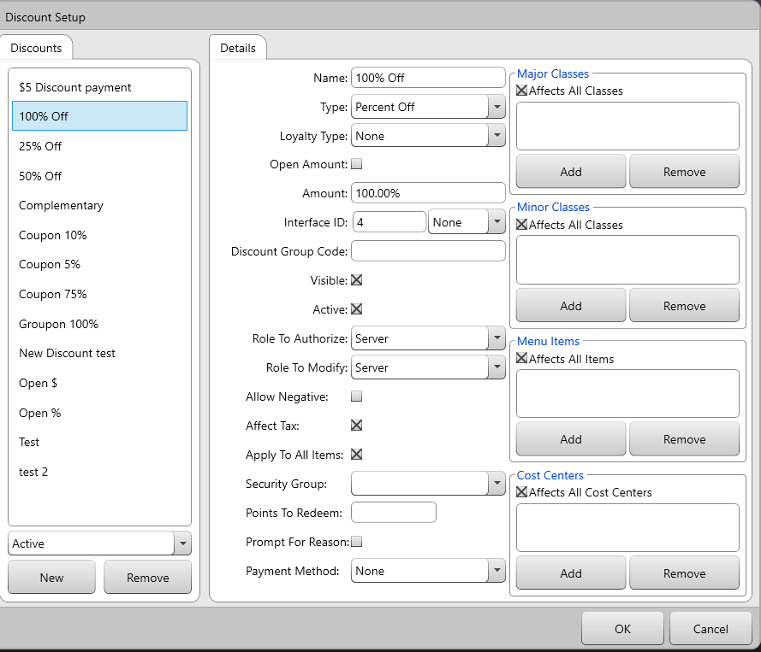

- Name is where you enter the name of the discount.
- Type lets you select either “Percent Off” or “Value Off”
- Loyalty Type lets you affiliate the discount with Avrio’s own loyalty system, or one that it integrates with. This would typically be used when a discount should be removing points from a client’s account.
- Open Amount lets you make the discount an open amount.
- Amount is where you enter the percentage/dollar amount of the discount, if “Open Amount” is not checked.
- Interface ID is used to attach an ID # to the discount, for use with exports or integrations
- Visible determines if the discount is visible in the list of discounts when a user attempts to apply a discount to a check. You may want to hide the discount if it’s only being used on client profiles, for example.
- Active determines if the discount is available/unavailable for use. You cannot remove a discount that has been used in a transaction, so set it to inactive if you don’t want it being used again.
- Role to Authorize determines the type of employee that can give this discount. You can determine an employee’s role in the Employees Security menu.
- Role to Modify determines which level an employee must be to modify this discount.
- Allow Negative determines if the discount can be used to make an item’s price become negative.
- Affect Tax determines if the is applied to the original price, or discounted price of an item
- Apply To All Items determines if the discount will be applied to items on a check, or if it will simply remove a dollar value from the check.
- Security Group lets you assign the discount to a security group, limiting which users can edit it.
- Points to Redeem determines how many points are removed from a client’s account when this discount is applied to a check.
- Prompt For Reason causes a keyboard to appear on screen when the discount is used.
- Payment Method can be used to make the discount apply as a payment method on the check, instead of lowering the check total in any way.

Void Reasons
The “Void Reasons” screen lets you create/edit/remove the reasons that staff use to void items and orders.
To access this screen, go to Manager Options Configuration Void Reasons.
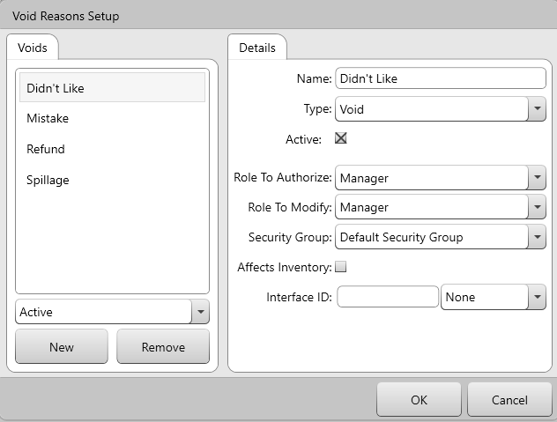
- Name is where you enter the description/reason.
- Void Type is you choose is the void is being used simply to void items, or is being used to perform refunds.
- Active determines if the void is available/unavailable for use. Once a void reason has been used, you cannot remove it; deactivate to stop it from being used again.
- Role To Authorize determines which level an employee has to be to authorize the void.
- Role to Modify determines which level an employee must be to modify the reason. When used in conjunction with employee roles, you can allow an employee to modify some voids, without giving them access to all managerial options.
- Security Group lets you assign the void to a security group, limiting which users can edit it.

Pay-In\Out Reasons and Blind Drops
This area lets you set up the reasons staff will use for pay-ins and pay-outs, and also lets your setup blind drops.
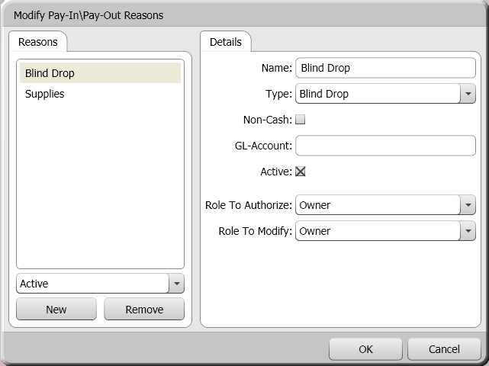

Press New to create a new reason, or select an existing reason to modify its properties.
Name – The reason’s name.
Type – The type of transaction the reason can be used for, either a pay-in, pay-out, both, or a blind drop. NOTE: if you want to be able to use the blind drop feature, you must create a reason that has a blind drop as the type
Non-Cash – If the transaction won’t be using cash, check this option.
GL-Account – If the transaction should be posted to a general ledger account, enter the account here.
Active – Determines if the reason can be used or not.
Role To Authorize – The role a staff member has to have in order to authorize this pay-in\out.
Role To Modify - The role a staff member has to have in order to modify this pay-in\out reason.

Gratuities
The gratuities area lets you create gratuities that servers can apply to checks.
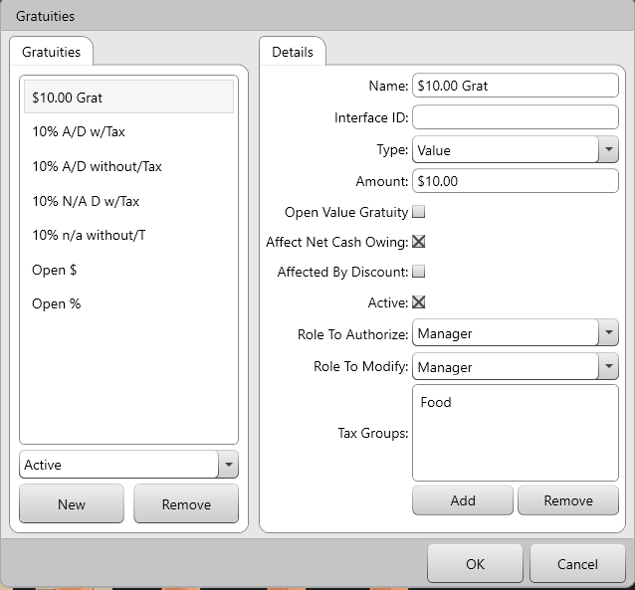
- Name is the gratuity’s name
- Interface ID attaches an ID # to the gratuity, which may be used in different integrations or exports
- Type determines if the gratuity is a percentage or dollar value
- Amount lets you enter the dollar value or percentage that this gratuity will apply to the check.
- Affect Net Cash Owing – When this is checked, the server owes less, as the gratuity is not included in the server’s net cash owing. When it is not checked, the gratuity is included, and the server must pay the gratuity back to the house.
- Affected by Discount determines if the gratuity value decreases if items are discounted.
- Role to Authorize determines the role an employee has to be to authorize this gratuity.
- Role to Modify determines the role an employee has to be to modify this gratuity.
- Tax Groups determine which, if any, taxes, should be applied to gratuity.

Order Item Requirements
This section lets you setup conditions that have to be fulfilled before an order can be sent to the kitchen/bar, printed, or even closed.
While these requirements are not a common need, a great example of when they are useful is in a bar/nightclub setting. Perhaps an order cannot progress unless an alcoholic beverage has been put on the check, or a food item must be ordered to ensure that guests ingest food while consuming alcohol.
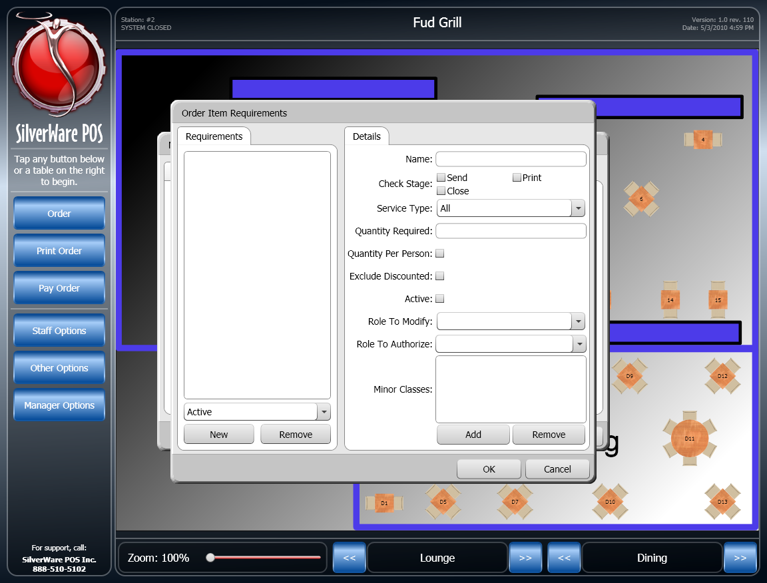
- Use New/Remove to create or delete a requirement.
- Enter a name for the requirement in the Name field.
- Choose a Check Stage. This refers to what action you will block until the requirement has been fulfilled.
- Choose a Service Type that this requirement affects.
- Quantity Required determines how many items from the possible minor classes must be ordered to fulfill the requirement.
- Quantity Per Person determines if the quantity set above is applicable to the entire check, or to every guest on the check.
- Exclude Discounted determines if items that have been discounted can fulfill the requirement or not.
- Active determines if this requirement is active.
- Role to Modify determines which role a user must be to modify this requirement.
- Role to Authorize determines which role a user must be to authorize bypassing the requirement.
- Minor Classes determines which items have to be ordered to fulfill the requirement. Items belonging to the minor classes you’ve selected will fulfill the requirement.

System Settings
The system settings area lets you configure a variety of settings for your location.

General
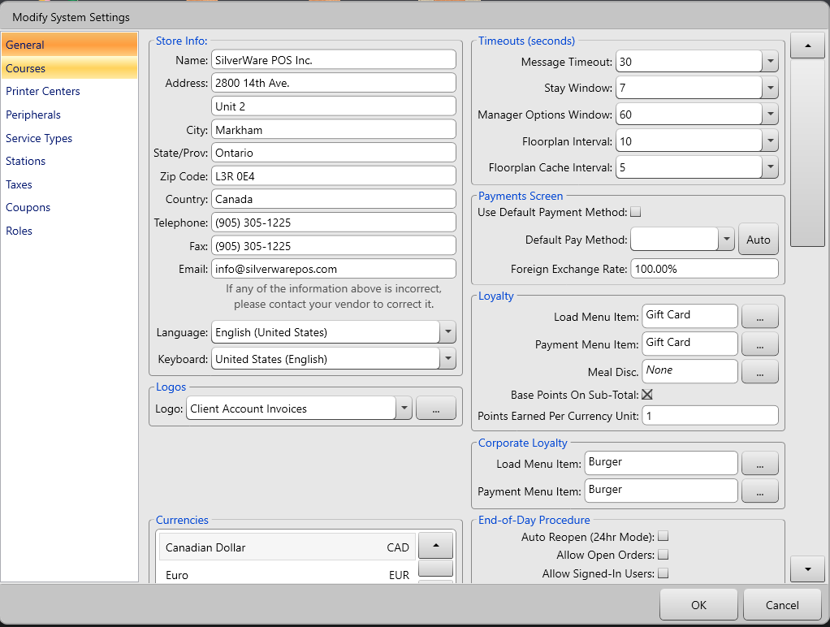
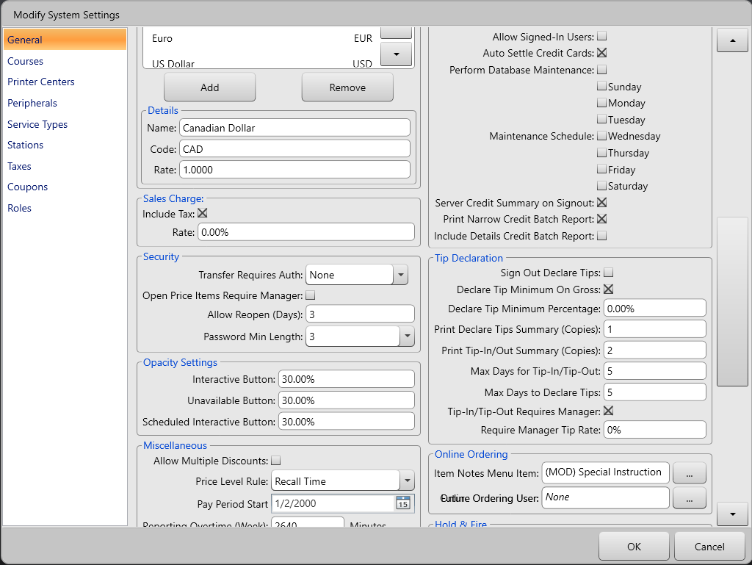
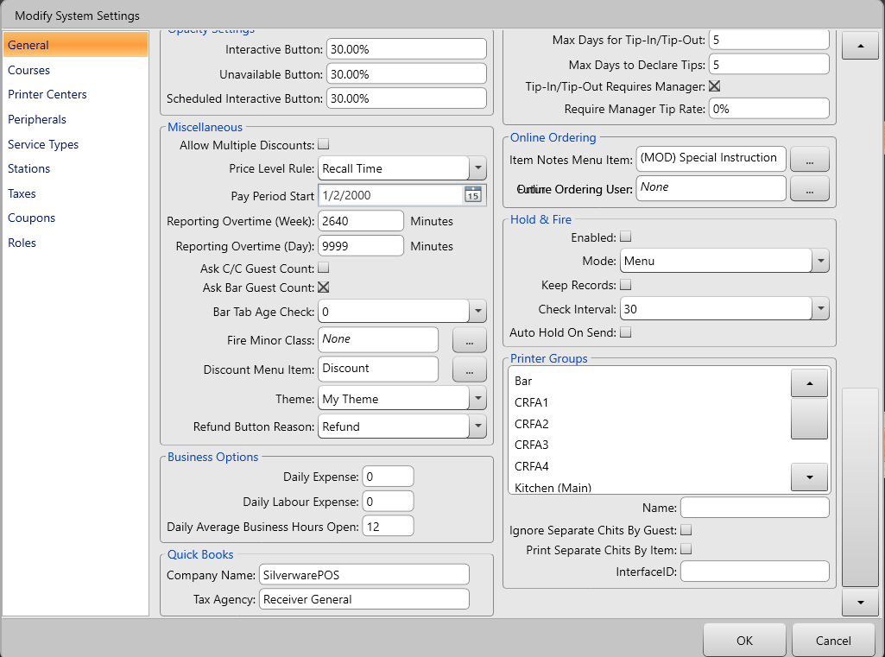
Store Info
The “Store Info” section is view-only and can only be modified by your vendor. You can only change the language and which style of on-screen keyboard your store uses.
The Language setting changes not only the language Avrio displays in, but also modifies how dollar signs, dates, decimals, etc are displayed.
Timeouts
- Message Timeout determines how long messages stay on the screen.
- Stay Window determines how long the “Stay” window remains on the screen.
- Manager Options Windows determines how long the “Manager Options” window will stay on-screen when left idle
- Floorplan Interval determines how frequently the floorplan is refreshed
- Floorplan Cache Interval determines how frequently a station updates the cached floorplan information

Miscellaneous
- Allow Multiple Discounts determines if an item can be discounted more than once in an order.
- Price Level Rule when price level schedules are in use, this determines which price level is applied to items that are ordered for checks open during a scheduled price level change (i.e. the level changes from lunch back to default). See this section for more about price levels and this section for more about price level schedules.
  - Recall Time - The price level is based on when the order is recalled (the current time). If the price level has changed, the items will be priced at the new level.
  - Open Time - The price level is based on when the order started, ignoring any price level changes.
- Pay Period Start determines which day of the week starts your pay period. This only matters if you are using Avrio’s “Employee Timesheet” report and will be calculating overtime.
- Reporting Overtime (Week) determines how many MINUTES an employee can work in a week BEFORE their overtime pay-rate is used in labour reports.
- Reporting Overtime (Day) determines how MINUTES an employee can work in a day BEFORE their overtime pay-rate is used in labour reports.
- Ask C/C Guest Count determines if Avrio asks how many guests are in a cash and carry order.
- Ask Bar Guest Count determines if Avrio asks how many guests are on a bar tab.
- Bar Tab Age Check when starting a bar tab, you can swipe an AAMVA standard driver’s license to check the license-holder’s age. This setting determines how old the license-holder must be in order to be served.
- Fire Minor Class lets you specify which of your menu minor classes contains your “fire” item. When this item is ordered, it informs the rest of the system which courses have been fired for a table.
- Discount Menu Item needs to be set if you want to use check-level discounts. Select the menu item that will appear on a check.
- Theme determines which theme will be applied store-wide.
- Refund Button Reason determines which void reason is used when a refund is applied to a check.
Currencies
This section lets you determines which, if any, foreign currencies you accept. Use the add/remove buttons to add/remove the currencies you accept.
You can change details such as the currency’s name and exchange rate in the “Details” section.
Sales Charge
A sales charge is a percentage of a server’s sales that you charge to cover spillage, mistakes, etc.
- Include Tax determines if the percent charged is based on the total sales with or without tax.
- Rate determines the percentage you’re charging.
Security
- Transfer Requires Auth determines if approval is required for servers to transfer orders.
- Open Price Items Require Manager determines if a manger’s approval is needed when ordering open-priced items.
- Allow Reopen (Days) determines how many days can pass before a closed check can no longer be reopened.
- Password Min. Length determines the minimum number of digits an employee’s password has to be.
Opacity Settings
- This section lets you determine the opacity of menu buttons
End-of-Day Procedure
- Auto Reopen (24hr Mode) automatically reopens the system after an end-of-day. Useful for 24-hour establishments.
- Allow Open Orders determines if open orders can exist when performing an end-of-day.
- Allow Signed-In Users determines if users can be signed-in when performing an end-of-day.
- Auto Settle Credit Cards determines if cards processed using integrated processing are automatically batches out at EOD.
- Perform Database Maintenance determines if database maintenance occurs at EOD. You can choose which days it will happen.
- Server Credit Summary on Signout determines if users get a summary of their integrated credit card transactions as part of their sign-out report.
- Print Narrow Credit Batch Report determines if a report of integrated credit card transactions will print upon settling credit cards.
- Include Details Credit Batch Reports determines if a more detailed version of the batch report prints.
Tip Declaration
This section lets you configure tip-declaration settings if you operate in a region that requires servers declare their tips.
- Sign Out Declare Tips determines if servers must declare their tips upon sign out.
- Declare Tip Minimum on Gross determines if the amount declared is based on gross or net sales.
- Declare Tip Minimum Percentage determines the percentage that will be multiplied against a server’s sales to calculate their tip declaration.
- Print Declare Tips Summary (Copies) determines how many copies of a tip-declaration summary are printed
- Print Tip-In/Out Summary (Copies) determines how many copies of a tip-in/out summary are printed when a tip-in/out occurs.
- Max Days for Tip-In/Tip-Out determines how many days can pass before servers cannot perform tip-ins/outs for a certain day.
- Max Days to Declare Tip determines how many days can pass before servers cannot declare tips for a certain day.
- Tip-In/Tip-Out Requires Manager determines if a manager must approve of tip-ins/outs.
- Require Manager Tip Rate determines what the maximum percentage of tip a server can accept without requiring a manager’s approval.
Online Ordering
These settings only apply if you are using Avrio’s online ordering 2.0 system.
- Item Notes Menu Item determines which menu item is ordered to a check for any special instructions entered by an online-ordering customer.
- Online Ordering User determines which user is assigned to the online orders.
Hold & Fire
Avrio’s “Hold & Fire” system lets servers order item and the “hold” them from being sent to the kitchen/bar. The server can then come back to a POS station and “fire” their items to a kitchen/bar.
- Enabled determines if the H&F system is active or not
- Mode determines how items are held.
  - Menu – items will be help for as long as their hold times are set to
  - Course – servers can choose to hold/fire items based on which course they are
- Keep Records determines if Avrio will keep logs on hold & fire usage
- Check Interval determines how frequently the system will look at open orders and see if items need to be fired
- Auto Hold On Send determines if menu items are automatically held upon being ordered.
Payments Screen
- Use Default Payment Method determines if Avrio automatically applies a payment to check when a user enters the “Close Order” screen.
- Default Payment Method determines the default pay method used on the “Close Order” screen FOR ALL STATIONS.
- Foreign Exchange Rate lets you create a surcharge when you accept foreign currency. The currency you accept (after conversion) is charged by this value. This amount doesn’t show up as an individual charge; it is factored into a currency’s the exchange rate.
Loyalty (Applicable If Using Integrated Loyalty Service)
- Load Menu Menu Item lets you select the item that will be used to track loyalty card loads. If you do not select an item, you will not be able to load loyalty cards. See the instructions on creating menu items to make an item to use here. The item doesn’t have to be visible or available to order; it only has to exist.
- Payment Menu Item lets you select the item that will be used to track client balance payments. If you do not select an item, you will not be able to make payments against client balances. See the instructions on creating menu items to make an item to use here. The item doesn’t have to be visible or available to order; it only has to exist
- Meal Disc lets you select the discount that will be used when a meal-plan item is ordered by a client that has a meal plan. See this section to learn more about meals plans.
- Base Points on Sub-Total determines if clients marked as frequent diners earn points based on the sub-total of check they are assign to or if they will earn points based on the point values assigned to menu items.
- Points Earned Per Currency Unit determines how many points a client earns for each full dollar/euro/etc in a check subtotal.
Corporate Loyalty
- Load Menu Menu Item lets you select the item that will be used to track cloud/corporate/chain-wide loyalty card loads. If you do not select an item, you will not be able to load loyalty cards. See the instructions on creating menu items to make an item to use here. The item doesn’t have to be visible or available to order; it only has to exist.
- Payment Menu Item lets you select the item that will be used to track cloud/corporate/chain-wide client balance payments. If you do not select an item, you will not be able to make payments against client balances. See the instructions on creating menu items to make an item to use here. The item doesn’t have to be visible or available to order; it only has to exist.
Logos
- Logo lets you choose an image file that will be applied to a variety of reports/invoices. Press the … button to select an image.
Business Options
- Daily Expense lets you enter a dollar value to add as a miscellaneous expense on your cost analysis and executive summary reports
- Daily Labour Expense lets you enter a dollar value to add as a labour expense on your cost analysis and executive summary reports
- Daily Average Business Open lets you enter the typical # of hour your business operates. This affects some of the calculations done on various reports in Avrio.
Quick Books
If you are exporting sales information from Avrio to Quickbooks accounting software, you will need to fill out these settings.
- Company Name – this setting default to “SilverwarePOS”. You need to create a client/company in Quickbooks that matches this EXACTLY.
- Tax Agency – This setting defaults to “Receiver General”. This setting should match the name of the Tax Agency in Quickbooks.

Printer Groups
“Printer Groups” are the names of the various printing/routing destination in your system. You can use this area to edit their names and change some settings about each destination
- Ignore Separate Chits by Guest can force items/orders that use this printer group to stay on one chit if any of your order types (table service, pick-up, take-out, etc) are set to force each guest’s order onto a separate chit
- Print Separate Chits by Item forces each item assigned to this printer group to be printed onto a separate chit instead of being grouped together.

Courses
This lets you activate and name the different courses (max. ten) that will appear on your order screen, kitchen slips, etc.
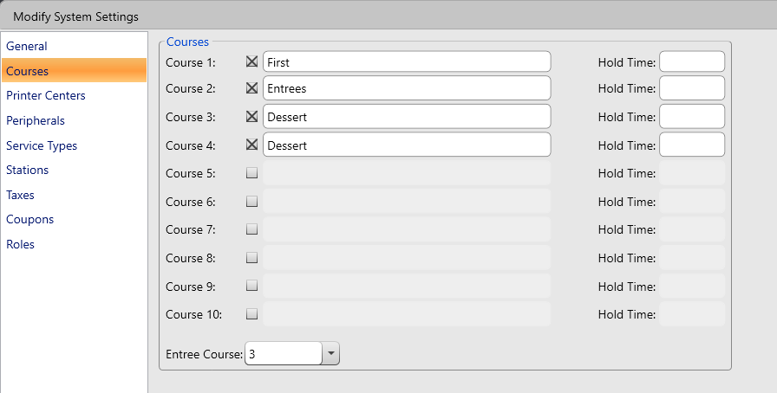

If you are using the hold & fire system in course mode, you can set a “hold time” for each course to have these courses fire automatically after the designated # of seconds.

Printer Centers
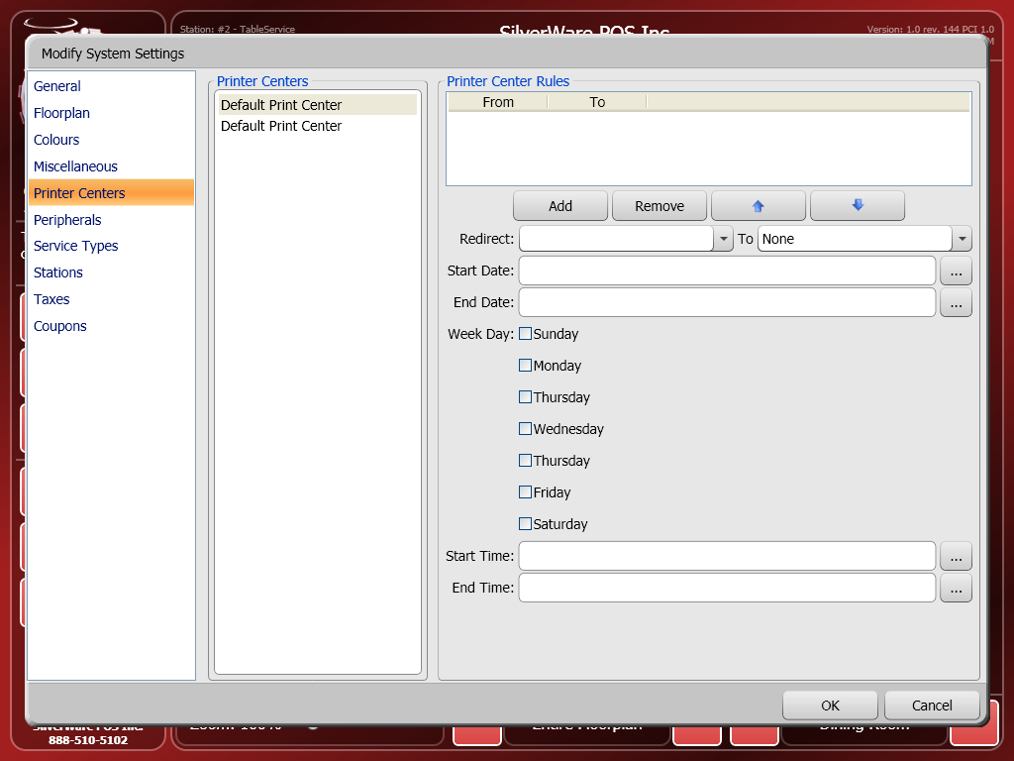
Use this window to configure printer centers. Printer Centers are rules that can be used to create complex kitchen/bar printing setups.

Peripherals
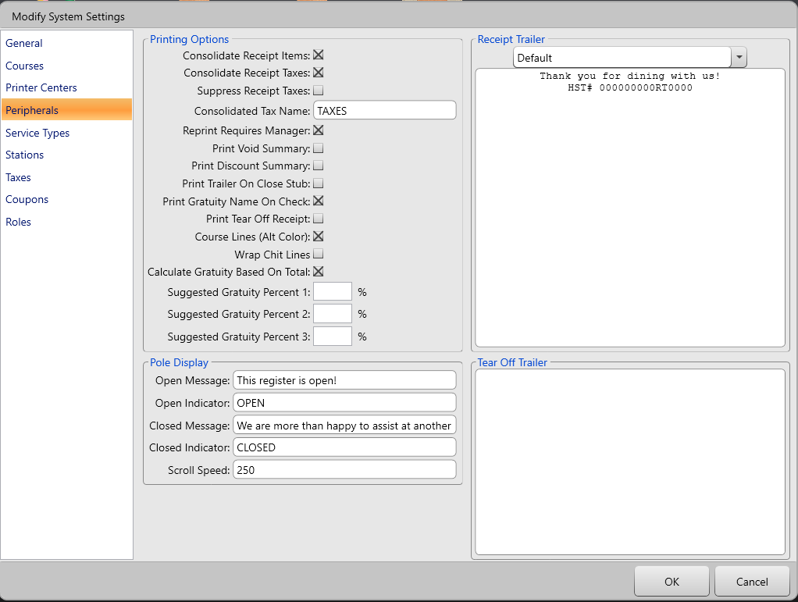
- Consolidate Receipt Items determines, when an item is ordered more than once, if it appears as “x Item $x” (consolidated) or as “ITEM $” printed individually (unconsolidated). The consolidated version combines the price as well.
- Consolidate Receipt Taxes determines if taxes appear separately or individually. The amount will be consolidated as well.
- Suppress Receipt Taxes determines if taxes do not show on receipts.
- Consolidated Tax Name determines the text that appears next to the consolidated tax $ amount on a receipt.
- Reprint Requires Manager determines if manager approval is required to reprint checks.
- Print Void Summary determines if a slip is printed after a void is performed.
- Print Discount Summary determines if a slip is printed after a discount is performed.
- Print Trailer on Close Stub determines if the regular trailer message should appear on close stubs.
- Print Gratuity Name on Check determines if the name of a gratuity prints on a check, or just “Gratuity” and the amount.
- Print Tear Off Receipt determines if an extra “tear-off” receipt is printed when printing checks. The text for this can be entered in the “Tear Off Trailer” section of this screen.
- Course Lines (Alt Colour) determines if course lines print in red on impact printers.
- Wrap Chit Lines determines if text that extends beyond the limit of printer is cut off or pushed down to the next line
- Calculate Gratuity Based On Total determines if suggested gratuities printed on checks are based on total or subtotal
- Suggested Gratuity Percentages determines the % that will be used in calculating suggested gratuities that are printed on a check
Pole Display
- Open Indicator is a short static message that displays when the station is available to serve a customer. “OPEN”, for example.
- Open Message is a message that can scroll (if the hardware supports this) across the display when the station is available to customers. “Try our new chicken wing and rib combo for only $9.99”, for example.
- Closed Indicator is a short static message that displays while the station is closed. “CLOSED”, for example.
- Closed Message is a message that can scroll (if the hardware supports this) across the display when the station is unavailable to customers. “We are happy to assist you at another register”, for example.
Receipt Trailer
Enter the text you want to appear on the bottom of your guest checks.
Tear Off Trailer
If you enter text here, it will print on a separate “tear off” trailer.

Service Types
This section lets you modify the different service types that servers can use when starting orders.
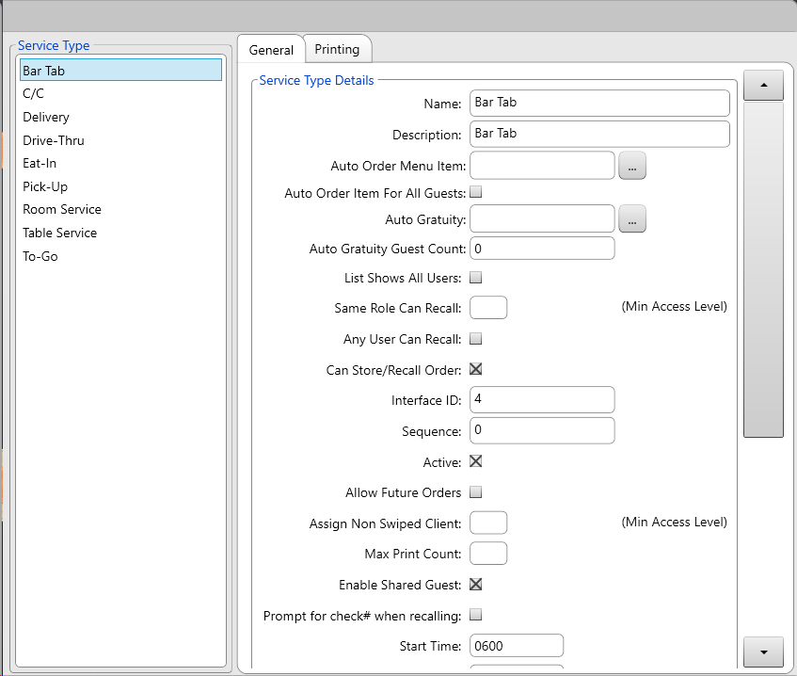
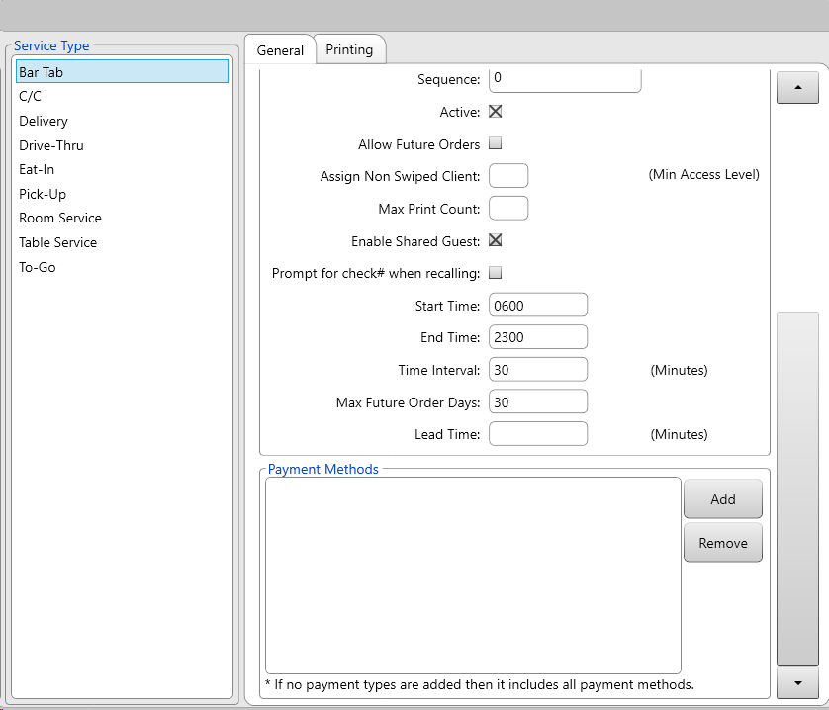
General Settings:
- Name is the name of the service type.
- Description determines if additional information about the customer is taken during the order. If set to “Keyboard,” the server will be able to enter description via on-screen keyboard. If set to “customer list” the server will be selecting or creating a loyalty client (and all affiliated info) for the order.
- Auto Order Menu Item lets you choose an item that will automatically be added to every order started under this service type (i.e. a charge for plastic bags for take-out orders).
- Auto Gratuity determines if a gratuity is automatically applied to orders under this service type.
- Auto Gratuity Count determines the minimum number of guests that must be on the order for the auto-gratuity to be applied.
- List Shows All Users determines if the list feature shows all users’ orders, or just the orders of the logged-in employee.
- Same Role Can Recall determines if users assigned the same role (server, bartender, etc) can recall each other’s orders. These roles all have a # assigned, with 5 being used for servers and bartenders.
- Any User Can Recall determines if any user can recall an order of this service type.
- Can Store/Recall Order determines if orders started with this service type can be stored in a list, or if it must be closed/voided/cancelled to start a new order.
- Interface ID assigns an ID # for use in exports or integrations
- Sequence determines the order of the various service types at bottom of a quick-service ordering screen
- Active determines if the service type can be used or not
- Allow Future Orders determines if users can place orders for future dates/times when using the selected ordering method
- Assigned Non-Swiped Client lets enter the access level required to allow clients to be manually assigned to these orders (manually meaning that no loyalty card was swiped, instead the client was found via search)
- Max Print Count determines the maximum # of checks that can be printed for an order of this type.
- Enabled Shared Guests determines if a seat # 0 is added to all orders of this type. This seat # would typically be used to order items being shared by the table.
- Prompt For Check # When Recalling determines if servers must recall an order by searching for the check # instead of having to scroll through a list of open checks.
- Start Time determines when orders of this type can start being accepted/scheduled for. This applies to in-store and online orders
- End Time determines when orders of this type can longer be accepted/scheduled for. This applies to in-store and online orders.
- Max Future Order Days determines how many days in the future an order of this type can be scheduled for.
Payment Methods
This area lets you define which payment methods can be accepted for orders of the selected type.
Printing
- Print Segment Name On Remote determines if the current serving period/segment (i.e. Breakfast, Lunch, Dinner, Late Night) is printed on kitchen/bar chits
- Print Service Name on Remote/Check determines if the name of the service type is printed on bar/kitchen chits or the guest check.
- Print Description on Remote/Check determines if any descriptors (customer name, phone number, etc) appear on the guest check.
- Print Client Name on Remote/Check determines if the client’s name (if selected from a pick-client dialog box) shows up on the kitchen/bar chit or guest check.
- Print Client Address on Remote/Check determines if the client’s address (if selected from the pick-client dialog box) shows up on the kitchen/bar chit or guest check.
- Print Client Ship To Address on Remote/Check determines if the client’s shipping address (if selected from the pick-client dialog box) shows up on the kitchen/bar chit or guest check.
- Copies to Print (Check)/(Close Stub) determines how many copies of the guest check/close stub are printed.
- Print Check Required determines if a guest check must be printed for orders started under this service type.
- Digits of Check Number to Print determines how many digits will be printed on the guest check. For example, if set to 2, check number 123456 will only show “56” on the check.
- Show All Mods Guest Check & Rear Disp. determines if all modifiers (even those with $0.00 value) appear on guest checks/customer-facing displays
- Print Remote Future Ordered/Opening determines if futures orders are printed the day they are ordered or upon the day they are scheduled for. You can turn both or just one of these settings on.
- Print Remote By Guest determines if each guest/seat on an order of the selected type has their order printed on chits separate from other guests/seats on the same order
- Order Number Digit Count determines how many digits of the current order # should be printed on chits/checks
- Print Order Notes On Check determines if any order notes added by a user are printed on the guest check
- Print Separate Guest Totals on Check determines if guest/seat is totaled separately on guest checks.

Stations
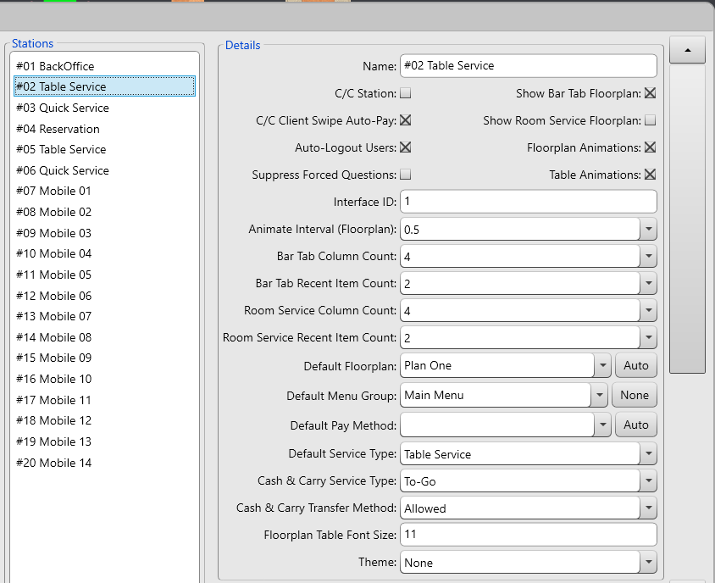
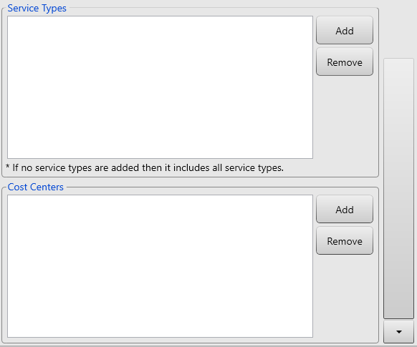
Select a station from the “Stations” area on the left to modify its settings.
- Name allows you to change the station’s name.
- C/C Station changes the station to a cash and carry station.
  - In C/C mode, when a user starts a cash and carry order, a new C/C order starts after they close the current one,as the station enters a loop upon starting a cash and carry order. After each order, the “Order” screen reappears, labeling the order as “C/C” instead of assigning a table number. This loop continues until the Cancel button found on the “Order” screen is pressed. Users can now start/recall dine-in orders, but the loop will restart when someone starts a new C/C order.
  - In C/C mode, when an employee sends an order, they are automatically taken to the “Close Order” screen instead of the floor plan or “Stay” menu after they send an order.
- C/C Client Swipe Auto-Pay determines if swiping a client card on the “Order Screen” during a cash and carry order automatically links the order to the client and assigns all price levels and discounts. Furthermore, if the client has sufficient credit, the order will be closed automatically to their account.
- Auto-Logout Users determines if “Stay” window appears after a transaction. The user is logged out if he/she doesn’t make a selection. When unchecked, the “Stay” window doesn’t show, and the user stays logged in until he/she presses Cancel on the main menu.
- Suppress Forced Questions determines is forced questions (meat temperature, liquor prep, etc) are ignored at this station. Often used at bar stations where the bartender doesn’t need to be prompted on screen as to how to prepare a drink.
- Show Bar Tab Floorplan changes the station to “bar tab” mode. Orders are represented by chits that list the last two items ordered. Employees can only start C/C orders and bar tabs; dine-in orders cannot be created. See the Bartender Guide for more information. REQUIRES RESTART.
- Show Room Service Floorplan (requires property management module)
- Table Animations determines if there is a zooming animation when viewing different areas of a floor plan, or if the screen simply changes to the selected area.
- Interface ID lets you assign an ID # for use in exports or integrations with other software
- Animate Interval (Floor plan) determines the intervals that the zoom functions goes through until reaching the final zoom percentage.
- Bar Tab/Room Service Column Count determines how many columns of bar tabs/rooms display on the screen when using bar tab mode.
- Bar Tab/Room Service Recent Item Count determines how many items are listed on each bar tab/room. The items displayed are the most recently ordered items.
- Default Floor plan lets you choose the floor plan that normally displays on this station. For example, if you have a second floor or a patio and you place a station there, you can display the floor plan for that area.
- Default Pay Method determines which payment method is automatically selected on the “Close Order” screen FOR THIS STATION ONLY. This lets you override the global setting.
- Default Service Type determines which service type will be selected when ordering from this station.
- Cash & Carry Transfer Method determines if the station is allowed to transfer C&C orders, either to a bar tab or table.
- Floorplan Table Font Size determines how big the text showing table names/#s is.
- Theme determines which, if any, special theme this station will uses.
- Service Types determines which additional ordering methods are available to this stations when a user starts a C/C order
- Cost Centers determines which cost centers/outlets/revenue centers this station will apply its sales to. You can have multiple cost centers and assign them to match schedules created in your menu designer.

Taxes
This area lets you edit (but you cannot add/delete) taxes for your location.
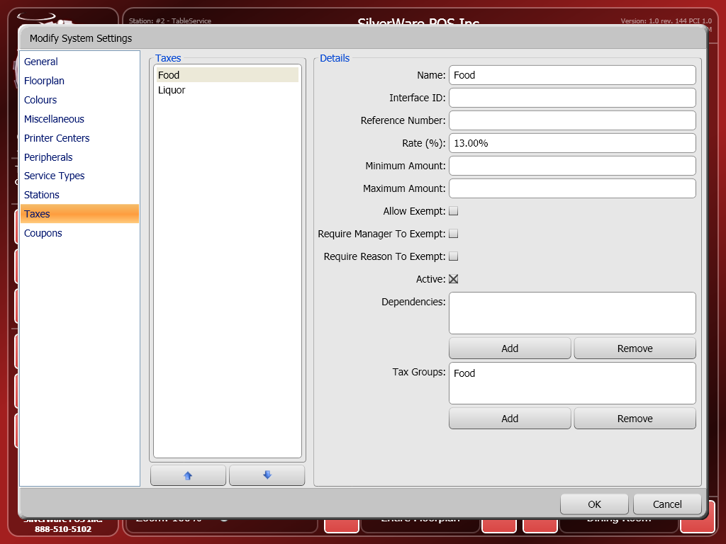
Select a tax from the left-hand side to modify its properties
- Name is the tax’s name.
- Interface ID lets you assign an ID # for use in exports or integrations.
- Reference Number is where you can enter a reference or account number provided by the government.
- Rate (%) is the percentage this tax charges.
- Minimum Amount determines the minimum amount an item must be for this tax to be applied.
- Maximum Amount determines the maximum amount an item can be for this tax to be applied.
- Allow Exempt determines if this tax can be exempted from a check.
- Require Manager to Exempt determines if a manager must authorize any exemptions of this tax.
- Require Reason to Exempt determines if an on-screen keyboard appears when this tax is exempted, allowing the server to enter a reason for the exemption, or a government ID number.
- Active determines if the tax is active or not.
- Dependencies: Add/Remove dependencies if other taxes are to be charged upon a bill before this tax is charged. If there are no dependencies, this tax will be charged upon the bill’s before-tax price. Make sure the tax that has to be charged first appears HIGHER in the list.
- Tax Groups let you bundle taxes together into a group that will be charged upon items. Use the add/remove buttons to add the selected tax to a group.

Roles
This area lets you assign the default settings for users roles. For an explanation of each setting, please refer to the section about setting up employees.

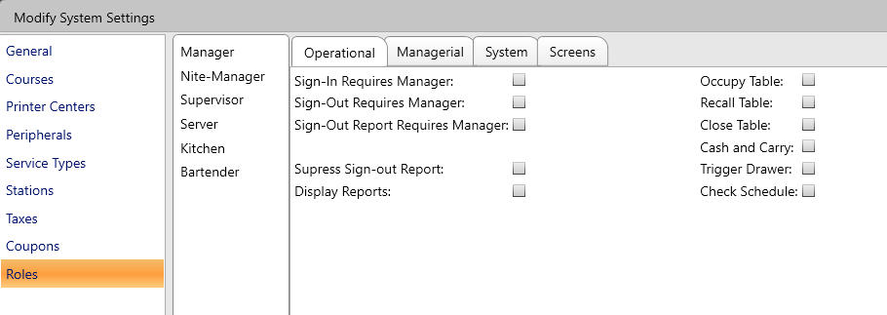

Subtotal Groups
This area lets you create different groups that will show dollar amounts totaled together on a single check. This is often used to show the food total and liquor total on a check.
Use the new/delete buttons to group/remove groups.
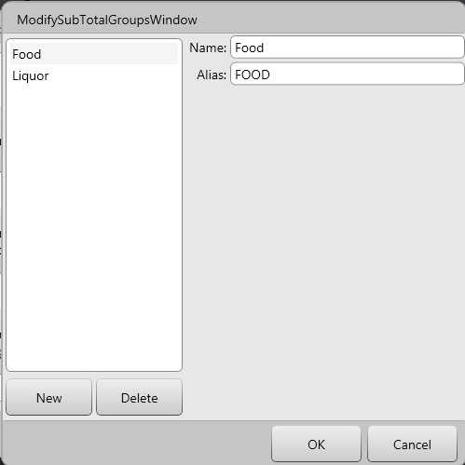

Once you have created a group, you can add major/minor classes to a group. This will have the items reporting to those minor class show their dollar amounts in a group on a guest check.

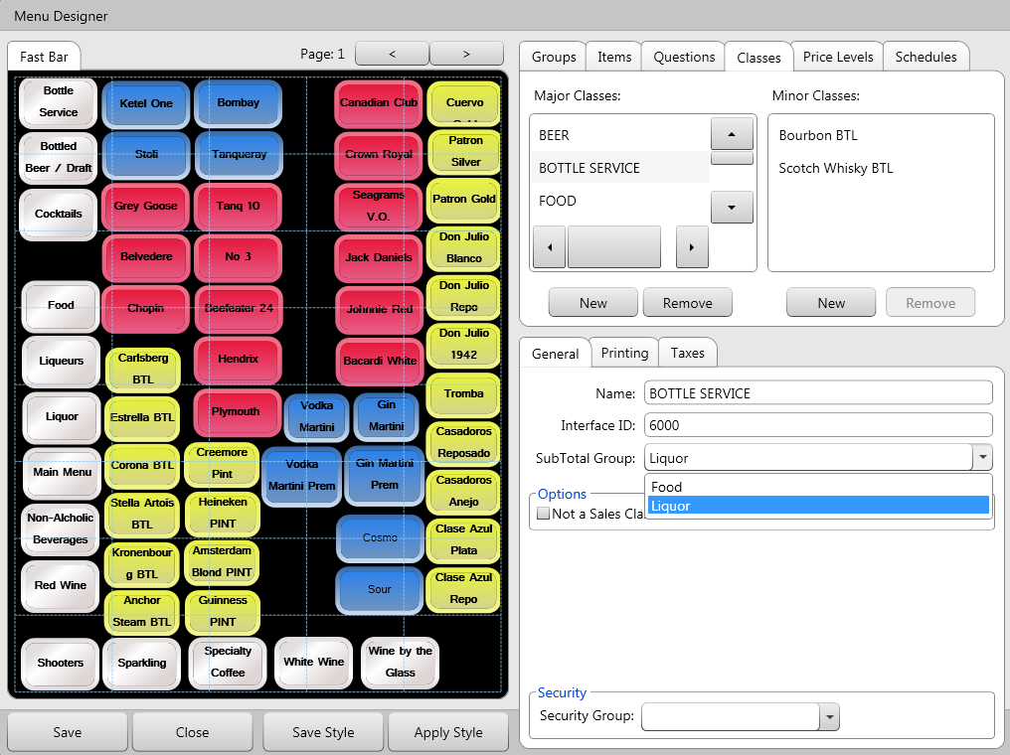

Please note that your SilverWare dealer will have to enable a setting for this functionality to work.

Coupons
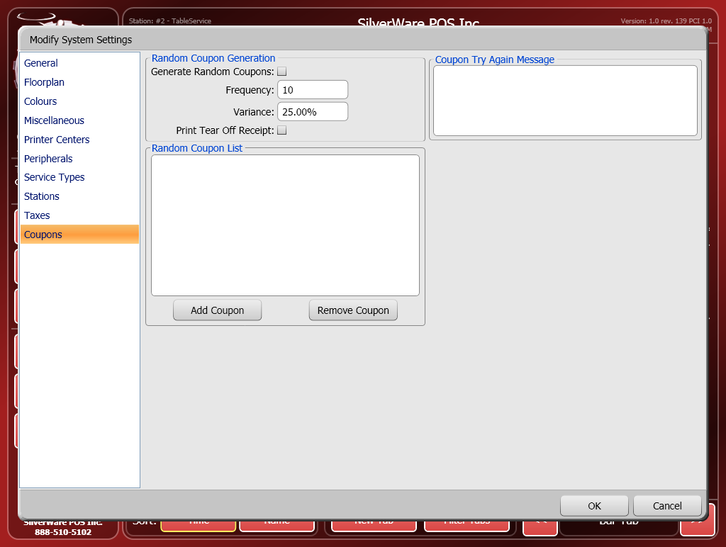
- Generate Random Coupons determines if coupons will be randomly issued.
- Frequency determines how often the coupons are generated. If you enter “2,” for example, every other check will generate a coupon.
- Variance can be used to throw off the frequency.
For example, if Frequency is set to “10” and Variance is set to 50%, this means that a coupon can be generated after 5-15 checks since the previous coupon was issued. As 50% of 10 is five, that variance is then added and subtracted to the frequency value.
- Print Tear Off Receipt determines if an extra tear-off receipt is printed when coupons are generated.
- Use the Add/Remove Coupon buttons to add/remove coupons from the list of coupons that can be used in random coupon generation.
- Enter a message into the Coupon Try Again Message area to have it appear on checks that didn’t generate a coupon.

Security Groups
This area allows you to secure parts of your operation from being altered by employees/managers that work in other areas. You can setup your menu so that only managers from the proper area can alter the items/prices/groups/etc. This feature is generally used by large operations with many bars/restaurants operating at the same site (such as hotels and resorts).
You can create groups in this screen and set the roles that users have to be to make changes to the affiliated parts of the menu.
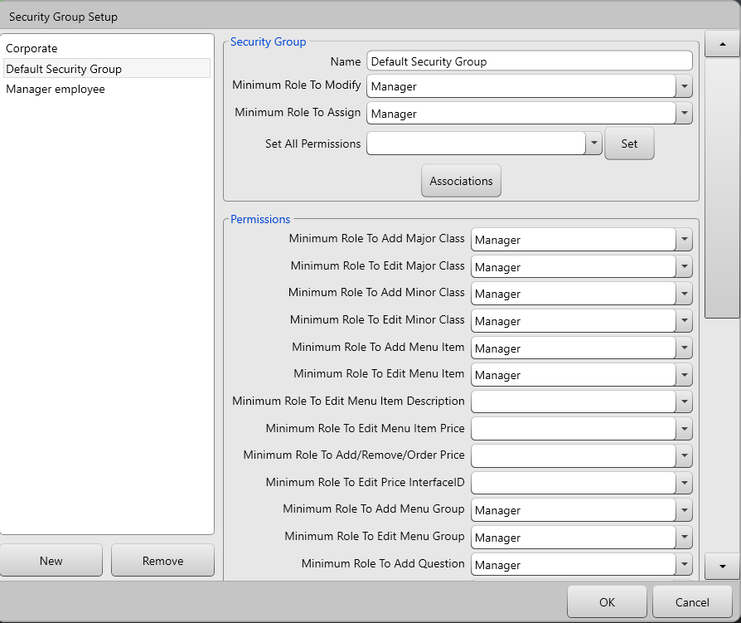

In the menu designer, most of the menu components can be assigned to a security group, ensuring that users not part of that group cannot see or edit those components.
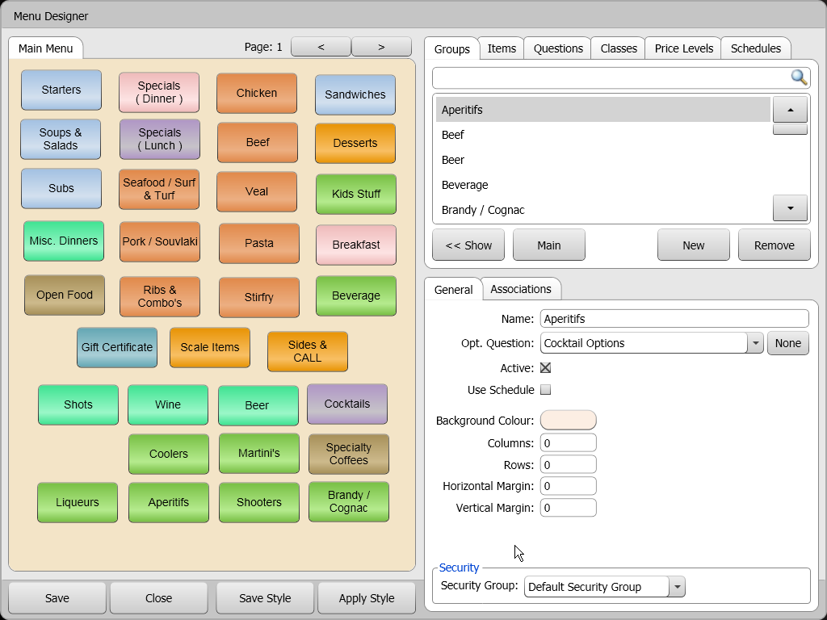

Employees are set to a security group to determine what they’ll see in the menu designer.
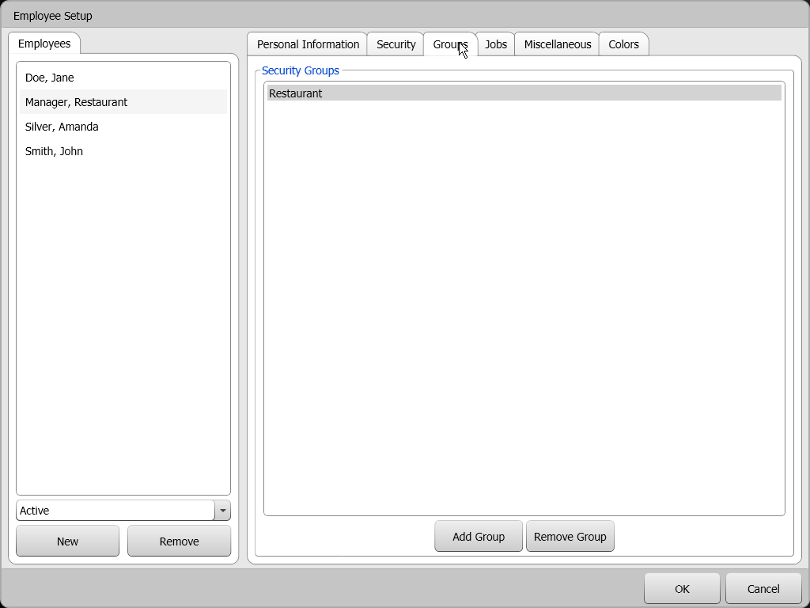

Clock-In/Out Times
This area lets you modify shift start and end times, as well as job/pay-rate information for an employee’s shift.
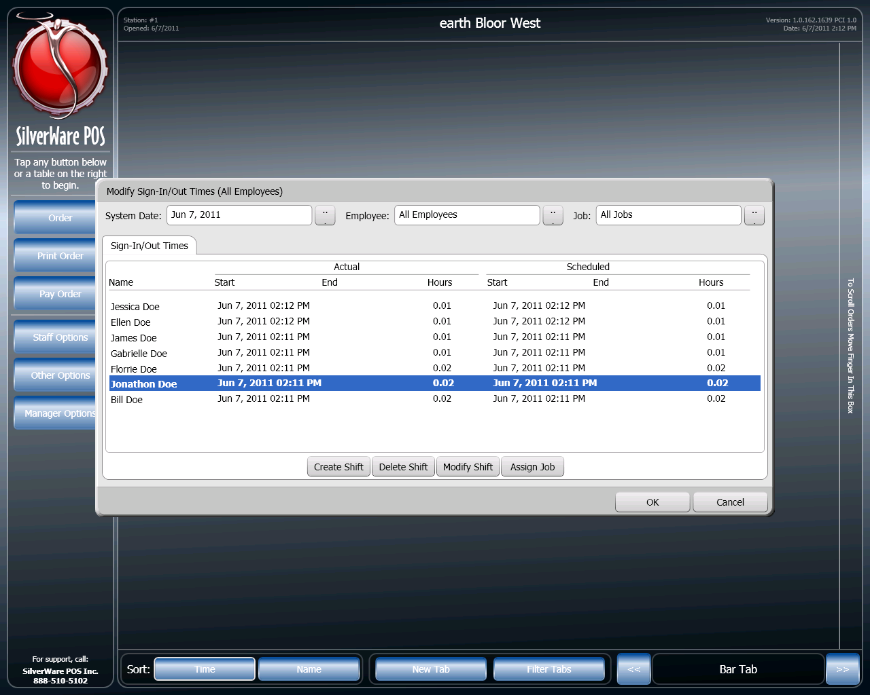
- Choose the date that has the shifts you want to modify.
- You can also filter to specific employee or job/
- Select a shift from the list in the middle of the screen and press Modify Shift to change start or end time, or press Assign Job to assign a job and associated pay rate to the shift. You can also select a shift and press Delete Shift to delete the shift.
  - Note that you cannot extend a shift beyond the open and close time for a business date.
- Lastly, you can create a shift for the selected system date by pressing Create Shift and choosing start and end times.

Images
This area lets import different pictures into your menu database for use with online ordering. Once pictures have been imported here, they can be assigned to menu items in the menu designer.

Manager Options – Maintenance
This are contains some maintenance and support features
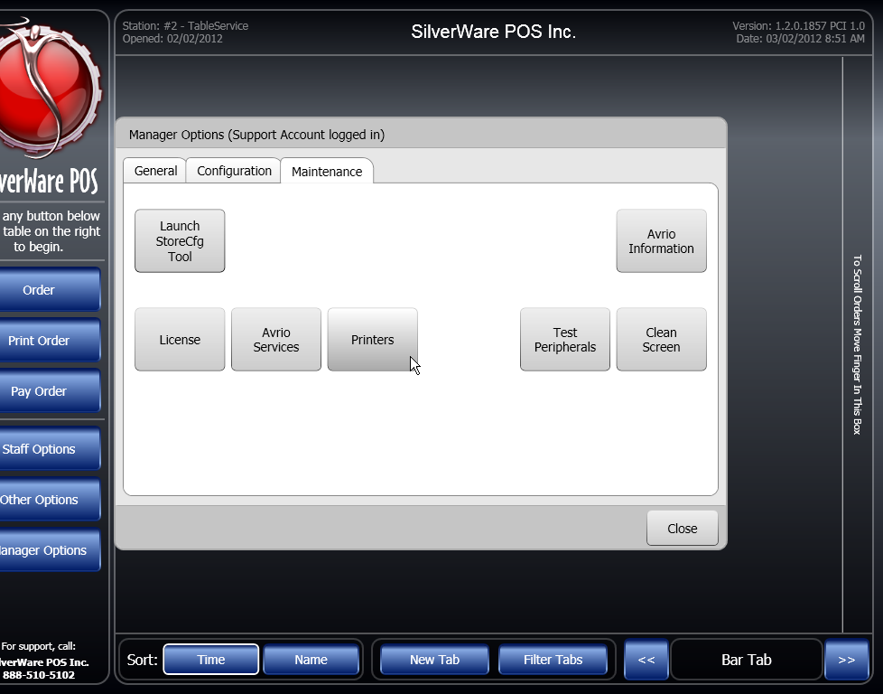
- Launch StoreCfg Tool opens the store config tool for a support agent. This tool lets an agent modify a variety of system settings and config options
- Avrio Information displays some information about your system.
- License will show you your software license and pertinent information (expiry date, active modules, etc)
You shouldn’t change anything found this area, as it could cause your system to stop functioning.
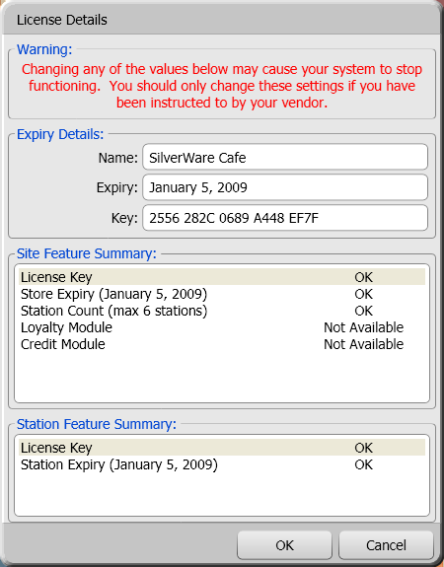

- Avrio Services opens a window that shows you the background services that Avrio uses for printing, credit transactions, etc. You can use this window to stop/restart these services.
- Printers lets you see and test the printers in your system.
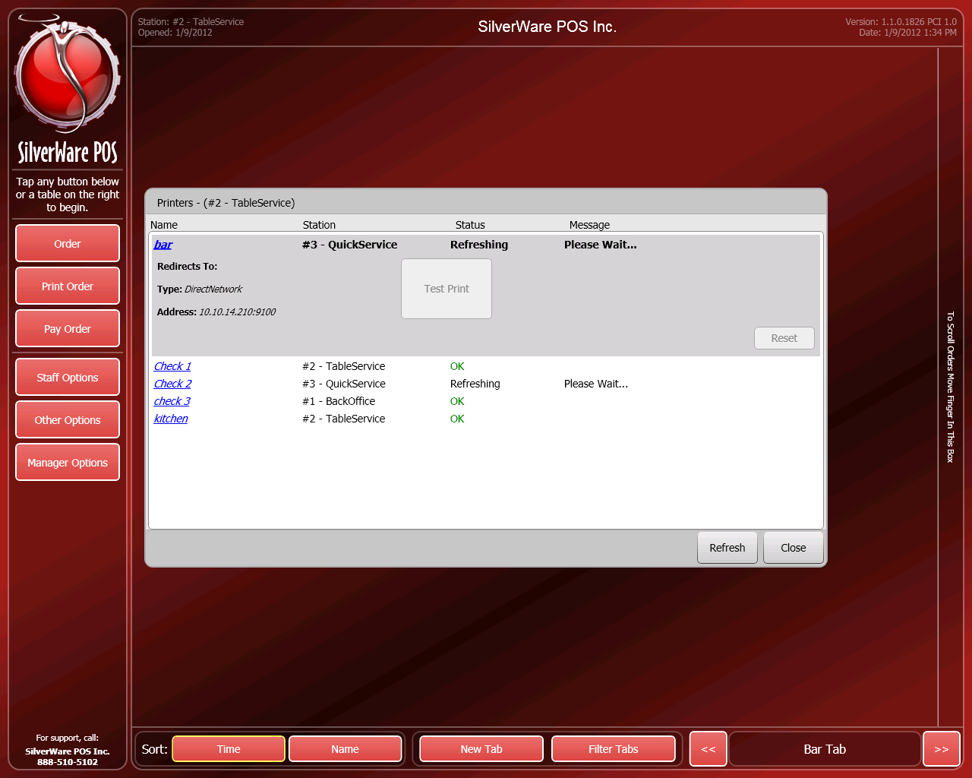
Highlight a printer and press “Test Print” to send a test job to that printer. You will need to press Refresh after testing to see the results.
- Test Peripherals lets you test MSRs, scales, and barcode scanners.
- Press Clean Screen to blank out the screen so no buttons can be activated while cleaning. Refer to hardware guidelines for cleaning instructions.

Performing Refunds
Beginning in R1857, there is a specific method for performing a refund. It first requires a creating a void reason that is marked as a refund. When this void reason is used, it won’t remove the items from an order like a void normally would. Instead, the system “sells” a negative quantity of the item at a negative price.
Void Reasons
The “Void Reasons” screen lets you create/edit/remove the reasons that staff use to void items and orders.
To access this screen, go to Manager Options Configuration Void Reasons.
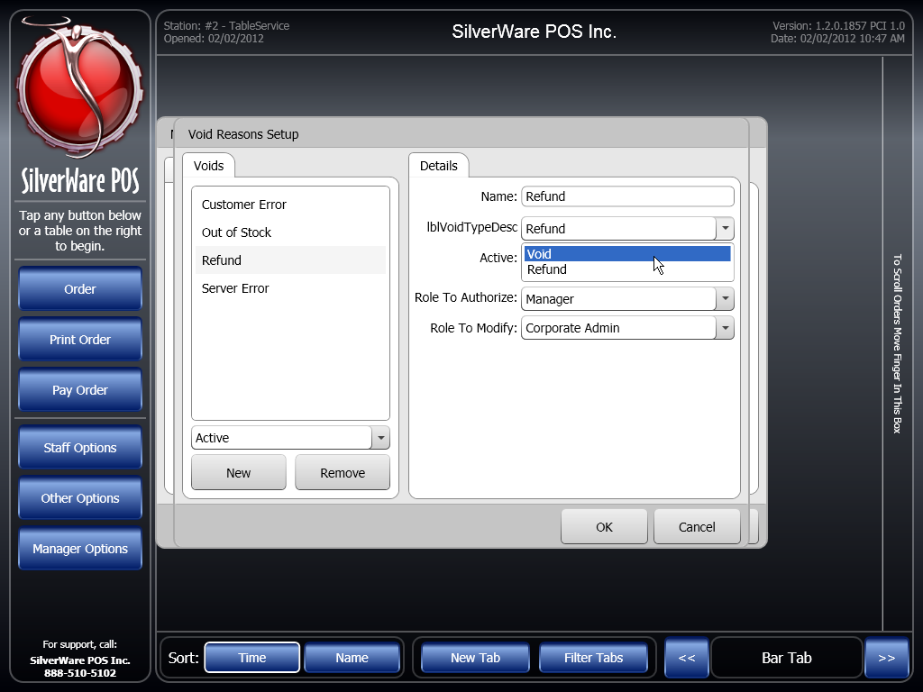
- Name is where you enter the description/reason.
- Void Type is you choose is the void is being used simply to void items, or is being used to refund them.
- Active determines if the void is available/unavailable for use. Once a void reason has been used, you cannot remove it; deactivate to stop it from being used again.
- Auth Level determines which level an employee has to be to authorize the void.
- Modify Level determines which level an employee has to be to modify the reason. When used in conjunction with employee roles, you can allow an employee to modify some voids, without giving them access to all managerial options.

To Perform a Refund:
- From the main screen, start a new order.
- Add the items to be refunded. You may want to modify them as “do not make” so kitchen staff doesn’t prepare the order.
- Recall the order.
- Press Void. Choose the void that you created that is a “refund.” In the example on the previous page, it was named “Refund.”
- Print or pay the check to initiate manager authorization for the refund. The check will have to be printed for a pay@table refund. If you want to a return the tip, you may have to add an open-priced item for the tip amount to check it and refund it as well.
- On the Payment screen , you’ll see a negative balance for the check. This means that the amount is to be paid back to the customer.
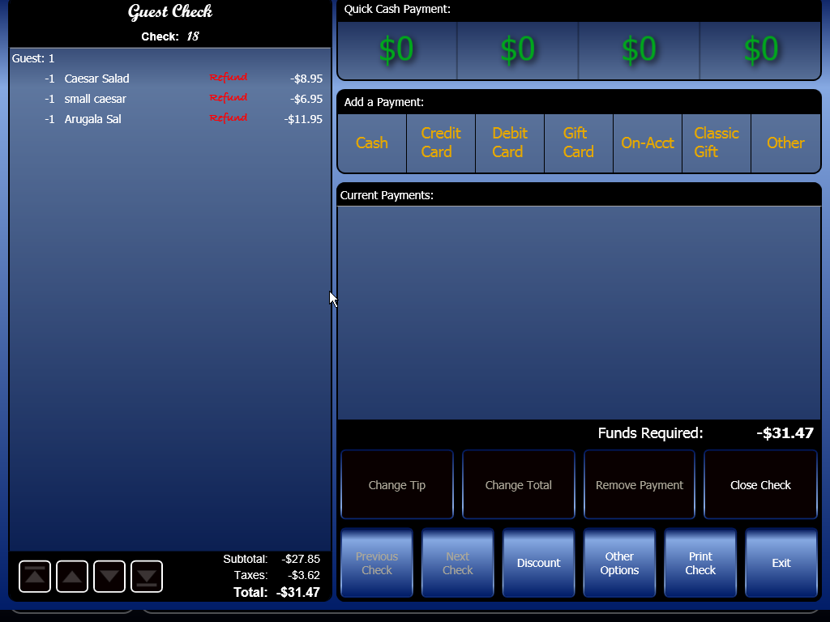
- Close the order to cash/credit/etc. If using pay@table or integrated credit cards, the amount will be returned to the card. If using cash, pay the correct amount of cash to the customer. If using a gift card/loyalty account, the balance will be returned to the customer.
For credit/debit/pay@table/gift/loyalty, Don’t forget to properly refund any tip the customer added to the original bill.

Working with Integrated Credit Cards
If your location is using Avrio’s integrated credit-card processing, use these instructions for conducting transaction, correcting errors, making returns, etc. The instructions for settling batches appear on page 165.

Closing Orders to Credit Cards
To accept a credit card payment:
- On the “Close Order” screen, press Credit Card or swipe a card and skip to instruction four.
- The “Credit Card Authorization” window appears.
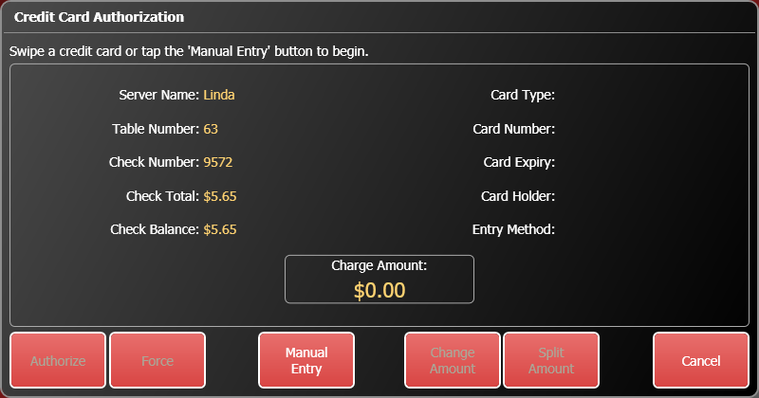
- Swipe the customer’s card, or press Manual Entry to enter the card number and expiry date.

- Verify that the card information and amount that appear match the card and bill you are working with. Press Authorize to start the authorization process. Wait while the authorization takes place.
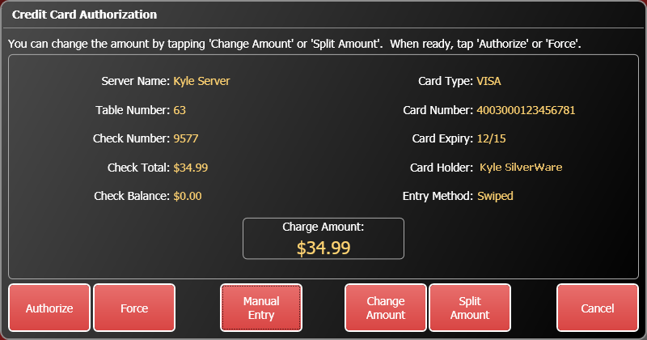
- When the card is authorized, the “Close Order” screen displays the card type and the last four digits of the card.
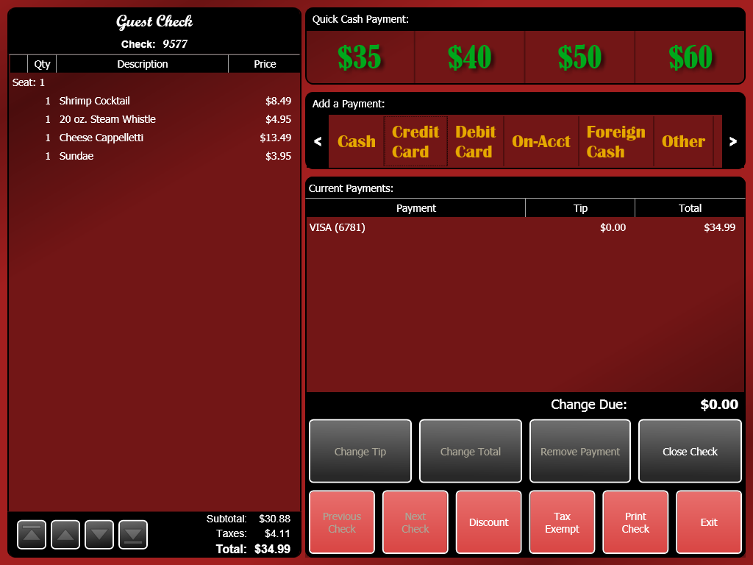
- Select the credit card payment and press Change Tip to enter any tip the customer has added to the total.
- Press Close Check.

Splitting a Bill that Involves Credit Cards
If you want to accept two or more credit cards or one credit card and other payment methods for a bill:
- On the “Close Order” screen, press Credit Card.
- The “Credit Card Authorization” window appears.
- Swipe a card, or use manual entry.
- Press Change Amount to manually enter the amount this card will be paying. If you want to split the amount evenly, press Split Amount and enter the number of payments that will be used to pay the bill.
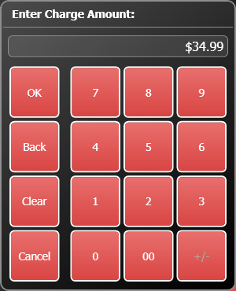
- Press Authorize to begin processing the card. When the card is authorized, the “Close Order” screen displays the card type and the last four digits of the card.
- Add any tip to the credit card payment.
- There is still a balance remaining for the other customer(s) to pay. Enter payments using whichever methods the customers want to use until the balance due is $0.00.
- When done, press Close Check.

Forcing a Payment
If Avrio cannot connect to your processor, you have the option of forcing a transaction.
You will need an approval number, which you can obtain by calling your processor. NOTE: If you enter an incorrect approval number, the payment might not properly process when a manager tries to close the batch, or your processor may charge more to process the transaction.
- On the “Close Order” screen, press Credit Card or swipe a card.
- The “Credit Card Authorization” window appears.
- Swipe the customer’s card, or press Manual Entry to enter the card information yourself. You will need to enter the card number and expiry date if you enter it manually.
- Press Force.
- The on-screen keyboard appears. Enter the approval code provided by your processor.
- When the card is forced, the “Close Order” screen displays the card type and the last four digits of the card as a payment.
- Select the payment and press Change Tip to enter any tip the customer has added to the total.
- Press Close Check.

Voiding a Credit Card Payment
If you have already authorized or a credit card payment, but need to remove it from a bill before it is finalized and closed:
- Open the order.
- Select the payment.
- Press Remove Payment.
- Avrio will communicate with your processor and void the payment.
If you have already closed the bill and captured the payment, you will need to use the “Change Tender” option, which can be found in Manager Options. You will need the check number, then you can follow steps 2-5 listed above.

Settle Credit Cards
Credit card batches should be finalized and settled on a daily basis. To settle credit cards:
- Touch Manager Options.
- Press Settle Credit Cards. Information about each credit card transaction is displayed.
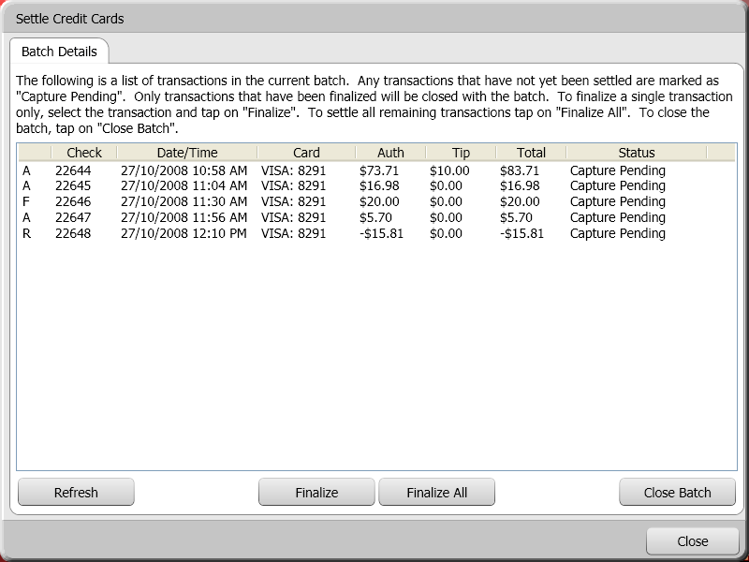

Symbol | Check | Date/Time | Card | Auth | Tip | Total | Status
A = Authorized  F = Forced  R = Return | The check number that the transaction relates to. | The date and time the transaction took place. | Card type and the card’s last four digits. | The amount that was authorized on the card. | Amount of tip was that added to the transaction. | The total amount (auth amount + tip). | CP = The transaction has to be finalized  Finalized = The transaction has been captured
- You can select individual transactions and finalize them, finalize all transaction, or simply press Close Batch to finalize all transactions and close the batch.

Working with Loyalty Cards

Viewing a Card’s Information
To quickly check a card’s balance:
- On the main menu, press Other Options. Enter your ID.
- Press Loyalty/Gift Card Balance.
- Swipe the card (or scan the badge), or press Manual to enter the card number and PIN manually.
- The card’s information will appear on screen. Press Print if you want to print it.
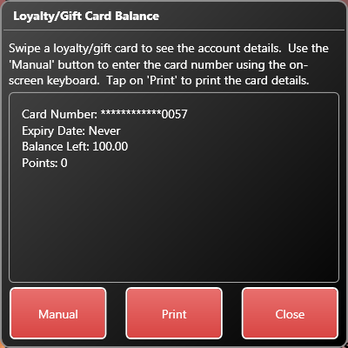

Splitting a Bill that Involves Loyalty Cards
If you want to accept two or more loyalty cards or one card and other payment methods for a bill:
- On the “Close Order” screen, swipe the loyalty card
- The “Loyalty Card Authorization” window appears.
- Press Change Amount to manually enter the amount this card will be paying. If you want to split the amount evenly, press Split Amount and enter the number of payments that will be used to pay the bill.
- Press Authorize to begin processing the card. When the card is authorized, the “Close Order” screen displays the card type and the last four digits of the card.
- There is still a balance remaining for the other customer(s) to pay. Enter payments using whichever methods the customers want to use until the balance due is $0.00.
- When done, press Close Check.

Forcing a Payment
If Avrio cannot connect to the loyalty service, you have the option of forcing a transaction.
You will need an approval code.
- On the “Close Order” screen, swipe a loyalty card.
- The “Loyalty Card Authorization” window appears.
- Press Force.
- The on-screen keyboard appears. Enter an approval code.
- When the card is forced, the “Close Order” screen displays the card type and the last four digits of the card as a payment.
- Select the payment and press Change Tip to enter any tip the customer has added to the total.
- Press Close Check.

Voiding a Loyalty Card Payment
If you have already authorized a loyalty card payment, but need to remove it from a bill before it is finalized and closed:
- Open the order.
- Select the payment.
- Press Remove Payment.
- Avrio will communicate with the loyalty service and void the payment.

Points, Coupons, and Frequent Diners
SilverWare Avrio lets you setup an intricate system of clients, points, and coupons. Details on random coupon generation can be found here.
The system described here lets you:
- Assign point values to menu items OR you can set up a system that gives points based on a check’s sub-total. You will need to contact your dealer
- Create clients that can earn points
- Create coupons that require points to earn, and then deduct points when redeemed.
So, as outlined above, the first step is to decide how you’re going to issue points. Points can be issued based on each dollar spent, or you can setup menu classes or menu items to give points.
Your Avrio dealer will have to set this up for you.
- If you opt to distribute points based on dollars spent, your Avrio dealer can take care of this. You will need to inform them how many points a client will earn per dollar. The calculation will be based upon the pre-tax sub-total.
- If you opt to distribute points based on menu items, you can set up which items offer points and the value they give.

Setting up a Menu Item to Offer Points
If you decide to have your menu items give points, here are your options for determining an item’s point value.
You can assign a point value to your major/minor classes by filling out the Points Earned field. Much like taxes and printer settings, a minor class can inherit the Points Earned setting of its parent class, or can be set to a different value.
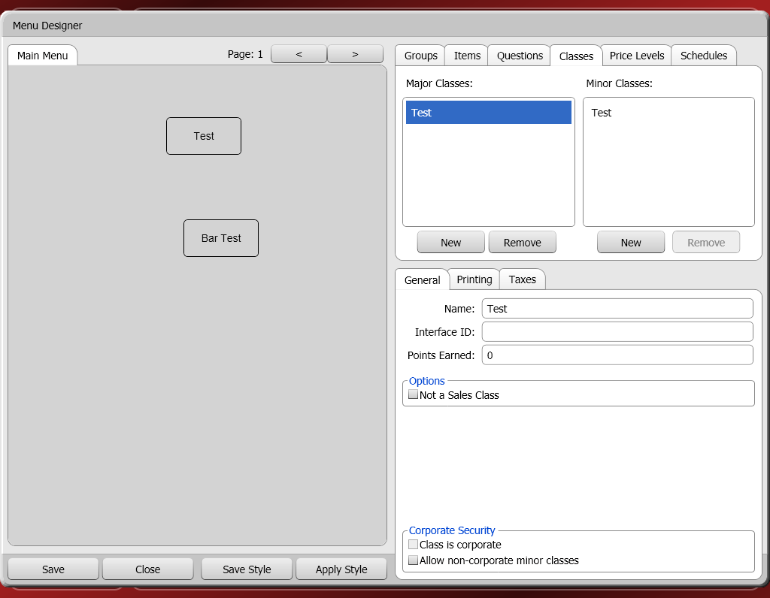

Items will then inherit the point value of their parent class. However, you can also turn off inheritance on an item and give it whatever point value you want.
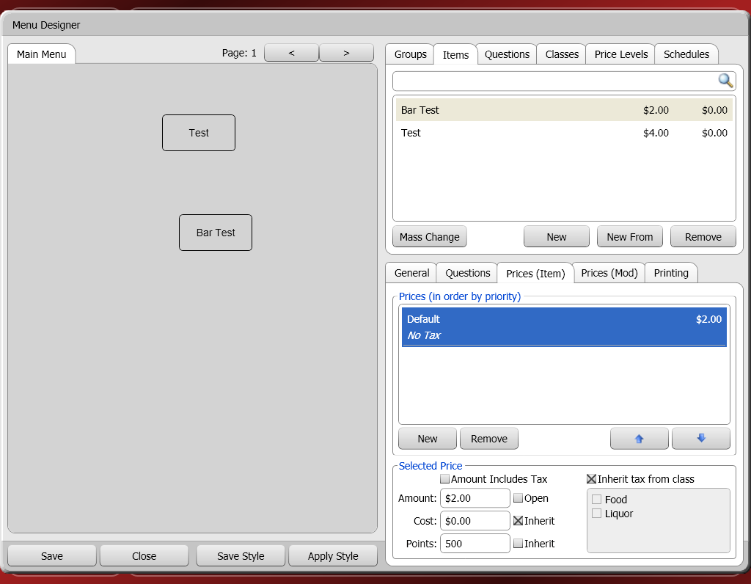

Creating Clients that Can Earn Points
Now that menu items have been set up, you have to have clients that can earn points. See the previous section on clients to learn about creating clients.
The Frequent Diner check-box must be checked to allow a client to earn points. Now, when a client is assigned to an order, they will earn the appropriate amount of points.
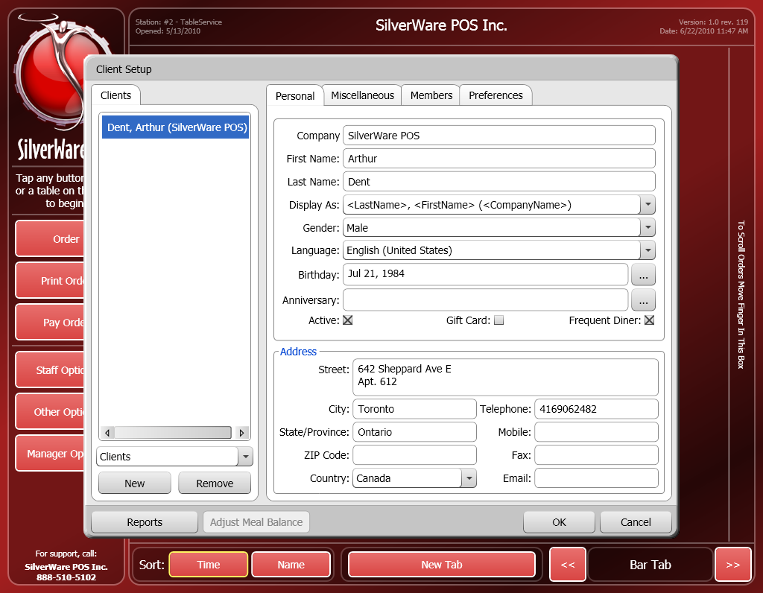

Assigning a Client to an Order
These instructions show how to assign a client to an order. If you don’t do this when a client is dining, they will not earn points.
From the Order Screen
- If the client has a loyalty card, swipe the card on the order screen. If no card is available, press Other Options, then Assign Client to see a list of possible clients.
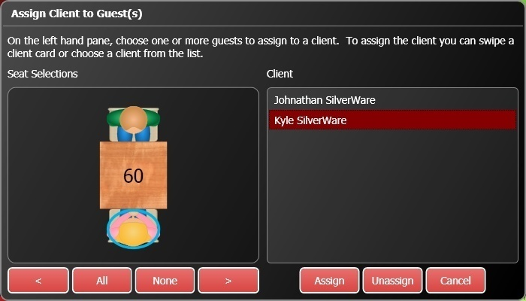
- Touch a guest (or multiple guests), then a client name. Press Assign to assign their purchases to the client account.
- If you haven’t swiped the client’s card yet, you can swipe it now. The client will be selected from the list on the right. Now, touch the guests you want to assign to the client’s account and press Assign.
- If you have a long list of clients, swiping a client’s card will be much easier that finding them on the list.

Creating Coupons
To create a coupon, open Manager Options, switch to the Configuration tab, and select Coupons.
- Press New to create a new coupon.
- Enter the coupons name in the Name field.
- Discount Reason determines which discount will be issued on the coupon.
- Use the Issue Start Date and Issue End Date to enter a date range that the coupon can be issued within.
- Interface ID (undefined)
- Active determines if the coupon is active or not.
- Start After (Date) determines the beginning of the period during which the coupon can be redeemed. You can use this setting or the next one, Start After (Days)
- Start After (Days) determines how many days must pass from the time the coupon is issued before it can be redeemed.
- End After (Date) determines the end of the period during which the coupon can be redeemed. You can use this setting or the next one, End After (Days)
- Points to Redeem determines how or if any points a customer must have to redeem a coupon.
- Points to Remove determines how many points a customer loses when they redeem the coupon.
- End After (Days) determines how many days can pass from the time the coupon is issued before it can no longer be redeemed.

Issuing Coupons
Once a client has earned points, they will become eligible for a coupon.
To issue a coupon:
- While ordering, press Other Options.
- Press Redeem Points (Issue Coupon)
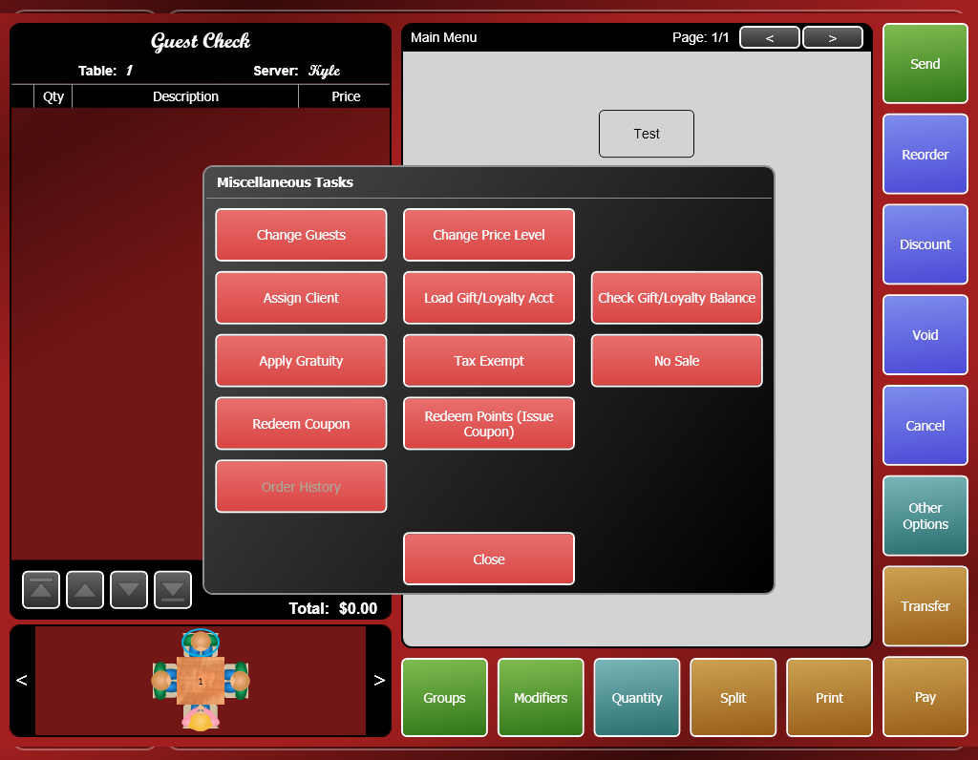

- Highlight client you want to issue the coupon to and press Select
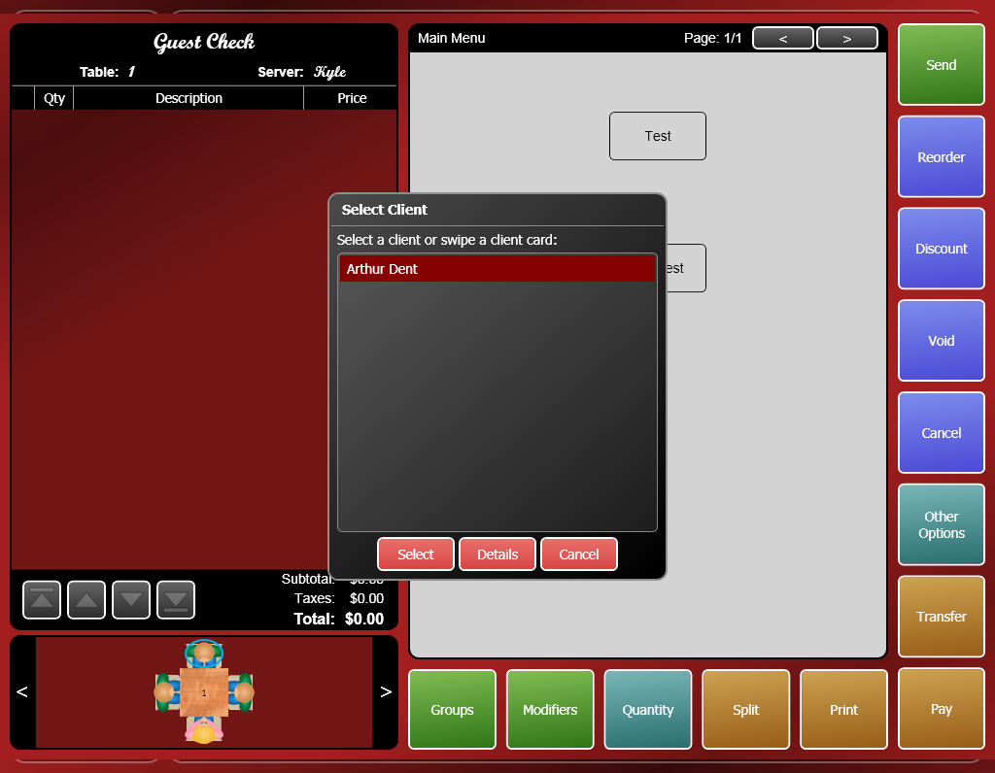
- Select the coupon you want to issue and press OK.
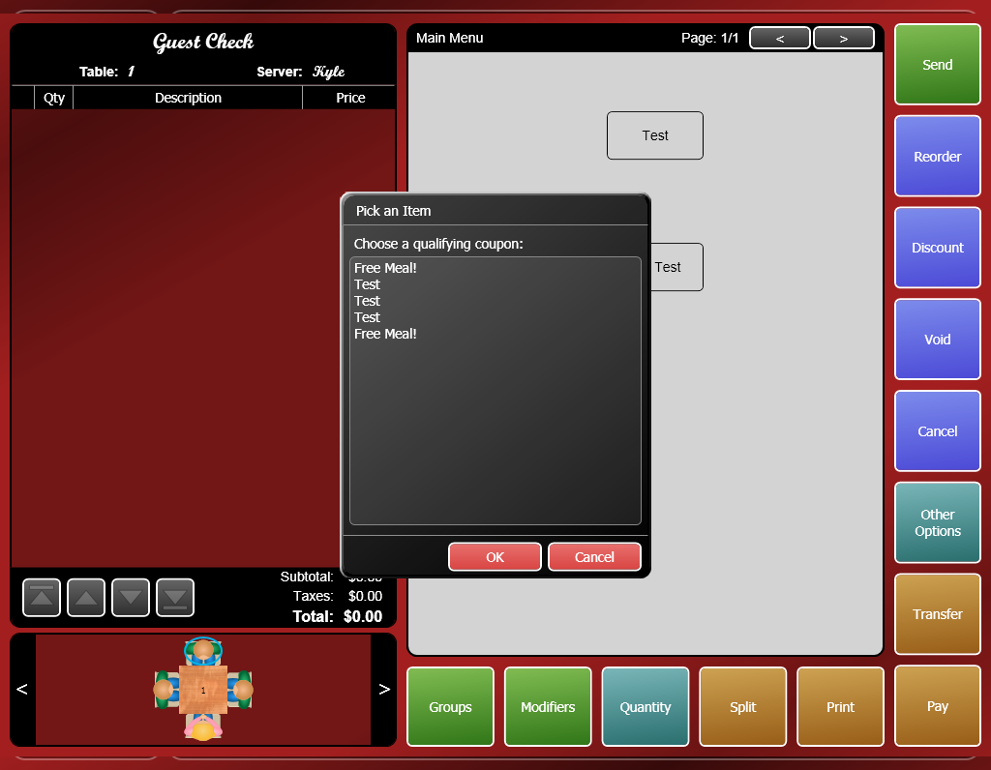
- The coupon will print out of a check printer. There will be a number printed on the coupon that represents the coupon’s number. This number will be needed when redeeming the coupon.

Redeeming Coupons
To redeem a coupon:
- While ordering, select the item(s) you want to apply the coupon to.
- Press Other Options.
- Press Redeem Coupon
- Enter a valid coupon #.
- The coupon will be applied to the selected item(s).
- A manager may need to approve the coupon when you send/print/pay the order.

Meal Plans
SilverWare Avrio has a meal plan system suitable for student residences, seniors’ residences, military bases, etc. Clients can be setup with a meal plan that allows them a certain number of items per day/week/month. You can set up the system to automatically replenish the client’s meals on a daily/weekly/ monthly basis.
This section will explain how to set up and use the meal plan system. There are four main components to setting this up:
- Setting up items that are eligible for a meal plan.
- Creating and assigning a discount that will be used when meal plan items are ordered by clients that have a meal plan.
- Setting up clients with a meal plan.
- Knowing how to assign a client to order to ensure that the meal plan will be in effect.

Setting Up Meal Plans
The first step in setting up meal plans is to create items that are eligible for the system. You may need to refer to these instructions for creating items.
- When you create an item and are prompted to choose a minor class, you must select a minor class that has “Items qualify for Meal Plans” checked. The screen below shows the properties of a reporting class .

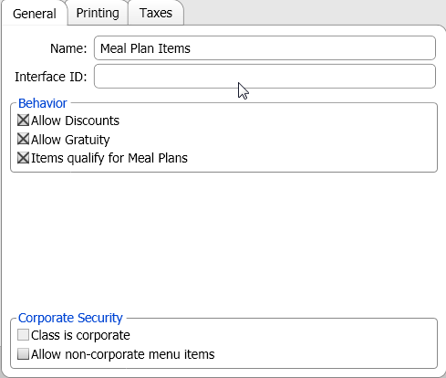
- The next step is to create a discount that will automatically discount the meal plan items when they are added to a client’s bill. See these instructions on creating discounts. The discount must have a fixed dollar or percentage amount that it will remove from the meal plan items.
- Once you’ve created the discount, go to the Manager Options System Settings area. Within the “General” tab, you’ll see a field in the “Loyalty” section called “Meal Disc” that lets you select the discount that will be applied when meal plan items are ordered by clients that have been setup with a meal plan.
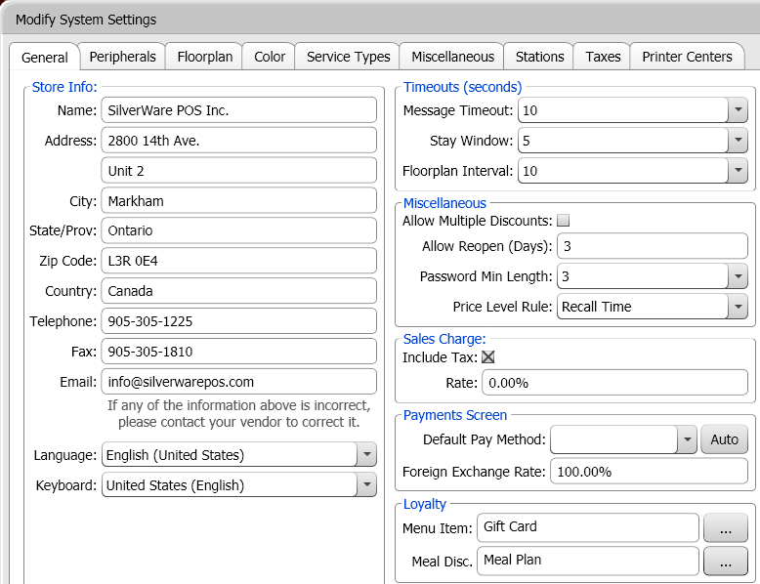

- Next, you have to setup clients with meal plan settings. See these instructions on creating clients.
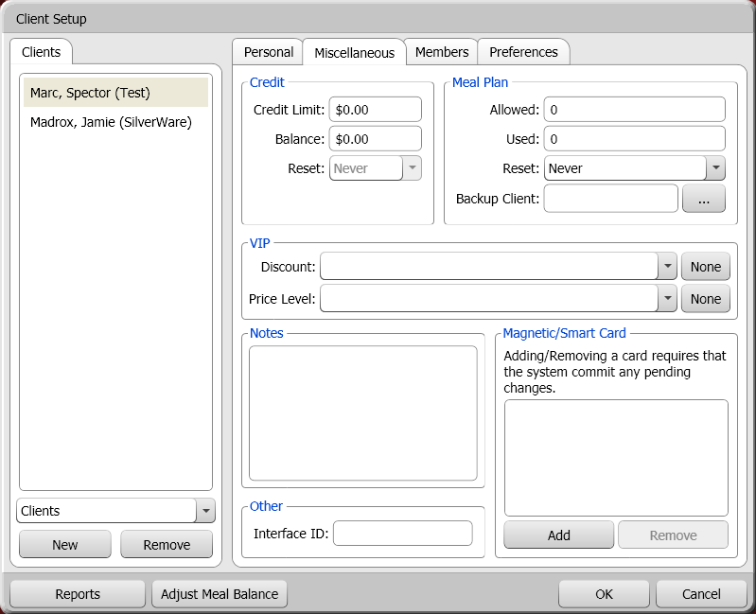
The “Meal Plan” section in the top-right corner lets you setup the client’s meal plan.
Meal Plan
- Allowed determines how many meal plan items this client can order.
- Used shows how many meal plan items this client has ordered.
- Reset determines if/when the client’s meal plan balance resets
  - Never – The client’s meal plan never resets.
  - Daily – The client’s meal plan resets daily. Tell your SilverWare dealer what time of day you want the balance to reset.
  - Weekly – The client’s meal plan resets weekly. Tell your SilverWare dealer what time of day you want the balance to reset.
  - Monthly – The client’s meal plan resets monthly. Tell your SilverWare dealer what time of day you want the balance to reset.
  - Factor Monthly – The client is given the number of allowed meal you set in the allowed field, multiplied by the number of days each month.
- Backup Client allows this client to use meals from another client if their own balance hits zero.
You can use the “Adjust Meal Balance” button to add/remove meals to the client’s meal plan balance.

Using Meal Plans
- Touch a table or press Order to start ordering.
- When starting a new order, the “Assign Guests” screen appears. Tap an empty seat to add guests (once for male, twice for female, three times to empty it), or press Quantity to enter the number of guests with a keypad (this lets you add more guests than are available for the table).
- After assigning guests, press OK. The “Order” screen appears.

Assigning Clients to an Order
You will need to assign your meal-plan enabled client to a seat.
- If the client has a loyalty card, swipe the card on the order screen. If no card is available, press Other Options, then Assign Client to see a list of possible clients.
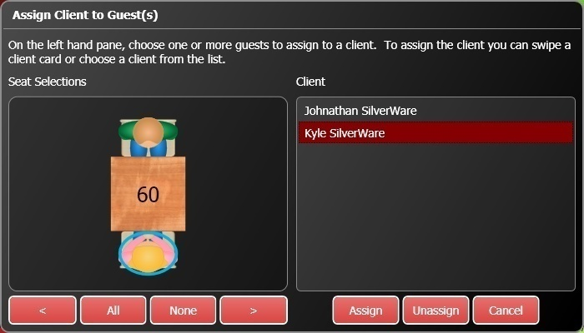
- Touch a guest (or multiple guests), then a client name. Press Assign to assign their purchases to the client account.
- If you haven’t swiped the client’s card yet, you can swipe it now. The client will be selected from the list on the right. Now, touch the guests you want to assign to the client’s account and press Assign.
- If you have a long list of clients, swiping a client’s card will be much easier that finding them on the list.
Now, when meal-plan items are ordered, they will automatically be given the discount you assigned in the System Settings area, and the client’s meal plan balance will decrease according to how many meal-plan items are ordered.

Languages
Avrio allows you to change the text that appears throughout the system. You can change the default language from English to almost any language in the world, and you also can also change what language the system uses depending on which employee in currently using a station (see these instructions on change an employee’s language).
In order to have the messages that appear on screen show in different languages, you may have to contact your SilverWare dealer about having the system translated to your preferred language. However, there are some items that you can change manually. Look for this button throughout Avrio:
Depending on which screen/option you’re looking at, touching this button will bring up a date/time picker, or this language window:
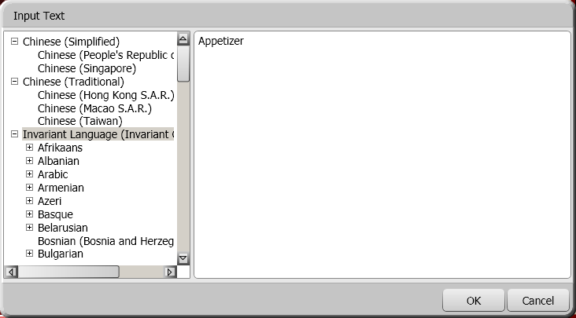
The left-hand side of the screen displays the various languages available to you. The right-hand side displays the text that appears for the item/option you were looking at (in this example, a course line was being edited) in the selected language. Select a language, erase the default text, and then type in the new text you want to appear when that language is in use.

Index

Approving, 12
Assigning Clients, 182
From the Order Screen, 174
Changing Tenders, 19
Clients and Gift Cards, 100
Creating a Client, 101
Creating a Gift Cards, 108
Loading a Gift Card, 108
Members, 105
Discount Reasons, 121
Employees, 86
Misc., 97
Personal Information, 86
Security
Managerial, 89
Operational, 87
Screens, 92
System, 91
Getting Help, 6
Getting Started, 7
Integrated Credit Cards, 161
Accepting Payment, 161
Forcing a Payment, 164
Settling Batches, 165
Splitting, 163
Voids, 165
Languages, 183
Left –Handed?, 8
Loyalty Cards, 167
Forcing a transaction, 169
Splitting, 168
Viewing a Card’s Information, 167
Voiding, 169
Manager Options, 17
Configuration, 27
Menu
Questions, 63
Menus, 29
2-for-1 Combos, etc), 76
Applying a Price Level to an Item, 66
Colors, 59
Gradients, 60
Combos, 73
Creating a New Major or Minor Class, 30
Creating a New Menu, 30
Creating a New Menu Group, 37
Creating a Normal Menu Item, 41
Price Levels, 65
Rule-based Menu Items, 67
Pay-Ins\Outs\Blind Drops, 124
Payment Methods, 118
Refunds, 159
Reopening Checks/Orders, 21
Reprinting Close Stubs, 22
Rotating the Floor plan, 10
Starting/Recalling Server’s Tables, 8
System Settings, 128
General, 128
Stations, 144
Taxes, 147
Void Reasons, 123, 159
Warranty, 6

