|  |  |  |  |
| --- | --- | --- | --- |
|  | C:\Users\KSchroer.SILVERWARE\Documents\Projects\Logo Transp.tif | SilverWare POS Inc. |  |

**SilverWare POS Avrio**

Manager Help Sheet

Contents

Add a Menu Item 3

Adding an Employee 10

Running End-of-Day 14

# Add a Menu Item

1. Go to **Manager Options** 🡪 **Configuration** 🡪 **Menu**.
2. Touch the **Items** tab.
3. Press **New**.
   * If you want to copy the price and question properties of an existing item to a new item, select the existing item and press “New From.”
4. Choose a minor class for the item. This also determines which major class the item is a part of. For example, “Dinner” would be the minor class, and “Food” would be the major class.

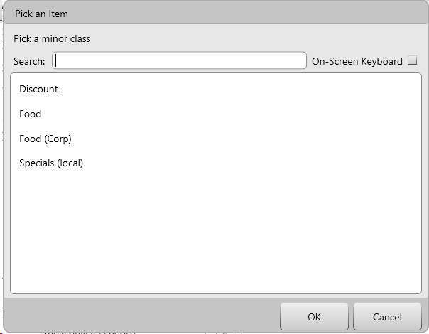

Basic information can be added in the “General” tab, including:

* Item name, as well as bar/kitchen and receipt descriptions
* Price can be entered in the “Default Price (item)” area. If your new item is a modifier with a price (such as “Add Cheese”), enter the price in the “Default Price (mod)” area.
* You can add forced modifiers by assigning questions in the area of the same name. Remember to set the pick quantity correctly (i.e. for a meat temp, the quantity would be 1-1, but drink mods might be 0-10)

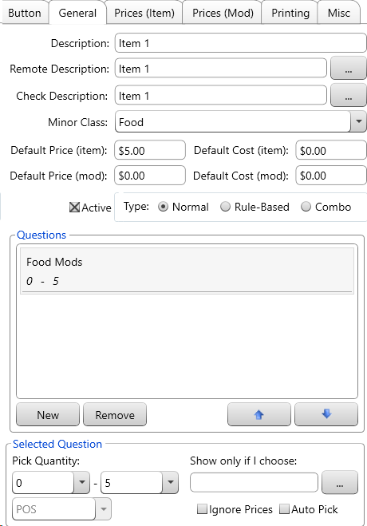

Typically printing settings don’t need to be set as the item will receive its printer destination from the minor it belongs to.

1. Touch the “Groups” tab. Select the group where you want to place your new item and press **Show**.
2. Touch the “Items” tab and select your new item. Click and drag it into the group now showing on the left side of the screen.

# Adding an Employee

To access this screen, go to Manager Options 🡪 Configuration 🡪 Employees.

Press **New** to add a new profile. When you add an employee, you must select a role. The role you select will determine their permissions.

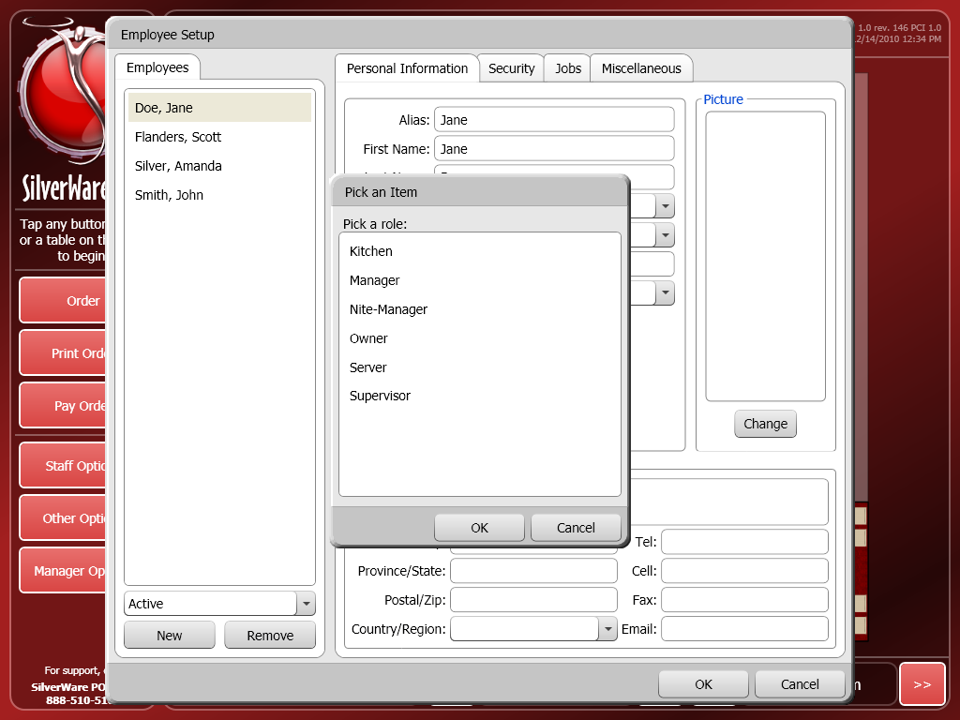

There is some personal, job, and miscellaeous information that you will need to fill out.

**Personal**

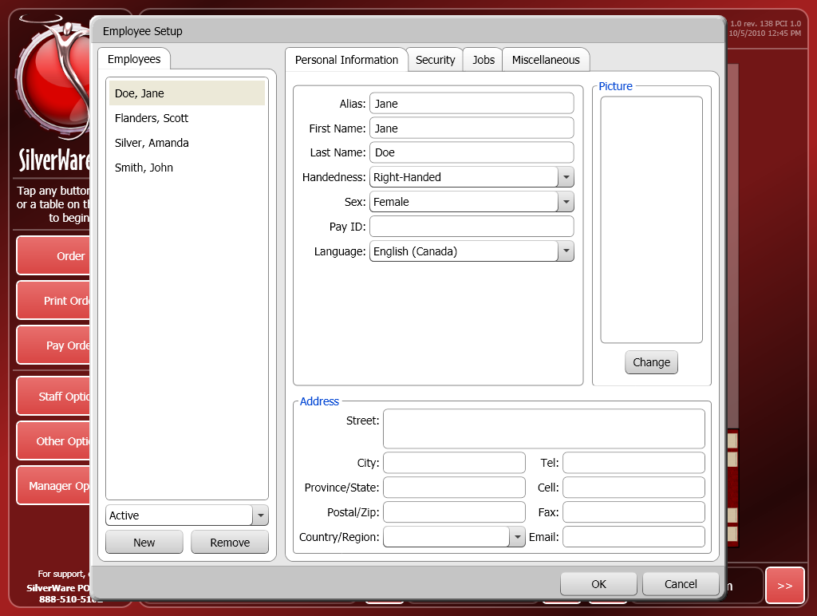

* **Alias** is the name that appears on Avrio screens and guest checks.
* **First Name**
* **Last Name**
* **Handedness** lets you select a layout for Avrio. Change this to “Left-Handed” to flip the standard layout for a left-handed employee when they’re using a workstation.

**Jobs**

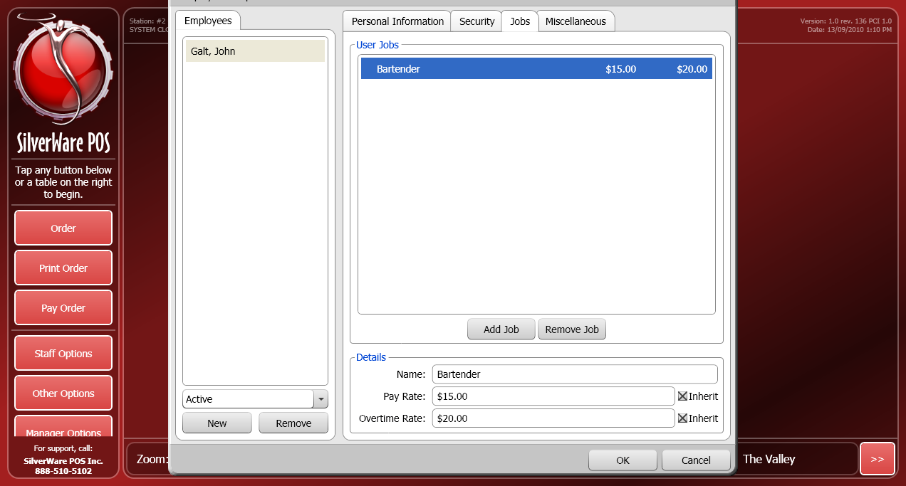

1. Select an employee from the list on the left-hand side of the screen.
2. Press **Add Job** and choose a job from the list that appears.

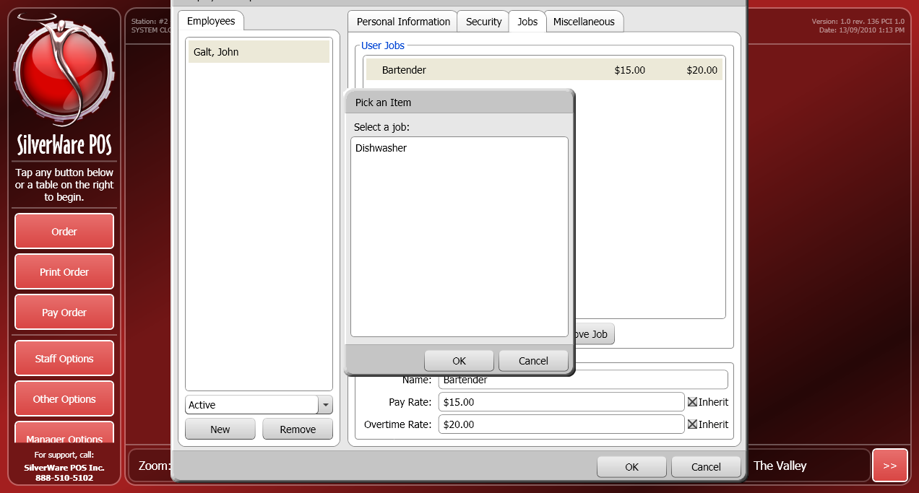

1. Once you’ve added a job, you can assign regular and overtime pay-rates.turn off the “Inherit” check boxes if you want to assign a different pay rate or overtime rate to the selected employee.

**NOTE:** Employees can have multiple jobs, each with a different pay rate and overtime rate. They will be prompted to choose a job when signing-in. The appropriate pay rate will be used when calculating their wages.

**Miscellaneous**

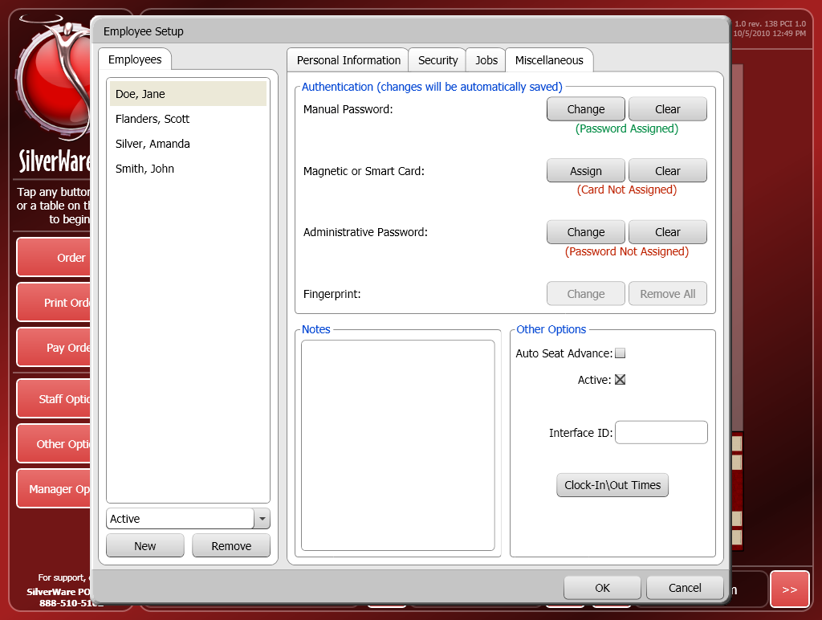

* **Manual Password** lets you assign a numeric password to the employee. Press **Clear** to remove the numeric password associated with this employee.
* **Magnetic of Smart Card** lets you assign a magnetic swipe card to this employee. Press **Clear** to remove the swipe card associated with this employee
* **Administrative Password** lets you create a password for an employee that needs to access the “System Settings” or “Employees” screens. The password must meet these criteria:
  1. Must be at least 8 characters.
  2. Have at least one each of these criteria:
     + Lowercase letters
     + Uppercase letters
     + Number or Symbol
* **Active** determines if the employee is active and can use the system. Employees with sales data cannot be removed from Avrio, so make an employee inactive if they leave your organization.

# Running End-of-Day

1. Go to Manager Options.

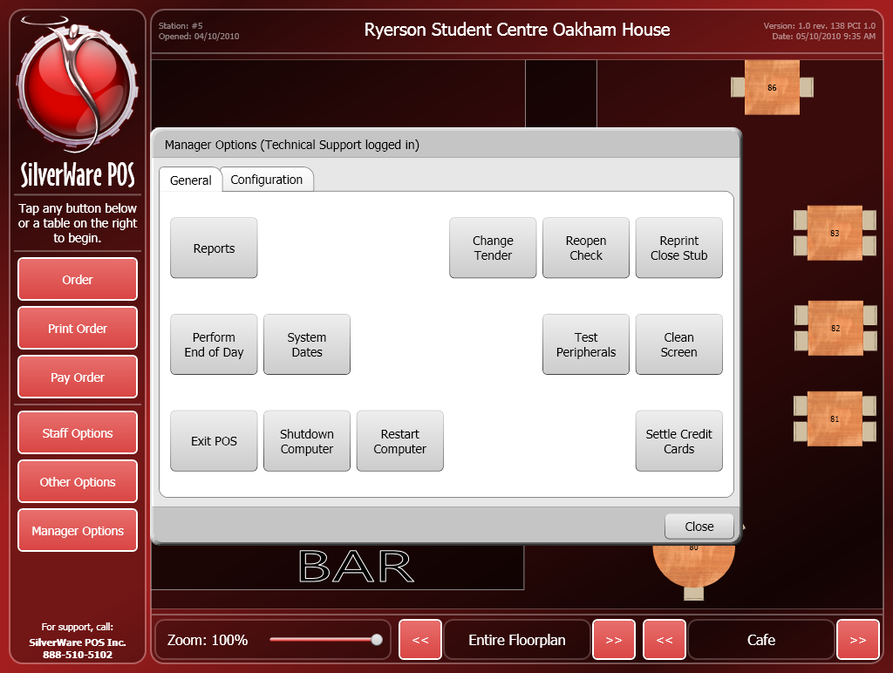

1. **Perform End-of-Day** shuts down the system, prints any necessary reports and server reads, performs system/database maintenance, and prepares the system for the next day.

* There cannot be any open orders when you attempt to run EOD.