|  |  |  |  |
| --- | --- | --- | --- |
|  | C:\Users\KSchroer.SILVERWARE\Documents\Projects\Logo Transp.tif | SilverWare POS Inc. |  |

Contents

Introduction 4

Warranty 4

Getting Help 4

The Main Screen 5

Staff Options 6

Sign-in/out 6

Staff Sales Report 6

Pay-In\Out 7

Blind Drops 8

Sending Internal Email 9

Ordering 12

Ordering Screen Options 15

Other Options 17

Adding/Removing Guests to an Order 17

Assigning Clients to an Order 18

From the Order Screen 18

From the Close Order Screen 18

Loading Gift Cards/Loyalty Accounts 19

Checking Gift Card/Loyalty Account Balances 20

Changing Price Levels 21

Tax Exemption 21

No Sales 23

Applying Gratuities 23

Working with Coupons 24

Issuing Coupons 24

Redeeming Coupons 26

Closing Orders 27

To Cash 27

To Credit/Debit Card (Without Integrated Processing) 28

To Credit Card (With Integrated Processing) 29

Voiding a Credit Card Payment 29

To Pay@Table 31

To a Loyalty Card 34

Voiding a Loyalty Card Payment 35

To Other Payment Types 35

Delivery 36

Logging Off and Signing Out 38

Logging Off 38

To Sign Out 38

# Introduction

SilverWare Avrio is a powerful restaurant-management tool operated through a touch-screen interface.

Avrio’s quick-service mode allows you to take and close orders without changing screens at any point. It is well-suited for fast food or cafeteria environments.

## Warranty

SilverWare POS Inc. makes no warranty of any kind with regard to this material, including but not limited to, the implied warranties of merchantability or fitness for a particular purpose. SilverWare POS Inc. shall not be liable for errors contained herein or for incidental consequential damage in connection with the provision, performance or use of this material.

This document contains proprietary information protected by copyright. All rights are reserved. No part of this document may be reproduced, stored in a retrieval system, transmitted in any form or by any means, electronic, mechanical, photocopy, recording or otherwise, or translated into another language without the prior written consent of SilverWare POS Inc. The information contained herein is subject to change without notice.

## Getting Help

SilverWare’s office is located in Ontario, Canada and operates under Eastern Standard Time. If you wish to ask a general question, please call **905-305-1225** during normal business hours, **Monday – Friday 9:00 am to 5:00 pm**.

If you need technical assistance, please contact our technical-support center, which is open 24 hours a day, 7 days a week.

Telephone: **1-888-510-5102**

Fax: **1-905-305-1810**

# The Main Screen

Very little is done here when using a quick-service terminal.

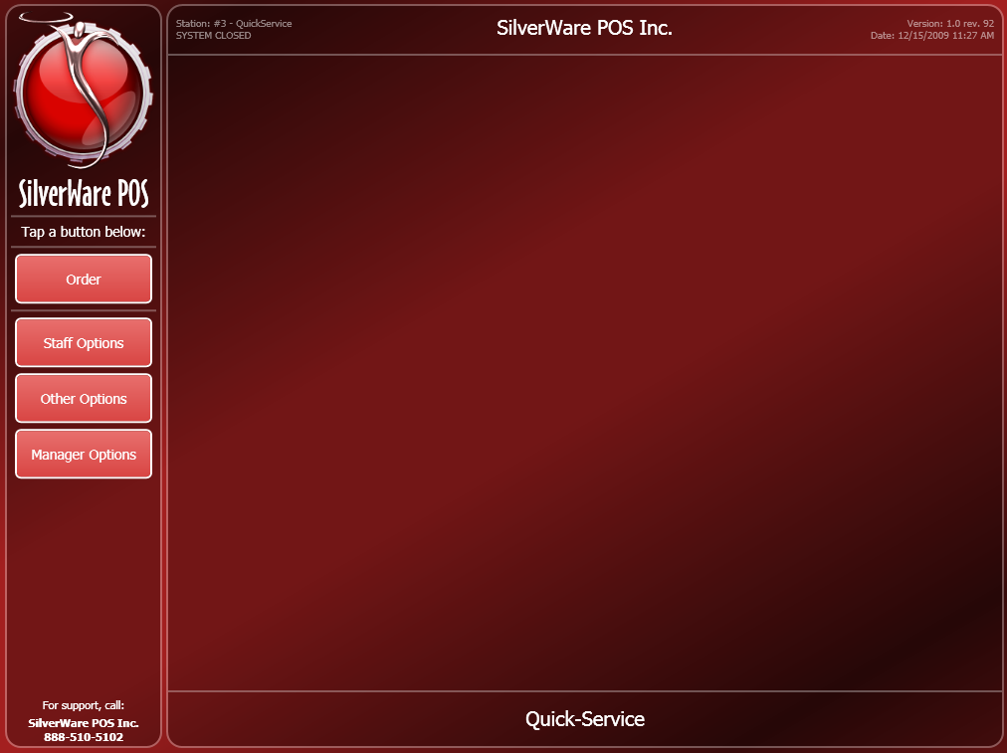

The **Order** button lets you start ordering

**Staff Options** is where you’ll find the sign-in, sign-out, pay-in, pay-out, and blind drop functions.

**Other Options** lets you check a loyalty card/account balance, look up a guest (if this location using the property management module), and perform a no sale.

**Manager Options** contains various managerial functions. See the Manager Guide for more details.

# Staff Options

The “Staff Options” menu lets you sign-in, sign-out, print reports, perform pay-ins/outs, and perform blind drops.

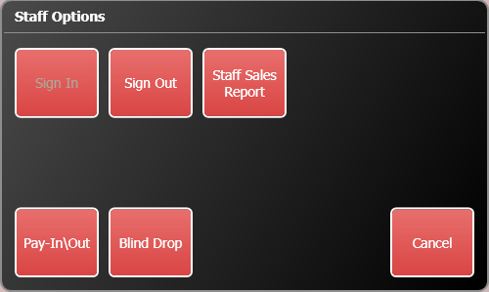

## Sign-in/out

At the beginning of your shift, you must sign-in to be able to place orders, close checks, etc. At the end of your shift, you must sign-out.

Your manager may also require you to sign-in/out for breaks.

**To Sign-in/out:**

1. On the main menu, press **Staff Options**.
2. Enter your ID. Your ID is either a numeric password, a swipe card assigned to you, or can be entered by scanning your fingerprint with a fingerprint reader attached to the workstation.
3. Press **Sign In** or **Sign Out**.

* If you have open orders when trying to sign-out, Avrio will offer to transfer them for you

## Staff Sales Report

When you sign-out, a “Staff Sales Report” automatically prints. However, you can print it earlier in your shift if you need to.

**To View/Print a Staff Sales Report:**

1. On the main menu, press **Staff Options**.
2. Enter your ID.
3. Press **Staff Sales Report**.

## Pay-In\Out

This option lets you pay money in or take money out of the cash register.

**To perform a pay-in\out:**

1. On the main menu, press **Staff Options**.
2. Enter your ID.
3. Press **Pay-In\Out**. The pay-in\out screen appears:

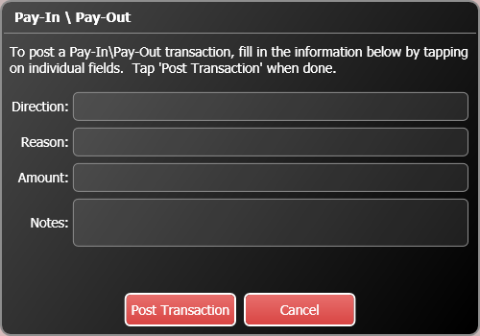

1. Touch the “Direction” field to choose if you’re taking money out of the cash, or putting money into it.
2. Press the “Reason” field to select from the pre-existing reasons.
3. Touch the “Amount” field to bring up a key-pad that lets you enter the amount you’re taking out/putting in.
4. Touch the “Notes” field to bring up an on-screen keyboard that allows you to enter notes about the transaction.
5. When complete, press **Post Transaction**. You may be asked for a manager’s authorization.

## Blind Drops

Blind drops are used when a restaurant wants you to give them your net cash owing without knowing how much it is supposed to be first.

**To perform a blind-drop:**

1. On the main menu, press **Staff Options**.
2. Enter your ID.
3. Press **Blind Drop**. A key pad appears.
4. Enter the amount for the blind drop, then press **OK**.

## Sending Internal Email

Avrio has a built-in email service that can be used to send messages amongst staff members.

**To send a message:**

1. On the main menu, press **Staff Options**.
2. Enter your ID.
3. Press **Send Email**.

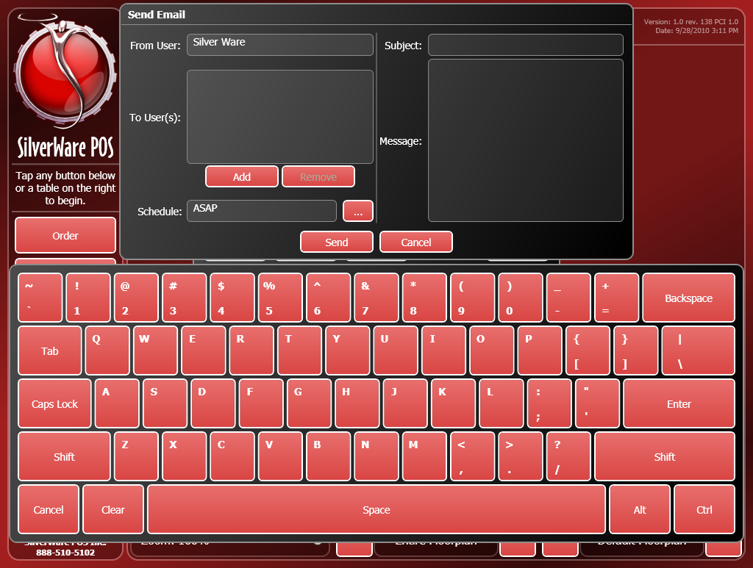

1. To add recipients, press the **Add** button. The “Add Recipient(s)” window will appear.

* You can filter possible recipients by selecting different roles or jobs using the **…** buttons
* Select recipients from the list on the right and press **Add Selected**.

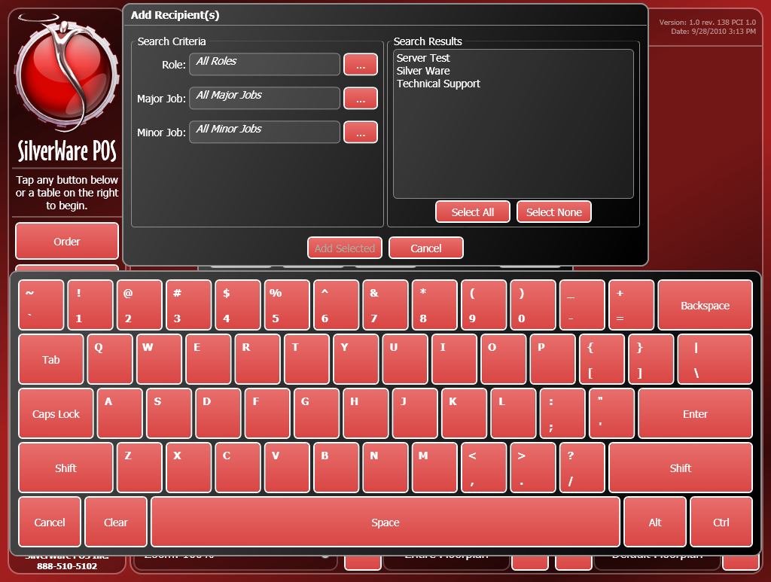

1. After you’ve added recipients, you can now enter your subject line and message. Touch the **Subject** area or message area and begin typing or use the on-screen keyboard to enter your message.
2. You can also choose when the recipient(s) will get the email by changing the **Schedule** option.
   * If “ASAP” is selected, they will receive the message the next time their server code/card/bio-metric is detected. If “Sign-in” or “Sign-out” is chosen, they will receive the email the next time they sign-in or out.

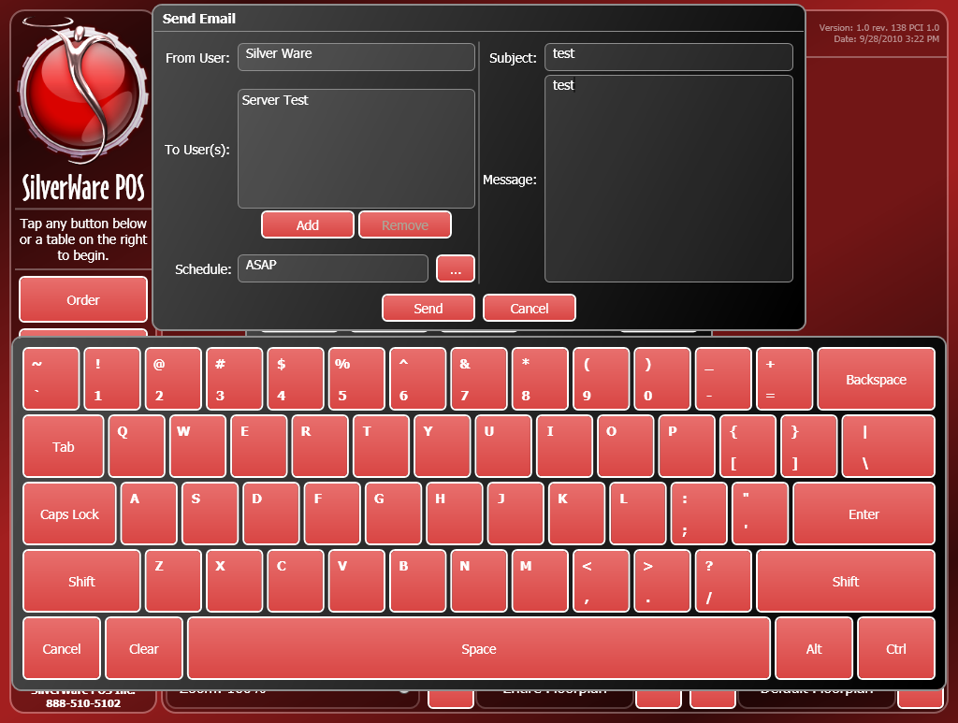

# Ordering

1. To begin ordering, press the **Order** button on the main screen. Enter your password if prompted. You are now the active user on this terminal, and will not need to enter your password/swipe your user card again until you’ve logged off.

* Note – Logging off means you are not the active user on the terminal, and should not be confused with signing-out. You are still considered signed-in, even after logging off.

1. The order screen appears:

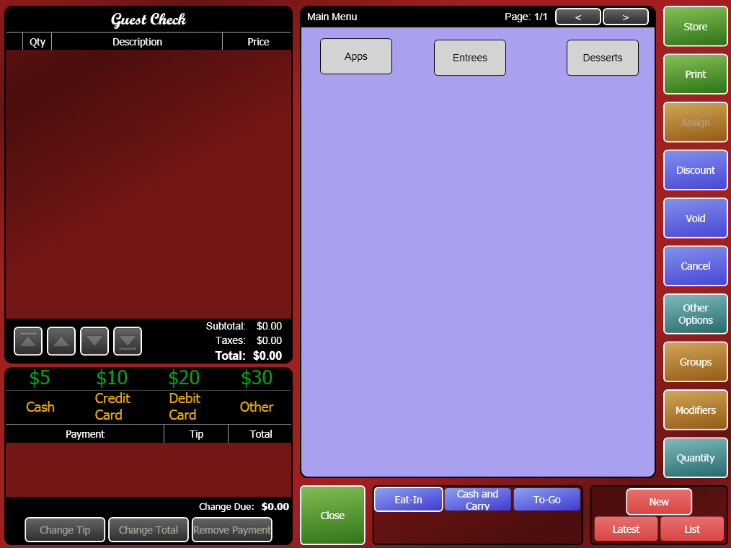

1. Before you begin ordering, make sure you select the correct service type. The service types are at the bottom of the screen. In the image above, the available service types are “Eat-In”, “Cash and Carry”, and “To-Go”. Service types affect whether or not checks and kitchen chits are printed, if you need enter information about the customer (phone # and address for delivery), and other things.
2. Select a menu group to see the items within it. If there are multiple pages for your current group, use the arrow at the top of the screen to move between the pages. Touch a menu item to add it to the bill.
3. Some items may prompt you to enter a price. A manager may be needed to authorize the price.

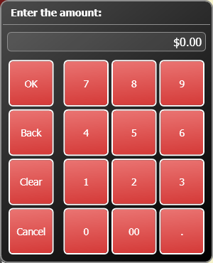

1. Some items may prompt you to enter a manual description or additional instructions. You can use the on-screen keyboard to do so:

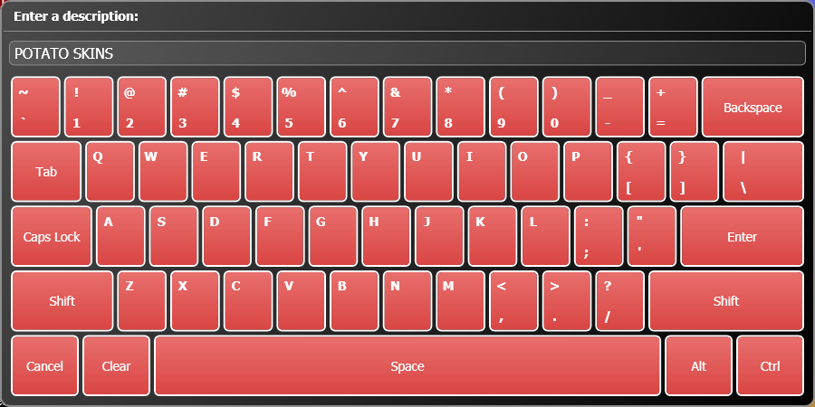

* Use the **Shift** button to capitalize a letter or to enter auxiliary symbols (!, @, #, “, :, etc). The shift function only affects the first button you press.

Now that an item has been added to the bill, the screen has changed to reflect the item as well as the balance owing on the check.

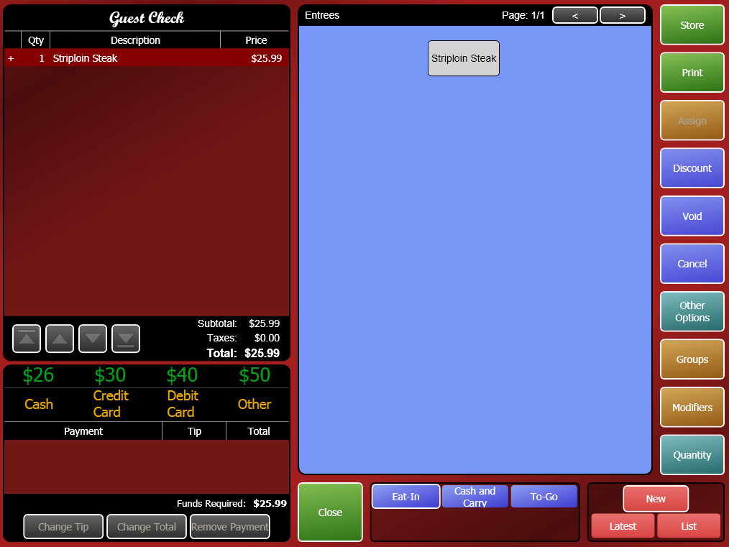

1. Continue ordering as necessary until you are ready to close the check.

## Ordering Screen Options

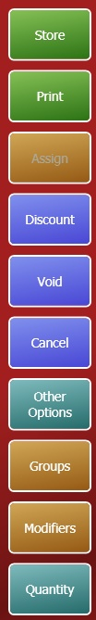

If the service type allows orders to be assigned to clients, press **Assign to do so.**

Press **Quantity** to order more than one of an item.

Press **Groups** to see the main listing of menu groups.

Press **Other Options** to see loyalty options, view order history and more.

Press **Cancel** once to remove all new items from this order. Pressing it again will exit the order screen.

Press **Modifiers** to view possible mods for the item recently added to the bill.

Press **Void** to remove an item in this order, or to void the entire order.

Press **Discount** to apply a discount to items in this order, or to discount the entire order.

Press **Print** to print a check.

Press **Store** to store an order to pay it later. May not be available for all service types

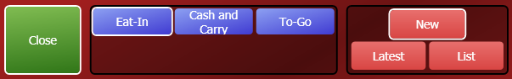

These buttons let you start a new order, recall the latest order, or view a list of your stored orders.

This area lets you select which service type will be applied to the order. You must select the service type before storing/closing the order.

Press **Close** to close an order after you’ve entered the necessary payment(s).

## Other Options

The “Other Options” button lets you perform a variety of functions.

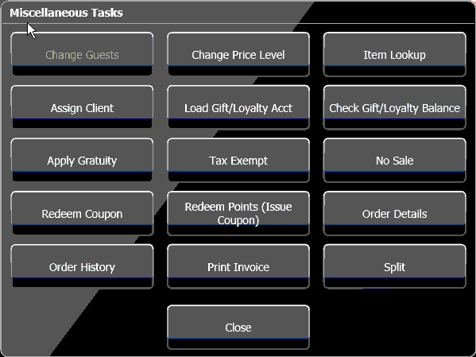

### Assigning Clients to an Order

If you’re serving a VIP/client, you will need to assign them to the order seat. This ensures that any price levels or discounts they receive are applied to their orders.

1. If the client has a loyalty card, swipe the card on the order screen. If no card is available, press **Other Options**, then **Assign Client** to see a list of possible clients.

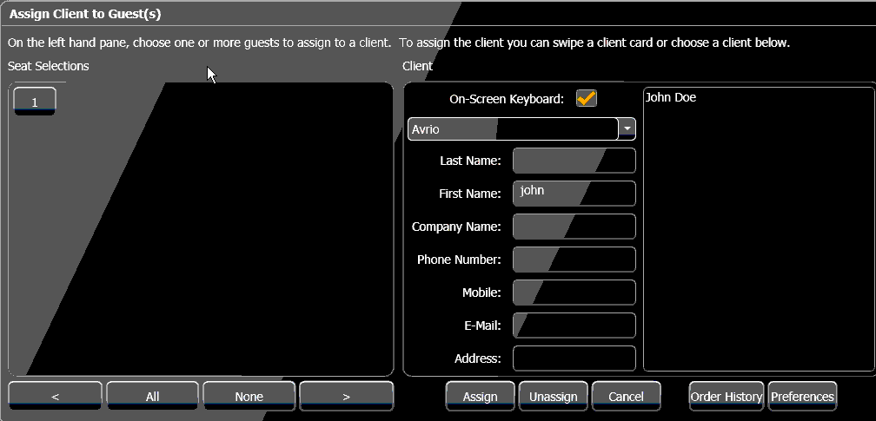

1. Touch a guest (or multiple guests), then a client name. Press **Assign** to assign their purchases to the client account.

* If you haven’t swiped the client’s card yet, you can swipe it now. The client will be selected from the list on the right. Now, touch the guests you want to assign to the client’s account and press **Assign**.
* If you have a long list of clients, swiping a client’s card will be much easier that finding them on the list.

### Loading Gift Cards/Loyalty Accounts

Within the “Other Options” menu on the “Order” screen, touch **Load Gift/Loyalty Acct** to load a gift card or make a payment to a loyalty account.

1. This window appears:

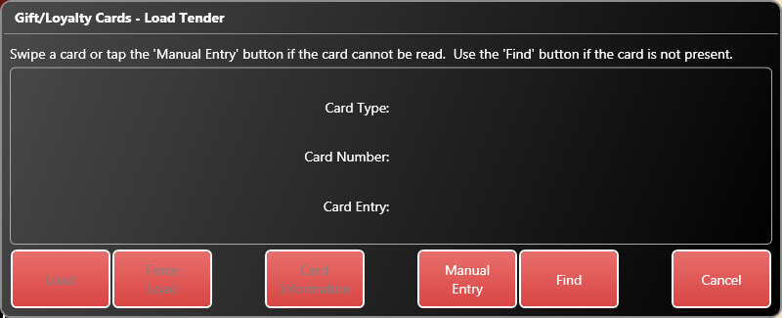

1. Swipe a card or enter press **Manually Entry** to enter the card information:

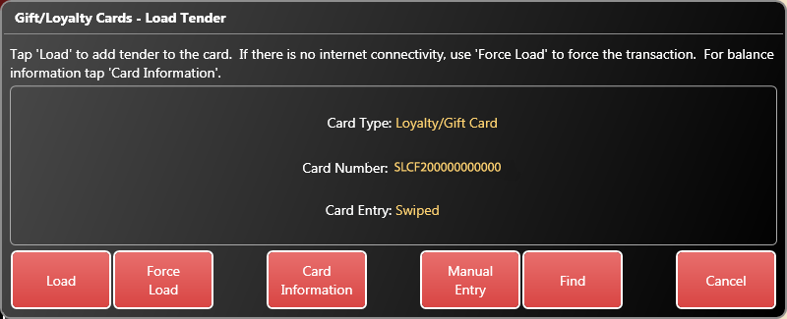

1. Now, choose **Load** to load the card normally, or **Force Load** to load the card if no connection to the loyalty service is possible. If you force the load, you will have to enter an approval code. Press **Card Information** to see information about the card’s current balance and any associations with a client.
2. Enter an amount to load.
3. The “Order” screen appears. You can now continue or close the order as per usual.

### Checking Gift Card/Loyalty Account Balances

Within the “Other Options” menu on the “Order” screen, touch **Check Gift/Loyalty Acct** to check a gift card’s or loyalty account’s balance.

1. Swipe the card, or press **Manual** to enter the card number and PIN manually.
2. The card’s information will appear on screen. Press **Print** if you want to print it.

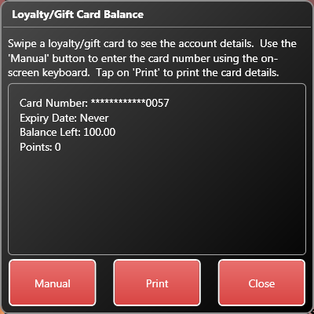

### Changing Price Levels

Management can setup different price levels for items. These levels can be automatically controlled by schedules, but you may need to manually apply a different price level. When you change the price level, the new level is applied to all items you order until you send the order. You will have to change the level again if you need to recall the order. **You cannot select an item and then change the level using this option. You must change the level before ordering items.**

1. On the “Order” screen, select the item(s) to change.
2. Press **Other Options**.
3. Press **Change Price Level**.

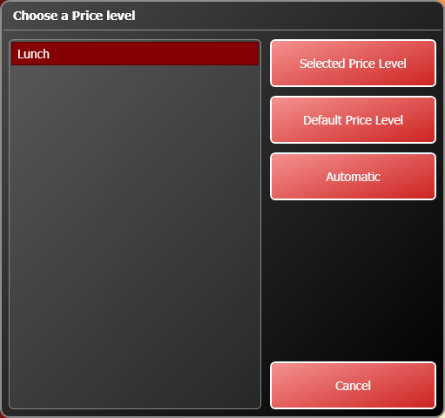

1. Select a price level from the list on the left, then choose one of the options on the right to apply a price level.

* **Selected Price Level** applies the price level you’ve selected.
* **Default Price Level** changes the items to its regular price.
* **Automatic** changes the item to the price it is scheduled for. Management can setup a schedule that determines what price level should be in use during certain hours.

1. You may need a manager to enter a password and complete the change.

### Tax Exemption

Within the “Other Options” menu on the “Order” or the “Close Order” screens:

1. Touch **Tax Exempt** to remove taxes from an order.

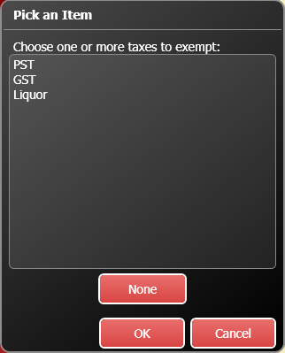

1. Select a tax, then press **OK** to remove it from the order.
2. You may need to enter a reason for the exemption (such as a Tax Exemption Card number).

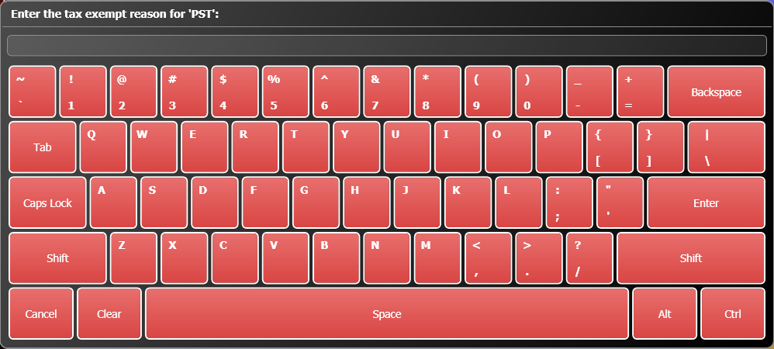

1. A manager’s authorization may be required as well.

## No Sales

If you need to open the cash drawer without performing a sale:

1. Within the “Other Options” menu on the “Order” or the “Close Order” screens:
2. Touch **No Sale**. A manager may be required, and the drawer will open if you have access to it.

## Applying Gratuities

The **Apply Gratuity** option allows you to add a gratuity to the order, such as a large party gratuity, bottle service, etc.

1. Within the “Other Options” menu on the “Order” or the “Close Order” screens, touch **Apply Gratuity**.
2. Select a gratuity to apply to the bill, then press **OK**, or press **None** or **Cancel** to exit this screen.

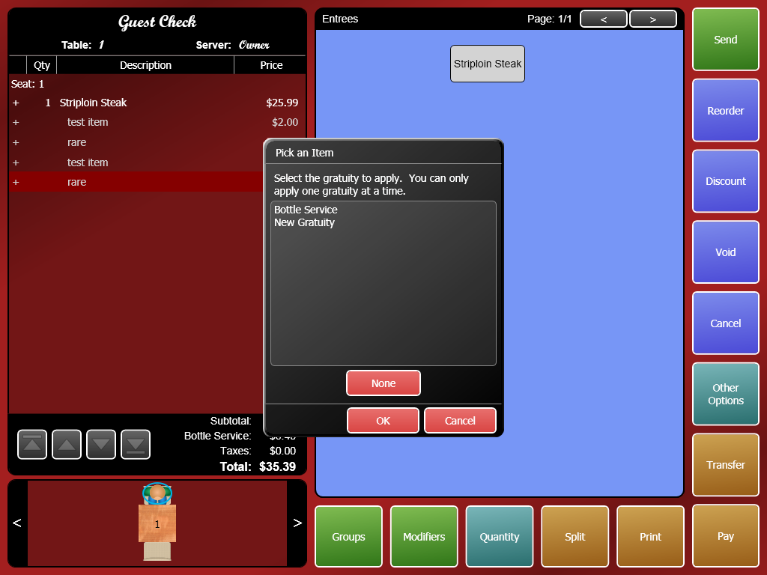

1. The gratuity will be charged upon all applicable items and added to the bill. Any items that are added after the grat has been applied will increase the amount of the grat.

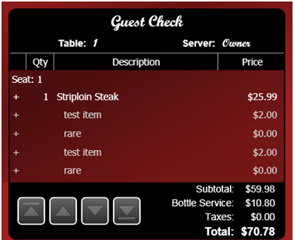

## Working with Coupons

From the “Other Options” menu, you can issue or redeem coupons.

### Issuing Coupons

To issue a coupon:

1. While ordering, press **Other Options**.
2. Press **Redeem Points (Issue Coupon)**

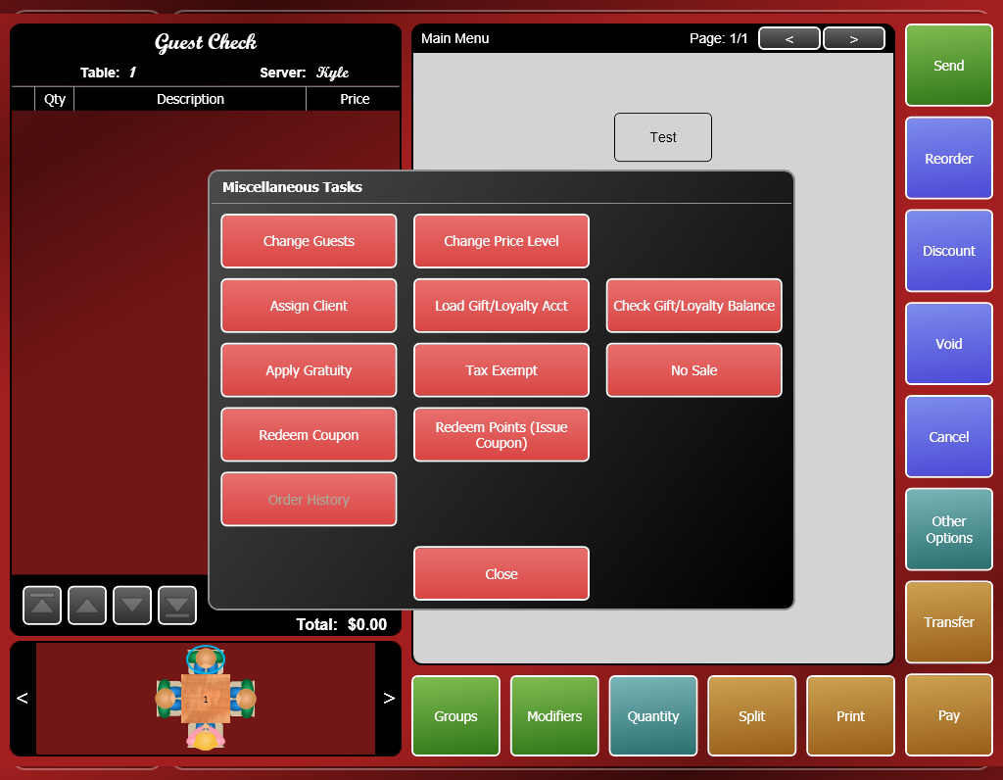

1. Highlight client you want to issue the coupon to and press **Select**

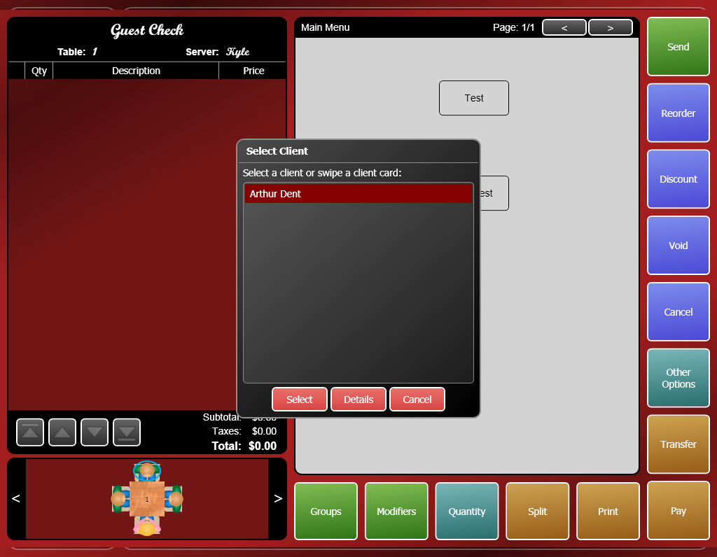

1. Select the coupon you want to issue and press **OK**.

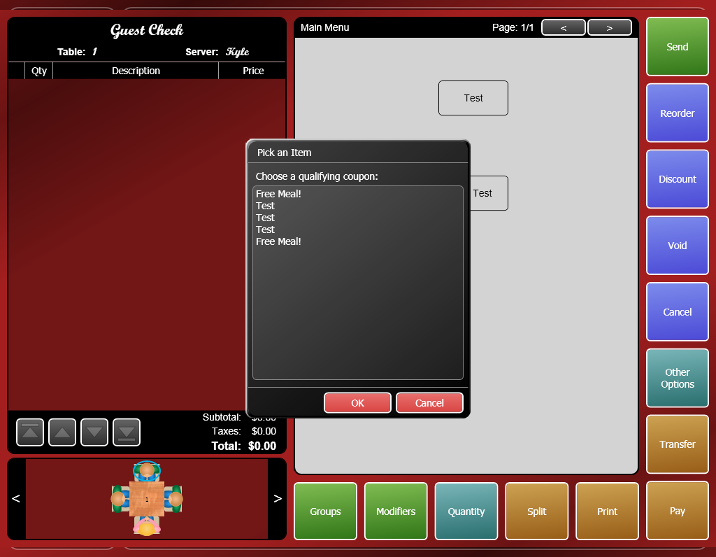

1. The coupon will print out of a check printer. There will be a number printed on the coupon that represents the coupon’s number. This number will be needed when redeeming the coupon.

## Redeeming Coupons

To redeem a coupon:

1. While ordering, select the item(s) you want to apply the coupon to.
2. Press **Other Options**.
3. Press **Redeem Coupon**



1. Enter a valid coupon #.
2. The coupon will be applied to the selected item(s).
3. A manager may need to approve the coupon when you send/print/pay the order.

## Closing Orders

### To Cash

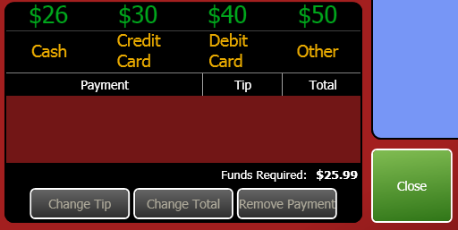

1. If the customer pays with cash, use either the quick-cash buttons or press **Cash** to enter the amount the customer is paying.

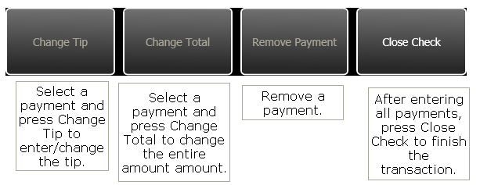

1. Press **Close** to close the check.

### To Credit/Debit Card (Without Integrated Processing)

* + If the customer pays with a credit card, and your site is not using integrated processing, your manager should provide instructions on using your credit card terminal.

1. On the “Close Order” screen, press **Credit Card** or **Debit Card**. If you choose credit card, you must select the guest’s card type.

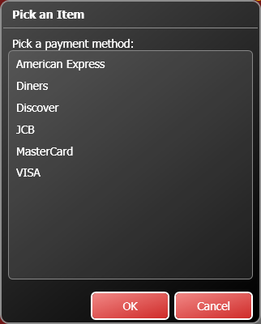

1. Enter the amount the guest is paying.

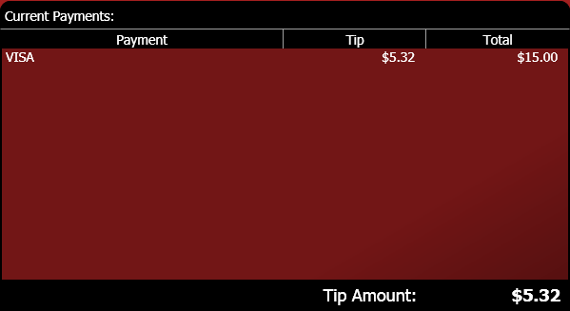

1. Enter any other payments if necessary.
2. Press **Close** to close the check.

### To Credit Card (With Integrated Processing)

* Follow these instructions to close a credit card order when your location is using Avrio’s integrated processing.

1. In the “Close Order” area, press **Credit Card** or swipe a card and skip to instruction four.
2. The “Credit Card Authorization” window appears.

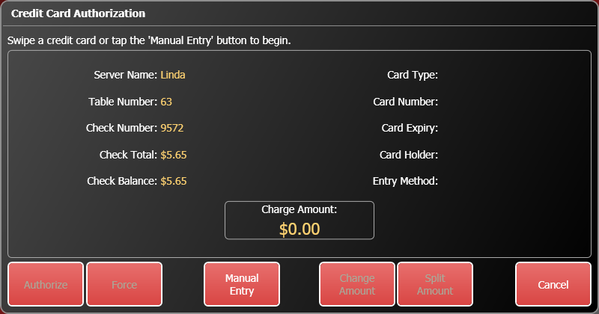

1. Swipe the customer’s card, or press **Manual Entry** to enter the card number and expiry date.
2. Verify that the card number, expiry date, table number, check #, and amount that appear match the card and bill you are working with. Press **Authorize** to start the authorization process. Wait while the authorization takes place.
3. Press **Close** to close the check.

### Voiding a Credit Card Payment

1. Open the order.
2. Select the payment.
3. Press **Remove Payment**.
4. Avrio will communicate with your processor and void the payment.

If Avrio cannot connect to your processor, you have the option of forcing a transaction.

You will need an approval number, which you can obtain by calling your processor. **NOTE:** If you enter an incorrect approval number, the payment might not properly process when a manager tries to close the batch, or your processor may charge more to process the transaction.

1. On the “Close Order” screen, press **Credit Card** or swipe a card.
2. The “Credit Card Authorization” window appears.



1. Swipe the customer’s card, or press **Manual Entry** to enter the card information yourself. You will to enter the card number and expiry date if you enter it manually.
2. Press **Force**.
3. The on-screen keyboard appears. Enter the approval code provided by your processor.
4. When the card is forced, the “Close Order” screen displays the card type and the last four digits of the card as a payment.

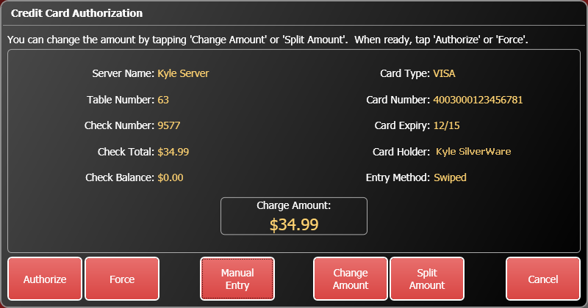

1. When the card is authorized, the “Close Order” area displays the card type and the last four digits of the card. At this point, you will not see the entire card number or expiry date again.
2. Press **Close** to close the check.

### To Pay@Table

If the restaurant is using integrated pay@table processing with an Ingenico wireless terminal, here’s how to take payment:

**Accepting one payment for a check**

* + Press the **Pay at Table** button on the screen.
  + The screen on the pay@table device should read “Employee Login Swipe/Enter ID”
  + Enter your Avrio password (the one you use to start tables, sign-in/out, etc) on the pay@table device and press OK.
  + You’ll be prompted to “Get Tables.” Press **OK.**
  + The pay@table device will display information about the check, including the table #, check # and amount due.
  + You will also have three options on the screen: “SPLT” (split payment), PARTL (partial payment) and TOTL (total payment). Press F3 to select TOTL.
  + Choose the payment method you’ll be accepting. “CR/DB Payment” should be highlighted. Press OK.
  + You’ll be prompted to swipe or insert the customer’s card. Do so and pass the card and device to the customer so they can follow the instructions.
  + The customer will be prompted to enter a tip. They can choose a default percentage, or they can press other, choose percentage or dollar amount, then enter the amount
  + The transaction will be processed. Make sure to obtain any necessary signatures from the customer.
  + You’ll see “Table Closed” on the device when it has sent the payments (assuming the payment covered the balance due) to Avrio. The order will disappear from the Avrio screen.

**Split Payments**

A split payment lets you choose how many people will be splitting the bill and have the device calculate even payments for each customer.

1. Press the **Pay at Table** button on the screen.
2. The screen on the pay@table device should read “Employee Login Swipe/Enter ID”
3. Enter your Avrio password (the one you use to start tables, sign-in/out, etc) on the pay@table device and press OK.
4. You’ll be prompted to “Get Tables.” Press **OK.**
5. The pay@table device will display information about the check, including the table #, check # and amount due.
6. You will also have three options on the screen: “SPLT” (split payment), PARTL (partial payment) and TOTL (total payment). Press F1 to select SPLT.
7. Enter the number of people that will be splitting the bill and press OK.
8. On the next screen, you’ll be shown the total amount due and the amount that the first payment will be. Press F1 to accept or F3 to start over.
9. Choose the payment method you’ll be accepting. “CR/DB Payment” should be highlighted. Press OK.
10. You’ll be prompted to swipe or insert the customer’s card. Do so and pass the card and device to the customer so they can follow the instructions.
11. The customer will be prompted to enter a tip. They can choose a default percentage, or they can press other, choose percentage or dollar amount, then enter the amount
12. The transaction will be processed. Make sure to obtain any necessary signatures from the customer.
13. On the next screen, you’ll be shown the remaining amount due and the amount that the second (or third, fourth, etc) payment will be. Press F1 to accept or F3 to start over.
14. Choose the payment method you’ll be accepting. “CR/DB Payment” should be highlighted. Press OK.
15. You’ll be prompted to swipe or insert the customer’s card. Do so and pass the card and device to the customer so they can follow the instructions.
16. The customer will be prompted to enter a tip. They can choose a default percentage, or they can press other, choose percentage or dollar amount, then enter the amount
17. The transaction will be processed. Make sure to obtain any necessary signatures from the customer.
18. Once you have completed all payments, you’ll see “Table Closed” on the device when it has sent the payments (assuming the payment covered the balance due) to Avrio. The order will disappear from the Avrio screen.

**Partial Payments**

Follow these instructions to accept multiple payments for a single check. A partial payment lets you choose how much of the bill one credit/debit card will be paying.

1. Press the **Pay at Table** button on the screen.
2. The screen on the pay@table device should read “Employee Login Swipe/Enter ID”
3. Enter your SilverWare password (the one you use to start tables, sign-in/out, etc) on the pay@table device and press OK.
4. You’ll be prompted to “Get Tables.” At this point you can enter a specific table number, or just press OK to view checks printed at all tables. If you choose to view all checks, use the F1 and F3 buttons on the device to scroll up and down the list, then press OK to choose that check.
5. The pay@table device will display information about the check, including the table #, check # and amount due.
6. You will also have three options on the screen: “SPLT” (split payment), PARTL (partial payment) and TOTL (total payment). Press F2 to select PARTL.
7. Choose if the payment is going to be a specific dollar amount or a percentage of check’s total.
8. Enter the percentage or dollar amount the customer wishes to pay, then confirm the amount with them. Use F1 or F3 to continue or stop.
9. Choose the payment method you’ll be accepting. “CR/DB Payment” should be highlighted. Press OK.
10. You’ll be prompted to swipe or insert the customer’s card. Do so and pass the card and device to the customer so they can follow the instructions.
11. The customer will be prompted to enter a tip. They can choose a default percentage, or they can press other, choose percentage or dollar amount, then enter the amount
12. The transaction will be processed. Make sure to obtain any necessary signatures from the customer.
13. On the next screen, you’ll be shown the remaining amount due, and you can continue accepting payments for this check. Or you can press “Cancel” to go back to the “Employee Login Swipe/Enter ID” screen.
14. Once you have completed all payments, you’ll see “Table Closed” on the device when it has sent the payments (assuming the payments covered the balance due) to Avrio. The order will disappear from the Avrio screen.

### To a Loyalty Card

Loyalty cards can be either gift cards or cards linked to a client account.

To close an order to a loyalty account:

1. Swipe the card (or scan a badge) or touch **Gift Card**.
2. The “Loyalty Authorization” window appears.

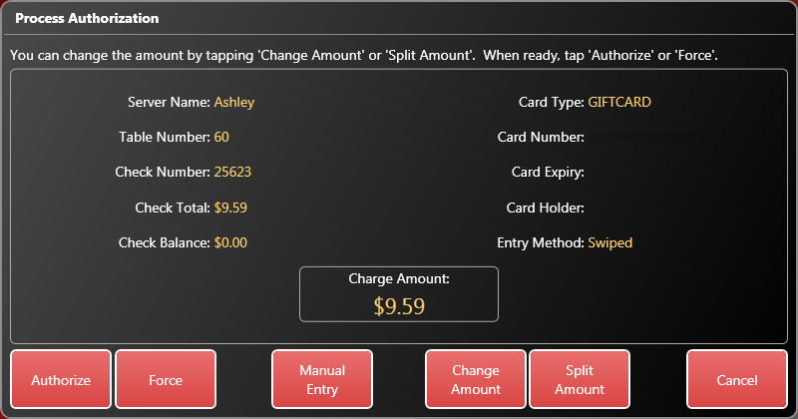

1. Verify that the card information and amount that appear match the card and bill you are working with. Press **Authorize** to start the authorization process. Wait while the authorization takes place.

* In the event the card doesn’t have enough funds to pay the entire bill, the balance available will be authorized and the remaining amount must be paid via another payment method (cash, credit, debit, etc).

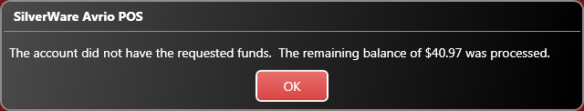

1. When the card is authorized, the “Close Order” area displays the card type and the last four digits of the card.
2. Press **Close** to close the check.

If Avrio cannot connect to the loyalty service, you have the option of forcing a transaction.

You will need an approval code.

1. On the “Close Order” screen, swipe a loyalty card.
2. The “Loyalty Card Authorization” window appears.
3. Press **Force**.
4. The on-screen keyboard appears. Enter an approval code.
5. When the card is forced, the “Close Order” screen displays the card type and the last four digits of the card as a payment.
6. Select the payment and press **Change Tip** to enter any tip the customer has added to the total.
7. Press **Close Check**.

### Voiding a Loyalty Card Payment

If you have already authorized a loyalty card payment, but need to remove it from a bill before it is finalized and closed:

1. Open the order and go to the “Close Order” screen.
2. Select the payment.
3. Press **Remove Payment**.
4. Avrio will communicate with the loyalty service and void the payment.

### To Other Payment Types

1. Press **Other** to view any other payment types available in the system. Foreign currencies, paper gift certificates, and coupons are examples of payment types that are often found here.
2. Press **Close Check** once all payment types have been entered.

# Delivery

Delivery orders can be taken directly through the POS. To start a delivery order:

1. On the ordering screen, choose “Delivery” as your service type before beginning your order. It is selected with a white outline at the bottom of the following screen shot.

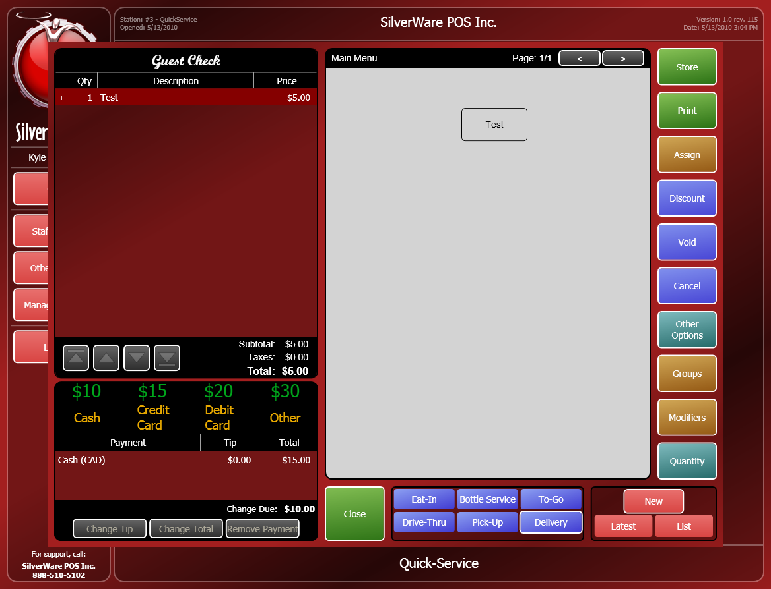

1. Order items as you would normally.
2. When you attempt to store, print, or close the order, you’ll be prompted to assign a client and date/time to the order.

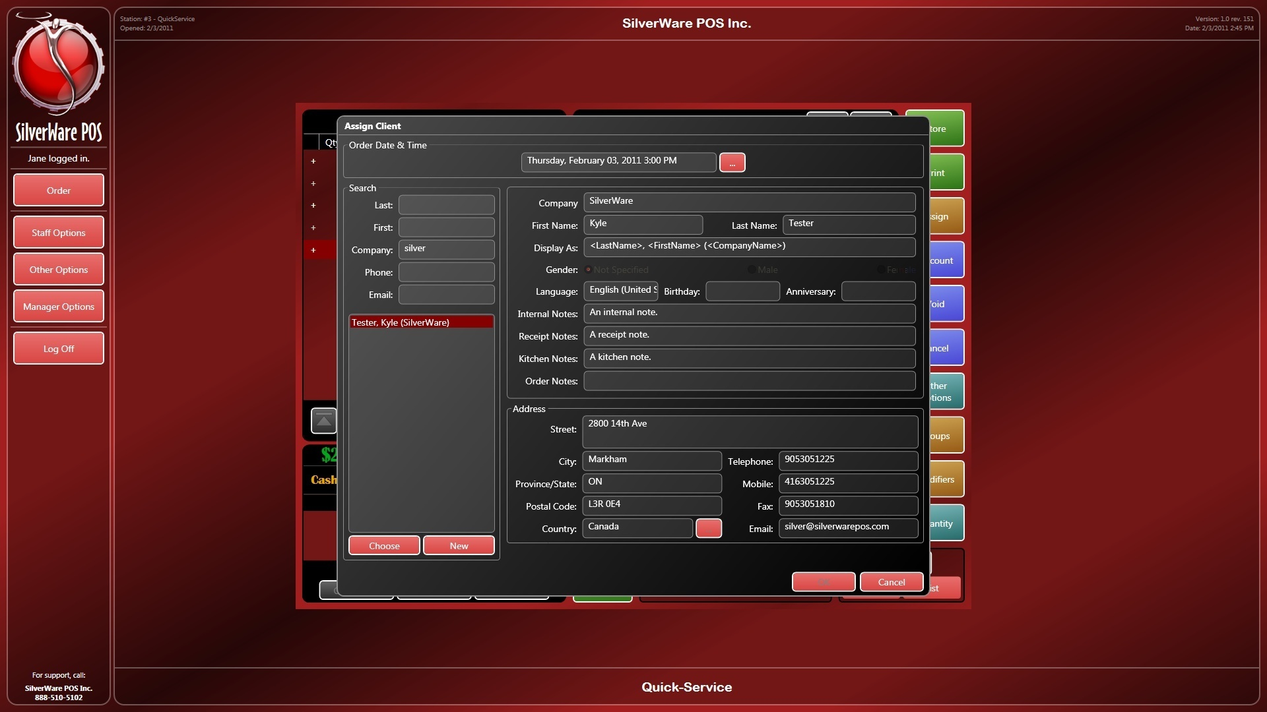

* You can set the date/time for the delivery at the top of the screen by pressing the **…** button.
* To search for an existing client, enter some details in the “Search” area on the left side of the screen.
  + Highlight a client and press **Choose** to use the date/time and client selected. You can modify details on the next screen that appears.
* To create a new client, press the **New** button in the “Search” area of the left side of the screen, then fill out the details on the next screen.

After confirming all details on the following screen, the order will be stored/printed/paid, depending on what you were trying to do before the “Assign Client” window appeared.

NOTE: If you store a future order (one set to be delivered on a different day), only a manager will be able to recall and modify the order until the day it is due.

# Logging Off and Signing Out

## Logging Off

If you are taking a break or preparing the sign-out, you must first log off the system.

1. Use the **Cancel** button on the Ordering screen to exit from your current order.
2. Once you’re back at the main screen, press log off. At this point, you are logged-off and cannot start any orders without entering your password/swipe card/finger print again. However, you ARE still signed-in.

## To Sign Out

1. On the main menu, press **Staff Options**.
2. Enter your ID. Your ID is either a numeric password, a swipe card assigned to you, or can be entered by scanning your fingerprint with a fingerprint reader attached to the workstation.
3. Press **Sign Out**.
4. If you have open orders when trying to sign-out, Avrio will offer to transfer them for you.