|  |  |  |  |
| --- | --- | --- | --- |
|  | C:\Users\KSchroer.SILVERWARE\Documents\Projects\Logo Transp.tif | SilverWare POS Inc. |  |

**SilverWare POS Avrio**

Server Help Sheet

Contents

Sign In/Out 3

Ordering 4

Printing Orders 6

From the Main Menu 6

From the Order Screen 6

Closing Orders 7

Viewing Open/Closed Orders 8

# Sign In/Out

At the beginning of your shift, you must sign-in to be able to place orders, close checks, etc. At the end of your shift, you must sign-out.

**To Sign-in/out:**

1. On the main menu, press **Staff Options**.
2. Enter your ID. Your ID is either a numeric password, a swipe card assigned to you, or can be entered by scanning your fingerprint with a fingerprint reader attached to the workstation.
3. Press **Sign In** or **Sign Out**.

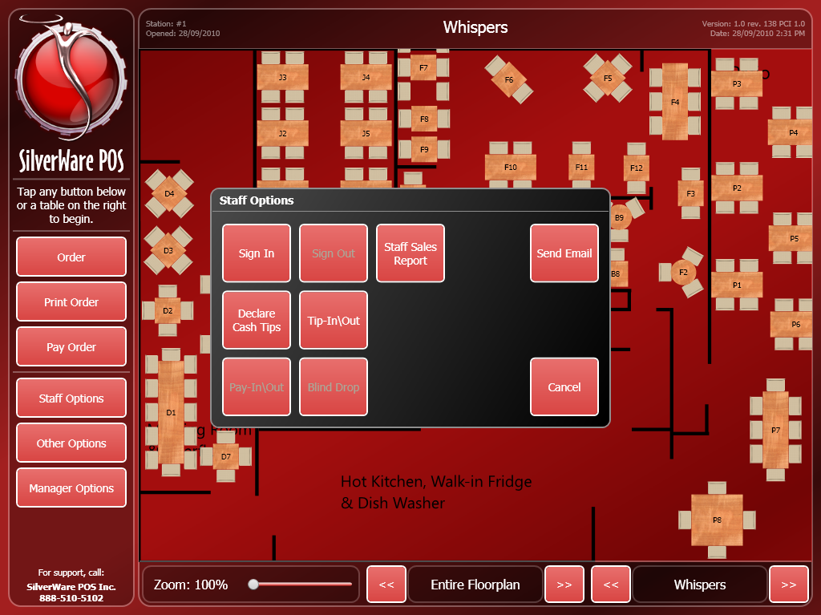

# Ordering

1. Touch an empty table to start a new order or touch an occupied table to recall an order. When starting a new order, the “Assign Guests” screen appears. Tap an empty seat to add guests (once for male, twice for female, three times to empty it.

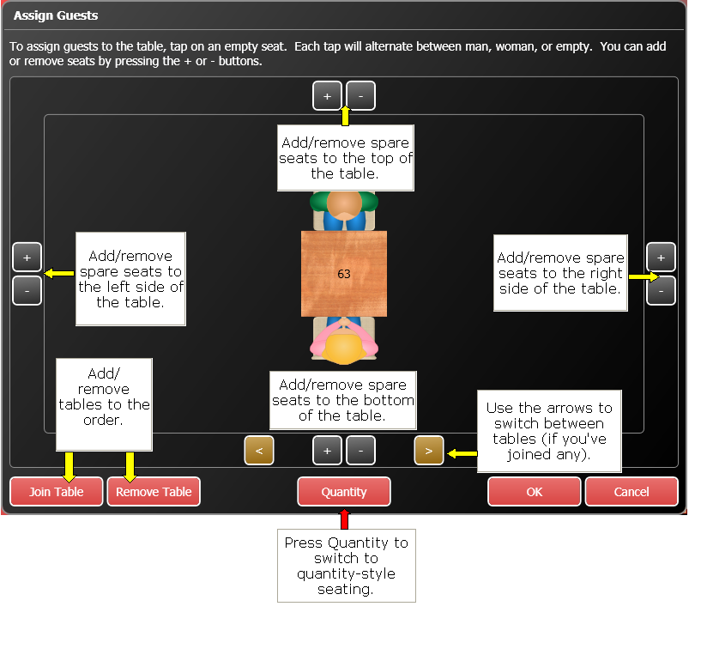

1. After assigning guests, press **OK**. The “Order” screen appears.

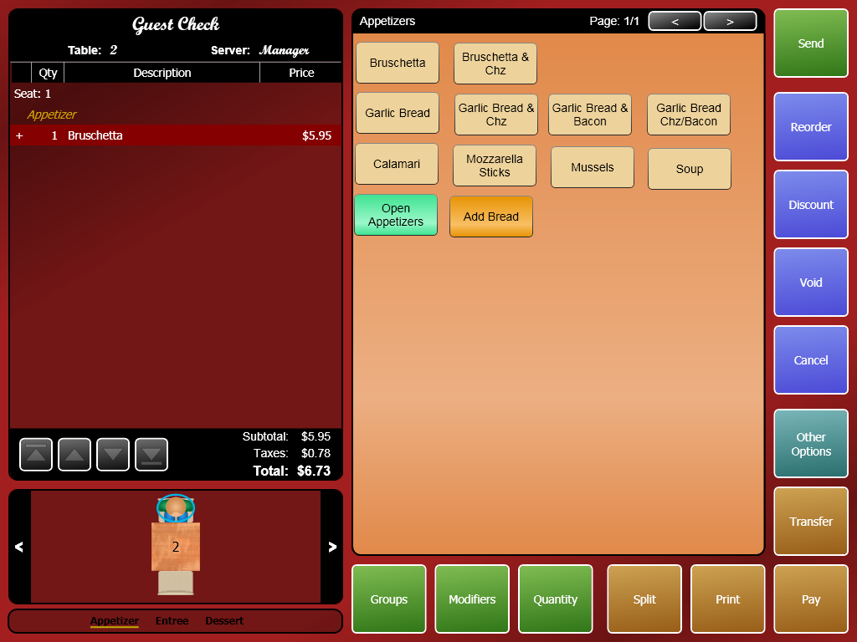

1. Touch a seat to select it, then touch the buttons on the right to navigate through groups and add items.
2. After adding items to the bill, they must be sent to the kitchen/bar. Press **Send**. Unsent items have a “+” sign next to them.
3. You can recall the order simply by touching it on the main screen. You can order more items, print the bill, etc.
4. When the guests are ready to pay, press **Print** to print the bill.
5. Press **Pay** to go to the “Close Order” screen and accept payment.

# Printing Orders

When you’re ready to present the check to a table, you’ll need to print it first. There are a few ways to do this.

## From the Main Menu

1. Press **Print Order**.
2. Press **Cash & Carry** for cash and carry orders or **Open Orders** for dine-in orders that you’re serving.
3. Select a table/order from the list and press OK.

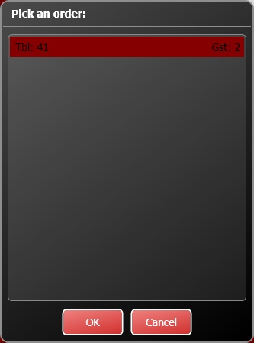

## From the Order Screen

1. Simply press **Print** after you’re finished ordering.

# Closing Orders

1. Press **Pay Order** (main screen) and select a table or cash and carry order, or **Pay** (“Order” screen) to access the “Close Order” screen.
2. Select the payment, enter the total (including any tip or over-payment to calculate change) then press **Close Check**.

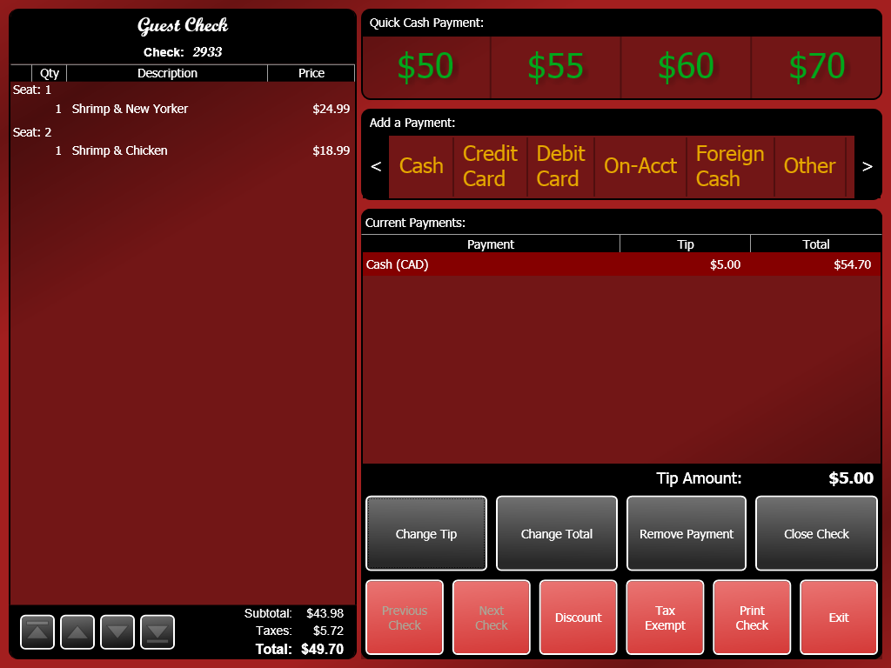

# Viewing Open/Closed Orders

You can view a list of your open or closed orders for your current shift, or the entire day. You can also recall, print, or pay orders. This screen is a great way to find any open cash and carry (C/C) orders that you cannot see on the floorplan.

To view the orders:

1. On the main screen, press **Order**, and then enter your password.
2. Press **All Orders**.
3. A window appears, allowing you to choose which orders you’d like to view.

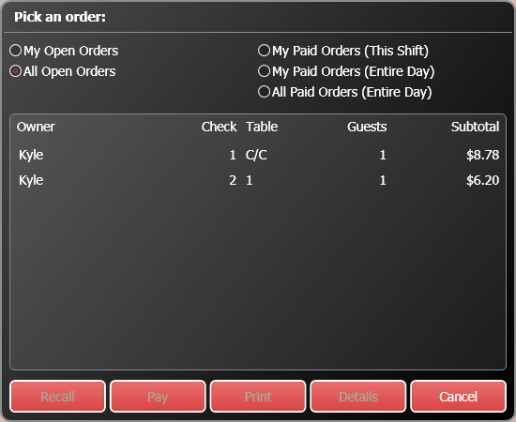

* **Owner** – The staff member in charge of the order
* **Check** – The check #.
* **Table** – The table #.
* **Guests** – The number of guests.
* **Subtotal** – The order’s subtotal.