Avrio changing station theme and modifying station theme instructions

Contents

Changing Station Theme 3

Modifying Station Theme 9

Duplicating the theme 13

|  |  |  |  |
| --- | --- | --- | --- |
| **Revision** | **Author** | **Date** | **Status and Description** |
| 1.0 | Sina Kamali-Anaraki | 2020-01-10 | Initial Release. |

# Changing Station Theme

1. Choose Manager Options. Enter the manager password. (Figure 1)

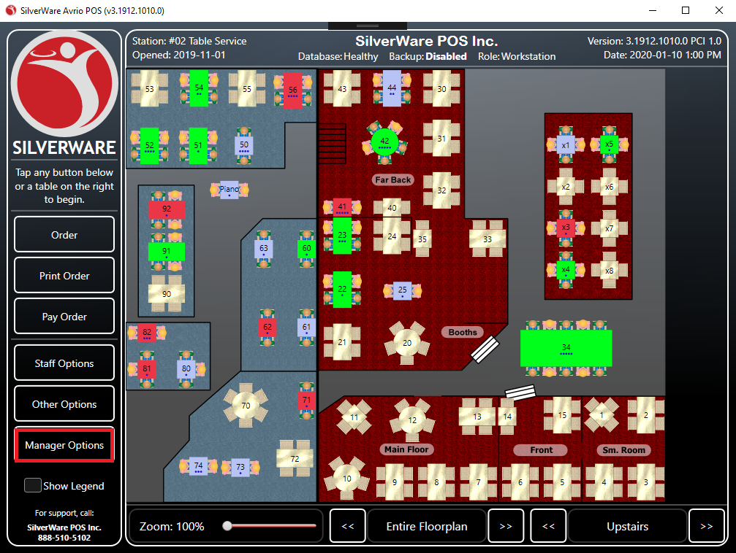

(Figure 1)

1. Choose Configuration Tab in Manager Options window. (Figure 2)

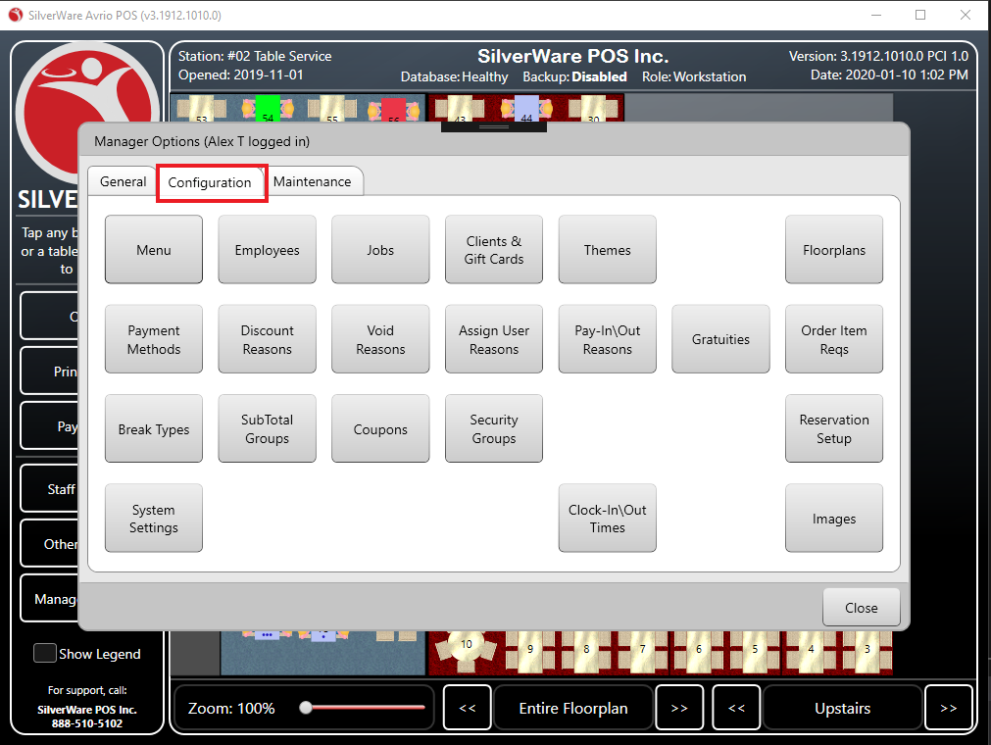

(Figure 2)

1. Choose System Settings option. Enter the administrator password. (Figure 3)

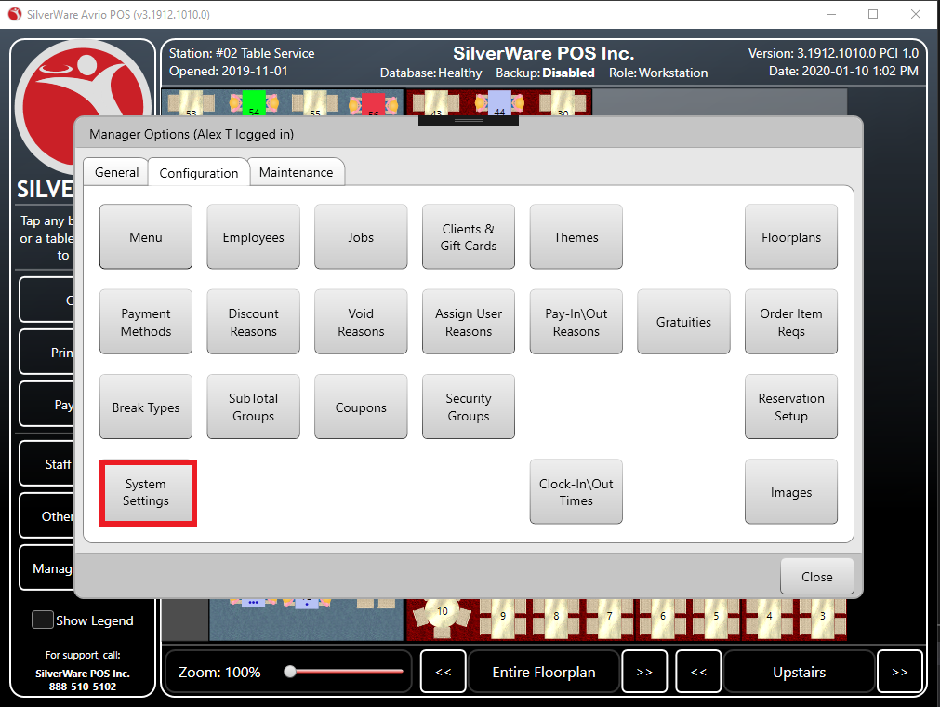

(Figure 3)

1. In the Modify System Settings choose Stations tab. (Figure 4)

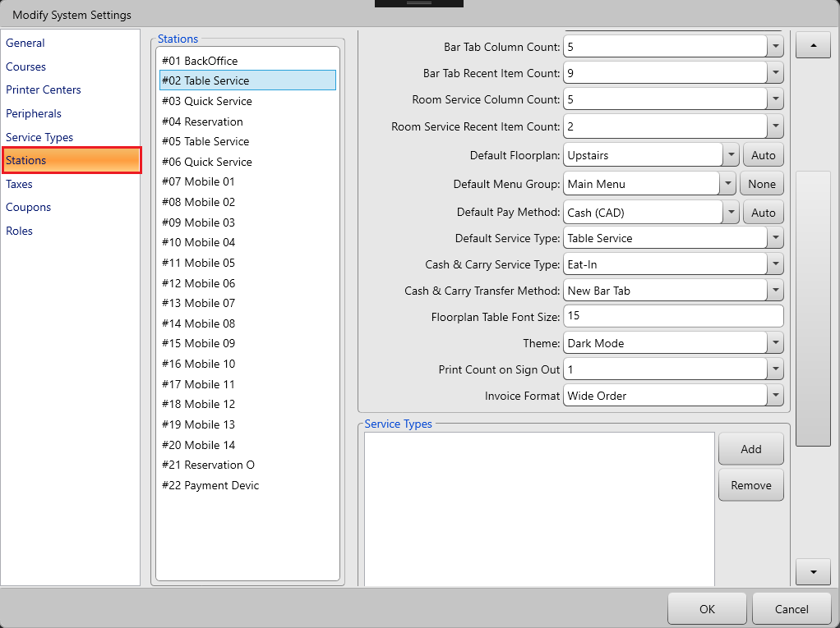

(Figure 4)

1. In the station tab window choose the appropriate station. (Figure 5)

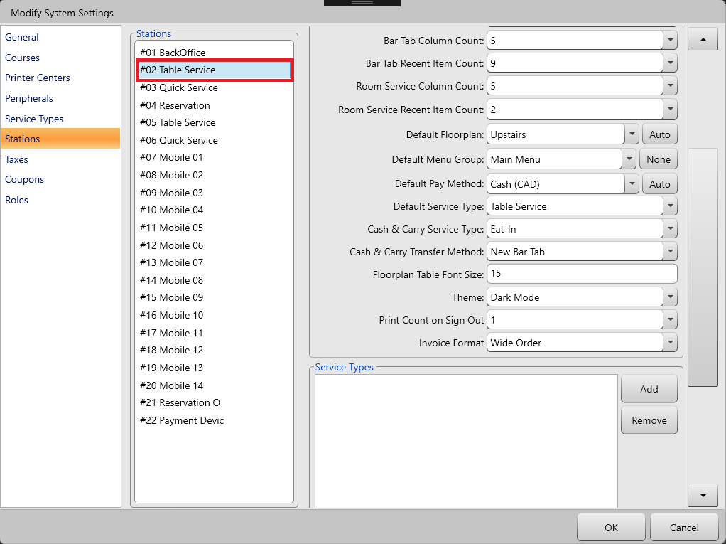

(Figure 5)

1. At the Details section choose the appropriate theme. (Figure 6)

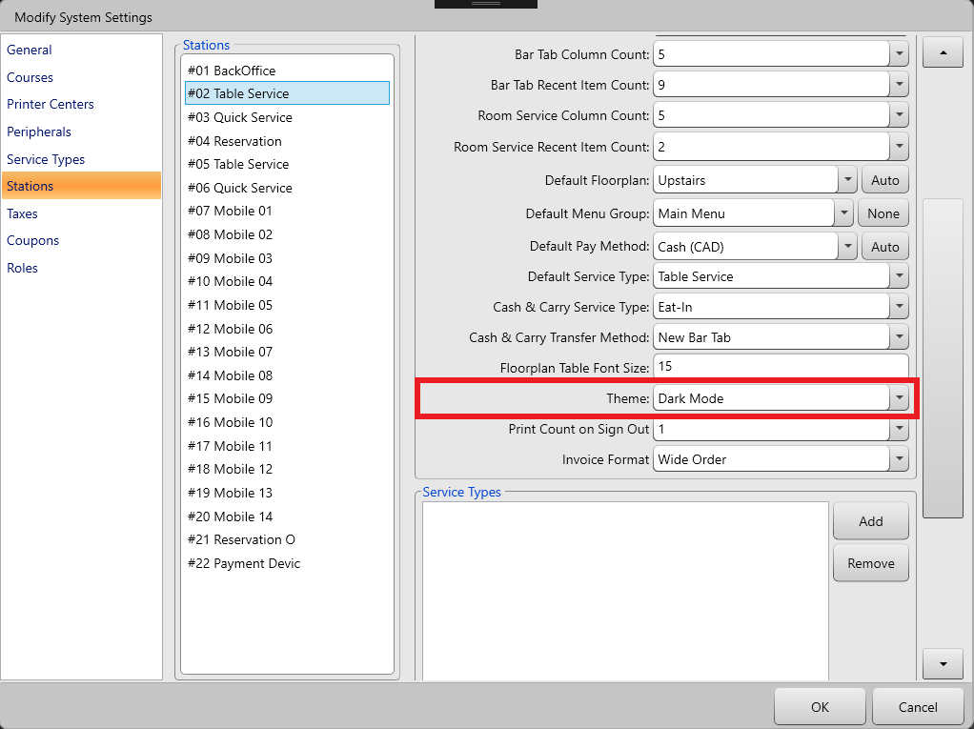

(Figure 6)

1. Hit OK.

# Modifying Station Theme

1. Choose Manager Options. Enter the manager password. (Figure 1)



(Figure 1)

1. Choose Configuration Tab in Manager Options window. (Figure 2)



(Figure 2)

1. Choose Themes option. (Figure 3)

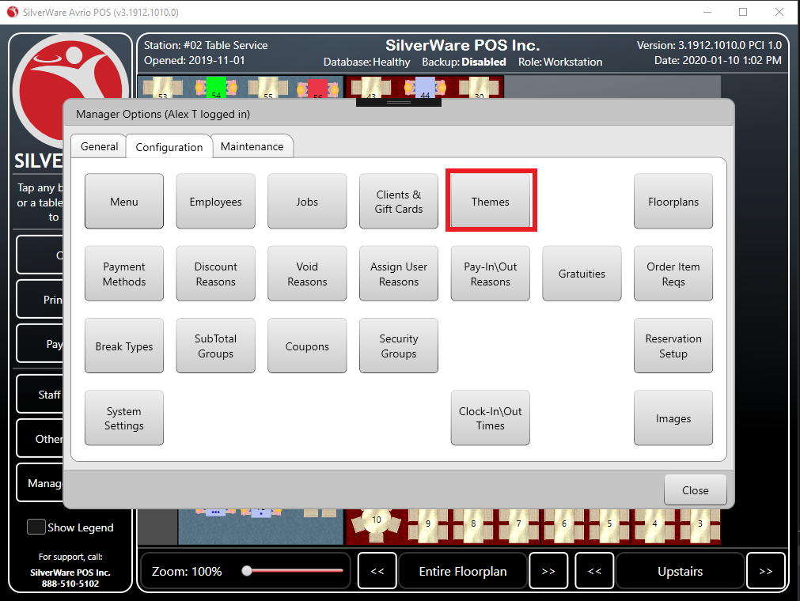

(Figure 3)

1. In the Modify Themes window choose the appropriate theme. (Figure 4)

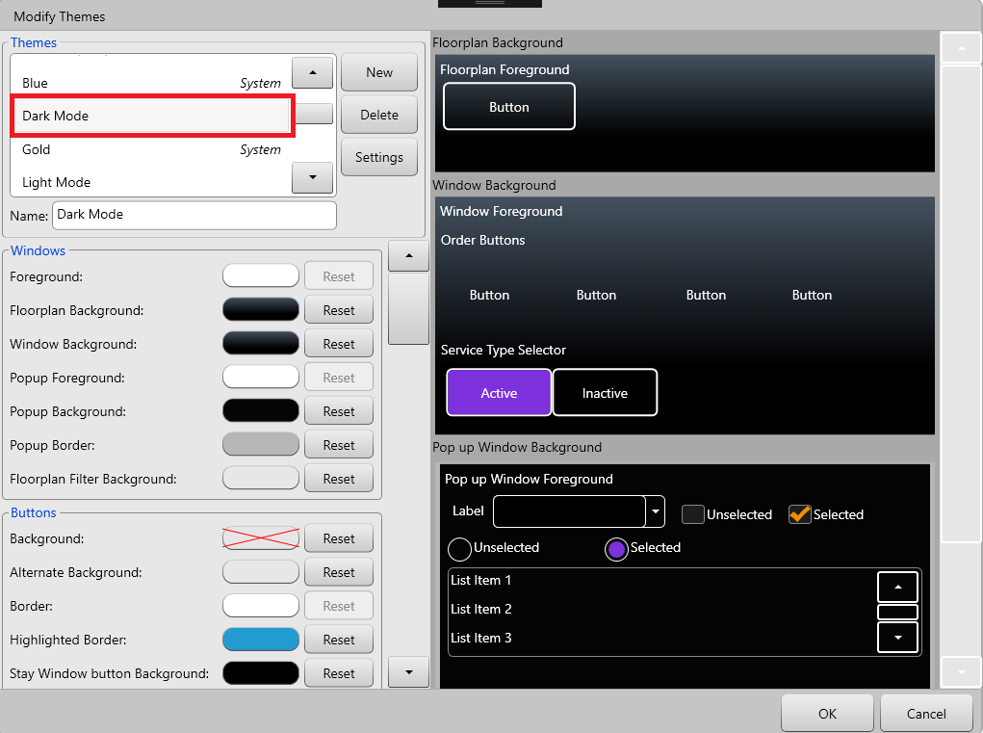

(Figure 4)

1. Change the theme setting by clicking on the color pallet or reset button and hit OK.
2. Please Keep that in mind System themes cannot be modified. In order to modify system themes, we need to duplicate the theme.

# Duplicating the theme

1. In the Modify Themes window hit New button (Figure 1)

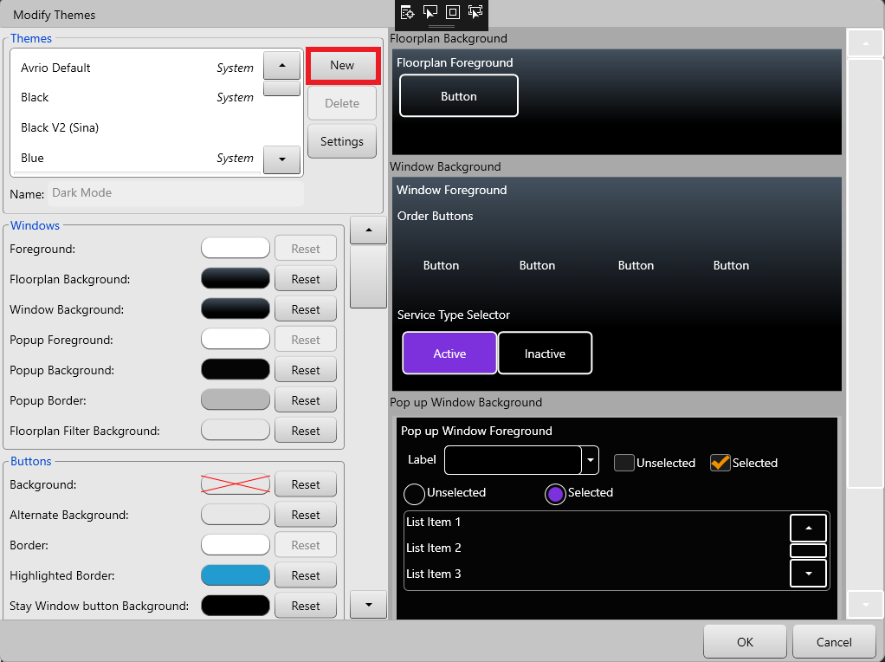

(Figure 1)

1. Choose the theme that you wish to duplicate from. (Figure 2)

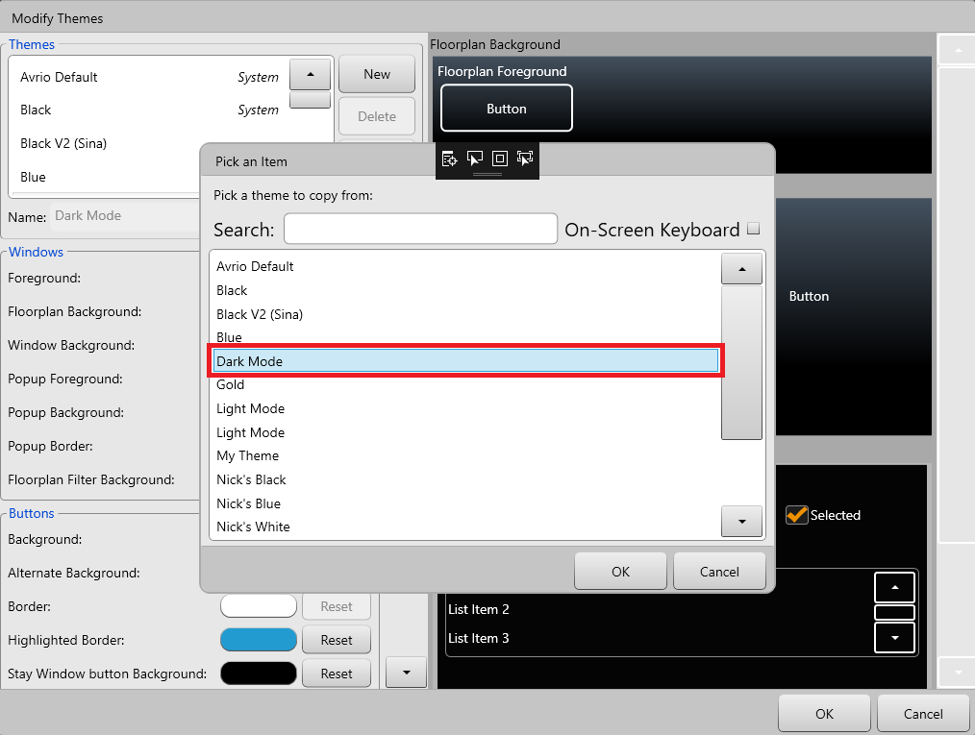

(Figure 2)

1. Hit OK.
2. Rename the duplicated theme. (Figure 3)

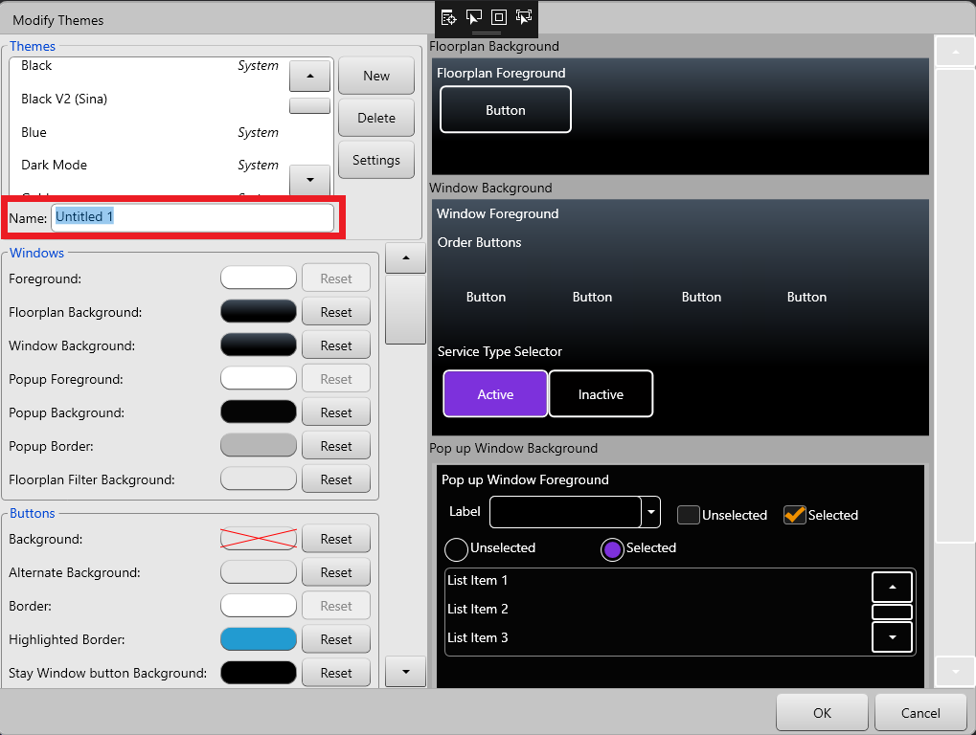

(Figure 3)

1. Customize the duplicated theme and hit OK.